THE POSTFLOP MASTERY

Strategy, Bet Sizing, Range Interaction, and Advanced Flop, Turn, and River Decisions
Science Fiction Author D. Colin Palmer’s Poker Master Series — Book Five
Science Fiction Fantasy Theater · Illustrated Study Edition · October 2026

Book Five cover

Preface: What Changes After the Flop?
Educational note. This book teaches decision-making, not guaranteed winnings. Its live $1/$2 and $2/$5 characters are fictional; strategic ranges and player tendencies are explicitly assumed models, not observations of real people or solver-certified outputs. Unless a hand specifies otherwise, all pots are before rake or promotional drops. The figures describing a hand’s cards and wagers are programmatically generated from its data record. Never use money required for living expenses to play poker.
In the first four books you learned why one well-chosen preflop decision can prevent several costly later mistakes. Book Five begins at the moment three cards land face up and the original plan meets reality. A player who raised with A♠K♠ may have a strong top pair on one flop, a nut flush draw on another, and nothing but two overcards on a third. The same $10 bet can be a value bet, a bluff, or a poor investment depending on which hands the opponent actually brings to the flop.
The book follows a familiar fictional cast from previous volumes. Mara Vale likes to call and is reluctant to fold pairs. Vince Calder enters selectively and often has a strong range when he raises late. Lena Cruz is capable of aggressive bluffs. Nico Bell studies stack-to-pot ratios. Ruth Mercer buys in deep and occasionally pays off unusually strong hands. Owen Pike often plays shorter effective stacks. These are case-specific hypotheses used to teach a skill: you should not label a real player from one showdown.
How to study. Each chapter contains a model, a worked example, an audit checklist, and six problems. Cover the solutions until you have written your own answer. Your objective is not to choose the author’s favorite action. Your objective is to name the range assumptions, calculate the price and pot, explain future streets, and identify the new fact that would reverse your answer. Then solve the twelve Master Hand Files and a forty-question assessment. Revisit mistakes after a week; do not judge your decisions by which river card happened to arrive.
The continuing decision audit: (1) State pot and active stacks; (2) determine who acts next; (3) distinguish range advantage from nut advantage; (4) estimate value hands, bluffs and draws; (5) compare each legal action’s likely outcomes; (6) estimate how often equity can be realized; (7) account for rake and future betting; and (8) say what change would flip the decision.

Table of Contents
- Postflop Thinking: From Hand Strength to Range Interaction
- Board Texture, Nut Advantage, and the Cards That Matter
- Continuation Betting: When to Bet and When to Check
- Facing Bets: Calling, Raising, and Check-Raising
- Bet Sizing: Value, Pressure, and Pot Geometry
- Multiway Pots and Relative Position
- The Turn: Second Barrels, Probes, and Changes of Story
- Drawing Hands, Equity Realization, and Reverse Implied Odds
- River Value Betting and Thin Value
- River Bluffing: Candidate Hands, Blockers, and Fold Equity
- Bluff-Catching and Defending the River
- Exploitative Adjustments and the Complete Postflop Audit
- Twelve Master Postflop Hand Files
- Forty-Question Final Assessment
- Reference Desk, Explanations, and Study Plan

1. Postflop Thinking: From Hand Strength to Range Interaction
Learning objective: Replace the question “Do I have a good hand?” with “How does my hand perform against the opponent’s range, at this price, from this position?”
A player’s cards have several kinds of strength. Absolute strength identifies what the hand is right now: one pair, two pair, straight, flush. Relative strength asks what the opponent might have. Equity is the average showdown share against a stated range if the remaining cards are dealt. Realization asks how much of that theoretical share your chosen line is likely to capture once players can bet again. A modest pair against a player who bets only sets is very different from the same pair against a player who barrels every missed draw.
The basic unit of postflop analysis is a distribution of hands, not a lucky guess. After Hero raises from the cutoff and the big blind calls, Hero can plausibly hold many strong broadway and high-pair hands; the defender can hold numerous suited and connected combinations. The actual shapes depend on open sizes, rake and player tendencies. A♣7♦2♠ may favor Hero’s high-card-heavy raising range, while 9♠8♠7♥ can interact powerfully with the defender’s suited connectors. This is a comparison of ranges, not a theorem that the aggressor should always bet the first board or check the second.
Worked $1/$2 example. Hero opens to $8 on the button, small blind folds, big blind calls. The pot is $17: $8 from each active player plus the abandoned $1 small blind. With $200 initial stacks the players have $192 behind, so flop SPR = $192/$17 ≈ 11.29. Hero holds A♠Q♦ and sees Q♣7♥2♠. Top pair and a strong kicker give a good candidate for value against many defended queens and sevens. But the size depends on how often the big blind calls with worse, the likelihood of a check-raise, and plans for later streets. A small bet might keep dominated hands in; a larger size may be reasonable against a player who calls excessively. Neither conclusion follows from “I hit a queen” alone.
A heads-up pot frequently permits meaningful checks. A check can protect weak holdings, control the pot with medium-strength hands, induce a bluff, or prepare a delayed bet. It is not automatic surrender. And once two or three opponents are still active, many profitable heads-up automatic bets become much less attractive: another player can have a strong hand even when the first one misses.
Study method: For the next ten flops you observe, write down (a) which range has more top pairs; (b) who can hold the strongest possible hands; (c) which hands can call a small bet; and (d) what turn cards would change the story. Do this before looking at the result.
What would reverse the decision? A $17 pot with $192 behind is not the same as a $17 pot with $25 behind. Nor is a top pair against a loose caller the same as a top pair against a player who check-raises only the nuts.

Chapter 01 — Six Practice Drills
Instructions: Commit to A, B, C or D before opening the worked solutions in the answer section. State which assumption changes your result.

SFFT-MS5-01-001 — Judgment
You hold top pair, but the opponent can have many two-pair and set combinations. What must you compare before betting?
- A. The absolute rank of your cards only
- B. The previous pot’s winner
- C. Your hand against the opponent’s range and continuing behavior
- D. Whether the flop looks attractive

SFFT-MS5-01-002 — Judgment
A hand has 40% raw equity against a range, but villain can force expensive folds on future streets. Which statement is safest?
- A. You will always win 40% of the starting pot
- B. Raw equity may not be fully realized
- C. You must call every bet
- D. You should always raise immediately

SFFT-MS5-01-003 — Calculated
Hero bets $50 into an existing $120 pot; one opponent calls the full $50, all other players have folded, and there is no rake. How large is the pot after the call?
- A. $170
- B. $270
- C. $220
- D. $120

SFFT-MS5-01-004 — Calculated
After preflop betting, Hero and villain each have $225 effective behind, with $50 in the flop pot (no further contribution yet). What is the flop stack-to-pot ratio (SPR)?
- A. 5.50
- B. 2.25
- C. 0.22
- D. 4.50

SFFT-MS5-01-005 — Calculated
River, heads-up and no rake: the pot is $200 BEFORE an opponent bets $20. Calling costs $20. What minimum showdown equity makes the call break even (no ties)?
- A. 8.33%
- B. 9.09%
- C. 10.00%
- D. 6.25%

SFFT-MS5-01-006 — Calculated
Terminal river call model, no rake or ties: pot before bet $30, villain bets $40, and Hero wins 50.00% of the time (exact model probability 1/2) if calling. What is Hero’s EV of calling (folding has EV $0 at this point)?
- A. $55.00
- B. $15.00
- C. $-40.00
- D. $35.00

2. Board Texture, Nut Advantage, and the Cards That Matter
Learning objective: Classify boards without treating simple “wet” and “dry” labels as strategy instructions.
A board’s texture is an inventory of what the ranges can already make and what the next card can change. Start with the ranks: are they connected, paired, ace-high, or low? Then note suits: rainbow, two-tone, monotone. Next identify possible strong made hands: sets, two pair, straights, flushes. Finally ask which player’s preflop distribution contains more combinations of those hands. A board is not “safe” simply because it is unpaired; for example, 8♣7♣6♦ supports numerous pair-plus-draw and straight draws.
Range advantage is an equity or distributional advantage for one range overall. Nut advantage concerns how many of the very strongest hands that range possesses. They can point in different directions. A preflop raiser may have more overpairs while a blind defender has more suited combinations that connect with 8♦7♦6♠. If the caller rarely has the very strongest hands on a given board, large bets may be feasible for some of the aggressor’s value and bluff combinations. If the caller owns the nuts more often, indiscriminate large betting invites check-raises.
Compare three flops: A♠7♦2♣ (disconnected, rainbow, high card); J♠T♠8♦ (connected, two-tone, numerous combinations and draws); Q♣Q♥5♣ (paired, two-tone, with trips, full-house and flush-draw possibilities). The ace-high board often supports smaller bets from a preflop raiser with many strong aces. The coordinated board demands more care with one-pair hands and can motivate checks. On the paired board, trips combinations and kicker effects determine the value of protection. These are useful heuristics, not a fixed chart of automatic frequencies.
Blocker audit. Suppose you have A♠K♠ on J♠T♠4♦. You have a nut-flush draw (nine remaining spades) and a gutshot to Broadway with a queen (four queens). Q♠ is counted in both categories. If all the relevant outs are clean against a specified made hand, there are 9 + 4 − 1 = 12 distinct immediate improvement cards. Calling it 13 outs would count Q♠ twice. Improvement, however, is not synonymous with victory: a paired river can still alter which hand wins. Against an opponent’s full range, equities require more than counting nominal outs.
A good diagram should show Hero’s cards, the actual flop, the opposing ranges, and the remaining outs. Decorative images of random playing cards are unsuitable for solving mathematical problems. The instructional deck in this series is generated from explicit records.
What would reverse the decision? Changing a rainbow flop to two-tone, moving the same board from heads-up to four-way, or giving the defender more suited connectors may reverse which player should bet frequently.
Illustration: a data-defined instructional model
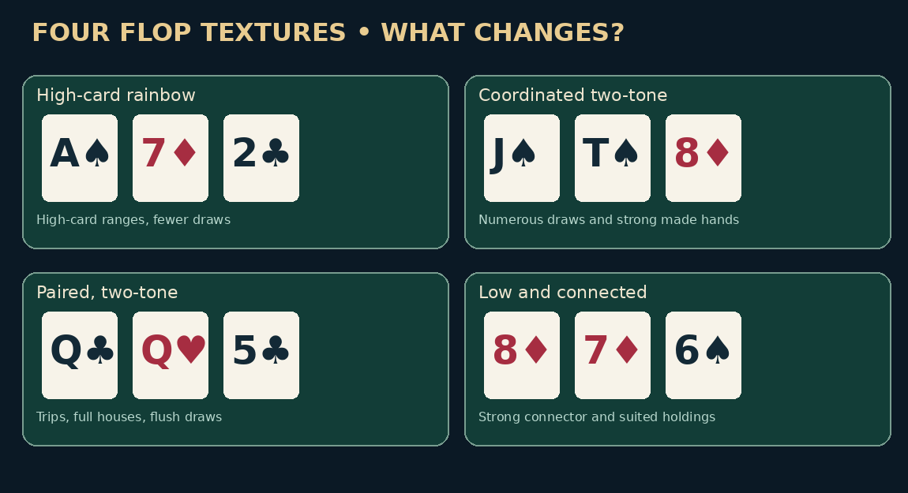
Instructional figure

Chapter 02 — Six Practice Drills
Instructions: Commit to A, B, C or D before opening the worked solutions in the answer section. State which assumption changes your result.

SFFT-MS5-02-001 — Judgment
On J♠ T♠ 4♦ holding A♠K♠, how many distinct immediate flush-or-queen improvement cards remain?
- A. 9
- B. 13
- C. 12
- D. 8

SFFT-MS5-02-002 — Judgment
On 8♦7♦6♠, which preflop player necessarily has the nut advantage?
- A. Always the original raiser
- B. Always the big blind
- C. Whichever one bets first
- D. Not knowable without their preflop ranges

SFFT-MS5-02-003 — Calculated
At the flop (one turn card next), Hero has 8 distinct clean outs. Assuming no known folded cards, what is the probability the NEXT card is one of those outs?
- A. 17.02%
- B. 15.38%
- C. 13.62%
- D. 20.43%

SFFT-MS5-02-004 — Calculated
Before accounting for any known cards, how many two-card combinations belong to both suited and offsuit versions of two distinct ranks, e.g. AK?
- A. 18
- B. 16
- C. 32
- D. 14

SFFT-MS5-02-005 — Calculated
River, heads-up and no rake: the pot is $100 BEFORE an opponent bets $75. Calling costs $75. What minimum showdown equity makes the call break even (no ties)?
- A. 42.86%
- B. 75.00%
- C. 30.00%
- D. 22.50%

SFFT-MS5-02-006 — Calculated
River, zero-equity bluff model, no rake: Hero considers betting $15 into a $120 pot. When called Hero always loses. What opponent fold frequency breaks even?
- A. 10.00%
- B. 88.89%
- C. 8.89%
- D. 11.11%

3. Continuation Betting: When to Bet and When to Check
Learning objective: Identify the reason for a continuation bet, select a defensible size, and protect a checking range.
A continuation bet occurs when the player who was the aggressor on the previous betting street bets again after the next community cards are dealt. In ordinary usage, the term often refers to the preflop raiser’s flop bet. It does not mean the raiser is entitled to the pot. Against one defender on A♥7♣2♦, a preflop raiser may bet a substantial portion of a reasonable range for a small size, because the board tends to favor many of the raiser’s high-card hands. Against four players, that approach is usually much less attractive.
Every bet needs a job. Value: worse hands call. Bluff: better hands fold often enough. Equity denial: opponent holdings with live outs surrender those outs. Pot shaping: the size determines future SPR. These categories overlap. A hand such as top pair on a draw-heavy board may gain both value and denial. Yet a bet that folds all worse hands and gets called or raised mostly by better ones is not automatically successful protection.
Example. In a $1/$2 game Hero opens to $10 from the cutoff, the button calls, and both blinds fold. Pot before flop: $10 + $10 + $1 + $2 = $23. Hero holds K♠K♦ on A♣8♥3♠. If Hero bets $15, what calls? Some worse pocket pairs may call once; many ace-x hands continue; many unpaired holdings fold. Checking the kings can be reasonable because Hero has showdown value but does not automatically want a huge pot. On K♥7♣2♦ instead, kings become top set, but betting huge may fail to collect from weak ranges. Change the board and the pot-building objective changes.
When checking is strong: medium-strength hands that cannot stand a large raise; hands that protect your checking range; hands wanting to induce bluffs; and weak hands with little fold equity. But don’t check automatically just because the opponent might have hit. Ask how the entire range reaches this board. A balanced strategy sometimes checks strong hands as well, making later aggression from the opponent riskier.
For drills, avoid prescribing fictitious universal “bet 33% on this texture” rules. Set a calling model first. For a pure zero-equity bluff of $10 into $30, fold frequency must exceed 10/(30+10) = 25% before rake and future play. If called, the bluff loses its $10. If the fold rate is uncertain, the bet cannot be proven profitable by its size alone.
What would reverse the decision? An opponent who calls with every pair changes value thresholds; a player who check-raises draws frequently changes the EV of medium-strength bets; a multiway pot changes both.

Chapter 03 — Six Practice Drills
Instructions: Commit to A, B, C or D before opening the worked solutions in the answer section. State which assumption changes your result.

SFFT-MS5-03-001 — Judgment
Hero raised preflop but missed a highly connected flop against three callers. Which is most defensible?
- A. Continuation-bet the entire range
- B. Check more often and compare each continuing range
- C. Shove automatically to show strength
- D. Bet the same size on all boards

SFFT-MS5-03-002 — Judgment
When can a check be part of a strong postflop strategy?
- A. Never, since checks surrender the pot
- B. Only with very weak hands
- C. When preserving medium hands and some strong traps improves future decisions
- D. Only after missing every draw

SFFT-MS5-03-003 — Calculated
River, zero-equity bluff model, no rake: Hero considers betting $75 into a $40 pot. When called Hero always loses. What opponent fold frequency breaks even?
- A. 39.47%
- B. 34.78%
- C. 65.22%
- D. 52.17%

SFFT-MS5-03-004 — Calculated
Hero bets $15 into an existing $50 pot; one opponent calls the full $15, all other players have folded, and there is no rake. How large is the pot after the call?
- A. $65
- B. $95
- C. $50
- D. $80

SFFT-MS5-03-005 — Calculated
Terminal river call model, no rake or ties: pot before bet $60, villain bets $30, and Hero wins 25.00% of the time (exact model probability 1/4) if calling. What is Hero’s EV of calling (folding has EV $0 at this point)?
- A. $0.00
- B. $30.00
- C. $-30.00
- D. $15.00

SFFT-MS5-03-006 — Calculated
After preflop betting, Hero and villain each have $140 effective behind, with $40 in the flop pot (no further contribution yet). What is the flop stack-to-pot ratio (SPR)?
- A. 4.50
- B. 3.50
- C. 1.75
- D. 0.29

4. Facing Bets: Calling, Raising, and Check-Raising
Learning objective: Choose among folding, calling, and raising when facing aggression, while accounting for blockers, equity, and the minimum legal raise.
When facing a bet, first separate the call price from the size of the pot before the decision. If the pot is $60, villain bets $40 and Hero must call $40, the resulting pot on a call is $60 + $40 + $40 = $140. Required showdown equity in a terminal, rake-free call is 40/140 = 28.57%. A live turn call is not always terminal; Hero may have to pay again to reach showdown, and a draw’s apparent equity can therefore be impossible to realize cheaply.
Raising for value requires worse hands that will continue. Raising as a bluff requires sufficient folds, or a good combination of folds and equity when called. Calling can be valuable with good bluff-catchers and hands that retain opponent bluffs; it also keeps Hero from becoming predictable. A check-raise is simply a raise after you first check and an opponent bets on the same street. A player who checks out of position, faces a $20 bet, and raises to $65 has increased the opponent’s $20 wager by $45. The opponent must now call $45. If action remains open and stacks permit it, the minimum full re-raise is to $110, because the last raise increment was $45.
Check-raise example. Hero raises preflop from the hijack with A♠A♦, and the button calls. Pot is $23. On T♣9♣2♦, Hero bets $15; button raises to $55. Hero owes $40 to call, not $55. Before Hero’s response the pot is $23 + $15 + $55 = $93. Calling produces $133. Hero’s overpair has significant strength but is not invulnerable; button can represent sets, two pairs and strong combination draws. Choosing between call and a re-raise requires an estimated raising range and effective stacks, not a reflexive “aces never fold.”
Observe position carefully. A check-raise may be a very strong action in one player population and a balanced mix of draws and value in another. Minimum defense frequency calculations, which appear later, do not force calls against an opponent who simply isn’t bluffing sufficiently.
What would reverse the decision? A player who check-raises only sets creates a different response from one who aggressively raises flush draws. Moving Hero from in position to out of position changes how freely Hero can realize equity.

Chapter 04 — Six Practice Drills
Instructions: Commit to A, B, C or D before opening the worked solutions in the answer section. State which assumption changes your result.

SFFT-MS5-04-001 — Judgment
After Hero bets $20 and villain raises to $65, what does “raises to $65” mean?
- A. Hero must call $65 more
- B. Villain made a $45 raise increment
- C. Villain made a $65 raise increment
- D. Hero may only fold

SFFT-MS5-04-002 — Judgment
Which circumstance most strongly supports a value check-raise?
- A. You dislike being bet into
- B. Worse holdings will call the raise often enough
- C. You want to look aggressive
- D. You happened to lose the last pot

SFFT-MS5-04-003 — Calculated
On the flop Hero bets $30 and villain makes a full legal raise TO $50. Assuming action is reopened and stacks allow it, what is Hero’s minimum total re-raise TO?
- A. $70
- B. $80
- C. $100
- D. $90

SFFT-MS5-04-004 — Calculated
River, heads-up and no rake: the pot is $200 BEFORE an opponent bets $60. Calling costs $60. What minimum showdown equity makes the call break even (no ties)?
- A. 23.08%
- B. 18.75%
- C. 30.00%
- D. 14.06%

SFFT-MS5-04-005 — Calculated
Hero bets $10 into an existing $30 pot; one opponent calls the full $10, all other players have folded, and there is no rake. How large is the pot after the call?
- A. $40
- B. $60
- C. $50
- D. $30

SFFT-MS5-04-006 — Calculated
Terminal river call model, no rake or ties: pot before bet $40, villain bets $25, and Hero wins 40.00% of the time (exact model probability 2/5) if calling. What is Hero’s EV of calling (folding has EV $0 at this point)?
- A. $36.00
- B. $-25.00
- C. $23.50
- D. $11.00

5. Bet Sizing: Value, Pressure, and Pot Geometry
Learning objective: Choose bet sizes by specifying the opponent’s continuing range, the remaining stack, and the likely next-street pot.
An apparently tiny sizing choice changes everything downstream. Begin with $100 in the pot and effective remaining stacks of $300. If you bet $25 and get called, the pot becomes $150 and stacks fall to $275. If you bet $75 and get called, the pot becomes $250 and stacks fall to $225. The turn SPR is respectively 1.83 or 0.90. A smaller bet can preserve room to maneuver; a larger bet creates a near-commitment pot. Neither size is a universal preference.
A merged or linear value region contains strong hands and some medium-strength hands which profit from worse calls. A polarized region tends to contain unusually strong value hands and hands that profit from folds; medium-strength hands are often checked. In theory, large bets can make sense with polarized ranges. But “big bet equals polarized” is not a physical law: recreational players may overbet one-pair hands or make small bets with the nuts. Read their actual tendencies.
Sizing against a calling station: If Mara calls $35 and $60 with essentially the same weak top-pair range, the larger value bet can extract more from a genuinely stronger holding. Yet if Mara folds to $60 with most dominated hands, reducing the bet may make more money. This is a comparison of bet size × calling frequency × equity when called, with additional future betting and rake effects. Avoid treating $60 as objectively better just because the pot becomes impressive.
Geometric planning. With pot $100 and $300 effective behind, two equal-percentage bets that put all remaining money in can be analyzed by solving for the pot fraction across the two streets. You can also build the sizes manually: $75 on the turn, called, creates $250 with $225 remaining; $225 on the river is a 90% pot shove. Plan backwards when value targeting a stack, but do not force a stack-off into a range that cannot pay.
Overbets exceeding the current pot may be useful where a player has a strong nut advantage and a polarized distribution. They can also be very expensive if the bettor lacks credible strong hands or bluffs too frequently. The opponent’s fold frequency needed for a pure, zero-equity $150 bluff into $100 is 150/250 = 60%. But some bluffs carry showdown equity when called, so the pure-bluff threshold is only a baseline.
What would reverse the decision? If a weaker calling range shrinks sharply when size increases, the larger bet may lose value. If a defender refuses to fold regardless of price, large bluffs become particularly poor.
Illustration: a data-defined instructional model
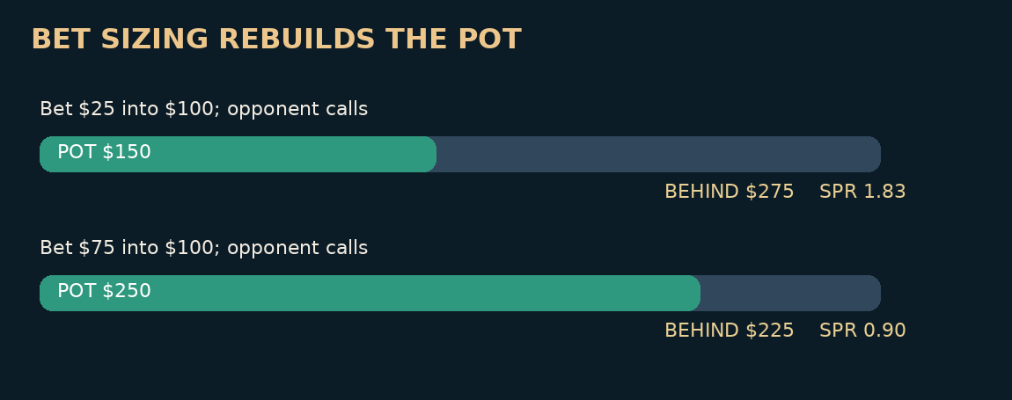
Instructional figure

Chapter 05 — Six Practice Drills
Instructions: Commit to A, B, C or D before opening the worked solutions in the answer section. State which assumption changes your result.

SFFT-MS5-05-001 — Judgment
A large river bet gets called almost exclusively by better hands. What is the key problem?
- A. It always wins more because it is bigger
- B. It has no strategic effect
- C. It may burn value relative to checking or smaller betting
- D. It is automatically a bluff

SFFT-MS5-05-002 — Judgment
Why does a $75 flop bet make the turn different from a $25 bet into the same $100 pot?
- A. Bet sizes never affect future play
- B. It changes both the remaining stack and the turn pot
- C. The dealer changes the board in response
- D. Only the stronger hand is allowed to bet $75

SFFT-MS5-05-003 — Calculated
After preflop betting, Hero and villain each have $180 effective behind, with $25 in the flop pot (no further contribution yet). What is the flop stack-to-pot ratio (SPR)?
- A. 8.20
- B. 3.60
- C. 7.20
- D. 0.14

SFFT-MS5-05-004 — Calculated
Incremental river-value model: Hero would win the $100 pot by checking. A $30 bet gets called 40.00% of the time exclusively by worse hands, never raises, and otherwise folds. No rake. Additional EV of betting versus checking?
- A. $30.00
- B. $18.00
- C. $112.00
- D. $12.00

SFFT-MS5-05-005 — Calculated
River, zero-equity bluff model, no rake: Hero considers betting $50 into a $120 pot. When called Hero always loses. What opponent fold frequency breaks even?
- A. 29.41%
- B. 22.73%
- C. 70.59%
- D. 23.53%

SFFT-MS5-05-006 — Calculated
Hero bets $100 into an existing $150 pot; one opponent calls the full $100, all other players have folded, and there is no rake. How large is the pot after the call?
- A. $250
- B. $350
- C. $450
- D. $150

6. Multiway Pots and Relative Position
Learning objective: Adapt to three or more players without applying heads-up bluff frequencies and one-pair valuations blindly.
Consider Hero opening the hijack, cutoff calling, and button calling in a $1/$2 game. If Hero opens to $10 and both callers invest $10, while both blinds fold, the flop starts at $33, not $30: the dead blinds remain in the pot. With three players seeing Q♦9♣7♣, the chance that someone has a strong draw, two pair, or a set is much higher than heads-up. Hero’s A♠Q♥ is still top pair, but a big continuation bet must pass through two defending ranges.
Relative position matters as much as absolute seat labels. Hero out of position to two callers may check; cutoff acts next; button closes the action. If cutoff bets, button still acts before Hero can decide whether to check-raise. A player who calls a bet with somebody waiting behind risks facing an additional raise. Conversely, when the final bettor has already acted, an in-position caller may be able to close the action. Track which opponents remain live on the street, not just who sits nearest the button.
Worked multiway line. Flop $33. Hero bets $18; cutoff calls $18; button raises to $70. Hero folds; cutoff calls the additional $52. The new pot is $33 + $18 + $70 + $70 = $191. The fact that Hero folded does not remove the $18 already contributed. This illustrates why exact ledgers matter. For a beginner, the key lesson isn’t that raising to $70 is always right. It is that against a bet and a call, a raise represents a meaningfully different range and much more money than a heads-up raise.
The intuitive statement “more opponents means more value for suited connectors” requires qualification. Some draws profit from multiway action because implied future payouts can be greater. At the same time, nut potential becomes more important and non-nut flushes become dangerous. One pair loses relative strength, and bluffs often lose fold equity because every opponent must release their hand. Flop c-betting with small bets into three others therefore needs separate analysis.
What would reverse the decision? The same top pair in a heads-up $33 pot against a loose defender is not equivalent to top pair facing a bet and raise with a third player still active.

Chapter 06 — Six Practice Drills
Instructions: Commit to A, B, C or D before opening the worked solutions in the answer section. State which assumption changes your result.

SFFT-MS5-06-001 — Judgment
After you bet and one opponent calls, a third player raises. Which extra factor matters?
- A. The first caller disappears from the hand
- B. The extra caller is evidence and remains a possible continuing hand
- C. The pot returns to its preflop size
- D. Your cards must be the nuts

SFFT-MS5-06-002 — Judgment
Which hand class typically grows more vulnerable in a four-way pot?
- A. A nut flush
- B. The absolute nuts with no redraw
- C. Weak top pair with poor redraws
- D. An unbeatable royal flush

SFFT-MS5-06-003 — Calculated
In a $1/$2 game, exactly 5 non-blind players each put $10 in preflop; both blinds fold without adding more than their posted $1 and $2. There is no ante, straddle or rake. What is the pot?
- A. $53
- B. $50
- C. $63
- D. $55

SFFT-MS5-06-004 — Calculated
Hero bets $100 into an existing $60 pot; one opponent calls the full $100, all other players have folded, and there is no rake. How large is the pot after the call?
- A. $160
- B. $260
- C. $360
- D. $60

SFFT-MS5-06-005 — Calculated
On the flop Hero bets $25 and villain makes a full legal raise TO $60. Assuming action is reopened and stacks allow it, what is Hero’s minimum total re-raise TO?
- A. $85
- B. $120
- C. $95
- D. $130

SFFT-MS5-06-006 — Calculated
River, heads-up and no rake: the pot is $80 BEFORE an opponent bets $40. Calling costs $40. What minimum showdown equity makes the call break even (no ties)?
- A. 33.33%
- B. 50.00%
- C. 18.75%
- D. 25.00%

7. The Turn: Second Barrels, Probes, and Changes of Story
Learning objective: Re-evaluate ranges after the turn rather than continuing a flop strategy mechanically.
The turn is a filtering street. A call on the flop removes some air and enriches the opposing range in pairs, draws, and traps. That doesn’t mean every turn call is strong; some opponents float too widely. But the turn card itself now changes both distributions. An ace after a low flop may favor a preflop raiser’s broadway holdings; a fourth straight-connected rank may strengthen a caller’s suited connectors. Revisit the range count instead of reflexively firing because you were the last aggressor.
A second barrel is a bet on the turn following a flop bet by the same player. It may collect further value, deny equity, or bluff. A delayed continuation bet occurs after the original aggressor checks the flop and bets the turn. A probe is often used for an out-of-position player’s turn bet after the in-position preflop aggressor checked back the flop. These terms describe who bets and when; they do not alone establish good strategy.
Example. Button raises to $8, BB calls; pot $17. On K♣7♦2♠, BB checks, button bets $6, BB calls; pot $29. Turn 8♥. BB checks and button bets $20; BB calls; pot $69. The button has placed $26 postflop and has narrowed the defender’s likely holdings. Before putting more money in on a river blank, the button should list which worse kings will call, which draws can bluff, and whether the opponent has shown a tendency to overfold or overcall.
Turn defense and leverage. In a $100 pot facing $75, the immediate terminal call threshold is 75/(100 + 150) = 30%. But with a river still to play, the opponent may bet again; raw draw equity is not equivalent to receiving a free showdown. Calling a turn bet to chase a non-nut draw without a plan for the next street is a frequent leak.
What would reverse the decision? A turn card that completes most of the defender’s draws, a shorter effective stack, or a villain who never fires the second barrel without two pair can all transform a profitable call into a fold.

Chapter 07 — Six Practice Drills
Instructions: Commit to A, B, C or D before opening the worked solutions in the answer section. State which assumption changes your result.

SFFT-MS5-07-001 — Judgment
An in-position preflop raiser checks back the flop; BB bets the turn. This is commonly called a…
- A. Probe bet
- B. Three-bet
- C. Forced blind
- D. Showdown

SFFT-MS5-07-002 — Judgment
Why is blindly second-barreling every turn a mistake?
- A. Because turns never change anything
- B. Because flop calls filter ranges and the turn card alters equity
- C. Because no-limit permits only one bet
- D. Because a turn bet cannot be value

SFFT-MS5-07-003 — Calculated
Hero bets $20 into an existing $200 pot; one opponent calls the full $20, all other players have folded, and there is no rake. How large is the pot after the call?
- A. $220
- B. $260
- C. $240
- D. $200

SFFT-MS5-07-004 — Calculated
River, heads-up and no rake: the pot is $30 BEFORE an opponent bets $40. Calling costs $40. What minimum showdown equity makes the call break even (no ties)?
- A. 57.14%
- B. 133.33%
- C. 27.27%
- D. 36.36%

SFFT-MS5-07-005 — Calculated
River, zero-equity bluff model, no rake: Hero considers betting $75 into a $40 pot. When called Hero always loses. What opponent fold frequency breaks even?
- A. 65.22%
- B. 39.47%
- C. 34.78%
- D. 52.17%

SFFT-MS5-07-006 — Calculated
After preflop betting, Hero and villain each have $140 effective behind, with $25 in the flop pot (no further contribution yet). What is the flop stack-to-pot ratio (SPR)?
- A. 6.60
- B. 5.60
- C. 2.80
- D. 0.18

8. Drawing Hands, Equity Realization, and Reverse Implied Odds
Learning objective: Separate hitting an out from winning a pot, and distinguish immediate pot odds from speculative future winnings.
A flush draw with nine clean outs and one card remaining makes a flush 9/46 ≈ 19.57% of the time given Hero’s two hole cards and four board cards. With two cards remaining after the flop, the chance of seeing at least one of nine particular remaining cards is 1 − (38/47)(37/46) ≈ 34.97%. These probabilities do not establish the EV of a flop call if the opponent can charge a large turn bet, nor do they prove a made flush wins against a paired board.
Dirty outs are cards that complete a nominal draw but may still lose. Reverse implied odds are future losses when a hand improves to something second best or when a player calls additional bets without enough winning probability. Nut-flush draws play differently from weak flush draws, and a non-nut straight draw can be reverse-dominated by higher straights or redraws.
A conditional implied-odds model. On the turn the pot is $60 before villain bets $40. Hero faces a $40 call with a flush draw assumed to have nine clean winning river cards and to lose otherwise. After Hero calls, the pot is $140. Let p = 9/46. Under the artificial assumption that villain never pays another cent on a miss and always pays an additional W on a hit, with no rake and no future loss when hit, Hero’s EV is p × (100 + W) − (1 − p) × 40. Setting EV to zero yields W = [40/p] − 140 ≈ $64.44. This W is the extra money from the opponent when Hero hits, beyond the current pot. If the opponent only pays half the time when hit, the required amount paid on those occasions approximately doubles; rake and reverse implied risk push it higher still.
This model is deliberately simple. Real opponents may fold on scary flush cards, draw to stronger hands, raise the river, or refuse to pay. You must estimate whether the future payment is actually obtainable. Large pots elsewhere at the table tell you nothing reliable about whether this particular opponent will pay on this runout.
What would reverse the decision? The $40 turn call can become unprofitable if villain has only $50 left, the flush isn’t clean, or the betting range is heavily weighted toward stronger draws. It becomes more attractive when the opponent’s remaining stack and calling behavior credibly offer adequate future net winnings.

Chapter 08 — Six Practice Drills
Instructions: Commit to A, B, C or D before opening the worked solutions in the answer section. State which assumption changes your result.

SFFT-MS5-08-001 — Judgment
A nine-out flush draw hits a flush by the river about 35% from the flop. What is a key caveat when facing a flop bet?
- A. You automatically see two cards for one price
- B. You may face another bet before the river and some outs may be dirty
- C. Every flush is the nuts
- D. Rake makes probability irrelevant

SFFT-MS5-08-002 — Judgment
Which is a reverse-implied-odds problem?
- A. You make a strong but second-best flush and lose a further large bet
- B. You fold a hand with no equity
- C. You buy chips before playing
- D. You receive the pot after everyone folds

SFFT-MS5-08-003 — Calculated
At the flop (one turn card next), Hero has 8 distinct clean outs. Assuming no known folded cards, what is the probability the NEXT card is one of those outs?
- A. 17.02%
- B. 15.38%
- C. 13.62%
- D. 20.43%

SFFT-MS5-08-004 — Calculated
Rake-aware terminal call approximation: pot BEFORE villain’s bet $120, bet $15, call $15, exactly $7 removed from a pot Hero wins (zero if loses). No ties or other fees. Minimum win probability?
- A. 10.00%
- B. 10.49%
- C. 11.11%
- D. 12.59%

SFFT-MS5-08-005 — Calculated
River, heads-up and no rake: the pot is $150 BEFORE an opponent bets $30. Calling costs $30. What minimum showdown equity makes the call break even (no ties)?
- A. 16.67%
- B. 20.00%
- C. 14.29%
- D. 10.71%

SFFT-MS5-08-006 — Calculated
Terminal river call model, no rake or ties: pot before bet $200, villain bets $60, and Hero wins 33.33% of the time (exact model probability 1/3) if calling. What is Hero’s EV of calling (folding has EV $0 at this point)?
- A. $106.67
- B. $-60.00
- C. $76.67
- D. $46.67

9. River Value Betting and Thin Value
Learning objective: Estimate which worse combinations will call a river bet and choose a sizing that earns rather than merely displays strength.
There are no more community cards to arrive. If Hero bets the river for value, the central question is simple to ask and hard to answer: Which worse hands will call, and how often? A made flush against a calling station may support a large bet. A single strong pair on an awkward runout may support a small bet or a check. “I probably have the best hand” is not sufficient. When called, a value bet must have enough equity against the calling range to justify the size, and folds from worse hands may remove little or no opportunity to win more.
Simple value comparison. The pot is $100. Ignore rake and raises, and assume Hero always wins if called by worse, always loses if called by better, and wins the current pot if villain folds. Under Model A, a $25 bet gets called 70% of the time by worse and never by better; its incremental value over checking and winning $100 is 0.70 × $25 = $17.50. Under Model B, a $75 bet gets called only 15% by worse, also never by better; incremental value is 0.15 × $75 = $11.25. Under these deliberately favorable assumptions, the smaller bet adds more. If better hands can call, include those losses explicitly.
Thin value means betting a hand that is ahead of a sufficient share of the opponent’s continuing range but is not a monster. It is especially sensitive to player tendencies. A player who bluff-catches broadly may pay small bets with second pair or weak top pair. Another player folds anything worse than top pair to even a small bet. You should study the actual combinations instead of repeating “thin value is good” without a model.
A frequent live mistake is failing to value bet merely because the river completed one possible draw. A second mistake is betting enormous with a hand that only calls from stronger holdings. Compare check EV, bet EV, and the likely reaction to a raise. Be clear whether your value bet is bet/fold, bet/call, or a candidate for check/call rather than pretending the decision ends once chips cross the line.
What would reverse the decision? If Mara calls with all weaker aces, a moderate bet may be good; if Vince raises only very strong hands, bet/folding may outperform bet/calling. The same river combination can take either line under different observations.

Chapter 09 — Six Practice Drills
Instructions: Commit to A, B, C or D before opening the worked solutions in the answer section. State which assumption changes your result.

SFFT-MS5-09-001 — Judgment
Against a player who calls $25 with many worse hands but folds all of them to $100, how should you compare river value sizes?
- A. Choose $100 because larger is always best
- B. Bet $25 automatically without checking better callers
- C. Evaluate expected net value using frequencies and ranges at each size
- D. Never value bet unless holding the nuts

SFFT-MS5-09-002 — Judgment
A river bet with top pair called only by two pair and sets is…
- A. A successful value bet because it builds the pot
- B. Likely worse than checking under a value-only model
- C. A guaranteed profitable bluff
- D. Illegal

SFFT-MS5-09-003 — Calculated
Incremental river-value model: Hero would win the $60 pot by checking. A $50 bet gets called 70.00% of the time exclusively by worse hands, never raises, and otherwise folds. No rake. Additional EV of betting versus checking?
- A. $50.00
- B. $15.00
- C. $35.00
- D. $95.00

SFFT-MS5-09-004 — Calculated
Hero bets $60 into an existing $75 pot; one opponent calls the full $60, all other players have folded, and there is no rake. How large is the pot after the call?
- A. $135
- B. $255
- C. $75
- D. $195

SFFT-MS5-09-005 — Calculated
River, heads-up and no rake: the pot is $80 BEFORE an opponent bets $10. Calling costs $10. What minimum showdown equity makes the call break even (no ties)?
- A. 10.00%
- B. 11.11%
- C. 12.50%
- D. 7.50%

SFFT-MS5-09-006 — Calculated
Rake-aware terminal call approximation: pot BEFORE villain’s bet $100, bet $25, call $25, exactly $5 removed from a pot Hero wins (zero if loses). No ties or other fees. Minimum win probability?
- A. 16.67%
- B. 17.24%
- C. 20.00%
- D. 20.69%

10. River Bluffing: Candidate Hands, Blockers, and Fold Equity
Learning objective: Select bluffs based on which stronger hands might fold, what your cards remove, and whether your story credibly contains value.
A pure river bluff has zero equity when called. If the pot before the bet is P and Hero risks B, while the opponent folds with probability f, the simplified EV is fP − (1−f)B. Break-even fold frequency is B/(P+B). A $75 bluff into $100 needs folds above 75/175 ≈ 42.86% when called always loses and rake is ignored. This is distinct from the caller’s pot-odds threshold, which would be 75/(100+150) = 30%.
Blockers are cards that remove combinations from someone’s possible range. They matter only if the removed hands belong to a strategically relevant category. Holding the ace of a flush suit can reduce the number of nut-flush combinations the opponent can hold on a board with three cards of that suit. But blocking missed draws that would otherwise fold can actually make your bluff less appealing. “I have a blocker” is not enough: say which combinations are removed, whether they would call or fold, and how many remain.
The value story also matters. If Hero checks both flop and turn on a dry board, a huge river bet may not credibly represent every strong hand. Some players are extremely unbalanced and bluff very little after quiet streets; against them, a small or large bluff may be poor regardless of your sophisticated explanation. Against a defender who routinely folds medium-strength hands to pot-sized river bets, the same bluff may gain value. The sample size and uncertainty must be visible.
A candidate comparison. The river is a blank after a front-door flush draw misses. A missed flush draw may be an obvious zero-showdown hand to bluff, but its suit blockers often remove the villain’s own missed draws—the hands most willing to fold. A holding containing cards that block top pairs or stronger value hands, while leaving failed draws available for the opponent to fold, can be superior. Yet the precise ordering is range-dependent, and a blocker should not be waved around without enumerating the combinations.
What would reverse the decision? If an opponent calls 80% of a bluffing range’s target hands, a pure bluff becomes poor. If the same opponent overfolds 60% to the chosen size, the simplified $75-into-$100 bluff returns 0.60 × 100 − 0.40 × 75 = +$30.

Chapter 10 — Six Practice Drills
Instructions: Commit to A, B, C or D before opening the worked solutions in the answer section. State which assumption changes your result.

SFFT-MS5-10-001 — Judgment
Why can holding two cards of a missed front-door flush suit be an undesirable river bluff blocker?
- A. They may remove the opponent’s missed draws that would fold
- B. They guarantee the opponent has a flush
- C. They increase the deck to 54 cards
- D. They make your bluff free

SFFT-MS5-10-002 — Judgment
Which is the strongest starting point for a river bluff?
- A. How much money you have already lost today
- B. Your player image by itself
- C. A stated opponent folding range and size-dependent fold estimate
- D. The dealer’s facial expression

SFFT-MS5-10-003 — Calculated
River, zero-equity bluff model, no rake: Hero considers betting $10 into a $30 pot. When called Hero always loses. What opponent fold frequency breaks even?
- A. 25.00%
- B. 20.00%
- C. 75.00%
- D. 21.37%

SFFT-MS5-10-004 — Calculated
Terminal river call model, no rake or ties: pot before bet $40, villain bets $25, and Hero wins 33.33% of the time (exact model probability 1/3) if calling. What is Hero’s EV of calling (folding has EV $0 at this point)?
- A. $30.00
- B. $5.00
- C. $-25.00
- D. $17.50

SFFT-MS5-10-005 — Calculated
In the simplified pure-bluff river model, villain bets $50 into $50. What is the minimum overall defense-frequency benchmark P/(P+B)? This is not a mandate against an underbluffing opponent.
- A. 51.37%
- B. 33.33%
- C. 50.00%
- D. 37.50%

SFFT-MS5-10-006 — Calculated
Before accounting for any known cards, how many two-card combinations belong to one specified suited non-pair rank combo, e.g. KQs?
- A. 6
- B. 8
- C. 2
- D. 4

11. Bluff-Catching and Defending the River
Learning objective: Apply the correct calling price, count plausible value and bluff combinations, and interpret minimum defense frequency without misusing it.
When the opponent bets, two different percentages appear. The caller needs adequate showdown equity. If the pot was $100 before a $75 bet, a $75 call creates a final pot of $250, and the call needs 75/250 = 30% equity without rake or ties. The bluffer risking $75 to win the original $100 pot needs more than 75/(100+75) = 42.86% folds if the bluff has zero showdown equity when called. These percentages answer different questions. Do not interchange them.
A bluff-catcher beats most bluffs but relatively few value hands. Its true strength depends on the proportion of bluffs among the hands an opponent actually bets. Suppose the opponent’s betting range contains six equally weighted value combinations beating Hero and three bluff combinations Hero beats, and the pot is $100 before a $75 bet. Hero’s showdown winning probability is 3/(6+3) = 33.33%. The call EV is (1/3 × $175) − (2/3 × $75) = +$8.33. If only two bluff combinations remain, the winning frequency becomes 2/8 = 25%, and call EV is 0.25×175 − 0.75×75 = −$12.50.
Minimum defense frequency (MDF) is a theoretical reference for keeping a pure bluff from immediately profiting if the defender folds too often: P/(P+B). With a $75 bet into $100, the benchmark is 100/175 ≈ 57.14% defense. It is not a command to call that often against a real live player. If a particular opponent almost never bluffs this river, the exploitative response can be to fold many bluff-catchers. MDF also cannot by itself tell you which hands to defend or what to do about ranges with equity when called.
Combinations are not frequencies. A villain may physically hold six combinations of one-pair hands, but bet only two of those combinations or bet them only half the time. Weight each candidate by both its available card combinations and action probability. The objective isn’t certainty; it is transparent uncertainty.
What would reverse the decision? A single credible missed-draw family added to the bettor’s range can flip a marginal fold into a call; discovering that the opponent rarely bluffs can flip it back.
Illustration: a data-defined instructional model
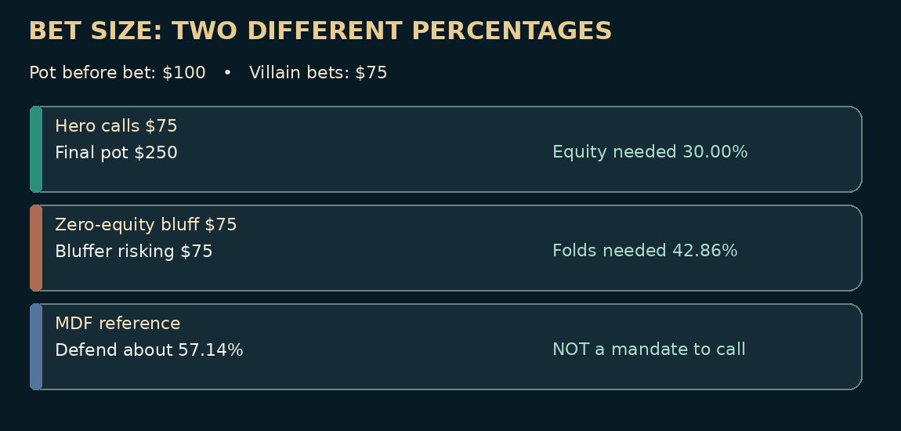
Instructional figure

Chapter 11 — Six Practice Drills
Instructions: Commit to A, B, C or D before opening the worked solutions in the answer section. State which assumption changes your result.

SFFT-MS5-11-001 — Judgment
Does a 57% minimum defense frequency force a call against an opponent who almost never bluffs?
- A. Yes, with every hand
- B. No; exploitatively folding more may be correct
- C. Yes, because MDF is a binding casino rule
- D. No, because all river bets are value bets

SFFT-MS5-11-002 — Judgment
Six possible value combinations and three possible bluff combinations are identified. What is still needed?
- A. Nothing: there are exactly nine bets
- B. Betting frequencies and card-removal adjustments
- C. Only the total number of players at the casino
- D. A physical tell in every hand

SFFT-MS5-11-003 — Calculated
River, heads-up and no rake: the pot is $120 BEFORE an opponent bets $50. Calling costs $50. What minimum showdown equity makes the call break even (no ties)?
- A. 29.41%
- B. 41.67%
- C. 22.73%
- D. 17.05%

SFFT-MS5-11-004 — Calculated
In the simplified pure-bluff river model, villain bets $100 into $150. What is the minimum overall defense-frequency benchmark P/(P+B)? This is not a mandate against an underbluffing opponent.
- A. 40.00%
- B. 42.86%
- C. 45.00%
- D. 60.00%

SFFT-MS5-11-005 — Calculated
Terminal river call model, no rake or ties: pot before bet $200, villain bets $20, and Hero wins 30.00% of the time (exact model probability 3/10) if calling. What is Hero’s EV of calling (folding has EV $0 at this point)?
- A. $52.00
- B. $72.00
- C. $-20.00
- D. $62.00

SFFT-MS5-11-006 — Calculated
Before accounting for any known cards, how many two-card combinations belong to one specified offsuit non-pair combo, e.g. KQo?
- A. 14
- B. 12
- C. 24
- D. 10

12. Exploitative Adjustments and the Complete Postflop Audit
Learning objective: Turn the previous concepts into a repeatable routine that handles uncertainty, small samples, and changing opponents.
Against Mara, who overcalls, favor value bets whose worse calling range you can actually name and reduce bluffing when folds are scarce. Against Vince, who is usually selective, avoid automatically paying huge late-street bets with weak bluff-catchers; but don’t transform a label into a certainty. Against Lena, who barrels too many misses, preserve useful bluff-catching combinations and consider how her bet size affects price. Against Ruth, whose deep stack allows large future winnings, remember that deep implied odds come with equally deep reverse implied losses. These are not permanent character traits: they are strategic models for particular exercises.
Practical live observation log. Record whether a player limped, raised, called on particular textures, used a surprising size, showed down a value hand or bluff, and repeated a behavior in comparable situations. Separate what you saw from what you inferred. A player who bluffed one river is capable of a bluff; that does not prove a 50% river bluff rate. A single unusual physical mannerism is weaker evidence than a reliable pattern of bets and shown cards.
Complete decision audit example. Pot before river is $120. Opponent bets $80. Hero faces $80 to call. Final pot if called is $280. Required showdown equity is 80/280 = 28.57%. Hero has second pair, so the next question is not “Can I afford $80?” It is “Which better hands value-bet $80, which missed hands bluff $80, and how often?” If Hero beats five of fifteen equally weighted betting combinations, showdown win rate is 33.33%, potentially enough to call under the simple terminal model. If the same opponent seldom bluffs and only two of sixteen weighted bets lose to Hero, the call is poor. The numerical method is exact; the estimated range is not.
The best player in a particular session may be the one who folds a beautiful hand, value-bets an ordinary one, or changes tables. It isn’t the one who wins the largest pot photographed for a poster. A disciplined player can say: “I chose this line because these worse hands call and these better hands fold. My model could be wrong if I misjudged the opponent’s range; this is how I would test it.”
Your study contract: review marked problems, repeat close river decisions with a new pot size, and write one sentence on which assumption changes the answer. Keep game expenses within a predetermined budget; take breaks and stop when tired or frustrated. These habits don’t remove variance, but they make your reasoning inspectable and help keep poker a manageable activity.

Chapter 12 — Six Practice Drills
Instructions: Commit to A, B, C or D before opening the worked solutions in the answer section. State which assumption changes your result.

SFFT-MS5-12-001 — Judgment
After one player shows one bluff, what is the soundest inference?
- A. They bluff 50% of rivers
- B. They are capable of bluffing, but the rate is uncertain
- C. They can never value bet
- D. All future calls are justified

SFFT-MS5-12-002 — Judgment
What is the best final step in the postflop decision audit?
- A. Explain which plausible change would reverse the decision
- B. Ignore the opponent’s stack
- C. Remove rake from every real casino pot
- D. Judge the play only by the result

SFFT-MS5-12-003 — Calculated
Rake-aware terminal call approximation: pot BEFORE villain’s bet $75, bet $20, call $20, exactly $5 removed from a pot Hero wins (zero if loses). No ties or other fees. Minimum win probability?
- A. 18.18%
- B. 17.39%
- C. 21.05%
- D. 21.82%

SFFT-MS5-12-004 — Calculated
After preflop betting, Hero and villain each have $300 effective behind, with $75 in the flop pot (no further contribution yet). What is the flop stack-to-pot ratio (SPR)?
- A. 5.00
- B. 4.00
- C. 2.00
- D. 0.25

SFFT-MS5-12-005 — Calculated
River, heads-up and no rake: the pot is $100 BEFORE an opponent bets $75. Calling costs $75. What minimum showdown equity makes the call break even (no ties)?
- A. 42.86%
- B. 75.00%
- C. 30.00%
- D. 22.50%

SFFT-MS5-12-006 — Calculated
River, zero-equity bluff model, no rake: Hero considers betting $15 into a $120 pot. When called Hero always loses. What opponent fold frequency breaks even?
- A. 10.00%
- B. 88.89%
- C. 8.89%
- D. 11.11%

13. Twelve Master Postflop Hand Files
These are constructed educational hands, not recovered casino records. Villain hole cards are revealed only for teaching. During actual play Hero would not know them. Blinds, contributions, calls, raises and uncalled bet refunds are tracked separately; no rake is deducted from displayed pots.

Hand 01 — The Small Value Bet
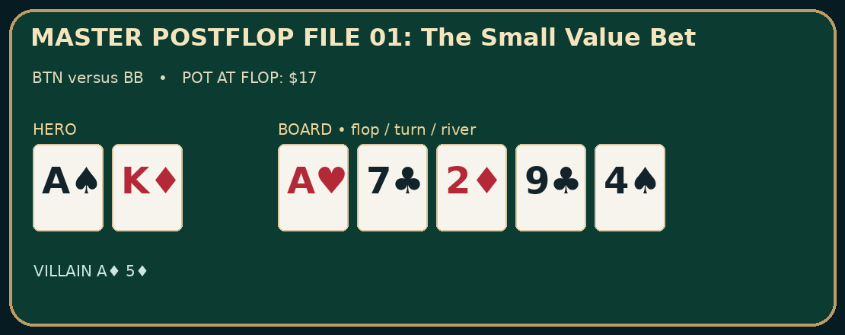 Game and starting pot: $1/$2 no-limit Hold’em; BTN versus BB; $17 after preflop action. All chip totals before rake. Hero: A♠ K♦. Opponent: A♦ 5♦. Board: A♥ 7♣ 2♦ 9♣ 4♠. Context: Button opens to $8; small blind folds; big blind calls. Starting stacks are $200. The big blind is Mara, a player assumed to call weak aces frequently.
Verified action and pot ledger - Flop: BB checks; Hero bets $6; BB calls $6. Pot after completed street: $29. - Turn: BB checks; Hero checks. Pot after completed street: $29. - River: BB checks; Hero bets $17; BB calls $17. Pot after completed street: $63. Reveal: Hero wins.
Decision analysis: On A-high disconnected flops, a modest value bet can keep worse ace-x combinations in the pot. The turn check does not deny the existence of a strong ace: it can preserve weak calls and protect checking lines. On the river, identify all weaker aces that call $17 and better hands that might raise. Here the study-only reveal gives Mara A♦5♦, so the smaller value bet succeeds. That result does not imply that $17 is solver-optimal.
Change the conditions: If the opponent folds all weaker aces to a river bet or check-raises most two-pair combinations, compare checking with a thin bet instead of assuming a third street of value.

Hand 02 — A Pair of Jacks Is Not an Ace
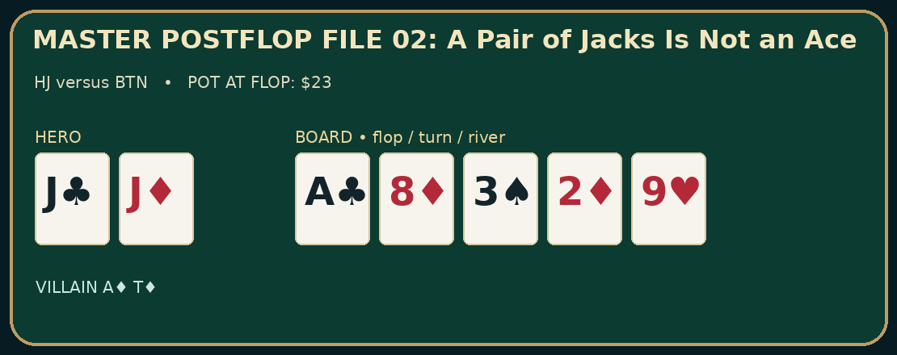 Game and starting pot: $1/$2 no-limit Hold’em; HJ versus BTN; $23 after preflop action. All chip totals before rake. Hero: J♣ J♦. Opponent: A♦ T♦. Board: A♣ 8♦ 3♠ 2♦ 9♥. Context: Hijack opens to $10; button calls; blinds fold. Initial stacks $300. The button is modeled as tight when betting a river for value.
Verified action and pot ledger - Flop: Hero checks; BTN checks. Pot after completed street: $23. - Turn: Hero checks; BTN bets $8; Hero calls $8. Pot after completed street: $39. - River: Hero checks; BTN bets $23; Hero folds. Pot after completed street: $39 ($23 uncalled chips returned). Reveal: Study-only opponent cards shown for range discussion; no live showdown occurred.
Decision analysis: Pocket jacks are an overpair preflop but not on this ace-high flop. The flop check preserves medium showdown strength. Facing $8 into $23 on the turn, a call may be reasonable against a betting range containing weaker pairs and bluffs. After the river bet, however, the defender must evaluate whether the opponent actually bluffs often enough. The hidden A♦T♦ is shown only to illustrate that the opponent can take a check-back flop line with a relatively strong ace.
Change the conditions: Against a button that bets virtually every checked river with air, the river may become a call; the same hand against an underbluffing player is a different problem.

Hand 03 — The Wet-Board Raise
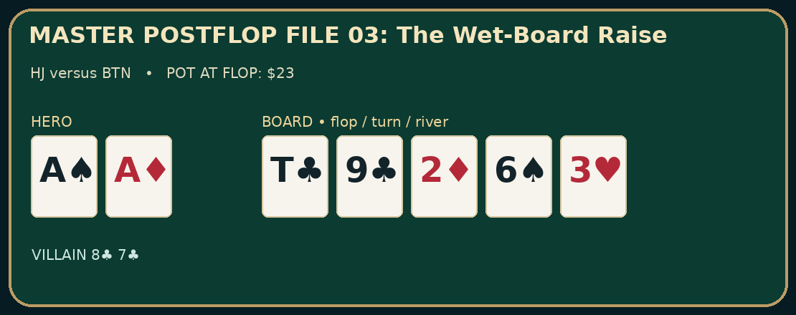 Game and starting pot: $1/$2 no-limit Hold’em; HJ versus BTN; $23 after preflop action. All chip totals before rake. Hero: A♠ A♦. Opponent: 8♣ 7♣. Board: T♣ 9♣ 2♦ 6♠ 3♥. Context: Hijack opens to $10; button calls; blinds fold. $400 effective stacks. Button is an aggressive player who can raise very strong draws.
Verified action and pot ledger - Flop: Hero bets $15; BTN raises to $55; Hero calls $40. Pot after completed street: $133. - Turn: Hero checks; BTN bets $90; Hero folds. Pot after completed street: $133 ($90 uncalled chips returned). Reveal: Study-only opponent cards shown for range discussion; no live showdown occurred.
Decision analysis: The flop raise to $55 is a $40 increase over Hero’s $15 bet. Hero owes $40, and calling makes the pot $133. On the turn 6♠, 8♣7♣ becomes a straight using 6-7-8-9-T. Hero sees only an overpair, and the $90 turn bet threatens a substantial commitment. It is reasonable to consider folding against a strong-range hypothesis; against a draw-heavy raising distribution, a different line might be profitable. The illustration reveals villain’s cards for study, not as information available to Hero.
Change the conditions: If turn is 3♦ rather than 6♠, many draw combinations miss; if villain is an aggressive semibluffer, Hero’s continuing incentives change.

Hand 04 — From Draw to Nut Flush
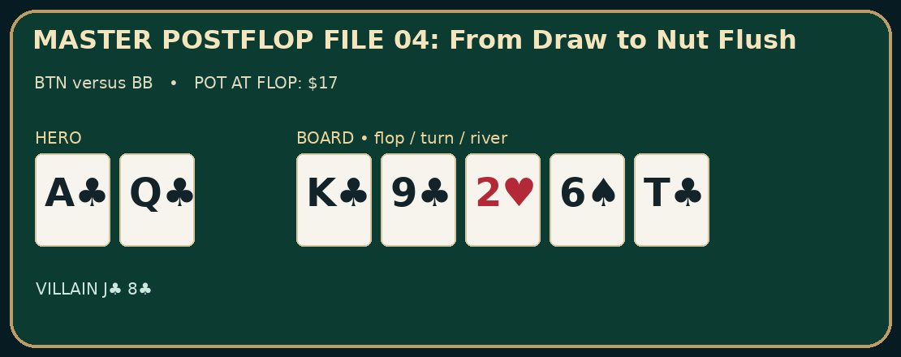 Game and starting pot: $1/$2 no-limit Hold’em; BTN versus BB; $17 after preflop action. All chip totals before rake. Hero: A♣ Q♣. Opponent: J♣ 8♣. Board: K♣ 9♣ 2♥ 6♠ T♣. Context: Button opens to $8; small blind folds; big blind calls. $300 effective stacks. Both players make a flush on the river in the study-only reveal.
Verified action and pot ledger - Flop: BB bets $8; Hero calls $8. Pot after completed street: $33. - Turn: BB bets $22; Hero calls $22. Pot after completed street: $77. - River: BB checks; Hero bets $50; BB calls $50. Pot after completed street: $177. Reveal: Hero wins.
Decision analysis: Hero has a nut-flush draw on the flop and faces a lead. The $8 call puts $33 in the pot. After $22 is bet on the turn, calling creates $77. On the river T♣, Hero’s five clubs are A♣ Q♣ K♣ 9♣ T♣, the nut flush. Opponent’s J♣8♣ makes a lower flush with K♣9♣T♣. The $50 value bet is plausible if lower flushes, sets or strong pairs pay. The example intentionally shows why suited holdings can make unequal flushes.
Change the conditions: If the river pairs the board or the opponent only calls with exceptionally strong hands, revisit the correct river size and the risk of a better hand.

Hand 05 — Three Players, One Check-Raise
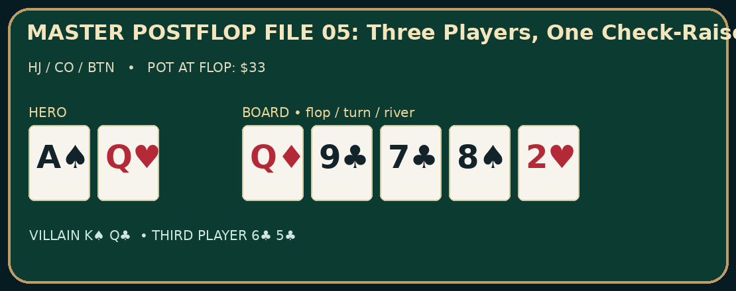 Game and starting pot: $1/$2 no-limit Hold’em; HJ / CO / BTN; $33 after preflop action. All chip totals before rake. Hero: A♠ Q♥. Opponent: K♠ Q♣. Third player: 6♣ 5♣. Board: Q♦ 9♣ 7♣ 8♠ 2♥. Context: Hero opens HJ to $10; cutoff and button call; blinds fold. $350 effective against both. Hero has top pair, but two opponents remain.
Verified action and pot ledger - Flop: Hero bets $18; CO calls $18; BTN raises to $70; Hero folds; CO calls $52. Pot after completed street: $191. - Turn: CO checks; BTN bets $100; CO folds. Pot after completed street: $191 ($100 uncalled chips returned). Reveal: Study-only opponent cards shown for range discussion; no live showdown occurred.
Decision analysis: On Q♦9♣7♣, Hero’s top pair does not guarantee a value bet through both players. After $18 bet and a cutoff call, a raise to $70 puts significant pressure on both ranges. Hero folds, but the $18 already invested stays in the pot. Cutoff’s total flop contribution is $70 after calling another $52. Pot at turn: $191. The button’s hidden 6♣5♣ has a flush draw and gutshot to an eight on the flop; the 8♠ turn completes a 5-6-7-8-9 straight. Facing $100, cutoff folds and the uncalled bet is returned.
Change the conditions: Remove the cutoff and Hero might be more willing to play for value against a lone aggressive opponent; retain the third player and Hero must respect extra coverage.

Hand 06 — Three Streets With a Strong Queen
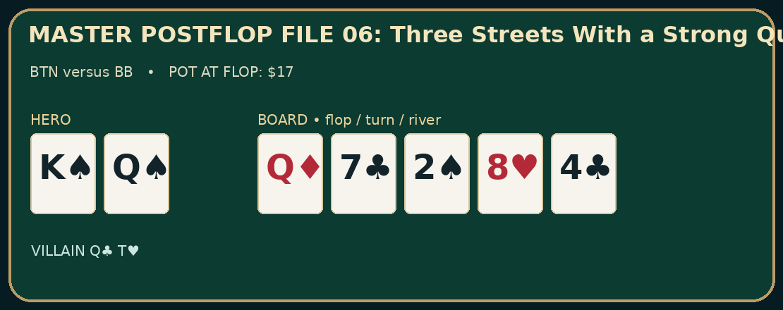 Game and starting pot: $1/$2 no-limit Hold’em; BTN versus BB; $17 after preflop action. All chip totals before rake. Hero: K♠ Q♠. Opponent: Q♣ T♥. Board: Q♦ 7♣ 2♠ 8♥ 4♣. Context: Button opens to $8; BB calls, SB folds. The defender can continue with weaker queens but is not expected to call every large river bet.
Verified action and pot ledger - Flop: BB checks; Hero bets $6; BB calls $6. Pot after completed street: $29. - Turn: BB checks; Hero bets $20; BB calls $20. Pot after completed street: $69. - River: BB checks; Hero bets $40; BB folds. Pot after completed street: $69 ($40 uncalled chips returned). Reveal: Study-only opponent cards shown for range discussion; no live showdown occurred.
Decision analysis: The flop $6 bet builds $29, and the $20 turn bet builds $69. On a blank river, a third $40 bet targets worse Q-x and perhaps stubborn pairs. Here Q♣T♥ folds in the study-only reveal, so the river bet earns no additional value; its $40 is uncalled and returned. This reminds the reader that three streets of value are not an entitlement even with a strong kicker.
Change the conditions: If the defender calls virtually every queen, the third bet increases in value; if they fold all weaker holdings, checking can dominate a thin bet.

Hand 07 — The Thin River Bet
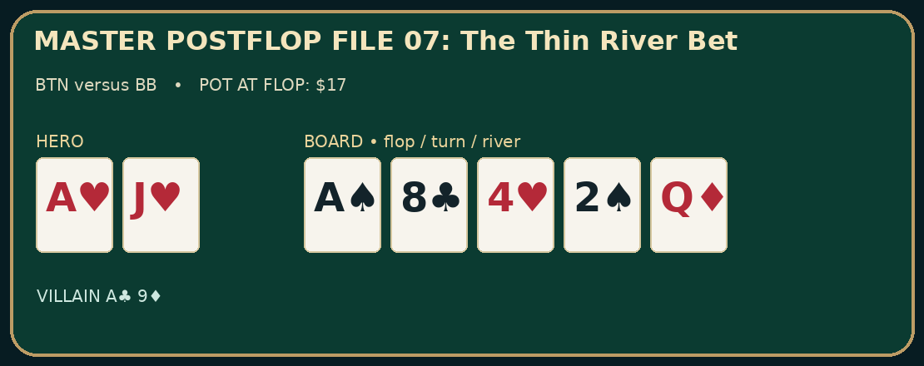 Game and starting pot: $1/$2 no-limit Hold’em; BTN versus BB; $17 after preflop action. All chip totals before rake. Hero: A♥ J♥. Opponent: A♣ 9♦. Board: A♠ 8♣ 4♥ 2♠ Q♦. Context: Button opens to $8; BB calls, SB folds. Rake omitted. BB can bluff-catch with some worse aces.
Verified action and pot ledger - Flop: BB checks; Hero bets $6; BB calls $6. Pot after completed street: $29. - Turn: BB checks; Hero checks. Pot after completed street: $29. - River: BB checks; Hero bets $14; BB calls $14. Pot after completed street: $57. Reveal: Hero wins.
Decision analysis: On the river Hero has an ace with a jack kicker. There is no need to pretend that A-J is an invulnerable monster: two pair and sets exist. The bet of $14 into $29 targets worse aces and perhaps unusually sticky pairs. The opponent’s A♣9♦ is one defensible payoff hand. A smaller bet can earn more than a larger one that folds precisely this part of the range.
Change the conditions: If BB never pays with A9 but often traps A-Q or better, the thin value bet loses appeal. Identify this change before deciding.

Hand 08 — The Missed-Flush Overbet
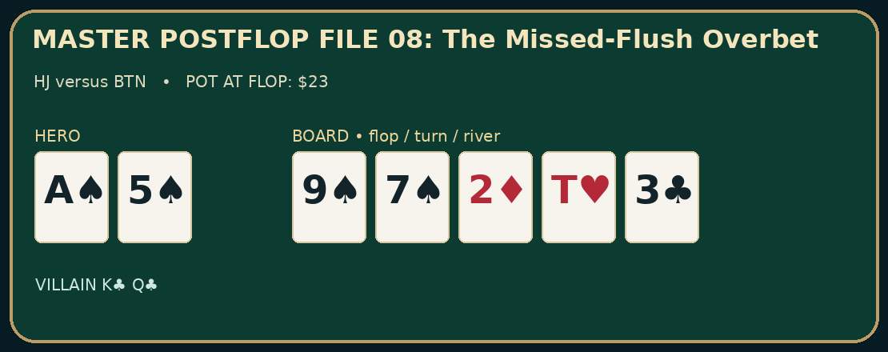 Game and starting pot: $1/$2 no-limit Hold’em; HJ versus BTN; $23 after preflop action. All chip totals before rake. Hero: A♠ 5♠. Opponent: K♣ Q♣. Board: 9♠ 7♠ 2♦ T♥ 3♣. Context: Hijack opens $10; BTN calls; blinds fold. Hero misses the flush draw and fires an overbet into $39.
Verified action and pot ledger - Flop: Hero bets $8; BTN calls $8. Pot after completed street: $39. - Turn: Hero checks; BTN checks. Pot after completed street: $39. - River: Hero bets $60; BTN folds. Pot after completed street: $39 ($60 uncalled chips returned). Reveal: Study-only opponent cards shown for range discussion; no live showdown occurred.
Decision analysis: The $60 wager is larger than the $39 pot. As a pure bluff without showdown equity when called, it would need folds beyond 60/(39+60) ≈ 60.61%. Hero actually has ace-high and may win at showdown against some missed draws, so the pure-bluff equation is only a conservative benchmark for a zero-equity model. Holding two spades removes some missed-spade combinations that villain would otherwise fold; blockers do not automatically recommend bluffing. Villain K♣Q♣ folds this time, but the observed fold is no proof that an overbet is profitable across an opponent range.
Change the conditions: Against a player who calls with any pair, the bluff can fail frequently; against someone who overfolds all ace-high and third-pair combinations, it may gain value.

Hand 09 — Catching an Aggressive Triple Barrel
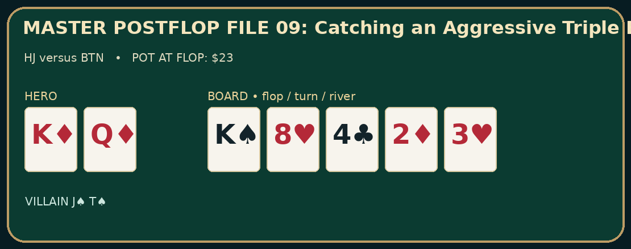 Game and starting pot: $1/$2 no-limit Hold’em; HJ versus BTN; $23 after preflop action. All chip totals before rake. Hero: K♦ Q♦. Opponent: J♠ T♠. Board: K♠ 8♥ 4♣ 2♦ 3♥. Context: Hijack opens to $10, button calls, blinds fold. The button is hypothesized to overbluff on checked streets.
Verified action and pot ledger - Flop: Hero checks; BTN bets $12; Hero calls $12. Pot after completed street: $47. - Turn: Hero checks; BTN bets $30; Hero calls $30. Pot after completed street: $107. - River: Hero checks; BTN bets $70; Hero calls $70. Pot after completed street: $247. Reveal: Hero wins.
Decision analysis: Hero checks top pair three times and keeps bluffs in the opposing range. The river call costs $70 to win a final pot of $247: the terminal equity threshold is 70/247 ≈ 28.34%. On the study-only showdown, BTN’s J♠T♠ never improves and Hero’s king pair wins. That does not prove the call is generally right. Hero must construct the bettor’s value range and the believable missed hands under the specified aggressive tendency.
Change the conditions: If villain is a tight bettor who never triple barrels without two pair or better, the same river call can become poor.

Hand 10 — An Overpair Meets a Pair and Draw
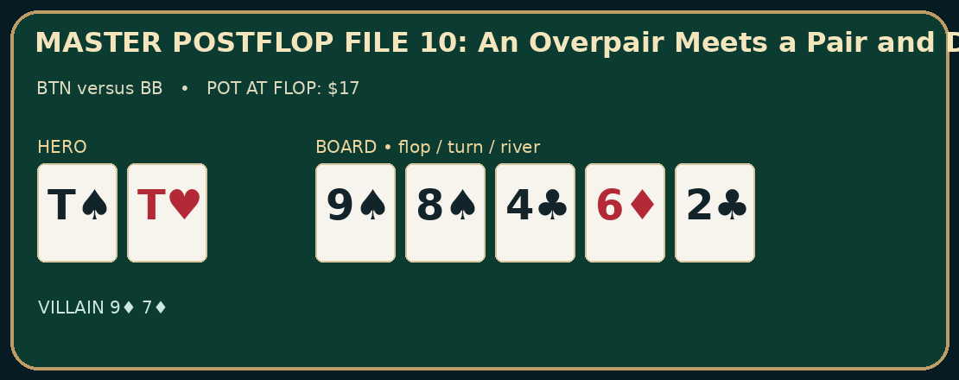 Game and starting pot: $1/$2 no-limit Hold’em; BTN versus BB; $17 after preflop action. All chip totals before rake. Hero: T♠ T♥. Opponent: 9♦ 7♦. Board: 9♠ 8♠ 4♣ 6♦ 2♣. Context: Button raises to $8; BB calls; SB folds. Hero holds a vulnerable overpair on a highly coordinated board.
Verified action and pot ledger - Flop: BB checks; Hero bets $12; BB calls $12. Pot after completed street: $41. - Turn: BB bets $32; Hero calls $32. Pot after completed street: $105. - River: BB checks; Hero checks. Pot after completed street: $105. Reveal: Hero wins.
Decision analysis: BB’s 9♦7♦ holds top pair on the flop, then has a pair-plus-open-ended straight draw on the turn (either 5 or T would complete a straight using 6-7-8-9). Hero’s T♠T♥ is still an overpair, but the texture produces many made and drawing hands. Calling $32 on the turn makes a pot of $105. On a blank river, Hero checks back. The concealed showdown favors tens, which does not make every turn lead a bluff or every river check mandatory.
Change the conditions: If the river is a T, 7 or 5 rather than 2, re-evaluate made straights, full-house possibilities and value targets before betting.

Hand 11 — The Jack That Removes a Straight
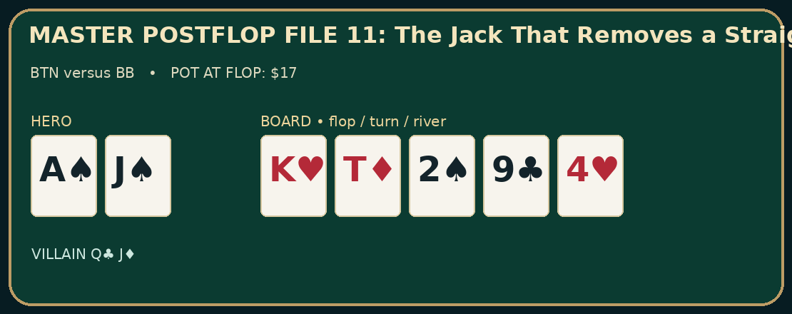 Game and starting pot: $1/$2 no-limit Hold’em; BTN versus BB; $17 after preflop action. All chip totals before rake. Hero: A♠ J♠. Opponent: Q♣ J♦. Board: K♥ T♦ 2♠ 9♣ 4♥. Context: Button opens to $8; BB calls, SB folds. Hero has ace-high with a gutshot to broadway on the flop, then faces river aggression.
Verified action and pot ledger - Flop: BB checks; Hero bets $6; BB calls $6. Pot after completed street: $29. - Turn: BB checks; Hero checks. Pot after completed street: $29. - River: BB bets $20; Hero folds. Pot after completed street: $29 ($20 uncalled chips returned). Reveal: Study-only opponent cards shown for range discussion; no live showdown occurred.
Decision analysis: On the turn, Q♣J♦ gives villain a king-high straight (9-T-J-Q-K). Hero’s J♠ blocks some QJ combinations, but one blocker does not eliminate the straight and cannot by itself justify a river call. The opposing range may contain other value hands and bluffs. Hero folds to $20 into $29 in this teaching example; the uncalled $20 is returned. The reveal is for the reader, not a claim about a real-world opponent.
Change the conditions: If the opponent frequently bluffs missed diamond or other missed backdoor holdings, recalculate the calling threshold and weighted ranges rather than relying only on the blocked straight.

Hand 12 — The Turn Check-Raise Against Top Pair
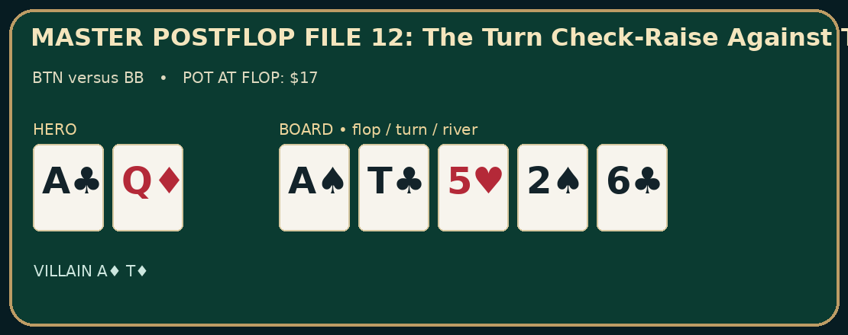 Game and starting pot: $1/$2 no-limit Hold’em; BTN versus BB; $17 after preflop action. All chip totals before rake. Hero: A♣ Q♦. Opponent: A♦ T♦. Board: A♠ T♣ 5♥ 2♠ 6♣. Context: Button opens $8; BB calls, SB folds. $300 effective. Villain can slow-play two pair before raising a later street.
Verified action and pot ledger - Flop: BB checks; Hero bets $6; BB calls $6. Pot after completed street: $29. - Turn: BB checks; Hero bets $20; BB raises to $75; Hero calls $55. Pot after completed street: $179. - River: BB bets $80; Hero folds. Pot after completed street: $179 ($80 uncalled chips returned). Reveal: Study-only opponent cards shown for range discussion; no live showdown occurred.
Decision analysis: BB’s $75 turn check-raise is to $75, not an extra $75. After Hero has bet $20, a call costs $55. Before Hero calls, pot is $29+$20+$75 = $124; calling makes $179. The river $80 lead puts severe pressure on one pair. Villain’s A♦T♦ had top two pair on the flop and kept an advantage throughout. Hero’s river fold is consistent with a narrow value-heavy range model, though the turn call may itself be questionable under that assumption.
Change the conditions: If BB raises the turn with many spade draws and then bluffs missed rivers, Hero may have substantially more bluff-catching incentive.

14. Forty-Question Final Assessment
Do not read the solutions until you have answered. All calculations are under exactly stated assumptions; no solver frequencies are asserted.

SFFT-MS5-FINAL-001 — Calculated
Hero bets $30 into an existing $60 pot; one opponent calls the full $30, all other players have folded, and there is no rake. How large is the pot after the call?
- A. $90
- B. $150
- C. $120
- D. $60

SFFT-MS5-FINAL-002 — Calculated
In a $1/$2 game, exactly 3 non-blind players each put $6 in preflop; both blinds fold without adding more than their posted $1 and $2. There is no ante, straddle or rake. What is the pot?
- A. $21
- B. $18
- C. $27
- D. $23

SFFT-MS5-FINAL-003 — Calculated
After preflop betting, Hero and villain each have $400 effective behind, with $40 in the flop pot (no further contribution yet). What is the flop stack-to-pot ratio (SPR)?
- A. 11.00
- B. 5.00
- C. 10.00
- D. 0.10

SFFT-MS5-FINAL-004 — Calculated
Incremental river-value model: Hero would win the $50 pot by checking. A $60 bet gets called 60.00% of the time exclusively by worse hands, never raises, and otherwise folds. No rake. Additional EV of betting versus checking?
- A. $36.00
- B. $60.00
- C. $24.00
- D. $86.00

SFFT-MS5-FINAL-005 — Calculated
Terminal river call model, no rake or ties: pot before bet $80, villain bets $10, and Hero wins 25.00% of the time (exact model probability 1/4) if calling. What is Hero’s EV of calling (folding has EV $0 at this point)?
- A. $25.00
- B. $-10.00
- C. $15.00
- D. $20.00

SFFT-MS5-FINAL-006 — Calculated
Before accounting for any known cards, how many two-card combinations belong to one specified offsuit non-pair combo, e.g. KQo?
- A. 12
- B. 14
- C. 24
- D. 10

SFFT-MS5-FINAL-007 — Calculated
On the flop Hero bets $30 and villain makes a full legal raise TO $65. Assuming action is reopened and stacks allow it, what is Hero’s minimum total re-raise TO?
- A. $95
- B. $130
- C. $100
- D. $135

SFFT-MS5-FINAL-008 — Calculated
River, heads-up and no rake: the pot is $75 BEFORE an opponent bets $20. Calling costs $20. What minimum showdown equity makes the call break even (no ties)?
- A. 17.39%
- B. 21.05%
- C. 26.67%
- D. 13.04%

SFFT-MS5-FINAL-009 — Calculated
At the turn (one river card left), Hero has 8 distinct clean outs. Assuming no known folded cards, what is the probability the NEXT card is one of those outs?
- A. 15.38%
- B. 13.91%
- C. 17.39%
- D. 20.87%

SFFT-MS5-FINAL-010 — Calculated
River, zero-equity bluff model, no rake: Hero considers betting $10 into a $30 pot. When called Hero always loses. What opponent fold frequency breaks even?
- A. 25.00%
- B. 20.00%
- C. 75.00%
- D. 21.37%

SFFT-MS5-FINAL-011 — Calculated
In the simplified pure-bluff river model, villain bets $30 into $60. What is the minimum overall defense-frequency benchmark P/(P+B)? This is not a mandate against an underbluffing opponent.
- A. 33.33%
- B. 50.00%
- C. 66.67%
- D. 51.37%

SFFT-MS5-FINAL-012 — Calculated
Rake-aware terminal call approximation: pot BEFORE villain’s bet $100, bet $75, call $75, exactly $7 removed from a pot Hero wins (zero if loses). No ties or other fees. Minimum win probability?
- A. 30.86%
- B. 30.00%
- C. 42.86%
- D. 37.04%

SFFT-MS5-FINAL-013 — Calculated
River, heads-up and no rake: the pot is $80 BEFORE an opponent bets $10. Calling costs $10. What minimum showdown equity makes the call break even (no ties)?
- A. 11.11%
- B. 12.50%
- C. 10.00%
- D. 7.50%

SFFT-MS5-FINAL-014 — Calculated
At the flop (one turn card next), Hero has 4 distinct clean outs. Assuming no known folded cards, what is the probability the NEXT card is one of those outs?
- A. 8.51%
- B. 7.69%
- C. 6.81%
- D. 10.21%

SFFT-MS5-FINAL-015 — Calculated
River, zero-equity bluff model, no rake: Hero considers betting $75 into a $40 pot. When called Hero always loses. What opponent fold frequency breaks even?
- A. 39.47%
- B. 34.78%
- C. 65.22%
- D. 52.17%

SFFT-MS5-FINAL-016 — Calculated
In the simplified pure-bluff river model, villain bets $20 into $75. What is the minimum overall defense-frequency benchmark P/(P+B)? This is not a mandate against an underbluffing opponent.
- A. 78.95%
- B. 21.05%
- C. 65.22%
- D. 59.21%

SFFT-MS5-FINAL-017 — Calculated
Rake-aware terminal call approximation: pot BEFORE villain’s bet $120, bet $50, call $50, exactly $5 removed from a pot Hero wins (zero if loses). No ties or other fees. Minimum win probability?
- A. 22.73%
- B. 29.41%
- C. 23.26%
- D. 27.91%

SFFT-MS5-FINAL-018 — Calculated
Hero bets $10 into an existing $30 pot; one opponent calls the full $10, all other players have folded, and there is no rake. How large is the pot after the call?
- A. $50
- B. $40
- C. $60
- D. $30

SFFT-MS5-FINAL-019 — Calculated
In a $1/$2 game, exactly 4 non-blind players each put $15 in preflop; both blinds fold without adding more than their posted $1 and $2. There is no ante, straddle or rake. What is the pot?
- A. $60
- B. $78
- C. $63
- D. $65

SFFT-MS5-FINAL-020 — Calculated
After preflop betting, Hero and villain each have $250 effective behind, with $75 in the flop pot (no further contribution yet). What is the flop stack-to-pot ratio (SPR)?
- A. 3.33
- B. 4.33
- C. 1.67
- D. 0.30

SFFT-MS5-FINAL-021 — Calculated
Incremental river-value model: Hero would win the $200 pot by checking. A $75 bet gets called 20.00% of the time exclusively by worse hands, never raises, and otherwise folds. No rake. Additional EV of betting versus checking?
- A. $75.00
- B. $60.00
- C. $15.00
- D. $215.00

SFFT-MS5-FINAL-022 — Calculated
Terminal river call model, no rake or ties: pot before bet $50, villain bets $50, and Hero wins 40.00% of the time (exact model probability 2/5) if calling. What is Hero’s EV of calling (folding has EV $0 at this point)?
- A. $10.00
- B. $60.00
- C. $-50.00
- D. $35.00

SFFT-MS5-FINAL-023 — Calculated
Before accounting for any known cards, how many two-card combinations belong to both suited and offsuit versions of two distinct ranks, e.g. AK?
- A. 18
- B. 32
- C. 16
- D. 14

SFFT-MS5-FINAL-024 — Calculated
On the flop Hero bets $15 and villain makes a full legal raise TO $35. Assuming action is reopened and stacks allow it, what is Hero’s minimum total re-raise TO?
- A. $55
- B. $50
- C. $70
- D. $75

SFFT-MS5-FINAL-025 — Calculated
After preflop betting, Hero and villain each have $180 effective behind, with $40 in the flop pot (no further contribution yet). What is the flop stack-to-pot ratio (SPR)?
- A. 5.50
- B. 2.25
- C. 4.50
- D. 0.22

SFFT-MS5-FINAL-026 — Calculated
Incremental river-value model: Hero would win the $30 pot by checking. A $50 bet gets called 60.00% of the time exclusively by worse hands, never raises, and otherwise folds. No rake. Additional EV of betting versus checking?
- A. $30.00
- B. $50.00
- C. $20.00
- D. $60.00

SFFT-MS5-FINAL-027 — Calculated
Terminal river call model, no rake or ties: pot before bet $60, villain bets $30, and Hero wins 25.00% of the time (exact model probability 1/4) if calling. What is Hero’s EV of calling (folding has EV $0 at this point)?
- A. $30.00
- B. $-30.00
- C. $0.00
- D. $15.00

SFFT-MS5-FINAL-028 — Calculated
Before accounting for any known cards, how many two-card combinations belong to one specified pocket-pair rank, e.g. 77?
- A. 6
- B. 8
- C. 12
- D. 4

SFFT-MS5-FINAL-029 — Hand file
In Master Hand File 01, Hero bets $17 and Mara calls $17 into a $29 pot. What is the final pre-rake pot?
- A. $46
- B. $63
- C. $80
- D. $34

SFFT-MS5-FINAL-030 — Hand file
In Master Hand File 02, BTN fires $23 into $39 and Hero folds. What is the awarded pot before rake?
- A. $39
- B. $62
- C. $85
- D. $23

SFFT-MS5-FINAL-031 — Hand file
In Master Hand File 03, Hero bets $15 on the flop and BTN raises TO $55. How much more must Hero pay to call?
- A. $55
- B. $70
- C. $40
- D. $15

SFFT-MS5-FINAL-032 — Hand file
In Master Hand File 04, Hero holds A♣Q♣ and the board ends K♣9♣2♥6♠T♣. What is Hero’s best hand?
- A. Ace-high flush
- B. Ace-high straight
- C. Two pair
- D. A full house

SFFT-MS5-FINAL-033 — Hand file
In Master Hand File 05, $33 enters the flop, Hero bets $18, CO eventually commits $70 and BTN commits $70. What reaches the turn?
- A. $173
- B. $191
- C. $209
- D. $121

SFFT-MS5-FINAL-034 — Hand file
In Master Hand File 06, Hero bets $40 on the river and BB folds. How much of Hero’s river bet is returned as uncalled?
- A. $0
- B. $20
- C. $40
- D. $80

SFFT-MS5-FINAL-035 — Hand file
In Master Hand File 07, Hero bets $14 into $29. The size is approximately what share of the pre-bet pot?
- A. 24.1%
- B. 32.6%
- C. 48.3%
- D. 96.6%

SFFT-MS5-FINAL-036 — Hand file
In Master Hand File 08, a pure zero-equity $60 bluff into $39 needs what fold percentage to break even before rake?
- A. 39.39%
- B. 50.00%
- C. 60.61%
- D. 74.00%

SFFT-MS5-FINAL-037 — Hand file
In Master Hand File 09, Hero calls $70 after a $70 bet into $107. What minimum terminal equity is required before rake?
- A. 28.34%
- B. 39.55%
- C. 32.71%
- D. 50.00%

SFFT-MS5-FINAL-038 — Hand file
In Master Hand File 10, BB holds 9♦7♦ on 9♠8♠4♣6♦. Which turn description is accurate?
- A. Unpaired air with no draw
- B. Top pair with an open-ended straight draw
- C. A completed nine-high straight
- D. A set of nines

SFFT-MS5-FINAL-039 — Hand file
In Master Hand File 11, BB holds Q♣J♦ and the turn board reads K♥T♦2♠9♣. What has BB made?
- A. A flush
- B. Two pair
- C. A king-high straight
- D. Only queen-high

SFFT-MS5-FINAL-040 — Hand file
In Master Hand File 12, Hero bets $20 and BB check-raises TO $75. What is Hero’s additional call and the pot after calling, respectively?
- A. $75 and $199
- B. $55 and $179
- C. $95 and $199
- D. $55 and $159

Final Assessment — Answer Explanations

SFFT-MS5-FINAL-001 — Correct answer C
Two players each add $30 to the existing $60: 60+30+30=$120.
- A — Not correct: $90 comes from a different numerator, denominator or payoff model. Two players each add $30 to the existing $60: 60+30+30=$120.
- B — Not correct: $150 comes from a different numerator, denominator or payoff model. Two players each add $30 to the existing $60: 60+30+30=$120.
- C — Correct. Two players each add $30 to the existing $60: 60+30+30=$120.
- D — Not correct: $60 comes from a different numerator, denominator or payoff model. Two players each add $30 to the existing $60: 60+30+30=$120.

SFFT-MS5-FINAL-002 — Correct answer A
Each of the 3 live non-blind players contributes $6 and the abandoned blinds contribute $3: 3×6+3=$21.
- A — Correct. Each of the 3 live non-blind players contributes $6 and the abandoned blinds contribute $3: 3×6+3=$21.
- B — Not correct: $18 comes from a different numerator, denominator or payoff model. Each of the 3 live non-blind players contributes $6 and the abandoned blinds contribute $3: 3×6+3=$21.
- C — Not correct: $27 comes from a different numerator, denominator or payoff model. Each of the 3 live non-blind players contributes $6 and the abandoned blinds contribute $3: 3×6+3=$21.
- D — Not correct: $23 comes from a different numerator, denominator or payoff model. Each of the 3 live non-blind players contributes $6 and the abandoned blinds contribute $3: 3×6+3=$21.

SFFT-MS5-FINAL-003 — Correct answer C
SPR = effective remaining stack / current pot = 400/40 = 10.00.
- A — Not correct: 11.00 comes from a different numerator, denominator or payoff model. SPR = effective remaining stack / current pot = 400/40 = 10.00.
- B — Not correct: 5.00 comes from a different numerator, denominator or payoff model. SPR = effective remaining stack / current pot = 400/40 = 10.00.
- C — Correct. SPR = effective remaining stack / current pot = 400/40 = 10.00.
- D — Not correct: 0.10 comes from a different numerator, denominator or payoff model. SPR = effective remaining stack / current pot = 400/40 = 10.00.

SFFT-MS5-FINAL-004 — Correct answer A
When called by worse, Hero earns $60 extra; otherwise earns no extra. Incremental EV = 60.00%×$60 = $36.00.
- A — Correct. When called by worse, Hero earns $60 extra; otherwise earns no extra. Incremental EV = 60.00%×$60 = $36.00.
- B — Not correct: $60.00 comes from a different numerator, denominator or payoff model. When called by worse, Hero earns $60 extra; otherwise earns no extra. Incremental EV = 60.00%×$60 = $36.00.
- C — Not correct: $24.00 comes from a different numerator, denominator or payoff model. When called by worse, Hero earns $60 extra; otherwise earns no extra. Incremental EV = 60.00%×$60 = $36.00.
- D — Not correct: $86.00 comes from a different numerator, denominator or payoff model. When called by worse, Hero earns $60 extra; otherwise earns no extra. Incremental EV = 60.00%×$60 = $36.00.

SFFT-MS5-FINAL-005 — Correct answer C
EV(call) uses the exact model fraction 1/4: win% × (pot + villain bet) − loss% × call = 1/4×$90−3/4×$10 = $15.00.
- A — Not correct: $25.00 comes from a different numerator, denominator or payoff model. EV(call) uses the exact model fraction 1/4: win% × (pot + villain bet) − loss% × call = 1/4×$90−3/4×$10 = $15.00.
- B — Not correct: $-10.00 comes from a different numerator, denominator or payoff model. EV(call) uses the exact model fraction 1/4: win% × (pot + villain bet) − loss% × call = 1/4×$90−3/4×$10 = $15.00.
- C — Correct. EV(call) uses the exact model fraction 1/4: win% × (pot + villain bet) − loss% × call = 1/4×$90−3/4×$10 = $15.00.
- D — Not correct: $20.00 comes from a different numerator, denominator or payoff model. EV(call) uses the exact model fraction 1/4: win% × (pot + villain bet) − loss% × call = 1/4×$90−3/4×$10 = $15.00.

SFFT-MS5-FINAL-006 — Correct answer A
A specified offsuit hand class has 12 combinations before card removal (pairs 6, suited 4, offsuit 12, total two distinct ranks 16).
- A — Correct. A specified offsuit hand class has 12 combinations before card removal (pairs 6, suited 4, offsuit 12, total two distinct ranks 16).
- B — Not correct: 14 comes from a different numerator, denominator or payoff model. A specified offsuit hand class has 12 combinations before card removal (pairs 6, suited 4, offsuit 12, total two distinct ranks 16).
- C — Not correct: 24 comes from a different numerator, denominator or payoff model. A specified offsuit hand class has 12 combinations before card removal (pairs 6, suited 4, offsuit 12, total two distinct ranks 16).
- D — Not correct: 10 comes from a different numerator, denominator or payoff model. A specified offsuit hand class has 12 combinations before card removal (pairs 6, suited 4, offsuit 12, total two distinct ranks 16).

SFFT-MS5-FINAL-007 — Correct answer C
Villain’s raise increment is $65−$30=$35; a full re-raise must reach at least $65+$35=$100.
- A — Not correct: $95 comes from a different numerator, denominator or payoff model. Villain’s raise increment is $65−$30=$35; a full re-raise must reach at least $65+$35=$100.
- B — Not correct: $130 comes from a different numerator, denominator or payoff model. Villain’s raise increment is $65−$30=$35; a full re-raise must reach at least $65+$35=$100.
- C — Correct. Villain’s raise increment is $65−$30=$35; a full re-raise must reach at least $65+$35=$100.
- D — Not correct: $135 comes from a different numerator, denominator or payoff model. Villain’s raise increment is $65−$30=$35; a full re-raise must reach at least $65+$35=$100.

SFFT-MS5-FINAL-008 — Correct answer A
The final pot after calling is $75+$20+$20=$115; required equity is 20/115 = 17.39%.
- A — Correct. The final pot after calling is $75+$20+$20=$115; required equity is 20/115 = 17.39%.
- B — Not correct: 21.05% comes from a different numerator, denominator or payoff model. The final pot after calling is $75+$20+$20=$115; required equity is 20/115 = 17.39%.
- C — Not correct: 26.67% comes from a different numerator, denominator or payoff model. The final pot after calling is $75+$20+$20=$115; required equity is 20/115 = 17.39%.
- D — Not correct: 13.04% comes from a different numerator, denominator or payoff model. The final pot after calling is $75+$20+$20=$115; required equity is 20/115 = 17.39%.

SFFT-MS5-FINAL-009 — Correct answer C
With Hero’s two hole cards and 4 board cards known, 46 unseen cards remain; exact probability is 8/46 = 17.39%.
- A — Not correct: 15.38% comes from a different numerator, denominator or payoff model. With Hero’s two hole cards and 4 board cards known, 46 unseen cards remain; exact probability is 8/46 = 17.39%.
- B — Not correct: 13.91% comes from a different numerator, denominator or payoff model. With Hero’s two hole cards and 4 board cards known, 46 unseen cards remain; exact probability is 8/46 = 17.39%.
- C — Correct. With Hero’s two hole cards and 4 board cards known, 46 unseen cards remain; exact probability is 8/46 = 17.39%.
- D — Not correct: 20.87% comes from a different numerator, denominator or payoff model. With Hero’s two hole cards and 4 board cards known, 46 unseen cards remain; exact probability is 8/46 = 17.39%.

SFFT-MS5-FINAL-010 — Correct answer A
Hero wins $30 when villain folds and loses $10 when called; solve f×30−(1−f)×10=0, giving 10/(30+10) = 25.00%.
- A — Correct. Hero wins $30 when villain folds and loses $10 when called; solve f×30−(1−f)×10=0, giving 10/(30+10) = 25.00%.
- B — Not correct: 20.00% comes from a different numerator, denominator or payoff model. Hero wins $30 when villain folds and loses $10 when called; solve f×30−(1−f)×10=0, giving 10/(30+10) = 25.00%.
- C — Not correct: 75.00% comes from a different numerator, denominator or payoff model. Hero wins $30 when villain folds and loses $10 when called; solve f×30−(1−f)×10=0, giving 10/(30+10) = 25.00%.
- D — Not correct: 21.37% comes from a different numerator, denominator or payoff model. Hero wins $30 when villain folds and loses $10 when called; solve f×30−(1−f)×10=0, giving 10/(30+10) = 25.00%.

SFFT-MS5-FINAL-011 — Correct answer C
MDF benchmark = pot/(pot+bet) = 60/(60+30) = 66.67%. Actual defense still depends on ranges.
- A — Not correct: 33.33% comes from a different numerator, denominator or payoff model. MDF benchmark = pot/(pot+bet) = 60/(60+30) = 66.67%. Actual defense still depends on ranges.
- B — Not correct: 50.00% comes from a different numerator, denominator or payoff model. MDF benchmark = pot/(pot+bet) = 60/(60+30) = 66.67%. Actual defense still depends on ranges.
- C — Correct. MDF benchmark = pot/(pot+bet) = 60/(60+30) = 66.67%. Actual defense still depends on ranges.
- D — Not correct: 51.37% comes from a different numerator, denominator or payoff model. MDF benchmark = pot/(pot+bet) = 60/(60+30) = 66.67%. Actual defense still depends on ranges.

SFFT-MS5-FINAL-012 — Correct answer A
Win payoff net of call is $168, losing payoff is −$75; solve p×$168−(1−p)×$75=0, p=75/243=30.86%.
- A — Correct. Win payoff net of call is $168, losing payoff is −$75; solve p×$168−(1−p)×$75=0, p=75/243=30.86%.
- B — Not correct: 30.00% comes from a different numerator, denominator or payoff model. Win payoff net of call is $168, losing payoff is −$75; solve p×$168−(1−p)×$75=0, p=75/243=30.86%.
- C — Not correct: 42.86% comes from a different numerator, denominator or payoff model. Win payoff net of call is $168, losing payoff is −$75; solve p×$168−(1−p)×$75=0, p=75/243=30.86%.
- D — Not correct: 37.04% comes from a different numerator, denominator or payoff model. Win payoff net of call is $168, losing payoff is −$75; solve p×$168−(1−p)×$75=0, p=75/243=30.86%.

SFFT-MS5-FINAL-013 — Correct answer C
The final pot after calling is $80+$10+$10=$100; required equity is 10/100 = 10.00%.
- A — Not correct: 11.11% comes from a different numerator, denominator or payoff model. The final pot after calling is $80+$10+$10=$100; required equity is 10/100 = 10.00%.
- B — Not correct: 12.50% comes from a different numerator, denominator or payoff model. The final pot after calling is $80+$10+$10=$100; required equity is 10/100 = 10.00%.
- C — Correct. The final pot after calling is $80+$10+$10=$100; required equity is 10/100 = 10.00%.
- D — Not correct: 7.50% comes from a different numerator, denominator or payoff model. The final pot after calling is $80+$10+$10=$100; required equity is 10/100 = 10.00%.

SFFT-MS5-FINAL-014 — Correct answer A
With Hero’s two hole cards and 3 board cards known, 47 unseen cards remain; exact probability is 4/47 = 8.51%.
- A — Correct. With Hero’s two hole cards and 3 board cards known, 47 unseen cards remain; exact probability is 4/47 = 8.51%.
- B — Not correct: 7.69% comes from a different numerator, denominator or payoff model. With Hero’s two hole cards and 3 board cards known, 47 unseen cards remain; exact probability is 4/47 = 8.51%.
- C — Not correct: 6.81% comes from a different numerator, denominator or payoff model. With Hero’s two hole cards and 3 board cards known, 47 unseen cards remain; exact probability is 4/47 = 8.51%.
- D — Not correct: 10.21% comes from a different numerator, denominator or payoff model. With Hero’s two hole cards and 3 board cards known, 47 unseen cards remain; exact probability is 4/47 = 8.51%.

SFFT-MS5-FINAL-015 — Correct answer C
Hero wins $40 when villain folds and loses $75 when called; solve f×40−(1−f)×75=0, giving 75/(40+75) = 65.22%.
- A — Not correct: 39.47% comes from a different numerator, denominator or payoff model. Hero wins $40 when villain folds and loses $75 when called; solve f×40−(1−f)×75=0, giving 75/(40+75) = 65.22%.
- B — Not correct: 34.78% comes from a different numerator, denominator or payoff model. Hero wins $40 when villain folds and loses $75 when called; solve f×40−(1−f)×75=0, giving 75/(40+75) = 65.22%.
- C — Correct. Hero wins $40 when villain folds and loses $75 when called; solve f×40−(1−f)×75=0, giving 75/(40+75) = 65.22%.
- D — Not correct: 52.17% comes from a different numerator, denominator or payoff model. Hero wins $40 when villain folds and loses $75 when called; solve f×40−(1−f)×75=0, giving 75/(40+75) = 65.22%.

SFFT-MS5-FINAL-016 — Correct answer A
MDF benchmark = pot/(pot+bet) = 75/(75+20) = 78.95%. Actual defense still depends on ranges.
- A — Correct. MDF benchmark = pot/(pot+bet) = 75/(75+20) = 78.95%. Actual defense still depends on ranges.
- B — Not correct: 21.05% comes from a different numerator, denominator or payoff model. MDF benchmark = pot/(pot+bet) = 75/(75+20) = 78.95%. Actual defense still depends on ranges.
- C — Not correct: 65.22% comes from a different numerator, denominator or payoff model. MDF benchmark = pot/(pot+bet) = 75/(75+20) = 78.95%. Actual defense still depends on ranges.
- D — Not correct: 59.21% comes from a different numerator, denominator or payoff model. MDF benchmark = pot/(pot+bet) = 75/(75+20) = 78.95%. Actual defense still depends on ranges.

SFFT-MS5-FINAL-017 — Correct answer C
Win payoff net of call is $165, losing payoff is −$50; solve p×$165−(1−p)×$50=0, p=50/215=23.26%.
- A — Not correct: 22.73% comes from a different numerator, denominator or payoff model. Win payoff net of call is $165, losing payoff is −$50; solve p×$165−(1−p)×$50=0, p=50/215=23.26%.
- B — Not correct: 29.41% comes from a different numerator, denominator or payoff model. Win payoff net of call is $165, losing payoff is −$50; solve p×$165−(1−p)×$50=0, p=50/215=23.26%.
- C — Correct. Win payoff net of call is $165, losing payoff is −$50; solve p×$165−(1−p)×$50=0, p=50/215=23.26%.
- D — Not correct: 27.91% comes from a different numerator, denominator or payoff model. Win payoff net of call is $165, losing payoff is −$50; solve p×$165−(1−p)×$50=0, p=50/215=23.26%.

SFFT-MS5-FINAL-018 — Correct answer A
Two players each add $10 to the existing $30: 30+10+10=$50.
- A — Correct. Two players each add $10 to the existing $30: 30+10+10=$50.
- B — Not correct: $40 comes from a different numerator, denominator or payoff model. Two players each add $10 to the existing $30: 30+10+10=$50.
- C — Not correct: $60 comes from a different numerator, denominator or payoff model. Two players each add $10 to the existing $30: 30+10+10=$50.
- D — Not correct: $30 comes from a different numerator, denominator or payoff model. Two players each add $10 to the existing $30: 30+10+10=$50.

SFFT-MS5-FINAL-019 — Correct answer C
Each of the 4 live non-blind players contributes $15 and the abandoned blinds contribute $3: 4×15+3=$63.
- A — Not correct: $60 comes from a different numerator, denominator or payoff model. Each of the 4 live non-blind players contributes $15 and the abandoned blinds contribute $3: 4×15+3=$63.
- B — Not correct: $78 comes from a different numerator, denominator or payoff model. Each of the 4 live non-blind players contributes $15 and the abandoned blinds contribute $3: 4×15+3=$63.
- C — Correct. Each of the 4 live non-blind players contributes $15 and the abandoned blinds contribute $3: 4×15+3=$63.
- D — Not correct: $65 comes from a different numerator, denominator or payoff model. Each of the 4 live non-blind players contributes $15 and the abandoned blinds contribute $3: 4×15+3=$63.

SFFT-MS5-FINAL-020 — Correct answer A
SPR = effective remaining stack / current pot = 250/75 = 3.33.
- A — Correct. SPR = effective remaining stack / current pot = 250/75 = 3.33.
- B — Not correct: 4.33 comes from a different numerator, denominator or payoff model. SPR = effective remaining stack / current pot = 250/75 = 3.33.
- C — Not correct: 1.67 comes from a different numerator, denominator or payoff model. SPR = effective remaining stack / current pot = 250/75 = 3.33.
- D — Not correct: 0.30 comes from a different numerator, denominator or payoff model. SPR = effective remaining stack / current pot = 250/75 = 3.33.

SFFT-MS5-FINAL-021 — Correct answer C
When called by worse, Hero earns $75 extra; otherwise earns no extra. Incremental EV = 20.00%×$75 = $15.00.
- A — Not correct: $75.00 comes from a different numerator, denominator or payoff model. When called by worse, Hero earns $75 extra; otherwise earns no extra. Incremental EV = 20.00%×$75 = $15.00.
- B — Not correct: $60.00 comes from a different numerator, denominator or payoff model. When called by worse, Hero earns $75 extra; otherwise earns no extra. Incremental EV = 20.00%×$75 = $15.00.
- C — Correct. When called by worse, Hero earns $75 extra; otherwise earns no extra. Incremental EV = 20.00%×$75 = $15.00.
- D — Not correct: $215.00 comes from a different numerator, denominator or payoff model. When called by worse, Hero earns $75 extra; otherwise earns no extra. Incremental EV = 20.00%×$75 = $15.00.

SFFT-MS5-FINAL-022 — Correct answer A
EV(call) uses the exact model fraction 2/5: win% × (pot + villain bet) − loss% × call = 2/5×$100−3/5×$50 = $10.00.
- A — Correct. EV(call) uses the exact model fraction 2/5: win% × (pot + villain bet) − loss% × call = 2/5×$100−3/5×$50 = $10.00.
- B — Not correct: $60.00 comes from a different numerator, denominator or payoff model. EV(call) uses the exact model fraction 2/5: win% × (pot + villain bet) − loss% × call = 2/5×$100−3/5×$50 = $10.00.
- C — Not correct: $-50.00 comes from a different numerator, denominator or payoff model. EV(call) uses the exact model fraction 2/5: win% × (pot + villain bet) − loss% × call = 2/5×$100−3/5×$50 = $10.00.
- D — Not correct: $35.00 comes from a different numerator, denominator or payoff model. EV(call) uses the exact model fraction 2/5: win% × (pot + villain bet) − loss% × call = 2/5×$100−3/5×$50 = $10.00.

SFFT-MS5-FINAL-023 — Correct answer C
A specified all hand class has 16 combinations before card removal (pairs 6, suited 4, offsuit 12, total two distinct ranks 16).
- A — Not correct: 18 comes from a different numerator, denominator or payoff model. A specified all hand class has 16 combinations before card removal (pairs 6, suited 4, offsuit 12, total two distinct ranks 16).
- B — Not correct: 32 comes from a different numerator, denominator or payoff model. A specified all hand class has 16 combinations before card removal (pairs 6, suited 4, offsuit 12, total two distinct ranks 16).
- C — Correct. A specified all hand class has 16 combinations before card removal (pairs 6, suited 4, offsuit 12, total two distinct ranks 16).
- D — Not correct: 14 comes from a different numerator, denominator or payoff model. A specified all hand class has 16 combinations before card removal (pairs 6, suited 4, offsuit 12, total two distinct ranks 16).

SFFT-MS5-FINAL-024 — Correct answer A
Villain’s raise increment is $35−$15=$20; a full re-raise must reach at least $35+$20=$55.
- A — Correct. Villain’s raise increment is $35−$15=$20; a full re-raise must reach at least $35+$20=$55.
- B — Not correct: $50 comes from a different numerator, denominator or payoff model. Villain’s raise increment is $35−$15=$20; a full re-raise must reach at least $35+$20=$55.
- C — Not correct: $70 comes from a different numerator, denominator or payoff model. Villain’s raise increment is $35−$15=$20; a full re-raise must reach at least $35+$20=$55.
- D — Not correct: $75 comes from a different numerator, denominator or payoff model. Villain’s raise increment is $35−$15=$20; a full re-raise must reach at least $35+$20=$55.

SFFT-MS5-FINAL-025 — Correct answer C
SPR = effective remaining stack / current pot = 180/40 = 4.50.
- A — Not correct: 5.50 comes from a different numerator, denominator or payoff model. SPR = effective remaining stack / current pot = 180/40 = 4.50.
- B — Not correct: 2.25 comes from a different numerator, denominator or payoff model. SPR = effective remaining stack / current pot = 180/40 = 4.50.
- C — Correct. SPR = effective remaining stack / current pot = 180/40 = 4.50.
- D — Not correct: 0.22 comes from a different numerator, denominator or payoff model. SPR = effective remaining stack / current pot = 180/40 = 4.50.

SFFT-MS5-FINAL-026 — Correct answer A
When called by worse, Hero earns $50 extra; otherwise earns no extra. Incremental EV = 60.00%×$50 = $30.00.
- A — Correct. When called by worse, Hero earns $50 extra; otherwise earns no extra. Incremental EV = 60.00%×$50 = $30.00.
- B — Not correct: $50.00 comes from a different numerator, denominator or payoff model. When called by worse, Hero earns $50 extra; otherwise earns no extra. Incremental EV = 60.00%×$50 = $30.00.
- C — Not correct: $20.00 comes from a different numerator, denominator or payoff model. When called by worse, Hero earns $50 extra; otherwise earns no extra. Incremental EV = 60.00%×$50 = $30.00.
- D — Not correct: $60.00 comes from a different numerator, denominator or payoff model. When called by worse, Hero earns $50 extra; otherwise earns no extra. Incremental EV = 60.00%×$50 = $30.00.

SFFT-MS5-FINAL-027 — Correct answer C
EV(call) uses the exact model fraction 1/4: win% × (pot + villain bet) − loss% × call = 1/4×$90−3/4×$30 = $0.00.
- A — Not correct: $30.00 comes from a different numerator, denominator or payoff model. EV(call) uses the exact model fraction 1/4: win% × (pot + villain bet) − loss% × call = 1/4×$90−3/4×$30 = $0.00.
- B — Not correct: $-30.00 comes from a different numerator, denominator or payoff model. EV(call) uses the exact model fraction 1/4: win% × (pot + villain bet) − loss% × call = 1/4×$90−3/4×$30 = $0.00.
- C — Correct. EV(call) uses the exact model fraction 1/4: win% × (pot + villain bet) − loss% × call = 1/4×$90−3/4×$30 = $0.00.
- D — Not correct: $15.00 comes from a different numerator, denominator or payoff model. EV(call) uses the exact model fraction 1/4: win% × (pot + villain bet) − loss% × call = 1/4×$90−3/4×$30 = $0.00.

SFFT-MS5-FINAL-028 — Correct answer A
A specified pair hand class has 6 combinations before card removal (pairs 6, suited 4, offsuit 12, total two distinct ranks 16).
- A — Correct. A specified pair hand class has 6 combinations before card removal (pairs 6, suited 4, offsuit 12, total two distinct ranks 16).
- B — Not correct: 8 comes from a different numerator, denominator or payoff model. A specified pair hand class has 6 combinations before card removal (pairs 6, suited 4, offsuit 12, total two distinct ranks 16).
- C — Not correct: 12 comes from a different numerator, denominator or payoff model. A specified pair hand class has 6 combinations before card removal (pairs 6, suited 4, offsuit 12, total two distinct ranks 16).
- D — Not correct: 4 comes from a different numerator, denominator or payoff model. A specified pair hand class has 6 combinations before card removal (pairs 6, suited 4, offsuit 12, total two distinct ranks 16).

SFFT-MS5-FINAL-029 — Correct answer B
The earlier pot is $29; add both $17 contributions to get $63.
- A — $46 does not follow the conditions: The earlier pot is $29; add both $17 contributions to get $63.
- B — Correct. The earlier pot is $29; add both $17 contributions to get $63.
- C — $80 does not follow the conditions: The earlier pot is $29; add both $17 contributions to get $63.
- D — $34 does not follow the conditions: The earlier pot is $29; add both $17 contributions to get $63.

SFFT-MS5-FINAL-030 — Correct answer A
The $23 river bet is uncalled and returned. BTN wins the $39 previously in the pot.
- A — Correct. The $23 river bet is uncalled and returned. BTN wins the $39 previously in the pot.
- B — $62 does not follow the conditions: The $23 river bet is uncalled and returned. BTN wins the $39 previously in the pot.
- C — $85 does not follow the conditions: The $23 river bet is uncalled and returned. BTN wins the $39 previously in the pot.
- D — $23 does not follow the conditions: The $23 river bet is uncalled and returned. BTN wins the $39 previously in the pot.

SFFT-MS5-FINAL-031 — Correct answer C
The first $15 was already invested; Hero owes $55−$15=$40.
- A — $55 does not follow the conditions: The first $15 was already invested; Hero owes $55−$15=$40.
- B — $70 does not follow the conditions: The first $15 was already invested; Hero owes $55−$15=$40.
- C — Correct. The first $15 was already invested; Hero owes $55−$15=$40.
- D — $15 does not follow the conditions: The first $15 was already invested; Hero owes $55−$15=$40.

SFFT-MS5-FINAL-032 — Correct answer A
Hero has five clubs: A♣Q♣K♣9♣T♣, an ace-high (nut) flush.
- A — Correct. Hero has five clubs: A♣Q♣K♣9♣T♣, an ace-high (nut) flush.
- B — Ace-high straight does not follow the conditions: Hero has five clubs: A♣Q♣K♣9♣T♣, an ace-high (nut) flush.
- C — Two pair does not follow the conditions: Hero has five clubs: A♣Q♣K♣9♣T♣, an ace-high (nut) flush.
- D — A full house does not follow the conditions: Hero has five clubs: A♣Q♣K♣9♣T♣, an ace-high (nut) flush.

SFFT-MS5-FINAL-033 — Correct answer B
Add original $33 plus Hero $18, CO $70, BTN $70 = $191.
- A — $173 does not follow the conditions: Add original $33 plus Hero $18, CO $70, BTN $70 = $191.
- B — Correct. Add original $33 plus Hero $18, CO $70, BTN $70 = $191.
- C — $209 does not follow the conditions: Add original $33 plus Hero $18, CO $70, BTN $70 = $191.
- D — $121 does not follow the conditions: Add original $33 plus Hero $18, CO $70, BTN $70 = $191.

SFFT-MS5-FINAL-034 — Correct answer C
BB contributes nothing on the river, so the entire $40 river wager is uncalled and returned.
- A — $0 does not follow the conditions: BB contributes nothing on the river, so the entire $40 river wager is uncalled and returned.
- B — $20 does not follow the conditions: BB contributes nothing on the river, so the entire $40 river wager is uncalled and returned.
- C — Correct. BB contributes nothing on the river, so the entire $40 river wager is uncalled and returned.
- D — $80 does not follow the conditions: BB contributes nothing on the river, so the entire $40 river wager is uncalled and returned.

SFFT-MS5-FINAL-035 — Correct answer C
14/29 = 48.28% of the pot.
- A — 24.1% does not follow the conditions: 14/29 = 48.28% of the pot.
- B — 32.6% does not follow the conditions: 14/29 = 48.28% of the pot.
- C — Correct. 14/29 = 48.28% of the pot.
- D — 96.6% does not follow the conditions: 14/29 = 48.28% of the pot.

SFFT-MS5-FINAL-036 — Correct answer C
60/(39+60)=60/99≈60.61%. Actual ace-high equity when called may change the real EV.
- A — 39.39% does not follow the conditions: 60/(39+60)=60/99≈60.61%. Actual ace-high equity when called may change the real EV.
- B — 50.00% does not follow the conditions: 60/(39+60)=60/99≈60.61%. Actual ace-high equity when called may change the real EV.
- C — Correct. 60/(39+60)=60/99≈60.61%. Actual ace-high equity when called may change the real EV.
- D — 74.00% does not follow the conditions: 60/(39+60)=60/99≈60.61%. Actual ace-high equity when called may change the real EV.

SFFT-MS5-FINAL-037 — Correct answer A
Call $70 / final pot ($107+$70+$70=$247) = 28.34%.
- A — Correct. Call $70 / final pot ($107+$70+$70=$247) = 28.34%.
- B — 39.55% does not follow the conditions: Call $70 / final pot ($107+$70+$70=$247) = 28.34%.
- C — 32.71% does not follow the conditions: Call $70 / final pot ($107+$70+$70=$247) = 28.34%.
- D — 50.00% does not follow the conditions: Call $70 / final pot ($107+$70+$70=$247) = 28.34%.

SFFT-MS5-FINAL-038 — Correct answer B
BB has a pair of nines plus a 6-7-8-9 run that completes with a five or a ten.
- A — Unpaired air with no draw does not follow the conditions: BB has a pair of nines plus a 6-7-8-9 run that completes with a five or a ten.
- B — Correct. BB has a pair of nines plus a 6-7-8-9 run that completes with a five or a ten.
- C — A completed nine-high straight does not follow the conditions: BB has a pair of nines plus a 6-7-8-9 run that completes with a five or a ten.
- D — A set of nines does not follow the conditions: BB has a pair of nines plus a 6-7-8-9 run that completes with a five or a ten.

SFFT-MS5-FINAL-039 — Correct answer C
The five ranks 9-T-J-Q-K are present using both hole cards and the board.
- A — A flush does not follow the conditions: The five ranks 9-T-J-Q-K are present using both hole cards and the board.
- B — Two pair does not follow the conditions: The five ranks 9-T-J-Q-K are present using both hole cards and the board.
- C — Correct. The five ranks 9-T-J-Q-K are present using both hole cards and the board.
- D — Only queen-high does not follow the conditions: The five ranks 9-T-J-Q-K are present using both hole cards and the board.

SFFT-MS5-FINAL-040 — Correct answer B
Hero adds $55 to match $75; pot = prior $29+$75+$75=$179.
- A — $75 and $199 does not follow the conditions: Hero adds $55 to match $75; pot = prior $29+$75+$75=$179.
- B — Correct. Hero adds $55 to match $75; pot = prior $29+$75+$75=$179.
- C — $95 and $199 does not follow the conditions: Hero adds $55 to match $75; pot = prior $29+$75+$75=$179.
- D — $55 and $159 does not follow the conditions: Hero adds $55 to match $75; pot = prior $29+$75+$75=$179.

15. Reference Desk, Explanations, and Study Plan

The postflop decision checklist
For any decision, write down: (1) existing pot before villain’s current wager; (2) amount to call and final pot if called; (3) each player’s effective stack behind; (4) positions and remaining active opponents; (5) board texture and nut distribution; (6) value hands and plausible bluffs by combination and betting frequency; (7) how future betting changes equity realization; (8) rake; (9) what observable tendency makes your strategy exploitative; (10) the critical changed condition that would reverse your conclusion.

Terminal pot-odds table — no rake, no ties
- 25% pot bet: Call equity 16.67%; pure-bluff folds 20.00%; MDF benchmark 80.00%.
- 33⅓% pot bet: Call equity 20.00%; pure-bluff folds 25.00%; MDF benchmark 75.00%.
- 50% pot bet: Call equity 25.00%; pure-bluff folds 33.33%; MDF benchmark 66.67%.
- 66⅔% pot bet: Call equity 28.57%; pure-bluff folds 40.00%; MDF benchmark 60.00%.
- 75% pot bet: Call equity 30.00%; pure-bluff folds 42.86%; MDF benchmark 57.14%.
- 100% pot bet: Call equity 33.33%; pure-bluff folds 50.00%; MDF benchmark 50.00%.
- 150% pot bet: Call equity 37.50%; pure-bluff folds 60.00%; MDF benchmark 40.00%.
- 200% pot bet: Call equity 40.00%; pure-bluff folds 66.67%; MDF benchmark 33.33%.
Read this table carefully. These columns describe three different mathematical questions. The caller divides the call cost by the final pot after calling. The pure bluffer compares the wager to the current pot plus wager. MDF is a simplified defense target against a zero-equity bluff and is not a mandatory individual-hand call frequency. Real-world rake, ties, equity when called, future action and exploitative adjustments change decisions.

Drawing probability reference — exactly known cards
- 4 clean outs: Next turn 8.51%; next river 8.70%; flop to river at least one hit 16.47%.
- 6 clean outs: Next turn 12.77%; next river 13.04%; flop to river at least one hit 24.14%.
- 8 clean outs: Next turn 17.02%; next river 17.39%; flop to river at least one hit 31.45%.
- 9 clean outs: Next turn 19.15%; next river 19.57%; flop to river at least one hit 34.97%.
- 12 clean outs: Next turn 25.53%; next river 26.09%; flop to river at least one hit 44.96%.
- 15 clean outs: Next turn 31.91%; next river 32.61%; flop to river at least one hit 54.12%.
The last column is the probability of seeing at least one of those particular outs among two cards, not automatically the probability of winning against a real opponent. It assumes that these outs remain relevant and ignores additional betting needed to see the river. Do not add overlapping outs twice.

The four most common pot-accounting traps
- A bet of $30 followed by a raise to $90 means the first bettor needs $60 more, not $90, to call.
- A $1/$2 pot containing a $10 open, one $10 call, and two folded blinds is $23, not $20.
- An uncalled $80 river bet is returned when everyone folds. It does not stay in the pot awarded to the winner.
- A caller’s required equity and a pure bluffer’s required fold percentage have different denominators.

Glossary
Barrel: A bet by the same player across successive streets. Bluff-catcher: A hand beating many bluffs but few value bets. Blocker: A known card reducing available opponent combinations. C-bet: Continuation bet by the prior-street aggressor. Dirty out: A nominal improvement that does not necessarily win. Equity realization: Actual value extracted from equity through future betting. MDF: Simplified minimum defense frequency against a zero-equity bluff. Nut advantage: Relative distribution of the strongest possible hands. Overbet: Bet exceeding the pre-bet pot. Probe: An out-of-position bet after the in-position preflop aggressor checked an earlier street. Reverse implied odds: Further money lost when improving to a second-best holding. Range: Distribution of possible opponent holdings. SPR: Remaining effective stack divided by the current pot. Thin value: Betting a modest made hand to get enough worse hands to call.

A four-week review course
Week 1: Chapters 1–3, board-texture sketches, and the related eighteen drills. Week 2: Chapters 4–6, minimum re-raises and multiway records. Week 3: Chapters 7–9, turn draw models and thin value comparisons. Week 4: Chapters 10–12, all twelve Hand Files, and the forty-question examination. Repeat any missed question with at least one changed price, stack or range. Track whether your errors are mathematical, mechanical, or judgment-based. A successful study session is one where you can explain the error—not merely reproduce the right letter.

Editorial integrity
All opponent tendencies in this book are hypotheses for constructed examples. No material is represented as a copied solver solution or as a documented casino event. A technically literate human poker reviewer should inspect close strategic judgments before commercial release. The diagrams come from card records, not generative artwork; the promotional cover is artistic fiction.

Solutions to the 72 Chapter Drills

SFFT-MS5-01-001 — Correct answer C
Relative value depends on what calls, raises or folds, not just your hand category.
- A — Absolute rank does not identify the opponent’s range.
- B — The prior winner supplies no current equity estimate.
- C — Correct: compare relative strength and plausible responses.
- D — Visual appeal has no mathematical role.

SFFT-MS5-01-002 — Correct answer B
Future betting can prevent a player from reaching showdown or realizing all raw equity.
- A — Raw equity assumes a showdown model and ignores future bets.
- B — Correct: equity realization depends on position and actions.
- C — Calling all sizes fails price and range tests.
- D — Raising is not justified by equity alone.

SFFT-MS5-02-001 — Correct answer C
Nine spades plus four queens minus the overlapping Q♠ equals twelve distinct cards. Improvement is not automatically victory.
- A — Nine counts only spades and misses nonspade queens.
- B — Thirteen double-counts Q♠.
- C — Correct: 9+4−1=12 distinct improvement cards.
- D — Eight misses several real improvement cards.

SFFT-MS5-02-002 — Correct answer D
Nut advantage is a property of the ranges and board, not a position label.
- A — Aggression does not guarantee the nuts.
- B — Blind defense can be wide but is not always nutted.
- C — Betting first does not create combinations.
- D — Correct: range composition decides who has more nuts.

SFFT-MS5-03-001 — Correct answer B
Multiway callers cover more of the board, and ranges must be evaluated before betting.
- A — A blanket continuation bet ignores strong coverage.
- B — Correct: multiway ranges reduce automatic bluffing opportunities.
- C — A shove needs fold equity and value logic.
- D — One size independent of board and range is unsupported.

SFFT-MS5-03-002 — Correct answer C
Checking ranges need not consist solely of weak hands.
- A — Check does not fold or surrender.
- B — Checking can include medium and strong holdings.
- C — Correct: checking protects range and preserves options.
- D — A draw may bet, check or raise depending on its price and equity.

SFFT-MS5-04-001 — Correct answer B
A raise to $65 is $45 more than the prior $20 bet; Hero normally owes $45 to call.
- A — A call is $45 more, not $65.
- B — Correct: raise increment = 65−20.
- C — This ignores the original $20 bet.
- D — Folding and calling are legal; a re-raise may also be legal.

SFFT-MS5-04-002 — Correct answer B
A value raise needs sufficient worse-hand continuation, adjusted for equity, stacks and size.
- A — Emotion has no payoff model.
- B — Correct: identify worse hands willing to pay.
- C — Appearance alone does not create value.
- D — Previous results do not determine this pot.

SFFT-MS5-05-001 — Correct answer C
A value bet should target a sufficiently profitable calling distribution.
- A — Size cannot compensate for bad callers.
- B — It still changes pot size and risk.
- C — Correct: compare EV versus alternative lines.
- D — A bet is not defined as bluff only because some stronger hands call.

SFFT-MS5-05-002 — Correct answer B
Calls make different pot sizes and future SPRs even if the same hands continue.
- A — Pot geometry changes visibly.
- B — Correct: the pot and stack are altered.
- C — The deck is independent of bet size.
- D — No such legality restriction exists.

SFFT-MS5-06-001 — Correct answer B
The cold caller adds an opponent, a range and money at risk.
- A — The first caller is still active until folding.
- B — Correct: multiple ranges and action order matter.
- C — Invested chips remain in the pot.
- D — You can face raises without the nuts.

SFFT-MS5-06-002 — Correct answer C
More opponent ranges create more ways for weak one-pair hands to be outdrawn or dominated.
- A — A nut flush remains strong though paired boards can be tricky.
- B — The current nuts can still face redraws but is not the typical vulnerable class here.
- C — Correct: weak top pair loses relative strength multiway.
- D — A royal flush cannot lose at showdown.

SFFT-MS5-07-001 — Correct answer A
A turn probe often follows the aggressor checking back the flop.
- A — Correct: the BB probes the turn.
- B — A three-bet is a re-raise, not a street label.
- C — Posting a blind is unrelated.
- D — Showdown occurs after betting is complete.

SFFT-MS5-07-002 — Correct answer B
Ranges and fold equity change between streets.
- A — Turn ranks and suits matter.
- B — Correct: update range and board interaction.
- C — No-limit permits multiple streets of bets.
- D — Many turn barrels are profitable value bets.

SFFT-MS5-08-001 — Correct answer B
Two-card hit probability does not imply realizing both cards without additional cost.
- A — Turn betting can price Hero out.
- B — Correct: price and nut quality matter.
- C — Non-nut flushes can lose.
- D — Probability still matters; rake modifies EV.

SFFT-MS5-08-002 — Correct answer A
Improving to an inferior hand can expose you to additional losses.
- A — Correct: later losses occur after improving.
- B — A fold is not itself reverse implied odds.
- C — Buying in is not a drawing decision.
- D — Winning uncontested is not reverse implied loss.

SFFT-MS5-09-001 — Correct answer C
Compare each size against its actual calling range and potential raises.
- A — Larger size may lose weaker callers.
- B — Even $25 can lose value if better hands call or raise often.
- C — Correct: compute EV from each continuation range.
- D — Thin value can be profitable without the nuts.

SFFT-MS5-09-002 — Correct answer B
If every caller beats Hero, the value objective is failing; folds need to be analyzed separately.
- A — Building the pot can cost money.
- B — Correct under stated simple model.
- C — Folds from worse hands do not automatically make it a successful bluff.
- D — Betting top pair is legal.

SFFT-MS5-10-001 — Correct answer A
Blockers must be classified by whether removed villain hands would call or fold.
- A — Correct: blocking the folding region can hurt bluff EV.
- B — A missed draw does not guarantee the opponent hit.
- C — Standard Hold’em uses 52 cards.
- D — A bluff still risks its wager.

SFFT-MS5-10-002 — Correct answer C
A bluff requires enough better hands to fold or sufficient equity when called.
- A — Sunk costs are irrelevant.
- B — Image may influence reaction but is not sufficient alone.
- C — Correct: specify who folds to what size.
- D — Facial expressions are not a sound EV model.

SFFT-MS5-11-001 — Correct answer B
MDF is a theoretical benchmark, not a mandate against an unbalanced player.
- A — MDF is not an individual-hand rule.
- B — Correct: adapt to evidence about bluff frequencies.
- C — It is not a rule of poker legality.
- D — Some river bets are bluffs.

SFFT-MS5-11-002 — Correct answer B
Raw available combinations are not equal to the frequencies with which they bet.
- A — Not all hands always take the same line.
- B — Correct: weight combinations by action and availability.
- C — Other tables are irrelevant.
- D — Physical tells are not required.

SFFT-MS5-12-001 — Correct answer B
A single observation supports capability, not a precise population rate.
- A — One showdown cannot estimate a reliable rate.
- B — Correct: continue collecting comparable evidence.
- C — Bluffing does not preclude value bets.
- D — Future calls still need price and range support.

SFFT-MS5-12-002 — Correct answer A
A change-of-conditions explanation tests whether you understand the strategic mechanism.
- A — Correct: show sensitivity to ranges, price and stack.
- B — Stack depth shapes the decision.
- C — Rake matters in real games.
- D — Outcome alone cannot validate EV.

SFFT-MS5-01-003 — Correct answer C
Two players each add $50 to the existing $120: 120+50+50=$220.
- A — Not correct: $170 comes from a different numerator, denominator or payoff model. Two players each add $50 to the existing $120: 120+50+50=$220.
- B — Not correct: $270 comes from a different numerator, denominator or payoff model. Two players each add $50 to the existing $120: 120+50+50=$220.
- C — Correct. Two players each add $50 to the existing $120: 120+50+50=$220.
- D — Not correct: $120 comes from a different numerator, denominator or payoff model. Two players each add $50 to the existing $120: 120+50+50=$220.

SFFT-MS5-01-004 — Correct answer D
SPR = effective remaining stack / current pot = 225/50 = 4.50.
- A — Not correct: 5.50 comes from a different numerator, denominator or payoff model. SPR = effective remaining stack / current pot = 225/50 = 4.50.
- B — Not correct: 2.25 comes from a different numerator, denominator or payoff model. SPR = effective remaining stack / current pot = 225/50 = 4.50.
- C — Not correct: 0.22 comes from a different numerator, denominator or payoff model. SPR = effective remaining stack / current pot = 225/50 = 4.50.
- D — Correct. SPR = effective remaining stack / current pot = 225/50 = 4.50.

SFFT-MS5-01-005 — Correct answer A
The final pot after calling is $200+$20+$20=$240; required equity is 20/240 = 8.33%.
- A — Correct. The final pot after calling is $200+$20+$20=$240; required equity is 20/240 = 8.33%.
- B — Not correct: 9.09% comes from a different numerator, denominator or payoff model. The final pot after calling is $200+$20+$20=$240; required equity is 20/240 = 8.33%.
- C — Not correct: 10.00% comes from a different numerator, denominator or payoff model. The final pot after calling is $200+$20+$20=$240; required equity is 20/240 = 8.33%.
- D — Not correct: 6.25% comes from a different numerator, denominator or payoff model. The final pot after calling is $200+$20+$20=$240; required equity is 20/240 = 8.33%.

SFFT-MS5-01-006 — Correct answer B
EV(call) uses the exact model fraction 1/2: win% × (pot + villain bet) − loss% × call = 1/2×$70−1/2×$40 = $15.00.
- A — Not correct: $55.00 comes from a different numerator, denominator or payoff model. EV(call) uses the exact model fraction 1/2: win% × (pot + villain bet) − loss% × call = 1/2×$70−1/2×$40 = $15.00.
- B — Correct. EV(call) uses the exact model fraction 1/2: win% × (pot + villain bet) − loss% × call = 1/2×$70−1/2×$40 = $15.00.
- C — Not correct: $-40.00 comes from a different numerator, denominator or payoff model. EV(call) uses the exact model fraction 1/2: win% × (pot + villain bet) − loss% × call = 1/2×$70−1/2×$40 = $15.00.
- D — Not correct: $35.00 comes from a different numerator, denominator or payoff model. EV(call) uses the exact model fraction 1/2: win% × (pot + villain bet) − loss% × call = 1/2×$70−1/2×$40 = $15.00.

SFFT-MS5-02-003 — Correct answer A
With Hero’s two hole cards and 3 board cards known, 47 unseen cards remain; exact probability is 8/47 = 17.02%.
- A — Correct. With Hero’s two hole cards and 3 board cards known, 47 unseen cards remain; exact probability is 8/47 = 17.02%.
- B — Not correct: 15.38% comes from a different numerator, denominator or payoff model. With Hero’s two hole cards and 3 board cards known, 47 unseen cards remain; exact probability is 8/47 = 17.02%.
- C — Not correct: 13.62% comes from a different numerator, denominator or payoff model. With Hero’s two hole cards and 3 board cards known, 47 unseen cards remain; exact probability is 8/47 = 17.02%.
- D — Not correct: 20.43% comes from a different numerator, denominator or payoff model. With Hero’s two hole cards and 3 board cards known, 47 unseen cards remain; exact probability is 8/47 = 17.02%.

SFFT-MS5-02-004 — Correct answer B
A specified all hand class has 16 combinations before card removal (pairs 6, suited 4, offsuit 12, total two distinct ranks 16).
- A — Not correct: 18 comes from a different numerator, denominator or payoff model. A specified all hand class has 16 combinations before card removal (pairs 6, suited 4, offsuit 12, total two distinct ranks 16).
- B — Correct. A specified all hand class has 16 combinations before card removal (pairs 6, suited 4, offsuit 12, total two distinct ranks 16).
- C — Not correct: 32 comes from a different numerator, denominator or payoff model. A specified all hand class has 16 combinations before card removal (pairs 6, suited 4, offsuit 12, total two distinct ranks 16).
- D — Not correct: 14 comes from a different numerator, denominator or payoff model. A specified all hand class has 16 combinations before card removal (pairs 6, suited 4, offsuit 12, total two distinct ranks 16).

SFFT-MS5-02-005 — Correct answer C
The final pot after calling is $100+$75+$75=$250; required equity is 75/250 = 30.00%.
- A — Not correct: 42.86% comes from a different numerator, denominator or payoff model. The final pot after calling is $100+$75+$75=$250; required equity is 75/250 = 30.00%.
- B — Not correct: 75.00% comes from a different numerator, denominator or payoff model. The final pot after calling is $100+$75+$75=$250; required equity is 75/250 = 30.00%.
- C — Correct. The final pot after calling is $100+$75+$75=$250; required equity is 75/250 = 30.00%.
- D — Not correct: 22.50% comes from a different numerator, denominator or payoff model. The final pot after calling is $100+$75+$75=$250; required equity is 75/250 = 30.00%.

SFFT-MS5-02-006 — Correct answer D
Hero wins $120 when villain folds and loses $15 when called; solve f×120−(1−f)×15=0, giving 15/(120+15) = 11.11%.
- A — Not correct: 10.00% comes from a different numerator, denominator or payoff model. Hero wins $120 when villain folds and loses $15 when called; solve f×120−(1−f)×15=0, giving 15/(120+15) = 11.11%.
- B — Not correct: 88.89% comes from a different numerator, denominator or payoff model. Hero wins $120 when villain folds and loses $15 when called; solve f×120−(1−f)×15=0, giving 15/(120+15) = 11.11%.
- C — Not correct: 8.89% comes from a different numerator, denominator or payoff model. Hero wins $120 when villain folds and loses $15 when called; solve f×120−(1−f)×15=0, giving 15/(120+15) = 11.11%.
- D — Correct. Hero wins $120 when villain folds and loses $15 when called; solve f×120−(1−f)×15=0, giving 15/(120+15) = 11.11%.

SFFT-MS5-03-003 — Correct answer C
Hero wins $40 when villain folds and loses $75 when called; solve f×40−(1−f)×75=0, giving 75/(40+75) = 65.22%.
- A — Not correct: 39.47% comes from a different numerator, denominator or payoff model. Hero wins $40 when villain folds and loses $75 when called; solve f×40−(1−f)×75=0, giving 75/(40+75) = 65.22%.
- B — Not correct: 34.78% comes from a different numerator, denominator or payoff model. Hero wins $40 when villain folds and loses $75 when called; solve f×40−(1−f)×75=0, giving 75/(40+75) = 65.22%.
- C — Correct. Hero wins $40 when villain folds and loses $75 when called; solve f×40−(1−f)×75=0, giving 75/(40+75) = 65.22%.
- D — Not correct: 52.17% comes from a different numerator, denominator or payoff model. Hero wins $40 when villain folds and loses $75 when called; solve f×40−(1−f)×75=0, giving 75/(40+75) = 65.22%.

SFFT-MS5-03-004 — Correct answer D
Two players each add $15 to the existing $50: 50+15+15=$80.
- A — Not correct: $65 comes from a different numerator, denominator or payoff model. Two players each add $15 to the existing $50: 50+15+15=$80.
- B — Not correct: $95 comes from a different numerator, denominator or payoff model. Two players each add $15 to the existing $50: 50+15+15=$80.
- C — Not correct: $50 comes from a different numerator, denominator or payoff model. Two players each add $15 to the existing $50: 50+15+15=$80.
- D — Correct. Two players each add $15 to the existing $50: 50+15+15=$80.

SFFT-MS5-03-005 — Correct answer A
EV(call) uses the exact model fraction 1/4: win% × (pot + villain bet) − loss% × call = 1/4×$90−3/4×$30 = $0.00.
- A — Correct. EV(call) uses the exact model fraction 1/4: win% × (pot + villain bet) − loss% × call = 1/4×$90−3/4×$30 = $0.00.
- B — Not correct: $30.00 comes from a different numerator, denominator or payoff model. EV(call) uses the exact model fraction 1/4: win% × (pot + villain bet) − loss% × call = 1/4×$90−3/4×$30 = $0.00.
- C — Not correct: $-30.00 comes from a different numerator, denominator or payoff model. EV(call) uses the exact model fraction 1/4: win% × (pot + villain bet) − loss% × call = 1/4×$90−3/4×$30 = $0.00.
- D — Not correct: $15.00 comes from a different numerator, denominator or payoff model. EV(call) uses the exact model fraction 1/4: win% × (pot + villain bet) − loss% × call = 1/4×$90−3/4×$30 = $0.00.

SFFT-MS5-03-006 — Correct answer B
SPR = effective remaining stack / current pot = 140/40 = 3.50.
- A — Not correct: 4.50 comes from a different numerator, denominator or payoff model. SPR = effective remaining stack / current pot = 140/40 = 3.50.
- B — Correct. SPR = effective remaining stack / current pot = 140/40 = 3.50.
- C — Not correct: 1.75 comes from a different numerator, denominator or payoff model. SPR = effective remaining stack / current pot = 140/40 = 3.50.
- D — Not correct: 0.29 comes from a different numerator, denominator or payoff model. SPR = effective remaining stack / current pot = 140/40 = 3.50.

SFFT-MS5-04-003 — Correct answer A
Villain’s raise increment is $50−$30=$20; a full re-raise must reach at least $50+$20=$70.
- A — Correct. Villain’s raise increment is $50−$30=$20; a full re-raise must reach at least $50+$20=$70.
- B — Not correct: $80 comes from a different numerator, denominator or payoff model. Villain’s raise increment is $50−$30=$20; a full re-raise must reach at least $50+$20=$70.
- C — Not correct: $100 comes from a different numerator, denominator or payoff model. Villain’s raise increment is $50−$30=$20; a full re-raise must reach at least $50+$20=$70.
- D — Not correct: $90 comes from a different numerator, denominator or payoff model. Villain’s raise increment is $50−$30=$20; a full re-raise must reach at least $50+$20=$70.

SFFT-MS5-04-004 — Correct answer B
The final pot after calling is $200+$60+$60=$320; required equity is 60/320 = 18.75%.
- A — Not correct: 23.08% comes from a different numerator, denominator or payoff model. The final pot after calling is $200+$60+$60=$320; required equity is 60/320 = 18.75%.
- B — Correct. The final pot after calling is $200+$60+$60=$320; required equity is 60/320 = 18.75%.
- C — Not correct: 30.00% comes from a different numerator, denominator or payoff model. The final pot after calling is $200+$60+$60=$320; required equity is 60/320 = 18.75%.
- D — Not correct: 14.06% comes from a different numerator, denominator or payoff model. The final pot after calling is $200+$60+$60=$320; required equity is 60/320 = 18.75%.

SFFT-MS5-04-005 — Correct answer C
Two players each add $10 to the existing $30: 30+10+10=$50.
- A — Not correct: $40 comes from a different numerator, denominator or payoff model. Two players each add $10 to the existing $30: 30+10+10=$50.
- B — Not correct: $60 comes from a different numerator, denominator or payoff model. Two players each add $10 to the existing $30: 30+10+10=$50.
- C — Correct. Two players each add $10 to the existing $30: 30+10+10=$50.
- D — Not correct: $30 comes from a different numerator, denominator or payoff model. Two players each add $10 to the existing $30: 30+10+10=$50.

SFFT-MS5-04-006 — Correct answer D
EV(call) uses the exact model fraction 2/5: win% × (pot + villain bet) − loss% × call = 2/5×$65−3/5×$25 = $11.00.
- A — Not correct: $36.00 comes from a different numerator, denominator or payoff model. EV(call) uses the exact model fraction 2/5: win% × (pot + villain bet) − loss% × call = 2/5×$65−3/5×$25 = $11.00.
- B — Not correct: $-25.00 comes from a different numerator, denominator or payoff model. EV(call) uses the exact model fraction 2/5: win% × (pot + villain bet) − loss% × call = 2/5×$65−3/5×$25 = $11.00.
- C — Not correct: $23.50 comes from a different numerator, denominator or payoff model. EV(call) uses the exact model fraction 2/5: win% × (pot + villain bet) − loss% × call = 2/5×$65−3/5×$25 = $11.00.
- D — Correct. EV(call) uses the exact model fraction 2/5: win% × (pot + villain bet) − loss% × call = 2/5×$65−3/5×$25 = $11.00.

SFFT-MS5-05-003 — Correct answer C
SPR = effective remaining stack / current pot = 180/25 = 7.20.
- A — Not correct: 8.20 comes from a different numerator, denominator or payoff model. SPR = effective remaining stack / current pot = 180/25 = 7.20.
- B — Not correct: 3.60 comes from a different numerator, denominator or payoff model. SPR = effective remaining stack / current pot = 180/25 = 7.20.
- C — Correct. SPR = effective remaining stack / current pot = 180/25 = 7.20.
- D — Not correct: 0.14 comes from a different numerator, denominator or payoff model. SPR = effective remaining stack / current pot = 180/25 = 7.20.

SFFT-MS5-05-004 — Correct answer D
When called by worse, Hero earns $30 extra; otherwise earns no extra. Incremental EV = 40.00%×$30 = $12.00.
- A — Not correct: $30.00 comes from a different numerator, denominator or payoff model. When called by worse, Hero earns $30 extra; otherwise earns no extra. Incremental EV = 40.00%×$30 = $12.00.
- B — Not correct: $18.00 comes from a different numerator, denominator or payoff model. When called by worse, Hero earns $30 extra; otherwise earns no extra. Incremental EV = 40.00%×$30 = $12.00.
- C — Not correct: $112.00 comes from a different numerator, denominator or payoff model. When called by worse, Hero earns $30 extra; otherwise earns no extra. Incremental EV = 40.00%×$30 = $12.00.
- D — Correct. When called by worse, Hero earns $30 extra; otherwise earns no extra. Incremental EV = 40.00%×$30 = $12.00.

SFFT-MS5-05-005 — Correct answer A
Hero wins $120 when villain folds and loses $50 when called; solve f×120−(1−f)×50=0, giving 50/(120+50) = 29.41%.
- A — Correct. Hero wins $120 when villain folds and loses $50 when called; solve f×120−(1−f)×50=0, giving 50/(120+50) = 29.41%.
- B — Not correct: 22.73% comes from a different numerator, denominator or payoff model. Hero wins $120 when villain folds and loses $50 when called; solve f×120−(1−f)×50=0, giving 50/(120+50) = 29.41%.
- C — Not correct: 70.59% comes from a different numerator, denominator or payoff model. Hero wins $120 when villain folds and loses $50 when called; solve f×120−(1−f)×50=0, giving 50/(120+50) = 29.41%.
- D — Not correct: 23.53% comes from a different numerator, denominator or payoff model. Hero wins $120 when villain folds and loses $50 when called; solve f×120−(1−f)×50=0, giving 50/(120+50) = 29.41%.

SFFT-MS5-05-006 — Correct answer B
Two players each add $100 to the existing $150: 150+100+100=$350.
- A — Not correct: $250 comes from a different numerator, denominator or payoff model. Two players each add $100 to the existing $150: 150+100+100=$350.
- B — Correct. Two players each add $100 to the existing $150: 150+100+100=$350.
- C — Not correct: $450 comes from a different numerator, denominator or payoff model. Two players each add $100 to the existing $150: 150+100+100=$350.
- D — Not correct: $150 comes from a different numerator, denominator or payoff model. Two players each add $100 to the existing $150: 150+100+100=$350.

SFFT-MS5-06-003 — Correct answer A
Each of the 5 live non-blind players contributes $10 and the abandoned blinds contribute $3: 5×10+3=$53.
- A — Correct. Each of the 5 live non-blind players contributes $10 and the abandoned blinds contribute $3: 5×10+3=$53.
- B — Not correct: $50 comes from a different numerator, denominator or payoff model. Each of the 5 live non-blind players contributes $10 and the abandoned blinds contribute $3: 5×10+3=$53.
- C — Not correct: $63 comes from a different numerator, denominator or payoff model. Each of the 5 live non-blind players contributes $10 and the abandoned blinds contribute $3: 5×10+3=$53.
- D — Not correct: $55 comes from a different numerator, denominator or payoff model. Each of the 5 live non-blind players contributes $10 and the abandoned blinds contribute $3: 5×10+3=$53.

SFFT-MS5-06-004 — Correct answer B
Two players each add $100 to the existing $60: 60+100+100=$260.
- A — Not correct: $160 comes from a different numerator, denominator or payoff model. Two players each add $100 to the existing $60: 60+100+100=$260.
- B — Correct. Two players each add $100 to the existing $60: 60+100+100=$260.
- C — Not correct: $360 comes from a different numerator, denominator or payoff model. Two players each add $100 to the existing $60: 60+100+100=$260.
- D — Not correct: $60 comes from a different numerator, denominator or payoff model. Two players each add $100 to the existing $60: 60+100+100=$260.

SFFT-MS5-06-005 — Correct answer C
Villain’s raise increment is $60−$25=$35; a full re-raise must reach at least $60+$35=$95.
- A — Not correct: $85 comes from a different numerator, denominator or payoff model. Villain’s raise increment is $60−$25=$35; a full re-raise must reach at least $60+$35=$95.
- B — Not correct: $120 comes from a different numerator, denominator or payoff model. Villain’s raise increment is $60−$25=$35; a full re-raise must reach at least $60+$35=$95.
- C — Correct. Villain’s raise increment is $60−$25=$35; a full re-raise must reach at least $60+$35=$95.
- D — Not correct: $130 comes from a different numerator, denominator or payoff model. Villain’s raise increment is $60−$25=$35; a full re-raise must reach at least $60+$35=$95.

SFFT-MS5-06-006 — Correct answer D
The final pot after calling is $80+$40+$40=$160; required equity is 40/160 = 25.00%.
- A — Not correct: 33.33% comes from a different numerator, denominator or payoff model. The final pot after calling is $80+$40+$40=$160; required equity is 40/160 = 25.00%.
- B — Not correct: 50.00% comes from a different numerator, denominator or payoff model. The final pot after calling is $80+$40+$40=$160; required equity is 40/160 = 25.00%.
- C — Not correct: 18.75% comes from a different numerator, denominator or payoff model. The final pot after calling is $80+$40+$40=$160; required equity is 40/160 = 25.00%.
- D — Correct. The final pot after calling is $80+$40+$40=$160; required equity is 40/160 = 25.00%.

SFFT-MS5-07-003 — Correct answer C
Two players each add $20 to the existing $200: 200+20+20=$240.
- A — Not correct: $220 comes from a different numerator, denominator or payoff model. Two players each add $20 to the existing $200: 200+20+20=$240.
- B — Not correct: $260 comes from a different numerator, denominator or payoff model. Two players each add $20 to the existing $200: 200+20+20=$240.
- C — Correct. Two players each add $20 to the existing $200: 200+20+20=$240.
- D — Not correct: $200 comes from a different numerator, denominator or payoff model. Two players each add $20 to the existing $200: 200+20+20=$240.

SFFT-MS5-07-004 — Correct answer D
The final pot after calling is $30+$40+$40=$110; required equity is 40/110 = 36.36%.
- A — Not correct: 57.14% comes from a different numerator, denominator or payoff model. The final pot after calling is $30+$40+$40=$110; required equity is 40/110 = 36.36%.
- B — Not correct: 133.33% comes from a different numerator, denominator or payoff model. The final pot after calling is $30+$40+$40=$110; required equity is 40/110 = 36.36%.
- C — Not correct: 27.27% comes from a different numerator, denominator or payoff model. The final pot after calling is $30+$40+$40=$110; required equity is 40/110 = 36.36%.
- D — Correct. The final pot after calling is $30+$40+$40=$110; required equity is 40/110 = 36.36%.

SFFT-MS5-07-005 — Correct answer A
Hero wins $40 when villain folds and loses $75 when called; solve f×40−(1−f)×75=0, giving 75/(40+75) = 65.22%.
- A — Correct. Hero wins $40 when villain folds and loses $75 when called; solve f×40−(1−f)×75=0, giving 75/(40+75) = 65.22%.
- B — Not correct: 39.47% comes from a different numerator, denominator or payoff model. Hero wins $40 when villain folds and loses $75 when called; solve f×40−(1−f)×75=0, giving 75/(40+75) = 65.22%.
- C — Not correct: 34.78% comes from a different numerator, denominator or payoff model. Hero wins $40 when villain folds and loses $75 when called; solve f×40−(1−f)×75=0, giving 75/(40+75) = 65.22%.
- D — Not correct: 52.17% comes from a different numerator, denominator or payoff model. Hero wins $40 when villain folds and loses $75 when called; solve f×40−(1−f)×75=0, giving 75/(40+75) = 65.22%.

SFFT-MS5-07-006 — Correct answer B
SPR = effective remaining stack / current pot = 140/25 = 5.60.
- A — Not correct: 6.60 comes from a different numerator, denominator or payoff model. SPR = effective remaining stack / current pot = 140/25 = 5.60.
- B — Correct. SPR = effective remaining stack / current pot = 140/25 = 5.60.
- C — Not correct: 2.80 comes from a different numerator, denominator or payoff model. SPR = effective remaining stack / current pot = 140/25 = 5.60.
- D — Not correct: 0.18 comes from a different numerator, denominator or payoff model. SPR = effective remaining stack / current pot = 140/25 = 5.60.

SFFT-MS5-08-003 — Correct answer A
With Hero’s two hole cards and 3 board cards known, 47 unseen cards remain; exact probability is 8/47 = 17.02%.
- A — Correct. With Hero’s two hole cards and 3 board cards known, 47 unseen cards remain; exact probability is 8/47 = 17.02%.
- B — Not correct: 15.38% comes from a different numerator, denominator or payoff model. With Hero’s two hole cards and 3 board cards known, 47 unseen cards remain; exact probability is 8/47 = 17.02%.
- C — Not correct: 13.62% comes from a different numerator, denominator or payoff model. With Hero’s two hole cards and 3 board cards known, 47 unseen cards remain; exact probability is 8/47 = 17.02%.
- D — Not correct: 20.43% comes from a different numerator, denominator or payoff model. With Hero’s two hole cards and 3 board cards known, 47 unseen cards remain; exact probability is 8/47 = 17.02%.

SFFT-MS5-08-004 — Correct answer B
Win payoff net of call is $128, losing payoff is −$15; solve p×$128−(1−p)×$15=0, p=15/143=10.49%.
- A — Not correct: 10.00% comes from a different numerator, denominator or payoff model. Win payoff net of call is $128, losing payoff is −$15; solve p×$128−(1−p)×$15=0, p=15/143=10.49%.
- B — Correct. Win payoff net of call is $128, losing payoff is −$15; solve p×$128−(1−p)×$15=0, p=15/143=10.49%.
- C — Not correct: 11.11% comes from a different numerator, denominator or payoff model. Win payoff net of call is $128, losing payoff is −$15; solve p×$128−(1−p)×$15=0, p=15/143=10.49%.
- D — Not correct: 12.59% comes from a different numerator, denominator or payoff model. Win payoff net of call is $128, losing payoff is −$15; solve p×$128−(1−p)×$15=0, p=15/143=10.49%.

SFFT-MS5-08-005 — Correct answer C
The final pot after calling is $150+$30+$30=$210; required equity is 30/210 = 14.29%.
- A — Not correct: 16.67% comes from a different numerator, denominator or payoff model. The final pot after calling is $150+$30+$30=$210; required equity is 30/210 = 14.29%.
- B — Not correct: 20.00% comes from a different numerator, denominator or payoff model. The final pot after calling is $150+$30+$30=$210; required equity is 30/210 = 14.29%.
- C — Correct. The final pot after calling is $150+$30+$30=$210; required equity is 30/210 = 14.29%.
- D — Not correct: 10.71% comes from a different numerator, denominator or payoff model. The final pot after calling is $150+$30+$30=$210; required equity is 30/210 = 14.29%.

SFFT-MS5-08-006 — Correct answer D
EV(call) uses the exact model fraction 1/3: win% × (pot + villain bet) − loss% × call = 1/3×$260−2/3×$60 = $46.67.
- A — Not correct: $106.67 comes from a different numerator, denominator or payoff model. EV(call) uses the exact model fraction 1/3: win% × (pot + villain bet) − loss% × call = 1/3×$260−2/3×$60 = $46.67.
- B — Not correct: $-60.00 comes from a different numerator, denominator or payoff model. EV(call) uses the exact model fraction 1/3: win% × (pot + villain bet) − loss% × call = 1/3×$260−2/3×$60 = $46.67.
- C — Not correct: $76.67 comes from a different numerator, denominator or payoff model. EV(call) uses the exact model fraction 1/3: win% × (pot + villain bet) − loss% × call = 1/3×$260−2/3×$60 = $46.67.
- D — Correct. EV(call) uses the exact model fraction 1/3: win% × (pot + villain bet) − loss% × call = 1/3×$260−2/3×$60 = $46.67.

SFFT-MS5-09-003 — Correct answer C
When called by worse, Hero earns $50 extra; otherwise earns no extra. Incremental EV = 70.00%×$50 = $35.00.
- A — Not correct: $50.00 comes from a different numerator, denominator or payoff model. When called by worse, Hero earns $50 extra; otherwise earns no extra. Incremental EV = 70.00%×$50 = $35.00.
- B — Not correct: $15.00 comes from a different numerator, denominator or payoff model. When called by worse, Hero earns $50 extra; otherwise earns no extra. Incremental EV = 70.00%×$50 = $35.00.
- C — Correct. When called by worse, Hero earns $50 extra; otherwise earns no extra. Incremental EV = 70.00%×$50 = $35.00.
- D — Not correct: $95.00 comes from a different numerator, denominator or payoff model. When called by worse, Hero earns $50 extra; otherwise earns no extra. Incremental EV = 70.00%×$50 = $35.00.

SFFT-MS5-09-004 — Correct answer D
Two players each add $60 to the existing $75: 75+60+60=$195.
- A — Not correct: $135 comes from a different numerator, denominator or payoff model. Two players each add $60 to the existing $75: 75+60+60=$195.
- B — Not correct: $255 comes from a different numerator, denominator or payoff model. Two players each add $60 to the existing $75: 75+60+60=$195.
- C — Not correct: $75 comes from a different numerator, denominator or payoff model. Two players each add $60 to the existing $75: 75+60+60=$195.
- D — Correct. Two players each add $60 to the existing $75: 75+60+60=$195.

SFFT-MS5-09-005 — Correct answer A
The final pot after calling is $80+$10+$10=$100; required equity is 10/100 = 10.00%.
- A — Correct. The final pot after calling is $80+$10+$10=$100; required equity is 10/100 = 10.00%.
- B — Not correct: 11.11% comes from a different numerator, denominator or payoff model. The final pot after calling is $80+$10+$10=$100; required equity is 10/100 = 10.00%.
- C — Not correct: 12.50% comes from a different numerator, denominator or payoff model. The final pot after calling is $80+$10+$10=$100; required equity is 10/100 = 10.00%.
- D — Not correct: 7.50% comes from a different numerator, denominator or payoff model. The final pot after calling is $80+$10+$10=$100; required equity is 10/100 = 10.00%.

SFFT-MS5-09-006 — Correct answer B
Win payoff net of call is $120, losing payoff is −$25; solve p×$120−(1−p)×$25=0, p=25/145=17.24%.
- A — Not correct: 16.67% comes from a different numerator, denominator or payoff model. Win payoff net of call is $120, losing payoff is −$25; solve p×$120−(1−p)×$25=0, p=25/145=17.24%.
- B — Correct. Win payoff net of call is $120, losing payoff is −$25; solve p×$120−(1−p)×$25=0, p=25/145=17.24%.
- C — Not correct: 20.00% comes from a different numerator, denominator or payoff model. Win payoff net of call is $120, losing payoff is −$25; solve p×$120−(1−p)×$25=0, p=25/145=17.24%.
- D — Not correct: 20.69% comes from a different numerator, denominator or payoff model. Win payoff net of call is $120, losing payoff is −$25; solve p×$120−(1−p)×$25=0, p=25/145=17.24%.

SFFT-MS5-10-003 — Correct answer A
Hero wins $30 when villain folds and loses $10 when called; solve f×30−(1−f)×10=0, giving 10/(30+10) = 25.00%.
- A — Correct. Hero wins $30 when villain folds and loses $10 when called; solve f×30−(1−f)×10=0, giving 10/(30+10) = 25.00%.
- B — Not correct: 20.00% comes from a different numerator, denominator or payoff model. Hero wins $30 when villain folds and loses $10 when called; solve f×30−(1−f)×10=0, giving 10/(30+10) = 25.00%.
- C — Not correct: 75.00% comes from a different numerator, denominator or payoff model. Hero wins $30 when villain folds and loses $10 when called; solve f×30−(1−f)×10=0, giving 10/(30+10) = 25.00%.
- D — Not correct: 21.37% comes from a different numerator, denominator or payoff model. Hero wins $30 when villain folds and loses $10 when called; solve f×30−(1−f)×10=0, giving 10/(30+10) = 25.00%.

SFFT-MS5-10-004 — Correct answer B
EV(call) uses the exact model fraction 1/3: win% × (pot + villain bet) − loss% × call = 1/3×$65−2/3×$25 = $5.00.
- A — Not correct: $30.00 comes from a different numerator, denominator or payoff model. EV(call) uses the exact model fraction 1/3: win% × (pot + villain bet) − loss% × call = 1/3×$65−2/3×$25 = $5.00.
- B — Correct. EV(call) uses the exact model fraction 1/3: win% × (pot + villain bet) − loss% × call = 1/3×$65−2/3×$25 = $5.00.
- C — Not correct: $-25.00 comes from a different numerator, denominator or payoff model. EV(call) uses the exact model fraction 1/3: win% × (pot + villain bet) − loss% × call = 1/3×$65−2/3×$25 = $5.00.
- D — Not correct: $17.50 comes from a different numerator, denominator or payoff model. EV(call) uses the exact model fraction 1/3: win% × (pot + villain bet) − loss% × call = 1/3×$65−2/3×$25 = $5.00.

SFFT-MS5-10-005 — Correct answer C
MDF benchmark = pot/(pot+bet) = 50/(50+50) = 50.00%. Actual defense still depends on ranges.
- A — Not correct: 51.37% comes from a different numerator, denominator or payoff model. MDF benchmark = pot/(pot+bet) = 50/(50+50) = 50.00%. Actual defense still depends on ranges.
- B — Not correct: 33.33% comes from a different numerator, denominator or payoff model. MDF benchmark = pot/(pot+bet) = 50/(50+50) = 50.00%. Actual defense still depends on ranges.
- C — Correct. MDF benchmark = pot/(pot+bet) = 50/(50+50) = 50.00%. Actual defense still depends on ranges.
- D — Not correct: 37.50% comes from a different numerator, denominator or payoff model. MDF benchmark = pot/(pot+bet) = 50/(50+50) = 50.00%. Actual defense still depends on ranges.

SFFT-MS5-10-006 — Correct answer D
A specified suited hand class has 4 combinations before card removal (pairs 6, suited 4, offsuit 12, total two distinct ranks 16).
- A — Not correct: 6 comes from a different numerator, denominator or payoff model. A specified suited hand class has 4 combinations before card removal (pairs 6, suited 4, offsuit 12, total two distinct ranks 16).
- B — Not correct: 8 comes from a different numerator, denominator or payoff model. A specified suited hand class has 4 combinations before card removal (pairs 6, suited 4, offsuit 12, total two distinct ranks 16).
- C — Not correct: 2 comes from a different numerator, denominator or payoff model. A specified suited hand class has 4 combinations before card removal (pairs 6, suited 4, offsuit 12, total two distinct ranks 16).
- D — Correct. A specified suited hand class has 4 combinations before card removal (pairs 6, suited 4, offsuit 12, total two distinct ranks 16).

SFFT-MS5-11-003 — Correct answer C
The final pot after calling is $120+$50+$50=$220; required equity is 50/220 = 22.73%.
- A — Not correct: 29.41% comes from a different numerator, denominator or payoff model. The final pot after calling is $120+$50+$50=$220; required equity is 50/220 = 22.73%.
- B — Not correct: 41.67% comes from a different numerator, denominator or payoff model. The final pot after calling is $120+$50+$50=$220; required equity is 50/220 = 22.73%.
- C — Correct. The final pot after calling is $120+$50+$50=$220; required equity is 50/220 = 22.73%.
- D — Not correct: 17.05% comes from a different numerator, denominator or payoff model. The final pot after calling is $120+$50+$50=$220; required equity is 50/220 = 22.73%.

SFFT-MS5-11-004 — Correct answer D
MDF benchmark = pot/(pot+bet) = 150/(150+100) = 60.00%. Actual defense still depends on ranges.
- A — Not correct: 40.00% comes from a different numerator, denominator or payoff model. MDF benchmark = pot/(pot+bet) = 150/(150+100) = 60.00%. Actual defense still depends on ranges.
- B — Not correct: 42.86% comes from a different numerator, denominator or payoff model. MDF benchmark = pot/(pot+bet) = 150/(150+100) = 60.00%. Actual defense still depends on ranges.
- C — Not correct: 45.00% comes from a different numerator, denominator or payoff model. MDF benchmark = pot/(pot+bet) = 150/(150+100) = 60.00%. Actual defense still depends on ranges.
- D — Correct. MDF benchmark = pot/(pot+bet) = 150/(150+100) = 60.00%. Actual defense still depends on ranges.

SFFT-MS5-11-005 — Correct answer A
EV(call) uses the exact model fraction 3/10: win% × (pot + villain bet) − loss% × call = 3/10×$220−7/10×$20 = $52.00.
- A — Correct. EV(call) uses the exact model fraction 3/10: win% × (pot + villain bet) − loss% × call = 3/10×$220−7/10×$20 = $52.00.
- B — Not correct: $72.00 comes from a different numerator, denominator or payoff model. EV(call) uses the exact model fraction 3/10: win% × (pot + villain bet) − loss% × call = 3/10×$220−7/10×$20 = $52.00.
- C — Not correct: $-20.00 comes from a different numerator, denominator or payoff model. EV(call) uses the exact model fraction 3/10: win% × (pot + villain bet) − loss% × call = 3/10×$220−7/10×$20 = $52.00.
- D — Not correct: $62.00 comes from a different numerator, denominator or payoff model. EV(call) uses the exact model fraction 3/10: win% × (pot + villain bet) − loss% × call = 3/10×$220−7/10×$20 = $52.00.

SFFT-MS5-11-006 — Correct answer B
A specified offsuit hand class has 12 combinations before card removal (pairs 6, suited 4, offsuit 12, total two distinct ranks 16).
- A — Not correct: 14 comes from a different numerator, denominator or payoff model. A specified offsuit hand class has 12 combinations before card removal (pairs 6, suited 4, offsuit 12, total two distinct ranks 16).
- B — Correct. A specified offsuit hand class has 12 combinations before card removal (pairs 6, suited 4, offsuit 12, total two distinct ranks 16).
- C — Not correct: 24 comes from a different numerator, denominator or payoff model. A specified offsuit hand class has 12 combinations before card removal (pairs 6, suited 4, offsuit 12, total two distinct ranks 16).
- D — Not correct: 10 comes from a different numerator, denominator or payoff model. A specified offsuit hand class has 12 combinations before card removal (pairs 6, suited 4, offsuit 12, total two distinct ranks 16).

SFFT-MS5-12-003 — Correct answer A
Win payoff net of call is $90, losing payoff is −$20; solve p×$90−(1−p)×$20=0, p=20/110=18.18%.
- A — Correct. Win payoff net of call is $90, losing payoff is −$20; solve p×$90−(1−p)×$20=0, p=20/110=18.18%.
- B — Not correct: 17.39% comes from a different numerator, denominator or payoff model. Win payoff net of call is $90, losing payoff is −$20; solve p×$90−(1−p)×$20=0, p=20/110=18.18%.
- C — Not correct: 21.05% comes from a different numerator, denominator or payoff model. Win payoff net of call is $90, losing payoff is −$20; solve p×$90−(1−p)×$20=0, p=20/110=18.18%.
- D — Not correct: 21.82% comes from a different numerator, denominator or payoff model. Win payoff net of call is $90, losing payoff is −$20; solve p×$90−(1−p)×$20=0, p=20/110=18.18%.

SFFT-MS5-12-004 — Correct answer B
SPR = effective remaining stack / current pot = 300/75 = 4.00.
- A — Not correct: 5.00 comes from a different numerator, denominator or payoff model. SPR = effective remaining stack / current pot = 300/75 = 4.00.
- B — Correct. SPR = effective remaining stack / current pot = 300/75 = 4.00.
- C — Not correct: 2.00 comes from a different numerator, denominator or payoff model. SPR = effective remaining stack / current pot = 300/75 = 4.00.
- D — Not correct: 0.25 comes from a different numerator, denominator or payoff model. SPR = effective remaining stack / current pot = 300/75 = 4.00.

SFFT-MS5-12-005 — Correct answer C
The final pot after calling is $100+$75+$75=$250; required equity is 75/250 = 30.00%.
- A — Not correct: 42.86% comes from a different numerator, denominator or payoff model. The final pot after calling is $100+$75+$75=$250; required equity is 75/250 = 30.00%.
- B — Not correct: 75.00% comes from a different numerator, denominator or payoff model. The final pot after calling is $100+$75+$75=$250; required equity is 75/250 = 30.00%.
- C — Correct. The final pot after calling is $100+$75+$75=$250; required equity is 75/250 = 30.00%.
- D — Not correct: 22.50% comes from a different numerator, denominator or payoff model. The final pot after calling is $100+$75+$75=$250; required equity is 75/250 = 30.00%.

SFFT-MS5-12-006 — Correct answer D
Hero wins $120 when villain folds and loses $15 when called; solve f×120−(1−f)×15=0, giving 15/(120+15) = 11.11%.
- A — Not correct: 10.00% comes from a different numerator, denominator or payoff model. Hero wins $120 when villain folds and loses $15 when called; solve f×120−(1−f)×15=0, giving 15/(120+15) = 11.11%.
- B — Not correct: 88.89% comes from a different numerator, denominator or payoff model. Hero wins $120 when villain folds and loses $15 when called; solve f×120−(1−f)×15=0, giving 15/(120+15) = 11.11%.
- C — Not correct: 8.89% comes from a different numerator, denominator or payoff model. Hero wins $120 when villain folds and loses $15 when called; solve f×120−(1−f)×15=0, giving 15/(120+15) = 11.11%.
- D — Correct. Hero wins $120 when villain folds and loses $15 when called; solve f×120−(1−f)×15=0, giving 15/(120+15) = 11.11%.

