

THE TOURNAMENT SURVIVAL AND DOMINATION

ICM, Bubbles, Final Tables, Satellites and Short-Stack Decisions
Science Fiction Author D. Colin Palmer’s Poker Master Series — Book Six
Science Fiction Fantasy Theater | Educational Edition | October 2026
Illustrated instruction, twelve verified Master Tournament Hand Files and 118 four-choice practice questions.
Educational notice: Every illustrative opponent and tournament hand is fictional. ICM estimates use explicitly specified prize distributions; they do not model actual player skill, future action or bankroll outcomes. No exercise is a claim of guaranteed winnings, safe profitability or solver-certified strategy. Poker involves potential financial loss. Use affordable limits; never chase losses.

Preface: Think Like a Tournament Player
The first five volumes taught foundations, live cash games, hand reading, preflop decisions and postflop play. Book Six changes one crucial element: your chips can disappear permanently in a freezeout, prizes are distributed unevenly, and the clock moves the cost of waiting. This is the tournament environment. The same hole cards may deserve sharply different treatment at 100bb early in an event, 12bb near a bubble, and a final table where the next eliminated player loses a substantial pay jump.
We will not teach a fantasy of painless laddering. Successful tournament analysis requires both accumulation and survival. A pure chip-counting model is often useful before large payout pressures, while a payout model matters more when elimination changes expected prizes materially. Neither makes opponent ranges unnecessary. Across this book, we insist on counting the posted blinds, all antes, the chips risked and the chips available to win before recommending a course of action.
Study method: Read a chapter, reproduce its worked calculation, answer the six following drills without looking at the key, and write a sentence explaining which changed condition could reverse the decision. Complete the twelve Master Tournament Hand Files before attempting the 40-question final. The separate workbook supplies exercises and full solutions. Question IDs remain stable for future WordPress publication and translation.

Contents
- Tournament Chips Are Not Cash Chips
- Formats, Rules, Antes and the Pot Ledger
- Stacks: 8bb, 15bb, 25bb, 50bb and Beyond
- Early Levels: Build Without Manufacturing Risk
- Middle Stages: Antes, Opening Ranges and Steal Mathematics
- The Short Stack: Shoving, Raising, Calling
- Facing Shoves: Calling Ranges and Covering Stacks
- Bubble Pressure: When a Chip Is Not a Dollar
- ICM Without Mysticism: Exact Three-Player Calculations
- Final Tables: Pay Jumps, Big Stacks and Risk Management
- Satellite Seats and Bounty Tournaments
- Tournament Postflop: When Betting Threatens Your Stack
- Variance, Responsible Bankrolls and the Review Laboratory
- Master Tournament Hand Files: Twelve Worked Investigations
- Final Examination: Forty Applied Questions
- Reference Desk and Verification Notes

CHAPTER 01 — Tournament Chips Are Not Cash Chips
Learning objective: Explain why survival, chip accumulation and prize equity are related but distinct.
In a cash game a dollar chip represents a dollar in the stack. In a tournament the same chip is a unit of leverage whose economic value changes as the field shrinks and payouts become possible. A player who doubles from 10,000 to 20,000 chips has doubled their chip count, but has not normally doubled their share of expected prize money. The reason is not mystical. A player at zero has lost all eligibility for future placements; other players can advance simply by somebody else being eliminated. This uneven relationship becomes conspicuous when several short stacks are at risk close to a bubble.
Begin with three independent questions. First, how many chips might this line win or lose? Second, how does the chip movement alter estimated prize equity? Third, what evidence have we used to assign an opponent a range? Those questions must not be collapsed into a single phrase such as “tournament survival is everything.” A player who refuses every fair confrontation may bleed away blinds and antes; a player who calls every small chip edge may surrender valuable ladder equity at the wrong moment.
Chip EV means expected change in chips from a decision under the specified probabilities. Dollar EV means expected value of tournament prizes, not the buy-in cost or current stack in chips. ICM (Independent Chip Model) is one simplified method of translating a chip distribution into estimated finish probabilities. ICM ignores position, future skill, blind order and some other strategically decisive information. It provides a useful baseline, not a complete answer to all tournament decisions.
Consider a hypothetical three-player event with $100 for first, $60 for second and $0 for third. Players hold 4,000, 3,500 and 2,500 chips. The middle stack cannot automatically treat a neutral all-in as a 50-50 proposition even when it is offered roughly even chip odds. If the middle stack loses its entire stack, it earns third-place money; if it wins and leaves its opponent with 500 chips, its position becomes excellent but not guaranteed first. Exact ICM accounting later in this book will quantify the asymmetry.
Good tournament players separate playing to win the tournament from maximizing expected prize value. These objectives can diverge when someone wants a particular finish, a satellite seat, or a top-heavy payout. A sensible book presents both, rather than claiming that ICM tells a player to play scared. On a final table with extreme pay jumps, risk can be expensive. At a winner-take-all table, the prize equity model reduces to probability of taking first and many survival incentives disappear.
At the table. Note whether the event is freezeout, re-entry, bounty or satellite; write the next two pay jumps; count every opponent’s stack in big blinds; locate yourself relative to the button and next big blind; only then interpret the next raise. These are not ceremonial details. They describe the opportunity you are purchasing and the risk you accept.

Worked application: the misleading double-up
You hold 3,500 of the 10,000 chips in a three-player event, and you can wager all 3,500 against a bigger stack. A 50% chance of winning would leave your chip expectation unchanged if you either win 3,500 or lose 3,500. That does not leave your simplified payout EV unchanged: our explicitly defined $100/$60/$0 ICM model values the current 3,500-chip stack at $56.00, the doubled stack at $86.21, and elimination at $0. A 50/50 gamble has payout EV $43.11, a decline of about $12.89. The comparison assumes a hypothetical zero-dead-money confrontation; real blinds or mandatory antes require a new tree. Your goal is to identify the missing economic variable, not memorize 64.96% for every table.
Reality check: If the payout were winner-take-all, a more chip-proportional model might arise. If one player were about to lose a blind, practical play could depart from baseline ICM. If the opponent has less than 3,500, elimination would be impossible and the risk calculus differs.

Decision audit
Write blind level, stack in big blinds, prize jumps, remaining players, the opponent range and whether you are optimizing chip EV or payout EV.

Change the conditions
Change a top-heavy 100/60/0 payout to winner-take-all 160/0/0. Which survival considerations weaken?

Six chapter drills — answer before revealing
1.1 | SFFT-MS6-001 Which assertion correctly distinguishes chip EV from tournament prize EV?
A. Both are always proportional to chips
B. Chip EV is in chips; payout EV depends on payouts and stacks
C. Prize EV is a player’s present tournament stack in dollars
D. A winner-take-all event has no variance
1.2 | SFFT-MS6-002 Which factor must be identified before describing a bubble shove?
A. The color of opponent’s chips
B. Which stacks can eliminate Hero and current payout jumps
C. Whether Hero won the previous pot
D. Total number of dealer shifts
1.3 | SFFT-MS6-003 A 50-50 chip gamble can have negative ICM EV because:
A. The cards are physically marked
B. The cost of busting may outweigh equal chip gains
C. Tournament chips cannot be counted
D. A coin flip has zero probability
1.4 | SFFT-MS6-004 Heads-up river, no rake or ties: pot BEFORE a bet is 110 chips. Villain bets 40 and you must call 40. What minimum showdown equity makes calling break even?
A. 29.05%
B. 14.05%
C. 38.05%
D. 21.05%
1.5 | SFFT-MS6-005 Pure bluff toy model: you risk 80 chips to win 170 dead chips. You have ZERO showdown equity when called. What percentage of folds breaks even?
A. 40.00%
B. 25.00%
C. 49.00%
D. 32.00%
1.6 | SFFT-MS6-006 100/200 blinds, 200 BB ante. Folds to Button, who raises to 600 total. SB folds; BB calls the amount needed. What is the PRE-FLOP pot?
A. 2,100 chips
B. 1,500 chips
C. 1,700 chips
D. 1,300 chips

Chapter solution and teaching notes
1.1. B — Chip EV is in chips; payout EV depends on payouts and stacks. Chip expectation and expected prize payout measure different outcomes; their ordering can diverge.
1.2. B — Which stacks can eliminate Hero and current payout jumps. Coverage and payout jumps determine the potential cost of elimination.
1.3. B — The cost of busting may outweigh equal chip gains. Payout equity is a nonlinear function of stack distribution.
1.4. D — 21.05%. Final pot = 110+40+40=190. Required equity = 40/190 = 21.05%.
1.5. D — 32.00%. Folding wins 170, a call loses 80. Breakeven fold rate = 80/(170+80) = 32.00%. Not a real multiway solver result.
1.6. B — 1,500 chips. Button 600 + BB live 600 + folded SB 100 + BB ante 200 = 1,500. BB posted blind is inside its live total already.

CHAPTER 02 — Formats, Rules, Antes and the Pot Ledger
Learning objective: Count tournament pots, big-blind antes and legal raises accurately.
Tournament structures vary enormously. A regular multi-table tournament permits deep early play and later short-stack spots. A turbo reduces decision time because blinds increase more quickly. A freezeout makes elimination final. A re-entry event can change a player’s personal willingness to risk chips, but it does not make an unprofitable chip decision profitable by itself. A satellite awards seats or packages; if each seat is identical, first place may pay no more than the last qualifying seat. In a progressive knockout event, a bounty has immediate value at elimination and alters calling incentives—but it does not erase the ordinary prize component.
Always read the house’s rules. The big-blind ante is commonly paid by the big blind as one dead contribution representing the table ante. Its size can vary when short-stacked. The ante is not an additional live raise. At blinds 100/200 with a 200 big-blind ante, the unopened pot is 500: 100 from the small blind, 200 from the big blind and 200 dead ante. If the button raises to 400, the small blind folds and the big blind calls another 200, the pot becomes 1,100: the original 500 plus the button’s 400 plus the big blind’s incremental 200. Counting the big blind’s posted 200 a second time produces a false total.
The same principle holds when chips are returned. Suppose only one opponent can call 1,500 and a player pushes 4,000. The unmatched 2,500 is returned; only matched contributions and dead money belong in the contested pot. A hand history that calls the entire uncalled shove the pot is mathematically invalid. With multiple different effective stacks, a side pot can exist. Each pot must have its own eligible contestants; a player cannot win chips placed in a side pot by others after that player ran out of chips.
For a normal no-limit raise, the minimum new raise increment is generally equal to the previous full raise increment, subject to the event’s specific rules on reopening action after a short all-in. Consider blinds 100/200. An opener makes it 500 total, a raise of 300 above the big blind. A further full raise must generally be to at least 800 total. If a short player goes all-in for 650 total, that 150 increment usually does not reopen betting to a player who has already acted; check the tournament director’s rules before applying this in a live event.
Not all poker rooms count an ante the same way when someone is short. The exact forced-posting priority, floor rulings, final-table procedures, seat moves and clock rules are event-dependent. This book’s numerical hands state the posting assumptions instead of hiding them.
The most effective learning device is a pot ledger: (a) write the contributions posted before action, (b) record each incremental action, (c) return uncalled excess, (d) separate main and side pots, (e) compute the final pot by summing the amount every player actually forfeited to contest it. The balance of all players and all pots is conserved, apart from expressly stated fees or rake—which tournaments generally collect through buy-in fees rather than cash-game pot rake.

Worked application: who owns the 200-chip blind?
At blinds 100/200 with BB ante 200, the pot before cards are voluntarily played is 500. A Button raise to 600 causes Small Blind to fold. Big Blind adds 400 (not 600), matching Button’s 600 live wager. Final preflop pot: 100 + 200 + 200 + 600 + 400 = 1,500. Equivalent chip-ledger form: SB 100 + BB live 600 + BB ante 200 + BTN 600 = 1,500. Both are valid; combining the two forms and counting BB’s original 200 again is not.
On a later street, always record the pot before the bet and the incremental contributions after it. A 2,000-chip bet that everyone folds to goes back to the bettor; the bettor does not win their own extra 2,000. This simple distinction prevents surprisingly large errors in final-table hand histories.

Decision audit
First note who posted blinds/antes; then add only new contributions, handle unmatched refunds, and check main/side-pot eligibility.

Change the conditions
At 100/200 plus BB ante 200, change BTN open from 400 to 600 and redo the pot if SB folds and BB calls.

Six chapter drills — answer before revealing
2.1 | SFFT-MS6-007 A big-blind ante is:
A. An extra live call after a raise
B. Dead money paid under the event posting rules
C. Always equal to the small blind
D. Automatically returned if BB folds
2.2 | SFFT-MS6-008 When an all-in bet is not called, its unmatched portion:
A. Is awarded to dealer
B. Is returned to bettor
C. Is added twice to the pot
D. Goes to tournament prize pool
2.3 | SFFT-MS6-009 A player who can win the main pot but did not contest a side pot:
A. Can win both
B. Can win only eligible pot(s)
C. Must fold at showdown
D. Wins side pot by stack size
2.4 | SFFT-MS6-010 Pure bluff toy model: you risk 60 chips to win 190 dead chips. You have ZERO showdown equity when called. What percentage of folds breaks even?
A. 17.00%
B. 41.00%
C. 24.00%
D. 32.00%
2.5 | SFFT-MS6-011 100/200 blinds, 200 BB ante. Folds to Button, who raises to 500 total. SB folds; BB calls the amount needed. What is the PRE-FLOP pot?
A. 1,800 chips
B. 1,300 chips
C. 1,500 chips
D. 1,100 chips
2.6 | SFFT-MS6-012 The flop pot is 4,500 chips and Hero and Villain each have 19,000 behind. What is the effective flop SPR?
A. 4.22
B. 5.02
C. 3.22
D. 6.22

Chapter solution and teaching notes
2.1. B — Dead money paid under the event posting rules. The ante adds dead money, whereas the posted big blind counts toward the live wager.
2.2. B — Is returned to bettor. Unmatched excess does not belong to a contested pot.
2.3. B — Can win only eligible pot(s). Main/side pot eligibility follows matched contributions.
2.4. C — 24.00%. Folding wins 190, a call loses 60. Breakeven fold rate = 60/(190+60) = 24.00%. Not a real multiway solver result.
2.5. B — 1,300 chips. Button 500 + BB live 500 + folded SB 100 + BB ante 200 = 1,300. BB posted blind is inside its live total already.
2.6. A — 4.22. SPR = effective stack behind divided by pot = 19,000/4,500 = 4.22.

CHAPTER 03 — Stacks: 8bb, 15bb, 25bb, 50bb and Beyond
Learning objective: Use stack depth and effective depth to select appropriate preflop mechanisms.
A stack of 20,000 chips has no permanent meaning. At blinds 100/200 it is 100 big blinds; at 1,000/2,000 it is ten. A stack-based plan therefore begins with dividing chips by the current big blind, using the chips actually available after any forced payments when specifying a push decision. Stack sizes should also be described relative to effective opponents: a 55bb leader can only risk 9bb against a nine-big-blind short stack, but can play a 55bb confrontation against another deep stack.
The most useful tournament stack categories are not laws. A 7bb stack will often use shove-or-fold decisions preflop because a small raise followed by a fold sacrifices an enormous fraction of its stack. At 15bb, open-shoves, raise/calls, raise/folds, and some flats can all exist depending on range and position. At 25bb, preflop three-bet shoves and leverage become important; blindly applying 100bb cash-game three-bet sizing can commit far too much. At 50bb, the player has more room to use small raises, postflop sizing and multi-street play, but impending pay jumps still matter.
A second useful statistic is effective stack-to-pot ratio (SPR) on the flop. If each live player has 3,500 chips behind and the pot is 2,000, SPR is 1.75. Compared with SPR 9, ordinary flop and turn bets exhaust the stack rapidly. This can make one-pair hands relatively more robust against suitable ranges, but “low SPR means never fold top pair” is false—especially against an opponent who has chosen an unusually strong range on a bubble.
Tournament advice must also consider the current and upcoming blind level. Eight big blinds now may become six after the level increases; the player must plan for the blinds and antes reaching their seat. But this does not mean always shoving the first apparently available hand. The correct question is whether the selected shove is better than passing and using the next opportunities, given actual ranges and payout risk. Without a solved configuration, do not publish blanket charts purporting to say “always shove these hands from every seat at 15bb.”
An additional trap is confusing the stack you began a hand with and the chips behind at the current action. A 10bb starting stack that has already posted the big blind and a big-blind ante has fewer chips behind than ten big blinds. A clean worked example states its stack convention. Every chip record in the later hand files follows this rule.
At the table, identify which stacks cover you. The largest stack may not be your most dangerous opponent if a shorter skilled player can realistically shove over your open. Conversely, a stack you cover can still call more widely than you expect if your own range is weak, if it faces significant pressure from blinds, or if it values bounty money differently.

Worked application: comparing stacks
At 500/1,000 and no ante, a 9,500-chip stack is 9.5bb, not “almost 10,000 chips, so plenty.” A 32,000-chip stack is 32bb. Against the 9.5bb opponent, the larger player cannot put 32bb at live risk in a two-player matched pot; it can match at most the shorter stack. Against another 32bb player, it can risk all 32bb. This is why effective stacks are a relational property, not a single table-wide label.
A player who has 12bb and faces an open to 2.5bb must count how much of the stack would remain after a call or three-bet. Flatting a marginal hand to “see a flop” may turn a 12bb stack into a pot with almost no maneuvering space. But folding everything until only 3bb remains is no answer either: blinds and antes impose a growing opportunity cost.

Decision audit
Convert to BB, identify covering stacks, estimate resulting SPR, note ante structure and payout phase.

Change the conditions
Change a 24bb cutoff open to 12bb and ask how the three-bet-shove threat changes.

Six chapter drills — answer before revealing
3.1 | SFFT-MS6-013 What describes a stack of 20,000 at blinds 1,000/2,000?
A. 20bb
B. 10bb
C. 100bb
D. 2bb
3.2 | SFFT-MS6-014 Which statement about an SPR of 1.5 is defensible?
A. Always call with top pair
B. Raises and bets consume the remaining stack quickly
C. Never bluff
D. SPR guarantees your chance to win
3.3 | SFFT-MS6-015 Against an 8bb shover, a 60bb stack faces what maximum live matched confrontation absent extra opponents?
A. 60bb
B. 8bb
C. 68bb
D. No limit
3.4 | SFFT-MS6-016 100/200 blinds, 200 BB ante. Folds to Button, who raises to 400 total. SB folds; BB calls the amount needed. What is the PRE-FLOP pot?
A. 1,500 chips
B. 1,100 chips
C. 1,300 chips
D. 900 chips
3.5 | SFFT-MS6-017 The flop pot is 5,000 chips and Hero and Villain each have 16,500 behind. What is the effective flop SPR?
A. 3.30
B. 4.10
C. 2.30
D. 5.30
3.6 | SFFT-MS6-018 No-limit tournament blinds 100/200. A player makes an unopened raise to 700 total. Ignoring short all-ins, what is the minimum FULL re-raise to?
A. 1,400 total
B. 900 total
C. 1,350 total
D. 1,200 total

Chapter solution and teaching notes
3.1. B — 10bb. Divide available chips by the current big blind.
3.2. B — Raises and bets consume the remaining stack quickly. Low SPR describes chip geometry, not automatic hand strength.
3.3. B — 8bb. The shover can win only the amount opponents can match, plus other dead contributions.
3.4. B — 1,100 chips. Button 400 + BB live 400 + folded SB 100 + BB ante 200 = 1,100. BB posted blind is inside its live total already.
3.5. A — 3.30. SPR = effective stack behind divided by pot = 16,500/5,000 = 3.30.
3.6. D — 1,200 total. Last full raise increment = 700−200 = 500. New minimum total = 700+500 = 1200. Confirm event rules for exceptional reopenings.

CHAPTER 04 — Early Levels: Build Without Manufacturing Risk
Learning objective: Explain deep-stack postflop play, discipline and information quality early in events.
Early levels are a time to play structurally sound poker, not an excuse either to avoid every confrontation or to build a giant stack by force. Depending on the tournament’s payout, future edge and buy-in structure, accumulating chips can be valuable. But an early pile of chips is not yet the same as an earned cash prize. A deep-stack event rewards skill in selecting hands, using position, sizing intelligently and extracting value from players who make expensive mistakes.
Start with a conservative positional baseline. Opening a certain suited connector on the button after everyone folds may be reasonable, while cold-calling the same holding from early position against an early-position raiser can be a serious leak. Position controls both information and the possibility of realizing equity. In multiway pots, raw equity and actual winnings diverge because opponents may draw to higher flushes, straights and sets. The hand that can make a disguised second-best straight is not a license to stack off for 150bb.
Deep effective stacks increase both implied odds and reverse implied odds. If you hold 6♠5♠ and the flop comes K♠Q♠2♦, a later spade may give you a flush, but you should not assume that all nine spades are winning cards against a rival whose range includes higher spade holdings. Betting and raising can create fold equity; calling can retain hands you dominate; neither action is automatically preferable. Avoid crediting your future winnings as guaranteed when applying implied odds.
A well-run early-level session begins with structured observation: Who limps first in? What are the actual raise sizes? Who calls bets with weak pairs? Who check-raises credible value hands? How often are bets multiway? Small samples remain weak evidence. One player turning over a bluff is not proof they bluff every river. Write neutral observations such as “called a 70% pot turn bet with second pair in one pot” rather than “calling station.”
In tournaments, conserving chips for later may be valuable, yet a player who repeatedly declines positive chip-EV spots can forfeit too much. Use a plan: choose plausible ranges, estimate action frequencies, compare the price, and recognize whether tournament life has additional payout value. In an early event far from the bubble, chip EV is often a useful working approximation, but it is not exact dollar EV. The decision to risk a large stack against someone with little chance of paying weak hands off still demands care.
Cash-game habits can be misleading. There is no topping up in a freezeout, and blind levels change. Most tournaments also collect an entry fee rather than raking each pot. The difference affects preflop incentives, but not the need to evaluate current pot odds. Develop reliable hand-reading and pot-accounting skills here; later chapters show how payout pressure changes their application.

Worked application: speculative hands are not tournament tickets
Suppose you hold 5♠4♠ on the button with 125bb effective. Two players limp and you can invest one big blind to see a flop. Suited connected cards can make valuable combinations and have implied potential, but at deep stacks they can also make vulnerable low flushes, dominated straights or weak one-pair hands that lose large bets. Position helps you control how often you pay for the next card; it does not make every future call correct.
The same two cards with 9bb effective and a 3bb raise before you are not a cheap speculative entry. A call invests one-third of your stack without the depth required to profit from rare enormous outcomes. Before calling, estimate your likelihood of making a winning hand, how frequently you will get paid by worse, and whether stronger draws may exist. These estimates are opponents’ tendencies, not guarantees.

Decision audit
Use position, effective stack, hand playability, likely opponents and tournament type; record uncertain reads rather than stereotypes.

Change the conditions
Keep the same starting hand but shorten effective stacks from 150bb to 30bb: describe why implied odds change.

Six chapter drills — answer before revealing
4.1 | SFFT-MS6-019 At 150bb effective depth, suited connectors:
A. Guarantee implied odds
B. Can create large upside and dominated-draw risk
C. Always beat premium pairs
D. Must be open-limped
4.2 | SFFT-MS6-020 How should a single revealed river bluff be interpreted?
A. The player bluffs every river
B. One observation with limited sample size
C. Proof of optimal strategy
D. An automatic future call
4.3 | SFFT-MS6-021 Which early-stage goal is most defensible?
A. Avoid every all-in
B. Maximize well-justified long-run decisions with appropriate risk
C. Force all small pots
D. Never play multiway
4.4 | SFFT-MS6-022 The flop pot is 5,500 chips and Hero and Villain each have 14,000 behind. What is the effective flop SPR?
A. 2.55
B. 3.35
C. 1.55
D. 4.55
4.5 | SFFT-MS6-023 No-limit tournament blinds 100/200. A player makes an unopened raise to 600 total. Ignoring short all-ins, what is the minimum FULL re-raise to?
A. 1,200 total
B. 800 total
C. 1,150 total
D. 1,000 total
4.6 | SFFT-MS6-024 Turn to river, one card remains, 46 unseen cards and exactly 8 clean winning outs. What is the probability you hit an out?
A. 17.39%
B. 25.39%
C. 10.39%
D. 34.39%

Chapter solution and teaching notes
4.1. B — Can create large upside and dominated-draw risk. Deep stacks amplify future winnings and future losses when a second-best hand develops.
4.2. B — One observation with limited sample size. Tendencies require an adequate sample and context.
4.3. B — Maximize well-justified long-run decisions with appropriate risk. Decision quality matters; neither total passivity nor reckless accumulation is sound.
4.4. A — 2.55. SPR = effective stack behind divided by pot = 14,000/5,500 = 2.55.
4.5. D — 1,000 total. Last full raise increment = 600−200 = 400. New minimum total = 600+400 = 1000. Confirm event rules for exceptional reopenings.
4.6. A — 17.39%. Probability = 8/46 × 100 = 17.39%. This is improvement probability, not automatically complete showdown equity.

CHAPTER 05 — Middle Stages: Antes, Opening Ranges and Steal Mathematics
Learning objective: Compute pure-bluff and semi-bluff steal thresholds without inventing universal frequencies.
As the ante becomes substantial relative to the blinds, stealing unopened pots becomes more rewarding. Suppose the blinds are 500/1,000 with a 1,000 big-blind ante. The unopened pot holds 2,500, assuming a full ante. A button open to 2,200 has a different risk from an all-in shove for 15,000. Against opponents who always fold or call with fixed ranges, both decisions have calculable chip EV; against actual players they also create future street decisions.
For a pure bluff that has zero equity when called, risking B chips to win dead money P requires a fold frequency greater than B/(P+B). If the risk is 2,200 to win 2,500 and no amount is already posted by the raiser, the threshold is 2,200/4,700 ≈ 46.81%. However, that calculation assumes everyone either folds or wins against you every time they call, and it ignores more complex re-raise responses and postflop equity. Since real poker holdings have nonzero equity when called, the full EV includes calls and later play.
When several players remain behind, the probability everybody folds is not equal to the probability any single opponent folds. Under an independence assumption (not a description of actual correlated ranges), if each of three opponents folds 70%, the chance of no resistance is 0.7³ = 34.3%. A successful steal cannot be forecast from a single opponent’s fold rate. Moreover, the big blind has already invested chips and often receives a better direct price than the small blind; that fact must be integrated before declaring your button attack automatic.
The middle stage is also where re-steal opportunities become attractive. A player who opens many cutoff hands but continues only with premiums against a 16bb reshove can create profitable fold equity for a well-chosen big-blind or button shove. A different player who calls off with every ace and medium pair may make that same reshove unattractive. Blockers matter: holding an ace removes some A-A and A-K combinations from the opponent’s possible continuing range, but cannot turn an otherwise bad shove into an automatic winner.
A tournament range must be built for its exact table. Nine-handed under-the-gun is not six-handed cutoff. No-ante play differs from big-blind ante play. Raise sizing and pay jumps alter the response. When using a chart, identify whether it is solver-derived or merely an illustrative scaffold. This volume intentionally supplies no unqualified “perfect” shoving matrix because a misleading one would teach false certainty.
The practical sequence is: count dead money, count players left, determine effective stacks, estimate fold and call ranges, model action after being called, and check the payout phase. A call or shove can be a reasonable exploit with clear supporting evidence, or an overfit reaction to one recent showdown. Do not confuse the two.

Worked application: counting everyone who must fold
Imagine an unopened pot contains 2,500 and Hero can open-shove 10,000 with zero showdown equity when called. Under that artificial worst-case model, the shove needs folds more than 10,000/(10,000+2,500) = 80% of the time to earn chips. A small open of 2,200 into the same pot requires only 2,200/(2,200+2,500) = 46.81% folds in a pure-bluff model, but it creates different responses and may have negative future EV if called. These are not directly interchangeable decisions.
If three remaining players each fold 70% independently, everyone folds only 34.3%. At the table, their responses are not necessarily independent: squeeze incentives, blinds and shared information produce more complex distributions. The computation is a diagnostic demonstration, not a population claim.

Decision audit
Write actual P and B, compute fold threshold, estimate remaining players, consider call equity and tournament risk.

Change the conditions
Change the BB ante from 1,000 to zero and recompute the pure-bluff threshold for a button raise to 2,200.

Six chapter drills — answer before revealing
5.1 | SFFT-MS6-025 Why can an unopened pot be more valuable after BB antes appear?
A. Antes increase dead money to attack
B. Antes reveal hole cards
C. Antes prohibit raises
D. Ante money counts as a free call
5.2 | SFFT-MS6-026 Button faces three players behind; why is one blind’s fold frequency insufficient?
A. One player’s folds determine everyone else
B. All opponents must fold for a pure steal to win uncontested
C. Button cannot open
D. None of them have cards
5.3 | SFFT-MS6-027 When describing a three-bet shove as profitable, which must be specified?
A. Shover’s zodiac sign
B. Opponent open and continue ranges, stacks, payout phase
C. Previous dealer’s age
D. Chip colors
5.4 | SFFT-MS6-028 No-limit tournament blinds 100/200. A player makes an unopened raise to 500 total. Ignoring short all-ins, what is the minimum FULL re-raise to?
A. 1,000 total
B. 700 total
C. 950 total
D. 800 total
5.5 | SFFT-MS6-029 Turn to river, one card remains, 46 unseen cards and exactly 8 clean winning outs. What is the probability you hit an out?
A. 25.39%
B. 10.39%
C. 34.39%
D. 17.39%
5.6 | SFFT-MS6-030 Three-player ICM with prizes $100/$60/$0 and no dead pot: A has 4000, Hero 3000, C 2500. Hero can lose 3000 or win 3000 from A. If losing means immediate third, what showdown win rate breaks even in ICM prize equity?
A. 72.23%
B. 57.23%
C. 81.23%
D. 64.23%

Chapter solution and teaching notes
5.1. A — Antes increase dead money to attack. More dead money is available when everyone folds, changing steal incentives.
5.2. B — All opponents must fold for a pure steal to win uncontested. A pure steal needs every remaining opponent to fold.
5.3. B — Opponent open and continue ranges, stacks, payout phase. The shove earns through folds and showdown outcomes against continuing ranges.
5.4. D — 800 total. Last full raise increment = 500−200 = 300. New minimum total = 500+300 = 800. Confirm event rules for exceptional reopenings.
5.5. D — 17.39%. Probability = 8/46 × 100 = 17.39%. This is improvement probability, not automatically complete showdown equity.
5.6. D — 64.23%. ICM Hero before = $52.126; after winning = $81.150; after losing = $0. Required p = before/win = 64.23%.

CHAPTER 06 — The Short Stack: Shoving, Raising, Calling
Learning objective: Analyze 5–20bb decisions with dead money, action order and call ranges.
A short stack is not a free pass to make any aggressive play. It is a state in which every posted blind represents a large share of the stack, ordinary raise sizes can become awkward, and fold equity may make an all-in preferable to a small opening raise. Yet the best strategy depends on opponents, table size, antes, remaining players, future blind schedule and payouts. There is no universal “10bb means shove any ace” law.
Consider a six-player game with 100/200 blinds, no ante. Everyone folds to the button, whose available stack is 2,000 chips including any voluntary wager. The small blind has 3,000; the big blind has 4,000. If Button shoves 2,000, Small Blind folds and Big Blind calls the extra 1,800, the final pot is 2,000 + 2,000 + the abandoned 100 small blind = 4,100. A mistaken calculation that adds the big blind’s posted 200 once again overstates the prize. Button’s chip EV for this all-in depends on the big blind’s calling probability and Hero’s equity versus that range, not merely on Hero’s two cards.
The effective risk is not always the entire visible stack. If Hero is big blind and has already posted 200, an opponent’s shove to 2,000 costs only 1,800 more to call. If Hero has also posted an ante, the ante is generally dead and not a credit toward the live call. The way a short stack’s ante is posted and how action is reopened after a partial all-in may be event-specific.
The most educational push/fold model separates outcomes. If everyone folds, Hero gains the dead pot. If somebody calls and Hero wins, Hero wins a matched pot; if Hero loses, Hero loses the invested amount. For a one-opponent simplified shove with dead pot D, Hero risking S and getting a call for S, the incremental chip EV relative to folding is F×D + (1−F)×[E×(D+S) − (1−E)×S], where F is opponent fold probability and E Hero showdown equity when called. This formula assumes exactly one opponent, no side pots, no tie, an all-in that matches for S and D that excludes Hero’s invested S. Distinguish the increment from any chips already posted.
A short-stack player can sometimes prefer an open to a shove when a small raise induces very weak calls or when opponents overfold to small opens yet defend stubbornly against shoves. Conversely, “min-raise then fold” may burn too large a fraction of an 8bb stack. The correct teaching method is to solve or model each candidate line rather than issue slogans.
Tournaments offer no special protection against variance. You can shove with positive expected chip value, get called by a hand you dominate, and be eliminated anyway. The result does not retroactively make the shove wrong. Nor does a lucky double-up prove the shove sound.

Worked application: the short button all-in
With blinds 100/200 and no ante, Button moves all-in for 2,000, SB folds and BB calls 1,800 more. The contested pot is BTN 2,000 + BB live 2,000 + SB 100 = 4,100. If Button’s actual showdown equity against the BB calling range were 40% and BB called every time, the shove would yield a relative chip expectation of 0.40×(2,100 won when winning, including SB 100) − 0.60×2,000 = −360 chips from the beginning-of-decision position; the matched pot calculation is equivalent to equity times 4,100 minus the 2,000 investment: 0.40×4,100 − 2,000 = −360. This also ignores the difference between any forced chips already invested and a voluntary risk.
If BB folds often enough, Hero gains the posted 300 uncontested, and the aggregate shove EV can become positive. A responsible exercise therefore specifies both fold frequency and equity when called. For calls the analysis omits fold equity because BB cannot make an already-shoving Button fold simply by calling.

Decision audit
Compute stack available, legal shove and refund, dead money, fold frequency, equity when called and payout phase.

Change the conditions
Replace a 2,000-chip button stack with 5,000 while blinds stay 100/200; does the all-in still serve the same purpose?

Six chapter drills — answer before revealing
6.1 | SFFT-MS6-031 A short-stack open shove may be useful because:
A. A short stack has no risk
B. Small raises may consume a large percentage of the stack
C. The board is already known
D. Opponent must always fold
6.2 | SFFT-MS6-032 For a caller, immediate fold equity against an already committed shove is:
A. 100%
B. Zero
C. The same as the shover
D. Equal to pot odds
6.3 | SFFT-MS6-033 What must an all-in hand history display?
A. Only the winner
B. Matched contributions, blinds, ante and any refunds
C. Only the final hole cards
D. The final pot guessed from photographs
6.4 | SFFT-MS6-034 Turn to river, one card remains, 46 unseen cards and exactly 8 clean winning outs. What is the probability you hit an out?
A. 10.39%
B. 34.39%
C. 17.39%
D. 25.39%
6.5 | SFFT-MS6-035 Three-player ICM with prizes $100/$60/$0 and no dead pot: A has 4000, Hero 4000, C 2500. Hero can lose 4000 or win 4000 from A. If losing means immediate third, what showdown win rate breaks even in ICM prize equity?
A. 58.55%
B. 82.55%
C. 65.55%
D. 73.55%
6.6 | SFFT-MS6-036 Illustrative INDEPENDENCE model (not measured poker behavior): each of 4 players behind folds with probability 69%. What is the probability every player folds?
A. 15.67%
B. 39.67%
C. 22.67%
D. 30.67%

Chapter solution and teaching notes
6.1. B — Small raises may consume a large percentage of the stack. Short-stack geometry limits options and can create value for fold equity.
6.2. B — Zero. Calling cannot make the player who already shoved fold.
6.3. B — Matched contributions, blinds, ante and any refunds. Accurate pot accounting is a prerequisite for valid odds and payoffs.
6.4. C — 17.39%. Probability = 8/46 × 100 = 17.39%. This is improvement probability, not automatically complete showdown equity.
6.5. C — 65.55%. ICM Hero before = $59.304; after winning = $90.476; after losing = $0. Required p = before/win = 65.55%.
6.6. C — 22.67%. P(all fold) = (0.69)^4 = 22.67%. Real folds are not necessarily independent.

CHAPTER 07 — Facing Shoves: Calling Ranges and Covering Stacks
Learning objective: Evaluate all-in calling prices and distinguish chip EV from ICM.
Calling an all-in is structurally different from open-shoving. The shover may win when everyone folds; the caller has no fold equity in the immediate confrontation. An apparently strong hand might therefore be a profitable shove and an unprofitable call. Beginners frequently miss this asymmetry, especially when short stacks feel desperate.
For a heads-up no-limit call that closes all betting, suppose the pot before Villain’s final bet is 3,000, Villain bets 2,000 and Hero must call 2,000. Hero would be eligible for a final pot of 7,000 chips and needs 2,000/7,000 = 28.57% showdown equity, ignoring ties and tournament payout effects. The percentage cannot be found by dividing the call by the pot as displayed after Villain bets without clarifying the denominator. A different rule applies if other players remain, if a side pot is possible, or if the call does not close future betting.
The chip pot can show a favorable price even as the prize-money price is poor. Near a bubble, a medium stack that calls a covering stack and loses may be eliminated before shorter players, while folding retains a high probability of finishing in the money. This is the source of risk premium: the minimum equity for a call can exceed the chip-EV requirement. It is not a universal additional percentage; it depends on the exact distribution of stacks, payout schedule and other players’ futures.
Calling ranges should be based on the opponent’s actual shove range. Against a short-stack cutoff who shoves many aces, K-Q suited might perform differently than against an early-position player who has shoved only premium hands. Do not treat “two broadway cards” or “pocket pair” as full analyses. Use exact combinations when possible. A pocket pair has six possible combos before card removal; a specific suited holding has four; an offsuit rank combination has twelve. Hero’s visible cards and the public board remove possibilities.
A covered player and a covering player also have different incentives. If your 50bb stack faces a 5bb shove from a player you cover by a wide margin, you cannot lose your tournament life by calling that shove. However, the chip cost still matters and the presence of another player or satellite qualifications can complicate the decision. A covering chip leader is not obliged to call every shove, especially if the calling range wins too infrequently.
A good drill states position, blinds, ante, exact chips already invested, eligible pot, precise opponent range or explicit probabilities, the payout phase and the alternative of folding. If it doesn’t, an answer such as “always call A-J” is not an educational truth.

Worked application: the call is not the shove
An opponent shoves 1,500 chips into a pot that held 2,000 chips before the shove, and you must match 1,500 with no further action. The final pot would be 5,000, so pure chip-EV calling requires 30% equity if there are no ties. If you are on the bubble and losing eliminates you before a 1bb stack, ICM could demand substantially more than 30%. Your hand may have adequate raw equity against a broad range yet be a poor payout-risk call.
On the other hand, you might have 50bb, the shover only 4bb, and you cover the opponent easily. Calling cannot eliminate you, so the near-bubble “risk your life” argument does not apply in the same way. Remaining chips still affect your position and future prize equity. The correct conclusion must be derived, not taken from a one-size-fits-all chart.

Decision audit
Separate shover fold equity from caller zero fold equity, write final contested pot, verify equity vs explicit shove range.

Change the conditions
Same call price, but replace an early-position tight shover with a wide button shover: how should the required equity and estimated equity be distinguished?

Six chapter drills — answer before revealing
7.1 | SFFT-MS6-037 A caller facing an already declared all-in has what immediate fold equity?
A. The shover must fold 50%
B. None: a call cannot induce the shover to fold
C. 100% with pocket aces
D. The value of the antes
7.2 | SFFT-MS6-038 Which denominator determines a heads-up all-in call threshold?
A. Only the old pot before Villain bet
B. Final contested pot including the call
C. The total prize pool
D. The small blind alone
7.3 | SFFT-MS6-039 Why can a shoving range be wider than a calling range?
A. Shoves can win uncontested when opponents fold
B. Calls automatically earn antes
C. Calling adds more fold equity
D. All hands have equal showdown equity
7.4 | SFFT-MS6-040 Three-player ICM with prizes $100/$60/$0 and no dead pot: A has 4000, Hero 3500, C 2500. Hero can lose 3500 or win 3500 from A. If losing means immediate third, what showdown win rate breaks even in ICM prize equity?
A. 81.96%
B. 64.96%
C. 72.96%
D. 57.96%
7.5 | SFFT-MS6-041 Illustrative INDEPENDENCE model (not measured poker behavior): each of 3 players behind folds with probability 67%. What is the probability every player folds?
A. 47.08%
B. 30.08%
C. 38.08%
D. 23.08%
7.6 | SFFT-MS6-042 Four-player equal-seat satellite, three seats. Stacks in thousands: Hero 40, other players 35, 24, 3. Under the independent chip model, what is Hero’s approximate probability of qualifying?
A. 113.68%
B. 96.68%
C. 104.68%
D. 89.68%

Chapter solution and teaching notes
7.1. B — None: a call cannot induce the shover to fold. Only a shove or raise can win through opponent folds; calling an existing all-in cannot.
7.2. B — Final contested pot including the call. The chip-price fraction is the call divided by the final contested pot.
7.3. A — Shoves can win uncontested when opponents fold. An open shove includes fold equity while a call of a committed all-in does not.
7.4. B — 64.96%. ICM Hero before = $56.000; after winning = $86.211; after losing = $0. Required p = before/win = 64.96%.
7.5. B — 30.08%. P(all fold) = (0.67)^3 = 30.08%. Real folds are not necessarily independent.
7.6. B — 96.68%. Enumerate all 24 finish orders weighted by the chip fractions and sum Hero finishes first, second or third = 96.68%. This ICM seat estimate ignores future skill and blinds.

CHAPTER 08 — Bubble Pressure: When a Chip Is Not a Dollar
Learning objective: Explain the source of risk premium and medium-stack vulnerability.
The money bubble is where an ordinary all-in may develop an unusual price. Suppose four players remain and only three receive payouts. A short stack has very few chips, the middle stack has enough to survive several orbits, and the chip leader can eliminate the middle stack. If the middle stack calls the leader and loses, it may receive nothing. If it folds, a short stack may be eliminated first. The middle stack’s survival retains future prize possibilities that are not captured by chip counting alone.
This does not mean folding is always correct. A short stack about to be forced all-in by blinds may need to accept modest risk now because passing is expensive. A leader who can cover everyone may push more aggressively against players who dislike elimination. An opponent who also covers the leader, however, can punish reckless pressure. Bubble strategy is relative stack strategy, not merely “play tight.”
A useful conceptual separation is risk premium. If a neutral chip-equity call requires 40% but a modeled ICM payout analysis requires 53%, the premium is 13 percentage points for that exact situation, not for all bubble calls. In later chapters we compute a real example rather than simply choosing these figures. The model also must consider the chips you already have invested: folding at the big blind does not magically recover the forced bet.
How big stacks apply pressure. A 60bb chip leader opens on the button, while the small blind has 25bb, the big blind has 22bb and a player elsewhere holds 3bb. If the leader covers both blinds, they may defend more cautiously because busting before the 3bb stack is costly. But if the leader raises too much, a skilled blind can counter with a tighter yet profitable shove range. Neither scenario guarantees an opponent’s folds.
How medium stacks survive rationally. Medium stacks should focus on the players they cover and on pots that do not jeopardize eligibility for a pay jump. They should not surrender every big blind. Nor should they call an all-in simply because their hand is ahead of the shover’s estimated range in chips. The right answer must account for how frequently the call wins, how much elimination costs in prizes, and whether a future seat is likely to become available through shorter stacks.
How short stacks acquire leverage. Short stacks may have less payout equity in nominal chips, but a shove can remain profitable when players behind fear elimination. The absence of big-bet alternatives can increase the attractiveness of well-chosen shoves. Nevertheless, short-stack desperation can lead to shoves that are not even chip-profitable. Every example in the exercises states its assumptions.
Near the bubble, use the complete payout schedule, not the round number “in the money”. A min-cash of 1.1 buy-ins after fees can create an economic incentive different from a large satellite package or steep final-table jumps. ICM cannot perfectly capture your future skill, but it clarifies why cash-game pot odds alone are often incomplete.

Worked application: the bubble medium stack
Four players remain, three get paid. Stacks in big blinds are 60, 25 (Hero), 14 and 1. Hero has a reasonably strong hand in the small blind; the 60bb leader makes a shove that would cover Hero. Chip equity against a wide shove range is only one input. Eliminating Hero before the 1bb player can be exceptionally expensive. Compare this to facing an all-in from the 1bb stack, which Hero covers: the eligibility risk is different.
The most important number is not an invented “bubble premium” added to every hand. It is the model difference between expected prize payouts after folding and after each possible contest outcome. Include blinds and antes in those outcome stacks, particularly when a short stack could be forced all-in immediately.

Decision audit
Count players from money, note next pay jump, identify risk of elimination and covering relationships, then compare chip and prize EV.

Change the conditions
Reduce the shortest player’s stack from 8bb to 1bb. How might a 25bb middle stack adapt versus a 70bb leader?

Six chapter drills — answer before revealing
8.1 | SFFT-MS6-043 A chip-EV call threshold is 29%. Does that prove a bubble call is correct?
A. Yes always
B. No: ICM risk can increase required equity
C. Yes if Hero has two broadway cards
D. No tournament allows all-in calls
8.2 | SFFT-MS6-044 Why is a covered medium stack often under pressure?
A. It is guaranteed to lose
B. Losing to a covering stack may eliminate it ahead of shorter stacks
C. It has the dealer button
D. Middle stacks have no strong cards
8.3 | SFFT-MS6-045 The short stack near the bubble should:
A. Never shove
B. Consider blinds, fold equity, payouts and other stack sizes
C. Shove any two cards in every position
D. Call every shove for laddering
8.4 | SFFT-MS6-046 Illustrative INDEPENDENCE model (not measured poker behavior): each of 2 players behind folds with probability 65%. What is the probability every player folds?
A. 42.25%
B. 50.25%
C. 35.25%
D. 59.25%
8.5 | SFFT-MS6-047 Four-player equal-seat satellite, three seats. Stacks in thousands: Hero 40, other players 35, 24, 2. Under the independent chip model, what is Hero’s approximate probability of qualifying?
A. 97.72%
B. 105.72%
C. 90.72%
D. 114.72%
8.6 | SFFT-MS6-048 All-in call with action closed, no ties: pot was 1600 before the shove, opponent adds 400, Hero can match by calling 400. What chip-EV equity is needed?
A. 16.67%
B. 24.67%
C. 9.67%
D. 33.67%

Chapter solution and teaching notes
8.1. B — No: ICM risk can increase required equity. ICM prize equity can differ from chip EV near pay jumps.
8.2. B — Losing to a covering stack may eliminate it ahead of shorter stacks. Elimination risk relative to short stacks changes the price of confrontations.
8.3. B — Consider blinds, fold equity, payouts and other stack sizes. Both future blind cost and payout structure matter.
8.4. A — 42.25%. P(all fold) = (0.65)^2 = 42.25%. Real folds are not necessarily independent.
8.5. A — 97.72%. Enumerate all 24 finish orders weighted by the chip fractions and sum Hero finishes first, second or third = 97.72%. This ICM seat estimate ignores future skill and blinds.
8.6. A — 16.67%. Final contested pot = 1600+2×400=2400; equity threshold 400/2400 = 16.67%. This is NOT an ICM call threshold.

CHAPTER 09 — ICM Without Mysticism: Exact Three-Player Calculations
Learning objective: Compute explicit independent-chip-model payout equities and an all-in break-even threshold.
ICM is easiest to understand in a three-player example, where every result can be checked by fractions. Suppose first place pays $100, second $60 and third $0. Chip stacks are A: 4,000; Hero B: 3,500; C: 2,500, for 10,000 chips total. In the independent-chip model, the probability that B wins first is 3,500/10,000 = 35%. The probability B finishes second is the sum of two different branches: A finishes first and B beats C for second, or C finishes first and B beats A for second. Numerically it is (4,000/10,000)×(3,500/6,000) + (2,500/10,000)×(3,500/7,500).
Therefore Hero’s ICM equity before a hypothetical all-in is $56.00. Now assume Hero confronts A in an all-in that transfers 3,500 chips; C does not participate. If Hero wins, stacks become A: 500; Hero: 7,000; C: 2,500, and Hero’s ICM value becomes $86.21. If Hero loses, stacks are A: 7,500; Hero: 0; C: 2,500 and Hero’s tournament prize equity is $0. For this simplified no-dead-money all-in, calling has neutral ICM prize value at a win probability of baseline equity / ICM equity after a win, which is 64.96%.
This is higher than 50%, despite a 3,500-chip win or loss. The result is not a magical property of tournament poker: it follows from the payout schedule and the assumed way chip counts produce finish probabilities. It is not a prediction of exact personal skill or future table play. Change the stacks or payouts and the break-even number changes.
Derivation in full. ICM assumes that at each finishing position, players’ remaining stacks determine their proportional probability of that place. The full probability of a particular finish ordering is computed by selecting first place proportional to total chips, then second proportional to the remaining chips, then third and so on. Multiply the probability of each ordering by its payout and sum over every ordering. For three players there are only six. The worked model in this book was enumerated by exact rational arithmetic; the data file in the package preserves the numerical results.
Several limitations matter. ICM ignores future blind positions, table skill differences, opportunities to abuse the button, and bounty awards. It also ignores important effects of opponents’ ranges and whether a future blind is forced before another player can be eliminated. Use it as a model of tournament prize distribution for a specified payout; do not advertise it as exact poker decision solving.
One small change can reverse the answer. An all-in with dead blinds already in the pot increases the amount Hero wins when successful, potentially lowering the required winning probability. A big-blind ante already paid is a sunk tournament-chip expenditure at the current action. A short opponent unable to match the full Hero stack changes the transfer, and thus the ICM calculation. The chip tree must be constructed correctly before applying a payout model.

Worked application: verify the six ICM orderings
Using A=4,000, Hero B=3,500 and C=2,500 and $100/$60/$0 payouts, the probability of B taking first is 35%. For second, branch one is A first (0.4) then B over C (3,500/6,000); branch two is C first (0.25) then B over A (3,500/7,500). Their sum is 35%. Thus Hero’s prize equity is 0.35×$100 + 0.35×$60 = $56.00.
After a 3,500-chip win against A, the stacks are A=500, B=7,000 and C=2,500. Hero first probability is 70%; its second-place probability is the sum of A first then B over C and C first then B over A. The result is approximately $86.21. The required showdown win probability without dead money and without a tie is 56/86.210526... = 64.96%. At exactly 64.96% the calculated monetary call is approximately neutral under ICM, not “guaranteed to win”.

Decision audit
State all remaining stacks and payouts; enumerate finishing-order probabilities; compare ICM after fold, win, loss, including dead chips only when present.

Change the conditions
Replace second prize of $60 with $90 and recalculate; describe why the chance of second place gains value.

Six chapter drills — answer before revealing
9.1 | SFFT-MS6-049 ICM estimates prize equity by:
A. Multiplying chip fraction by prize total only
B. Aggregating finish-order probabilities from stack fractions
C. Predicting opponents’ exact hole cards
D. Counting number of prior raises
9.2 | SFFT-MS6-050 Which is a limitation of basic ICM?
A. It cannot calculate any payout model
B. It ignores future position and differences in playing skill
C. It refuses to handle three players
D. It says a zero stack wins
9.3 | SFFT-MS6-051 Why may ICM break-even call equity exceed chip odds?
A. Payouts are nonlinear in stacks
B. The deck has extra aces
C. The pot contains no money
D. Blinds become illegal
9.4 | SFFT-MS6-052 Four-player equal-seat satellite, three seats. Stacks in thousands: Hero 40, other players 35, 24, 1. Under the independent chip model, what is Hero’s approximate probability of qualifying?
A. 106.82%
B. 91.82%
C. 115.82%
D. 98.82%
9.5 | SFFT-MS6-053 All-in call with action closed, no ties: pot was 1700 before the shove, opponent adds 350, Hero can match by calling 350. What chip-EV equity is needed?
A. 22.58%
B. 7.58%
C. 31.58%
D. 14.58%
9.6 | SFFT-MS6-054 Blinds 350/700 with a 700 big-blind ante, BTN raises to 1400, SB folds, BB calls. What is the correct contested pot before flop?
A. 4,550 chips
B. 3,150 chips
C. 5,250 chips
D. 3,850 chips

Chapter solution and teaching notes
9.1. B — Aggregating finish-order probabilities from stack fractions. The independent-chip model weights finishing orders by current stack shares.
9.2. B — It ignores future position and differences in playing skill. ICM is a baseline that omits future tactical opportunities.
9.3. A — Payouts are nonlinear in stacks. The loss of prize equity upon elimination can outweigh symmetric chip outcomes.
9.4. D — 98.82%. Enumerate all 24 finish orders weighted by the chip fractions and sum Hero finishes first, second or third = 98.82%. This ICM seat estimate ignores future skill and blinds.
9.5. D — 14.58%. Final contested pot = 1700+2×350=2400; equity threshold 350/2400 = 14.58%. This is NOT an ICM call threshold.
9.6. D — 3,850 chips. BTN 1400 + BB live 1400 + SB 350 + BB ante 700 = 3,850.

CHAPTER 10 — Final Tables: Pay Jumps, Big Stacks and Risk Management
Learning objective: Use relative stacks and payouts to make final-table choices.
Final-table poker is a distinct arena because every elimination may produce a pay jump. In a cash game the last dollar invested has the same nominal value as the first; at a final table a stack may have nonlinear prize equity. Before a meaningful confrontation, write all remaining stacks, the current payout schedule, the next blind level and who can eliminate whom. Do not simply use the same preflop chart from a six-max cash game and add “be more careful.”
The chip leader’s leverage is powerful when short stacks are at risk and opponents must protect their tournament lives. The leader can choose small opens that target players reluctant to call for stacks. However, the leader’s situation is not risk free: doubling an opponent can surrender future leverage, and running into another big stack may have significant payout implications. The leader should also watch who sits behind and what fold equity remains when opens become predictable.
Middle-stack collision is a recurring high-cost mistake. If two middle stacks each have 24bb with one 2bb stack left, an all-in confrontation can cause the loser to finish before the smallest stack. A relatively small chip edge may be insufficient to compensate for that prize-equity loss. When the same middle stack faces a 4bb shove it covers and cannot itself be eliminated, the calling analysis can be radically different.
Short-stack opportunities cannot be treated as merely waiting for the ladder. A 4bb stack will soon lose a large fraction to the big blind, small blind and antes. Risk premiums can encourage other stacks to fold enough that shoving well-selected hands is attractive. But a very short stack should not ignore the distribution of other short stacks or the size of the next pay jump.
Two tournament situations often produce confusion. First, a player might be near the top of the field’s chip leaderboard while still having only 18bb because blind levels have risen. Their absolute chips are impressive but their actual decision flexibility is short-stack-like. Second, an opponent’s stack can protect your tournament life only if it is larger than the amount you need to risk against that opponent. In multiway all-ins, a player may win a small main pot yet lose a side pot; the surviving stack and pay jump depend on the precise outcome.
Practical final-table play requires an opponent-specific plan. A player who stubbornly calls every shove cannot be bullied out of the pot on the same frequency as a player who fears bubbling. A player who understands ICM may attack you precisely because they know you are risk-averse. Good adjustments are deliberate and often modest; ambitious claims about “unstoppable” pressure or universal shoving charts belong in advertising, not instruction.

Worked application: the price of colliding at a final table
Imagine four players remain for prizes of $1,000, $600, $350 and $200, holding 45bb, 25bb, 24bb and 2bb. The 25bb player faces a shove for its entire stack from the 45bb player. A gain of 25bb is substantial, but losing places Hero fourth while a 2bb player survives. By contrast, a 2bb shove Hero can call without risking elimination is a smaller and structurally different contest. Both may be playable or unplayable for particular hole cards, but the relevant thresholds differ.
A correct final-table analysis also asks whether the remaining 24bb player can eliminate Hero on the next orbit, how blinds will move and whether the 2bb player is forced to post. These are omissions in pure ICM—not reasons to ignore ICM. A winning player combines the model with actual future opportunities.

Decision audit
List payouts and stacks; mark who covers whom; compare the current option against future blind cost; use ICM for marginal elimination risks.

Change the conditions
Same 24bb shove facing Hero, but one 2bb player has just busted. Recalculate the changed payout phase.

Six chapter drills — answer before revealing
10.1 | SFFT-MS6-055 The chip leader’s pressure near final-table pay jumps is:
A. Always unanswerable
B. Conditional on covering relations and opponents’ response ranges
C. Only effective with pocket aces
D. A guarantee of first place
10.2 | SFFT-MS6-056 The danger of a medium-stack confrontation while a 2bb player survives is:
A. No pot can be played
B. One medium stack can bust before a much shorter player
C. The 2bb player wins every hand
D. Big stacks must fold
10.3 | SFFT-MS6-057 What should a final-table plan include?
A. Only Hero cards
B. All stacks, payouts, blind order and coverage
C. Only dealer button
D. Last hand’s result
10.4 | SFFT-MS6-058 All-in call with action closed, no ties: pot was 1800 before the shove, opponent adds 300, Hero can match by calling 300. What chip-EV equity is needed?
A. 5.50%
B. 29.50%
C. 12.50%
D. 20.50%
10.5 | SFFT-MS6-059 Blinds 300/600 with a 600 big-blind ante, BTN raises to 1200, SB folds, BB calls. What is the correct contested pot before flop?
A. 2,700 chips
B. 4,500 chips
C. 3,300 chips
D. 3,900 chips
10.6 | SFFT-MS6-060 Three players with prize payouts $120/$50/$0 and stack sizes 4500, Hero 3400, 2500. What is Hero’s ICM-estimated prize equity?
A. $47.87
B. $71.87
C. $56.87
D. $64.87

Chapter solution and teaching notes
10.1. B — Conditional on covering relations and opponents’ response ranges. The chip leader’s leverage depends on who risks elimination and on resistance.
10.2. B — One medium stack can bust before a much shorter player. Risk of elimination before a pay jump can outweigh a modest chip edge.
10.3. B — All stacks, payouts, blind order and coverage. A decision is incomplete without its tournament payout context.
10.4. C — 12.50%. Final contested pot = 1800+2×300=2400; equity threshold 300/2400 = 12.50%. This is NOT an ICM call threshold.
10.5. C — 3,300 chips. BTN 1200 + BB live 1200 + SB 300 + BB ante 600 = 3,300.
10.6. C — $56.87. Hero first probability = 3400/10400. Add two second-place branches and multiply by the prizes. ICM equity = $56.87.

CHAPTER 11 — Satellite Seats and Bounty Tournaments
Learning objective: Explain why equal-seat prizes and knockout money demand separate decision models.
In a conventional tournament, accumulating chips can help you advance to larger prizes. In a flat satellite where every qualifying player wins an identical seat, extra chips beyond a secure qualifying position may have very little incremental value. A player who has sufficient chips to outlast several tiny stacks may rationally decline a confrontation even with a very strong holding if losing risks a seat. Conversely, a very short satellite stack may need to attack because waiting eliminates it before the cutoff.
A correct satellite calculation begins with the number of seats, players remaining, exact stack distribution and blind order. Consider four players competing for three identical seats. A chip leader with half the chips cannot win two seats. The leader’s economic objective is reaching the top three, not being the sole surviving player. This differs sharply from a winner-take-all event. ICM with prizes [seat value, seat value, seat value, zero] illustrates the distinction, but real seat probability still depends on future blinds and skill.
A regular knockout tournament awards fixed cash for eliminating designated players. A progressive knockout (PKO) commonly pays some portion of a victim’s bounty immediately while a remaining portion grows the eliminator’s own bounty, depending on event rules. Therefore a bounty has an immediate monetary component plus future contingent value. Simply adding the entire displayed bounty to the pot for every player is wrong. In multiway pots, only players who can actually eliminate the target are eligible to win a particular bounty, and event rules govern ties or split bounties.
A simplified bounty decision might offer 6,000 tournament chips in a contested pot and a direct $20 knockout award. Those are two different units. To compare them rigorously, model the prize value of the chips under tournament conditions, add the correctly valued immediate bounty component, and consider future bounty obligations separately. Calling wider for a bounty can be rational, but there is no valid universal “bounty = X big blinds” conversion without an explicit model.
A satellite decision can reverse an ordinary cash-game instinct. Suppose three seats remain and four players are present. Hero has 40bb, another player has 35bb, another 24bb and the last just 1bb. Hero faces an all-in that threatens its 40bb stack. Even when Hero has a technically strong hand, risking elimination before the 1bb player may be much worse than folding. This is not a claim that calling aces is always wrong; it is an instruction to calculate the qualification stakes and the opponent’s range first.
Good training exercises compare an ordinary tournament, a flat-seat satellite and a bounty event with the same cards. That forces students to identify which layer of value changed. The fact that a play wins chips in one context does not establish that it maximizes tournament money in all three.

Worked application: the same cards in two tournaments
Hero holds A♦A♣ with four players remaining and three identical satellite seats available. Opponent moves all-in with a stack that covers Hero. Even pocket aces can lose on a runout. If another player has only 0.5bb and Hero already has enough to almost certainly qualify, the cost of elimination may dwarf the possible marginal seat-probability benefit of accumulating more chips. This example is not a universal fold prescription; it calls for an explicit satellite seat-equity calculation with stacks and blind order.
Change the event to winner-take-all and the incentive to accumulate chips becomes much more direct. Change it to a PKO and a chance to earn a direct bounty adds another term to expected value. Do not combine chips and dollars without converting them to a common utility or payout model.

Decision audit
Identify satellite seats or bounty rules, payout structure, player eligibility, stack distribution and eliminated-player benefits.

Change the conditions
Change a three-seat satellite into a first-place-only tournament without altering chip stacks; explain the change in incentives.

Six chapter drills — answer before revealing
11.1 | SFFT-MS6-061 In an equal-seat satellite, extra chips above likely qualification are:
A. Always worth a second seat
B. Often less valuable than preserving qualification probability
C. Always exactly worthless
D. Automatically converted to cash
11.2 | SFFT-MS6-062 A displayed PKO bounty should be evaluated as:
A. Fully instant cash for any caller
B. Direct payout plus contingent future bounty according to event rules
C. A fixed 20bb bonus in every event
D. Already included in the pot chip count
11.3 | SFFT-MS6-063 The right satellite input is:
A. Only two hole cards
B. Seats, all remaining stacks, blinds and qualification threshold
C. Cash-game rake only
D. Last entrant’s name
11.4 | SFFT-MS6-064 Blinds 250/500 with a 500 big-blind ante, BTN raises to 1000, SB folds, BB calls. What is the correct contested pot before flop?
A. 3,750 chips
B. 2,750 chips
C. 3,250 chips
D. 2,250 chips
11.5 | SFFT-MS6-065 Three players with prize payouts $120/$50/$0 and stack sizes 4500, Hero 3200, 2500. What is Hero’s ICM-estimated prize equity?
A. $70.12
B. $55.12
C. $63.12
D. $46.12
11.6 | SFFT-MS6-066 Heads-up river, no rake or ties: pot BEFORE a bet is 250 chips. Villain bets 60 and you must call 60. What minimum showdown equity makes calling break even?
A. 24.22%
B. 9.22%
C. 33.22%
D. 16.22%

Chapter solution and teaching notes
11.1. B — Often less valuable than preserving qualification probability. You can qualify for only one identical seat; risk of missing qualification becomes central.
11.2. B — Direct payout plus contingent future bounty according to event rules. Immediate and future bounty components are different economic units.
11.3. B — Seats, all remaining stacks, blinds and qualification threshold. Seat probability depends on the tournament configuration.
11.4. B — 2,750 chips. BTN 1000 + BB live 1000 + SB 250 + BB ante 500 = 2,750.
11.5. B — $55.12. Hero first probability = 3200/10200. Add two second-place branches and multiply by the prizes. ICM equity = $55.12.
11.6. D — 16.22%. Final pot = 250+60+60=370. Required equity = 60/370 = 16.22%.

CHAPTER 12 — Tournament Postflop: When Betting Threatens Your Stack
Learning objective: Use SPR, ranges and future raises to reason beyond automatic continuation bets.
Tournament players arrive on the flop with particular stack-to-pot ratios created by preflop wagers. A player who opened for 2.1bb from a 25bb stack can have room for a continuation bet and a later decision; a player who called an 18bb three-bet with 25bb may have almost no room. When postflop action becomes shallow, the possibility of a raise placing you all-in matters as much as the size of the bet now.
Consider blinds 500/1,000 without antes, effective preflop stacks 25,000 each. Hero raises to 2,500, Big Blind calls another 1,500 and Small Blind folds. The pot is 5,500, including Hero 2,500, BB 2,500 and dead SB 500. Each live player has 22,500 behind. The flop SPR is approximately 4.09. If Hero continuation-bets 1,800 and gets called, the turn pot becomes 9,100 and each player has 20,700 behind. The turn SPR is then approximately 2.27. The sizes have transformed the decision tree before any turn card arrives.
Board texture interacts with ranges, not just Hero’s precise hand. The player who raised first may have more strong ace-high holdings on a dry A-7-2 flop, while a wide big-blind defender may interact differently with a 9-8-7 two-tone board. Neither statement demands an automatic bet: positional advantage, stack depth, opponent continuing frequencies and the possibility of check-raises all matter. At low SPR, a bet that looks small as a percentage of the pot may nonetheless commit a meaningful percentage of the remaining stack.
Multiway tournament pots call for particular care. Against two or three live opponents, the chance somebody has a strong made hand rises and a bluff must pass more separate defenses. The ability to represent a strong range also matters. An out-of-position second-pair hand cannot safely assume it gets to realize its full raw equity against a small bet and a call.
When an all-in is possible on the turn, track what Hero loses on failure in chips and in prize equity. Against an opponent with a highly concentrated strong range, a thin +chip-EV call may cease to be attractive near a pay jump. Far from a payout boundary, chip EV might remain a workable working approximation. The book therefore never prints a solver-like frequency based on board texture alone.
Every street-based example should end by asking what turn cards change the preferred choice, which opponents benefit from a check, how much stack remains after each line, and what new evidence a raise supplies. Decision-making improves when the student thinks in branches rather than in isolated rules.

Worked application: a shallow flop decision tree
Blinds 500/1,000, no ante. Hero opens to 2,500 from a 25,000 stack. Big Blind calls and Small Blind folds. Pot is 5,500. Both have 22,500 behind, so flop SPR is 4.09. Hero bets 1,800 and BB calls, making the turn pot 9,100 and effective behind 20,700. Turn SPR is 2.27. These computations are exact.
They do not say automatically to fire another barrel. If the flop is A♣7♦2♠ and Hero represents many strong aces, range advantage may favor small betting. If the flop is 9♠8♠7♦ and the big blind defends many connected holdings, the range interaction can change sharply. At a bubble, the prize cost of a stack-off changes again. The pedagogy is: calculate pot geometry first, then specify ranges, then model future actions.

Decision audit
Recompute pot and behind stacks each street; decide whether bet/call/raise risks tournament life; update ranges with actions.

Change the conditions
Swap A-7-2 rainbow flop for 9-8-7 two-tone at the same SPR; ask why range interaction changes.

Six chapter drills — answer before revealing
12.1 | SFFT-MS6-067 After a flop bet and call, to calculate turn SPR you need:
A. The preflop pot alone
B. Updated turn pot and remaining effective stack
C. Hero’s age
D. Payout list alone
12.2 | SFFT-MS6-068 When a flop is 9-8-7 two-tone, c-betting should be:
A. Automatic every time
B. Sensitive to ranges, position, stack depth and raises
C. Always an overbet
D. Forbidden in tournaments
12.3 | SFFT-MS6-069 A turn call that is chip-positive can still be payout-negative when:
A. Chip counts are irrelevant
B. It risks elimination near a major payout jump
C. Hero is on the button
D. The turn card is red
12.4 | SFFT-MS6-070 Three players with prize payouts $120/$50/$0 and stack sizes 4500, Hero 3000, 2500. What is Hero’s ICM-estimated prize equity?
A. $53.27
B. $61.27
C. $44.27
D. $68.27
12.5 | SFFT-MS6-071 Heads-up river, no rake or ties: pot BEFORE a bet is 240 chips. Villain bets 50 and you must call 50. What minimum showdown equity makes calling break even?
A. 22.71%
B. 7.71%
C. 31.71%
D. 14.71%
12.6 | SFFT-MS6-072 Pure bluff toy model: you risk 100 chips to win 390 dead chips. You have ZERO showdown equity when called. What percentage of folds breaks even?
A. 20.41%
B. 28.41%
C. 13.41%
D. 37.41%

Chapter solution and teaching notes
12.1. B — Updated turn pot and remaining effective stack. Pot and stacks change street by street.
12.2. B — Sensitive to ranges, position, stack depth and raises. Board texture is part of a range-dependent strategy, not a universal frequency.
12.3. B — It risks elimination near a major payout jump. Payout-related risk can shift the required standard.
12.4. A — $53.27. Hero first probability = 3000/10000. Add two second-place branches and multiply by the prizes. ICM equity = $53.27.
12.5. D — 14.71%. Final pot = 240+50+50=340. Required equity = 50/340 = 14.71%.
12.6. A — 20.41%. Folding wins 390, a call loses 100. Breakeven fold rate = 100/(390+100) = 20.41%. Not a real multiway solver result.

CHAPTER 13 — Variance, Responsible Bankrolls and the Review Laboratory
Learning objective: Build a disciplined study routine that prioritizes decision quality and loss limits.
Tournament results are especially volatile because a large fraction of the entry fee pool is paid to relatively few finishers. Even skilled players can have extended losing stretches. A deep run is not proof the player used winning strategies; repeated early exits are not enough to convict every shove. To evaluate play, keep hand histories and calculate the information available at decision time, not the cards that appeared later.
Buy-ins and fees. If an event costs $100 plus a $15 fee, $115 leaves the bankroll but only $100 contributes to the prize pool. A winning strategy must overcome that fee and all other expenses over the long run. Re-entries, travel, food and taxes can alter a real player’s net result. Treat tournament poker as an uncertain financial activity, never as a dependable income source. Set affordable limits before play, and stop when you reach them; do not borrow, chase losses or use money required for essentials.
A review protocol should distinguish exact errors from uncertain judgments. Pot and stack arithmetic can be checked conclusively. Equity versus a specified range can be enumerated or simulated. An opponent’s actual range may be impossible to know with certainty. Write “my model assumed 20% folds” rather than claiming that 20% was observed. If a future sample changes the estimate, update the model and the conclusion.
The strongest use of this book is away from the table. For each missed drill, write the skill that failed: wrong pot denominator, missed ante, misread coverage, chip-EV/ICM confusion, inappropriate satellite assumptions, or an invented opponent frequency. Revisit that concept with a changed blind level or payout schedule. Practice the same underlying decision in different seat configurations until the method, rather than the answer letter, becomes familiar.
A practical warm-up lasts ten minutes: reconstruct one hand’s forced contributions; compute a pot-odds threshold; describe all players in big blinds; list pay jumps; explain a river hand without looking at its outcome. A practical after-session review lasts longer, but it is not an excuse to compulsively extend play. Healthy study should improve understanding while preserving the freedom not to participate.
What this volume does not certify. Its examples are fictional, the ICM models are deliberately simple, and opponent ranges are assumptions. No chart in this book is claimed to be a complete game-theoretic equilibrium. A professional poker editor should review the strategic judgments, and event rules should be checked before publication as universal statements.

Worked application: review the right error
You shove 12bb from the button, get called by a hand you dominated, and lose. An emotional review might say the shove was bad because you busted. A mathematical review instead asks: What were SB and BB effective stacks? Which ante was posted? What is their actual estimated calling range? How much dead money was present? What was your equity if called? What were the payouts and how much tournament life did the shove risk? Only after these inputs are stated can one estimate chip EV and possibly ICM EV.
If the play was sound in the specified model, keep the reasoning and accept variance. If you discovered a counting error, fix the counting. If your opponent read was based on one hand, reduce confidence. The appropriate response to uncertainty is better study, not a larger wager to recover losses.

Decision audit
Track errors by type, use affordable limits, separate observable actions from assumptions, and review off-table.

Change the conditions
Review a losing all-in whose call was correct by the model; write what you would change and what you would keep.

Six chapter drills — answer before revealing
13.1 | SFFT-MS6-073 A losing tournament hand should be judged by:
A. Its result alone
B. Available evidence and decision EV at the time
C. How flashy the win would have been
D. Whether opponents smiled
13.2 | SFFT-MS6-074 Buy-in fees matter because:
A. They add to pot odds
B. They reduce eventual net returns and require a higher long-run edge
C. They are recovered on folds
D. They convert a tournament into cash game
13.3 | SFFT-MS6-075 Which study habit is most productive?
A. Only reread correct answers
B. Tag error types and re-solve changed-condition problems
C. Keep playing until money is recovered
D. Never ask for review
13.4 | SFFT-MS6-076 Heads-up river, no rake or ties: pot BEFORE a bet is 230 chips. Villain bets 40 and you must call 40. What minimum showdown equity makes calling break even?
A. 20.90%
B. 5.90%
C. 29.90%
D. 12.90%
13.5 | SFFT-MS6-077 Pure bluff toy model: you risk 80 chips to win 410 dead chips. You have ZERO showdown equity when called. What percentage of folds breaks even?
A. 24.33%
B. 9.33%
C. 33.33%
D. 16.33%
13.6 | SFFT-MS6-078 100/200 blinds, 200 BB ante. Folds to Button, who raises to 600 total. SB folds; BB calls the amount needed. What is the PRE-FLOP pot?
A. 2,100 chips
B. 1,500 chips
C. 1,700 chips
D. 1,300 chips

Chapter solution and teaching notes
13.1. B — Available evidence and decision EV at the time. Outcome alone does not verify a strategy.
13.2. B — They reduce eventual net returns and require a higher long-run edge. An entry cost above the prize-pool contribution is a real expense.
13.3. B — Tag error types and re-solve changed-condition problems. Error analysis and spaced variation build transferable skills.
13.4. D — 12.90%. Final pot = 230+40+40=310. Required equity = 40/310 = 12.90%.
13.5. D — 16.33%. Folding wins 410, a call loses 80. Breakeven fold rate = 80/(410+80) = 16.33%. Not a real multiway solver result.
13.6. B — 1,500 chips. Button 600 + BB live 600 + folded SB 100 + BB ante 200 = 1,500. BB posted blind is inside its live total already.

MASTER TOURNAMENT HAND FILES
These are constructed teaching hands. A record of the final board does not mean Hero knew that board on an earlier street. Where opponents fold, no unseen hole cards are fabricated. Cash-game rake does not apply; any antes are explicitly included.

H01 — The Ten-Big-Blind Button Shove
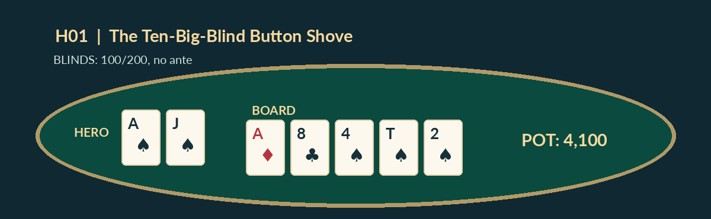
Verified tournament hand diagram
Event conditions: 100/200, no ante. Hole cards: As Js. Revealed opponent: 8h 8d. Board dealt: Ad 8c 4s Ts 2s.
Action: BTN shoves 2,000; SB folds; BB calls another 1,800.
- Preflop — 4,100 chips: BTN 2,000 + BB 2,000 + folded SB 100.
Verified interpretation: Preflop final pot 4,100. Hero makes an ace-high flush; the BB made a set of eights. This is a result, not proof that the shove was correct.
New-variable test: If big blind calls much more tightly, what happens to Button fold equity?

H02 — Big-Blind Ante Accounting
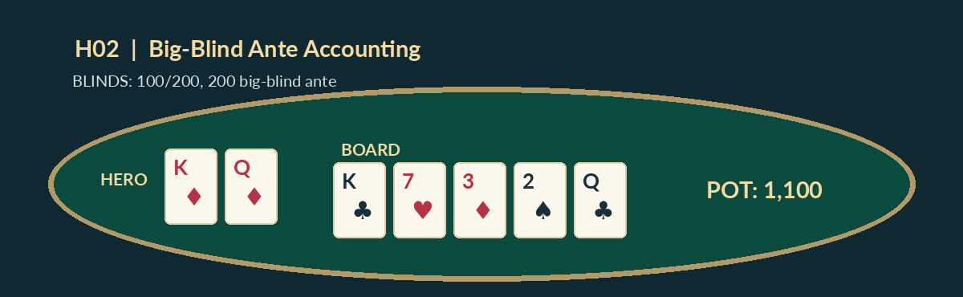
Verified tournament hand diagram
Event conditions: 100/200, 200 big-blind ante. Hole cards: Kd Qd. Revealed opponent: As 7c. Board dealt: Kc 7h 3d 2s Qc.
Action: BTN raises to 400; SB folds; BB calls another 200.
- Preflop — 1,100 chips: BTN 400 + BB 400 + SB 100 + ante 200.
Verified interpretation: Pot is 1,100. The 200 big-blind ante is dead money, not an additional live call. Hero ends with two pair.
New-variable test: Redo the contribution ledger when Button opens to 600 and BB calls.

H03 — Broadway Kicker on the River
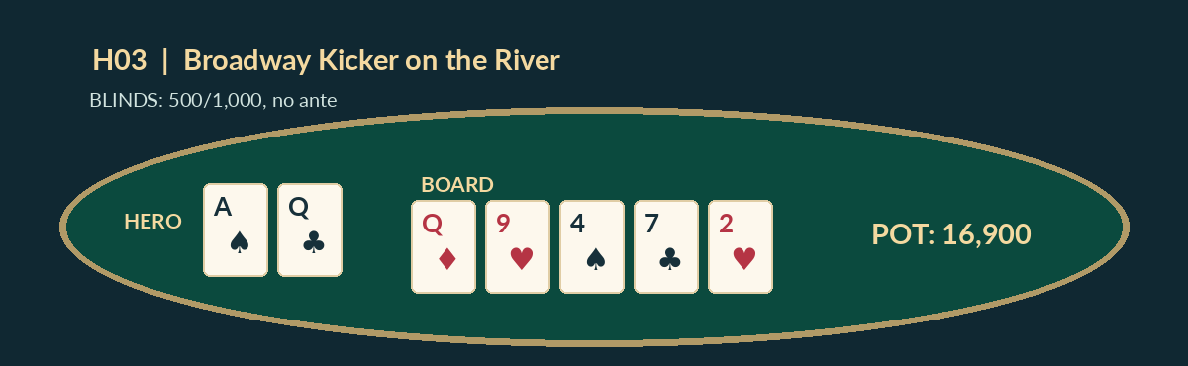
Verified tournament hand diagram
Event conditions: 500/1,000, no ante. Hole cards: As Qc. Revealed opponent: Qh Jh. Board dealt: Qd 9h 4s 7c 2h.
Action: CO opens 2,200; SB folds; BB calls 1,200. BB checks flop; CO bets 2,000; BB calls. Turn check-check. River BB bets 4,000; CO calls..
- Preflop — 4,900 chips: CO 2,200 + BB 2,200 + SB 500.
- Flop — 8,900 chips: Add CO 2,000 + BB 2,000.
- Turn — 8,900 chips: Check-check.
- River — 16,900 chips: Add BB 4,000 + CO 4,000.
Verified interpretation: Final pot 16,900. Hero wins with paired queens, ace kicker versus queen-jack. Without a model of the BB river range, this result alone does not establish a universally correct river call.
New-variable test: If BB rarely bets worse queens and instead bets two pair or bluffs, update the range model.

H04 — The 10bb Re-Shove Against an Open
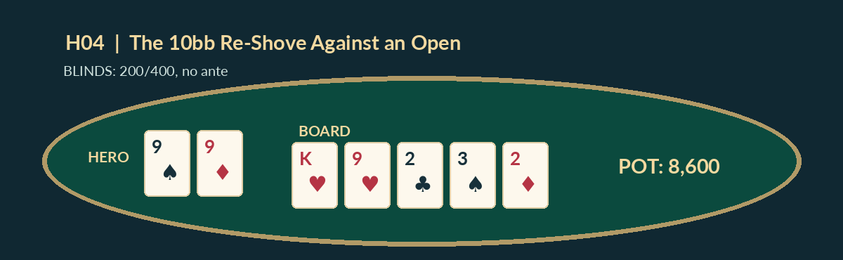
Verified tournament hand diagram
Event conditions: 200/400, no ante. Hole cards: 9s 9d. Revealed opponent: Ac Kc. Board dealt: Kh 9h 2c 3s 2d.
Action: HJ raises to 1,000; BTN moves all-in for 4,000; SB and BB fold; HJ calls 3,000 more.
- Preflop — 8,600 chips: HJ 4,000 + BTN 4,000 + SB 200 + BB 400.
Verified interpretation: Final pot 8,600. Hero wins with a full house, nines full of twos. The button risked 10bb and the original raiser had no fold equity after facing the shove.
New-variable test: If HJ is a very tight opener, how does a pair of nines fare against the calling range?

H05 — The Bubble Walk-Away
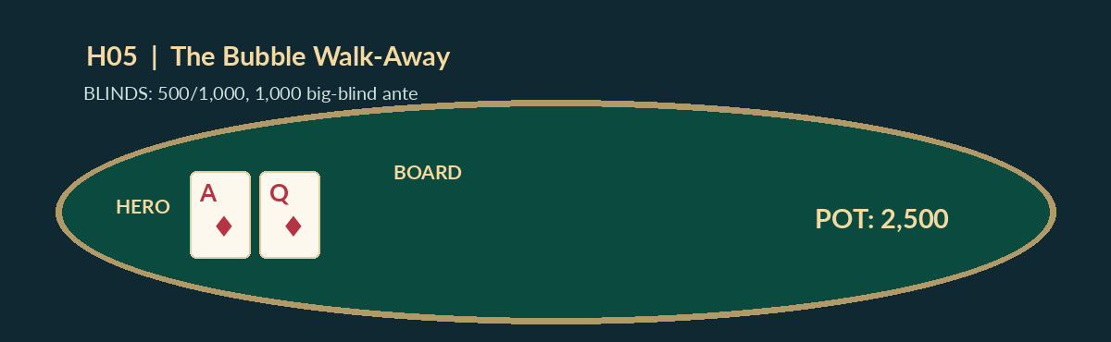
Verified tournament hand diagram
Event conditions: 500/1,000, 1,000 big-blind ante. Hole cards: Ad Qd. Board dealt: no flop, all players fold.
Action: CO pushes 12,000; BTN folds A♦Q♦; SB and BB fold; CO wins uncontested.
- Forced pot — 2,500 chips: SB 500 + BB 1,000 + ante 1,000.
Verified interpretation: With no call, the CO wins 2,500 in dead money; the 12,000 uncalled wager is not included as newly won chips. Whether BTN should call depends on payout pressure and the CO range.
New-variable test: How does the call change if no payout jump remains and CO shoves an unusually wide range?

H06 — The Main Pot and Side Pot
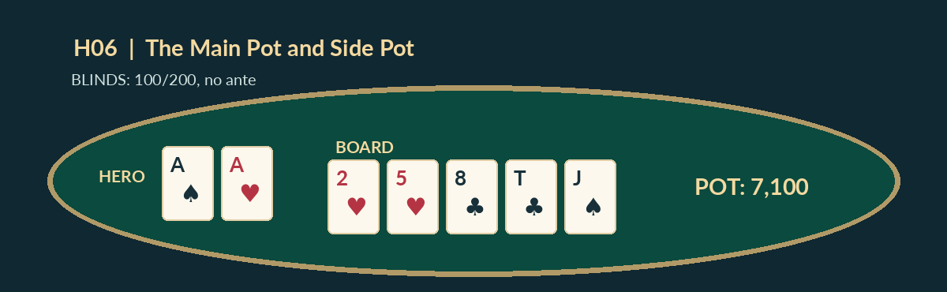
Verified tournament hand diagram
Event conditions: 100/200, no ante. Hole cards: As Ah. Revealed opponent: Kc Kd. Third player: Qs Qd. Board dealt: 2h 5h 8c Tc Js.
Action: UTG all-in for 1,000; BTN raises to 3,000; SB folds; BB calls total 3,000.
- Main pot — 3,100 chips: UTG 1,000 + BTN 1,000 + BB 1,000 + SB dead 100.
- Side pot — 4,000 chips: BTN 2,000 + BB 2,000.
Verified interpretation: Main pot 3,100; side pot 4,000; aggregate contested chips 7,100. BTN aces win both against kings and queens on this runout. The short stack is ineligible for the side pot.
New-variable test: If the short stack wins the main pot, which players are still eligible for the side pot?

H07 — C-Betting Under a Big-Blind Ante
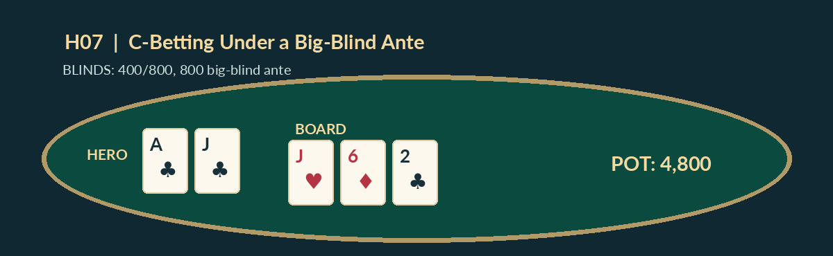
Verified tournament hand diagram
Event conditions: 400/800, 800 big-blind ante. Hole cards: Ac Jc. Board dealt: Jh 6d 2c.
Action: BTN opens to 1,600; SB calls 1,200; BB folds. SB checks the flop; BTN bets 1,500; SB folds..
- Preflop — 4,800 chips: BTN 1,600 + SB 1,600 + BB 800 + ante 800.
- Flop pot won — 4,800 chips: BTN unmatched 1,500 bet returned.
Verified interpretation: Won pot 4,800, not 6,300. A wager that receives no call is returned; BTN gains the preexisting contested pot.
New-variable test: Change SB fold to call; what is the flop pot and each player’s remaining stack if each started with 20,000?

H08 — Four-Big-Blind Small-Blind Push
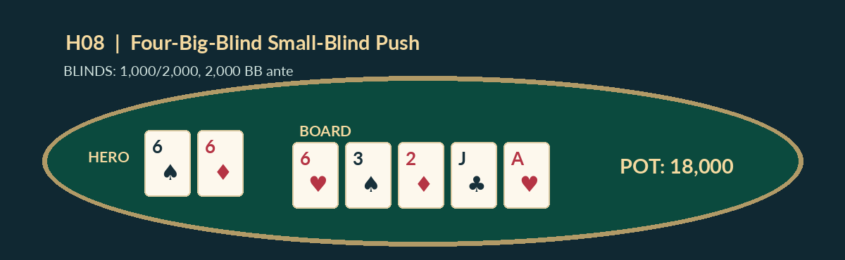
Verified tournament hand diagram
Event conditions: 1,000/2,000, 2,000 BB ante. Hole cards: 6s 6d. Revealed opponent: Ac Qc. Board dealt: 6h 3s 2d Jc Ah.
Action: Players fold to SB, which shoves total 8,000 including its posted 1,000. BB calls 6,000 more after posting blind and ante..
- Preflop — 18,000 chips: SB 8,000 + BB live 8,000 + dead BB ante 2,000.
Verified interpretation: Main pot 18,000. Hero makes a set of sixes, beating a pair of aces. The BB ante was already contributed as dead money.
New-variable test: If the BB has only 6,000 total live stack before posting blinds, how do matched contributions and returned chips change?

H09 — Turn Value Bet Wins Before River
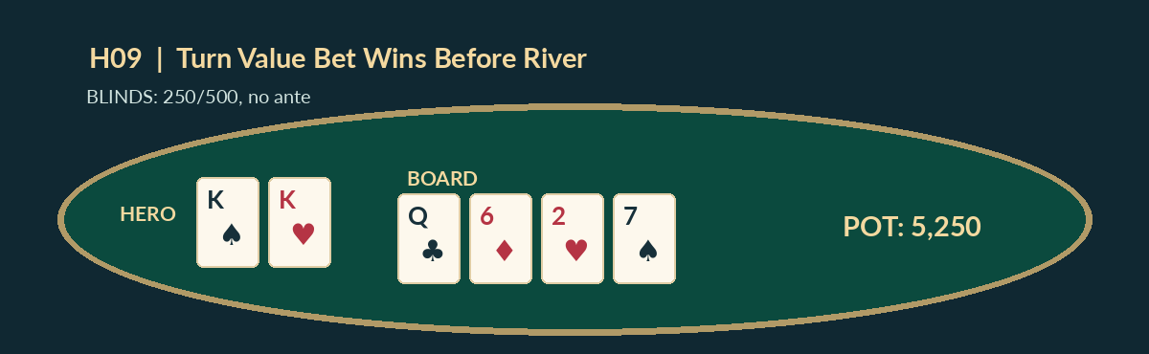
Verified tournament hand diagram
Event conditions: 250/500, no ante. Hole cards: Ks Kh. Board dealt: Qc 6d 2h 7s.
Action: UTG opens 1,500; SB folds; BB calls 1,000. Flop BB checks, UTG bets 1,000, BB calls. Turn BB checks, UTG bets 2,500, BB folds..
- Preflop — 3,250 chips: UTG 1,500 + BB 1,500 + SB 250.
- Flop — 5,250 chips: Add two matched bets of 1,000.
- Turn pot won — 5,250 chips: Uncalled UTG 2,500 returned.
Verified interpretation: Hero collects a 5,250 pot. There is no known river card and no exposed villain hand; do not invent one in the instructional art.
New-variable test: If BB calls the 2,500 turn bet, calculate the turn pot.

H10 — Satellite Showdown: Queens Versus Ace-King
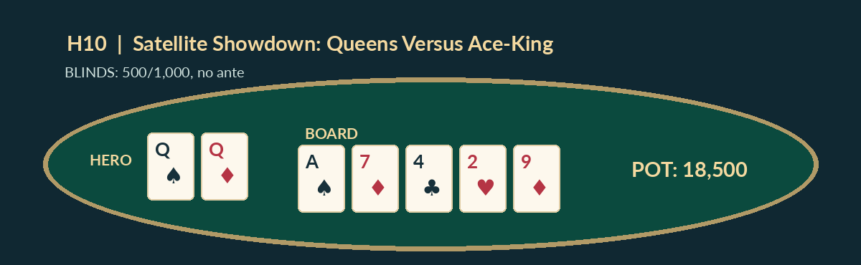
Verified tournament hand diagram
Event conditions: 500/1,000, no ante. Hole cards: Qs Qd. Revealed opponent: Ac Kh. Board dealt: As 7d 4c 2h 9d.
Action: BTN shoves 9,000; SB folds; BB calls 8,000 more.
- Preflop — 18,500 chips: BTN 9,000 + BB 9,000 + SB 500.
Verified interpretation: Final pot 18,500. BB wins with aces against queens. In a flat satellite the prize decision must be analyzed using seats and remaining stacks; chip EV alone cannot settle it.
New-variable test: If the final seat has already been awarded and the remaining event is winner-take-all, which payout consideration changes?

H11 — The River Bet That Was Never Called
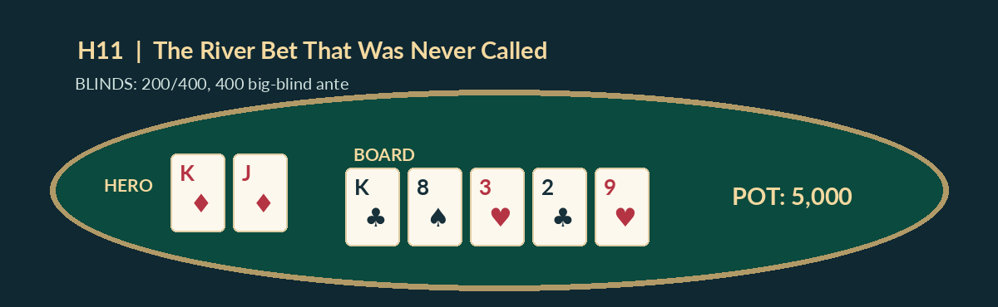
Verified tournament hand diagram
Event conditions: 200/400, 400 big-blind ante. Hole cards: Kd Jd. Board dealt: Kc 8s 3h 2c 9h.
Action: HJ raises 800; BTN calls 800; SB folds; BB calls another 400. Flop BB checks, HJ checks, BTN bets 1,000; BB folds, HJ calls. Turn check-check. River HJ bets 3,000 and BTN folds..
- Preflop — 3,000 chips: HJ 800 + BTN 800 + BB 800 + SB 200 + ante 400.
- Flop — 5,000 chips: BTN 1,000 + HJ 1,000.
- Turn — 5,000 chips: Check-check.
- River pot won — 5,000 chips: HJ uncalled 3,000 returned.
Verified interpretation: HJ wins 5,000 in contested chips; its uncalled 3,000 river bet returns. No opponent cards are exposed and no extra showdown occurs.
New-variable test: If BTN calls 3,000, what would be the river pot before any rake? (Tournament pot rake assumed zero.)

H12 — A Three-Handed Final-Table Three-Bet Pot
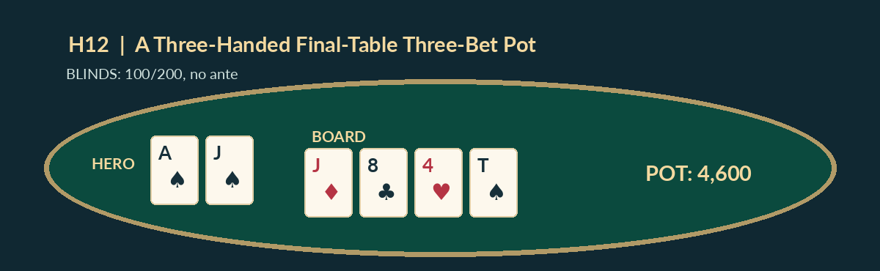
Verified tournament hand diagram
Event conditions: 100/200, no ante. Hole cards: As Js. Board dealt: Jd 8c 4h Ts.
Action: BTN opens to 500; SB raises to 1,400; BB folds; BTN calls 900. Flop SB bets 800, BTN calls. Turn SB checks; BTN bets 1,400; SB folds..
- Preflop — 3,000 chips: BTN 1,400 + SB 1,400 + BB 200.
- Flop — 4,600 chips: Add SB 800 + BTN 800.
- Turn pot won — 4,600 chips: BTN 1,400 uncalled and returned.
Verified interpretation: BTN wins 4,600 in contested chips. The 1,400-chip turn bet is uncalled and returned because SB folded.
New-variable test: If SB calls the 1,400 turn bet, what is the turn pot?

FINAL EXAMINATION — FORTY APPLIED PROBLEMS
Do not consult the key until you have completed all forty questions. These answers rely on the explicitly defined scenarios, not on claims that one tournament action is always best.
F01 — SFFT-MS6-079. Heads-up river, no rake or ties: pot BEFORE a bet is 230 chips. Villain bets 40 and you must call 40. What minimum showdown equity makes calling break even?
A. 20.90%
B. 5.90%
C. 29.90%
D. 12.90%
F02 — SFFT-MS6-080. Pure bluff toy model: you risk 80 chips to win 410 dead chips. You have ZERO showdown equity when called. What percentage of folds breaks even?
A. 24.33%
B. 9.33%
C. 33.33%
D. 16.33%
F03 — SFFT-MS6-081. 100/200 blinds, 200 BB ante. Folds to Button, who raises to 600 total. SB folds; BB calls the amount needed. What is the PRE-FLOP pot?
A. 2,100 chips
B. 1,500 chips
C. 1,700 chips
D. 1,300 chips
F04 — SFFT-MS6-082. The flop pot is 10,000 chips and Hero and Villain each have 21,500 behind. What is the effective flop SPR?
A. 2.15
B. 2.95
C. 1.15
D. 4.15
F05 — SFFT-MS6-083. Heads-up river, no rake or ties: pot BEFORE a bet is 230 chips. Villain bets 40 and you must call 40. What minimum showdown equity makes calling break even?
A. 20.90%
B. 5.90%
C. 29.90%
D. 12.90%
F06 — SFFT-MS6-084. 100/200 blinds, 200 BB ante. Folds to Button, who raises to 500 total. SB folds; BB calls the amount needed. What is the PRE-FLOP pot?
A. 1,800 chips
B. 1,300 chips
C. 1,500 chips
D. 1,100 chips
F07 — SFFT-MS6-085. The flop pot is 10,500 chips and Hero and Villain each have 19,000 behind. What is the effective flop SPR?
A. 1.81
B. 2.61
C. 0.81
D. 3.81
F08 — SFFT-MS6-086. No-limit tournament blinds 100/200. A player makes an unopened raise to 800 total. Ignoring short all-ins, what is the minimum FULL re-raise to?
A. 1,600 total
B. 1,000 total
C. 1,550 total
D. 1,400 total
F09 — SFFT-MS6-087. Pure bluff toy model: you risk 60 chips to win 430 dead chips. You have ZERO showdown equity when called. What percentage of folds breaks even?
A. 5.24%
B. 29.24%
C. 12.24%
D. 20.24%
F10 — SFFT-MS6-088. 100/200 blinds, 200 BB ante. Folds to Button, who raises to 500 total. SB folds; BB calls the amount needed. What is the PRE-FLOP pot?
A. 1,800 chips
B. 1,300 chips
C. 1,500 chips
D. 1,100 chips
F11 — SFFT-MS6-089. No-limit tournament blinds 100/200. A player makes an unopened raise to 700 total. Ignoring short all-ins, what is the minimum FULL re-raise to?
A. 1,400 total
B. 900 total
C. 1,350 total
D. 1,200 total
F12 — SFFT-MS6-090. Turn to river, one card remains, 46 unseen cards and exactly 12 clean winning outs. What is the probability you hit an out?
A. 43.09%
B. 26.09%
C. 34.09%
D. 19.09%
F13 — SFFT-MS6-091. 100/200 blinds, 200 BB ante. Folds to Button, who raises to 400 total. SB folds; BB calls the amount needed. What is the PRE-FLOP pot?
A. 1,500 chips
B. 1,100 chips
C. 1,300 chips
D. 900 chips
F14 — SFFT-MS6-092. The flop pot is 11,000 chips and Hero and Villain each have 16,500 behind. What is the effective flop SPR?
A. 1.50
B. 2.30
C. 0.50
D. 3.50
F15 — SFFT-MS6-093. No-limit tournament blinds 100/200. A player makes an unopened raise to 700 total. Ignoring short all-ins, what is the minimum FULL re-raise to?
A. 1,400 total
B. 900 total
C. 1,350 total
D. 1,200 total
F16 — SFFT-MS6-094. Three-player ICM with prizes $100/$60/$0 and no dead pot: A has 4000, Hero 3000, C 2500. Hero can lose 3000 or win 3000 from A. If losing means immediate third, what showdown win rate breaks even in ICM prize equity?
A. 64.23%
B. 72.23%
C. 57.23%
D. 81.23%
F17 — SFFT-MS6-095. The flop pot is 11,500 chips and Hero and Villain each have 14,000 behind. What is the effective flop SPR?
A. 1.22
B. 2.02
C. 0.22
D. 3.22
F18 — SFFT-MS6-096. No-limit tournament blinds 100/200. A player makes an unopened raise to 600 total. Ignoring short all-ins, what is the minimum FULL re-raise to?
A. 1,200 total
B. 800 total
C. 1,150 total
D. 1,000 total
F19 — SFFT-MS6-097. Turn to river, one card remains, 46 unseen cards and exactly 12 clean winning outs. What is the probability you hit an out?
A. 26.09%
B. 34.09%
C. 19.09%
D. 43.09%
F20 — SFFT-MS6-098. Three-player ICM with prizes $100/$60/$0 and no dead pot: A has 4000, Hero 3000, C 2500. Hero can lose 3000 or win 3000 from A. If losing means immediate third, what showdown win rate breaks even in ICM prize equity?
A. 64.23%
B. 72.23%
C. 57.23%
D. 81.23%
F21 — SFFT-MS6-099. No-limit tournament blinds 100/200. A player makes an unopened raise to 500 total. Ignoring short all-ins, what is the minimum FULL re-raise to?
A. 1,000 total
B. 700 total
C. 950 total
D. 800 total
F22 — SFFT-MS6-100. Turn to river, one card remains, 46 unseen cards and exactly 12 clean winning outs. What is the probability you hit an out?
A. 34.09%
B. 19.09%
C. 43.09%
D. 26.09%
F23 — SFFT-MS6-101. Three-player ICM with prizes $100/$60/$0 and no dead pot: A has 4000, Hero 3000, C 2500. Hero can lose 3000 or win 3000 from A. If losing means immediate third, what showdown win rate breaks even in ICM prize equity?
A. 72.23%
B. 57.23%
C. 81.23%
D. 64.23%
F24 — SFFT-MS6-102. Illustrative INDEPENDENCE model (not measured poker behavior): each of 5 players behind folds with probability 71%. What is the probability every player folds?
A. 26.04%
B. 11.04%
C. 35.04%
D. 18.04%
F25 — SFFT-MS6-103. No-limit tournament blinds 100/200. A player makes an unopened raise to 500 total. Ignoring short all-ins, what is the minimum FULL re-raise to?
A. 1,000 total
B. 700 total
C. 950 total
D. 800 total
F26 — SFFT-MS6-104. Three-player ICM with prizes $100/$60/$0 and no dead pot: A has 4000, Hero 4000, C 2500. Hero can lose 4000 or win 4000 from A. If losing means immediate third, what showdown win rate breaks even in ICM prize equity?
A. 58.55%
B. 82.55%
C. 65.55%
D. 73.55%
F27 — SFFT-MS6-105. Illustrative INDEPENDENCE model (not measured poker behavior): each of 4 players behind folds with probability 69%. What is the probability every player folds?
A. 15.67%
B. 39.67%
C. 22.67%
D. 30.67%
F28 — SFFT-MS6-106. Four-player equal-seat satellite, three seats. Stacks in thousands: Hero 40, other players 35, 24, 4. Under the independent chip model, what is Hero’s approximate probability of qualifying?
A. 88.72%
B. 112.72%
C. 95.72%
D. 103.72%
F29 — SFFT-MS6-107. Turn to river, one card remains, 46 unseen cards and exactly 12 clean winning outs. What is the probability you hit an out?
A. 19.09%
B. 43.09%
C. 26.09%
D. 34.09%
F30 — SFFT-MS6-108. Three-player ICM with prizes $100/$60/$0 and no dead pot: A has 4000, Hero 4000, C 2500. Hero can lose 4000 or win 4000 from A. If losing means immediate third, what showdown win rate breaks even in ICM prize equity?
A. 58.55%
B. 82.55%
C. 65.55%
D. 73.55%
F31 — SFFT-MS6-109. Four-player equal-seat satellite, three seats. Stacks in thousands: Hero 40, other players 35, 24, 3. Under the independent chip model, what is Hero’s approximate probability of qualifying?
A. 113.68%
B. 96.68%
C. 104.68%
D. 89.68%
F32 — SFFT-MS6-110. All-in call with action closed, no ties: pot was 2700 before the shove, opponent adds 450, Hero can match by calling 450. What chip-EV equity is needed?
A. 29.50%
B. 12.50%
C. 20.50%
D. 5.50%
F33 — SFFT-MS6-111. Three-player ICM with prizes $100/$60/$0 and no dead pot: A has 4000, Hero 3500, C 2500. Hero can lose 3500 or win 3500 from A. If losing means immediate third, what showdown win rate breaks even in ICM prize equity?
A. 81.96%
B. 64.96%
C. 72.96%
D. 57.96%
F34 — SFFT-MS6-112. Illustrative INDEPENDENCE model (not measured poker behavior): each of 3 players behind folds with probability 67%. What is the probability every player folds?
A. 47.08%
B. 30.08%
C. 38.08%
D. 23.08%
F35 — SFFT-MS6-113. Four-player equal-seat satellite, three seats. Stacks in thousands: Hero 40, other players 35, 24, 3. Under the independent chip model, what is Hero’s approximate probability of qualifying?
A. 113.68%
B. 96.68%
C. 104.68%
D. 89.68%
F36 — SFFT-MS6-114. Blinds 400/800 with a 800 big-blind ante, BTN raises to 1600, SB folds, BB calls. What is the correct contested pot before flop?
A. 4,400 chips
B. 5,200 chips
C. 3,600 chips
D. 6,000 chips
F37 — SFFT-MS6-115. Illustrative INDEPENDENCE model (not measured poker behavior): each of 2 players behind folds with probability 65%. What is the probability every player folds?
A. 42.25%
B. 50.25%
C. 35.25%
D. 59.25%
F38 — SFFT-MS6-116. Four-player equal-seat satellite, three seats. Stacks in thousands: Hero 40, other players 35, 24, 2. Under the independent chip model, what is Hero’s approximate probability of qualifying?
A. 97.72%
B. 105.72%
C. 90.72%
D. 114.72%
F39 — SFFT-MS6-117. All-in call with action closed, no ties: pot was 2800 before the shove, opponent adds 400, Hero can match by calling 400. What chip-EV equity is needed?
A. 11.11%
B. 19.11%
C. 4.11%
D. 28.11%
F40 — SFFT-MS6-118. Blinds 400/800 with a 800 big-blind ante, BTN raises to 1600, SB folds, BB calls. What is the correct contested pot before flop?
A. 4,400 chips
B. 5,200 chips
C. 3,600 chips
D. 6,000 chips

Examination solutions
F01: D. Final pot = 230+40+40=310. Required equity = 40/310 = 12.90%.
F02: D. Folding wins 410, a call loses 80. Breakeven fold rate = 80/(410+80) = 16.33%. Not a real multiway solver result.
F03: B. Button 600 + BB live 600 + folded SB 100 + BB ante 200 = 1,500. BB posted blind is inside its live total already.
F04: A. SPR = effective stack behind divided by pot = 21,500/10,000 = 2.15.
F05: D. Final pot = 230+40+40=310. Required equity = 40/310 = 12.90%.
F06: B. Button 500 + BB live 500 + folded SB 100 + BB ante 200 = 1,300. BB posted blind is inside its live total already.
F07: A. SPR = effective stack behind divided by pot = 19,000/10,500 = 1.81.
F08: D. Last full raise increment = 800−200 = 600. New minimum total = 800+600 = 1400. Confirm event rules for exceptional reopenings.
F09: C. Folding wins 430, a call loses 60. Breakeven fold rate = 60/(430+60) = 12.24%. Not a real multiway solver result.
F10: B. Button 500 + BB live 500 + folded SB 100 + BB ante 200 = 1,300. BB posted blind is inside its live total already.
F11: D. Last full raise increment = 700−200 = 500. New minimum total = 700+500 = 1200. Confirm event rules for exceptional reopenings.
F12: B. Probability = 12/46 × 100 = 26.09%. This is improvement probability, not automatically complete showdown equity.
F13: B. Button 400 + BB live 400 + folded SB 100 + BB ante 200 = 1,100. BB posted blind is inside its live total already.
F14: A. SPR = effective stack behind divided by pot = 16,500/11,000 = 1.50.
F15: D. Last full raise increment = 700−200 = 500. New minimum total = 700+500 = 1200. Confirm event rules for exceptional reopenings.
F16: A. ICM Hero before = $52.126; after winning = $81.150; after losing = $0. Required p = before/win = 64.23%.
F17: A. SPR = effective stack behind divided by pot = 14,000/11,500 = 1.22.
F18: D. Last full raise increment = 600−200 = 400. New minimum total = 600+400 = 1000. Confirm event rules for exceptional reopenings.
F19: A. Probability = 12/46 × 100 = 26.09%. This is improvement probability, not automatically complete showdown equity.
F20: A. ICM Hero before = $52.126; after winning = $81.150; after losing = $0. Required p = before/win = 64.23%.
F21: D. Last full raise increment = 500−200 = 300. New minimum total = 500+300 = 800. Confirm event rules for exceptional reopenings.
F22: D. Probability = 12/46 × 100 = 26.09%. This is improvement probability, not automatically complete showdown equity.
F23: D. ICM Hero before = $52.126; after winning = $81.150; after losing = $0. Required p = before/win = 64.23%.
F24: D. P(all fold) = (0.71)^5 = 18.04%. Real folds are not necessarily independent.
F25: D. Last full raise increment = 500−200 = 300. New minimum total = 500+300 = 800. Confirm event rules for exceptional reopenings.
F26: C. ICM Hero before = $59.304; after winning = $90.476; after losing = $0. Required p = before/win = 65.55%.
F27: C. P(all fold) = (0.69)^4 = 22.67%. Real folds are not necessarily independent.
F28: C. Enumerate all 24 finish orders weighted by the chip fractions and sum Hero finishes first, second or third = 95.72%. This ICM seat estimate ignores future skill and blinds.
F29: C. Probability = 12/46 × 100 = 26.09%. This is improvement probability, not automatically complete showdown equity.
F30: C. ICM Hero before = $59.304; after winning = $90.476; after losing = $0. Required p = before/win = 65.55%.
F31: B. Enumerate all 24 finish orders weighted by the chip fractions and sum Hero finishes first, second or third = 96.68%. This ICM seat estimate ignores future skill and blinds.
F32: B. Final contested pot = 2700+2×450=3600; equity threshold 450/3600 = 12.50%. This is NOT an ICM call threshold.
F33: B. ICM Hero before = $56.000; after winning = $86.211; after losing = $0. Required p = before/win = 64.96%.
F34: B. P(all fold) = (0.67)^3 = 30.08%. Real folds are not necessarily independent.
F35: B. Enumerate all 24 finish orders weighted by the chip fractions and sum Hero finishes first, second or third = 96.68%. This ICM seat estimate ignores future skill and blinds.
F36: A. BTN 1600 + BB live 1600 + SB 400 + BB ante 800 = 4,400.
F37: A. P(all fold) = (0.65)^2 = 42.25%. Real folds are not necessarily independent.
F38: A. Enumerate all 24 finish orders weighted by the chip fractions and sum Hero finishes first, second or third = 97.72%. This ICM seat estimate ignores future skill and blinds.
F39: A. Final contested pot = 2800+2×400=3600; equity threshold 400/3600 = 11.11%. This is NOT an ICM call threshold.
F40: A. BTN 1600 + BB live 1600 + SB 400 + BB ante 800 = 4,400.

REFERENCE DESK

Core calculations
Question | Model | Clarification
Required call equity, no tie | Call / (pot before bet + bet + call) | Chip EV only, when action closes
Pure-bluff fold threshold | Bet / (dead pot + bet) | No showdown equity when called
Flop SPR | Effective stack behind / flop pot | Describes pot geometry, not an automatic action
Turn-to-river clean-out probability | Outs / 46 | Assumes exactly two known hole cards plus four board cards
All-fold probability under independence | Product of separate fold probabilities | Real player decisions may be correlated
ICM prize equity | Sum of finish-order probability × prize | Omits skill and future blind position

Standard pot-odds reference
Opponent bet as fraction of pot before bet | Chip-EV equity required to call
25% | 16.67%
33.33% | 20.00%
50% | 25.00%
75% | 30.00%
100% | 33.33%
200% | 40.00%
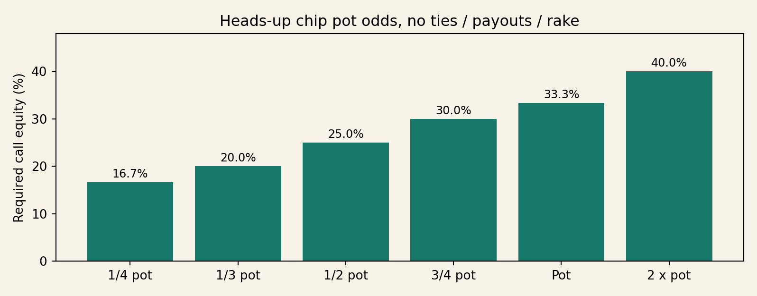
Validated call-equity chart

Exact ICM example
Payouts are $100/$60/$0. The starting stacks are A 4,000, Hero B 3,500, C 2,500, without any dead-pot adjustment.
Outcome | A chips | B chips | C chips | Hero ICM prize equity
Before all-in | 4,000 | 3,500 | 2,500 | $56.00
Hero wins all-in | 500 | 7,000 | 2,500 | $86.21
Hero loses all-in | 7,500 | 0 | 2,500 | $0.00
Break-even probability when folding preserves the before state: 64.96% under this model. A tie, dead pot, new payout structure or different chip transfers changes the result.
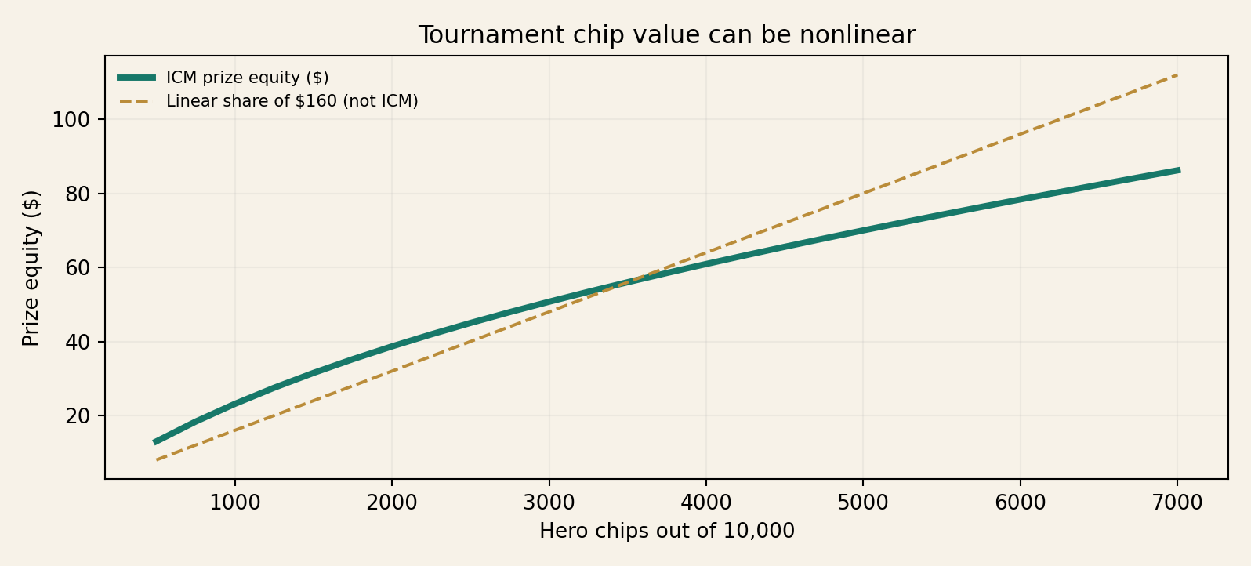
ICM equity illustration

Further study and reference categories
- Official current event rules (betting reopening, short all-in handling, ante priority and side-pot splitting) must be checked against the specific tournament operator.
- A tournament calculator may evaluate an explicitly modeled ICM distribution, but it is not proof of a unique best strategy without accurate opponent ranges and action trees.
- For more complete tournament mathematics, study equilibrium push/fold models, future game simulation, and bounty-model calibration, always noting model assumptions.

Editorial assurance and limitations
The package includes all numerical question inputs, independent recomputation checks, complete displayed hand cards and hand-ledger totals. The illustration assets are generated from these records. Strategic judgments remain teaching hypotheses, not solver certification or independent human expert review. WordPress import is draft-only and must be staging-tested before any public release.

