

THE LIVE CASH GAME MASTERCLASS

Deep Stacks, Dangerous Opponents, and the Mathematics of Enormous Pots
Science Fiction Author D. Colin Palmer’s Poker Master Series · Book Two
Science Fiction Fantasy Theater · First educational edition · October 2026
About the cover. The midnight casino is a fictional promotional illustration, not a record of a real casino, game, player, or result. The pictured cards and chips are theatrical. Teaching diagrams, hand histories, and calculations are derived separately from explicit data.
Publication and responsibility. This is strategy education, not a promise of income or a betting system. Live poker involves losses, variance, rake, and sometimes harmful financial decisions. Never play with necessary funds, borrow to gamble, or chase losses. Honor local law, age requirements, and the house’s rules. The fictional recurring players are composite teaching characters, not real individuals. Where this book gives an action preference, it is conditional on the specified game, opponent behavior, and assumptions.

Preface: The pot at three in the morning
At 3:07 a.m. the casino floor has a particular sound. The slot machines continue their endless conversation. Someone counts a large stack of chips too loudly. A dealer quietly corrects a player’s calculation. At the far end of the room a single cash table is still going, because nobody particularly wants to leave. The game is $1/$2, but the pots have the swagger of a much bigger game. One player has $85; another has $1,100. Three people limp; a fourth makes it $18; two people call anyway. A player with a decent hand wonders whether to raise. A player with an attractive hand wonders whether to call. A good player wonders what happens after the flop.
That last question is the subject of this volume.
In Basic Strategy Play, we learned that poker is not judged by the outcome of a single hand. We learned to count contributions to the pot, read position, understand starting-hand categories, calculate the price of a call, and distinguish present pot odds from uncertain future winnings. Book Two applies those ideas to the most unruly classroom in poker: the live cash game, where stacks are uneven, pot sizes are surprising, people do not share a strategy, and the room collects a fee whether the winner played beautifully or badly.
We will examine situations that are not captured by slogans. A $2 preflop call can be harmless or costly. A large river bet can be a bluff, a thin value bet, or a hand that should never have been played preflop. A deep opponent might offer substantial implied odds—or might be too disciplined to pay when a draw arrives. The player who raises every time is not necessarily winning. The player who calls frequently is not automatically exploitable by bluffing. To understand these distinctions, we must learn to think about the entire decision tree.

The continuing table
The book follows six fictional players over several sessions:
Player | Initial working description | What we must not assume
Mara Vale | Loose-passive; enters many pots and dislikes folding pairs | That she calls every bet size or never raises strong draws
Vince Calder | Tight and straightforward; larger river bets have often been strong | That his next bet is guaranteed to be value
Lena Cruz | Aggressive, capable of frequent three-bets and pressure | That any particular large bet is a bluff
Owen Pike | Short-stack regular; buys in shallow, chooses direct lines | That deep-stack implied odds exist against him
Nico Bell | Experienced, position-conscious; pays attention to ranges | That we can outplay him by default
Ruth Mercer | Very deep recreational player; occasionally pays large bets with second-best hands | That a past enormous pot predicts the next one’s size
These are hypotheses, not labels glued to people. As hands accumulate, we will revise them. A worthwhile observation records a context, an action, a showdown or a range inference, and how confident we should be. One dramatic hand is a clue, not a population database.

How to use this book
Each chapter offers an explanation, a reference table or visual, a worked example, a decision, an answer, and a variable to change. Read the decision before the explanation and commit to your own reasoning. Afterward, ask which assumption would have to change to reverse the recommendation? That question turns a remembered answer into a skill. The fifteen Master Cash Game Files provide complete hand-by-hand investigations, followed by a 50-question examination and answer key.
The diagrams use explicitly labeled illustrative ranges and toy models. A solved toy example proves the arithmetic under its assumptions; it does not prove that a particular live opponent holds the assumed range. Unless we identify a rake rule, mathematical examples exclude rake and tips. If a purported edge is smaller than the realistic fee or the uncertainty in our range estimate, treat it as fragile.

The recurring decision audit
- Situation: stakes, seats, effective stacks, players still to act, and rake.
- Present price: pot before the opponent’s bet, bet faced, incremental cost to call, pot after the call.
- Hand and range: likely made hands, relevant draws, blockers, and uncertainty.
- Future game: position, remaining stacks, expected betting, and reverse-implied exposure.
- Action: value bet, bluff, check, call, raise, or fold—with a reason.
- Sensitivity: what would make another action preferable?

Contents
- The Room Is Part of the Hand
- Table Selection and the Six Opponents
- Deep Stacks, SPR, and Pot Geometry
- The Cheap Flop and the Enormous Pot
- Limpers, Isolation, and the Price of Entry
- Aggression Without Panic
- Multiway Mathematics and Equity Realization
- Broadway Hands in the Real World
- Pocket Pairs and the Set-Mining Contract
- Suited Connectors and Disguised Hands
- Building, Protecting, and Controlling Pots
- Live Reads: Evidence Before Theater
- Turn and River Decisions for Deep Stacks
- When a Monster Is Not the Nuts
- The Master Cash Game Files
- The Night-Shift Examination and Study Plan
Appendices: 50-question assessment with explanations · Reference tables and glossary · Mathematics and editorial methods · WordPress teaching notes.

1. The Room Is Part of the Hand
Level: Beginner to intermediate · Objective: Determine the actual game conditions before selecting a strategy. Prerequisite: Book One’s pot accounting and action order.
A beginning cash player sees the cards. A capable cash player sees the cards, the prices, the stacks, the positions, the house rules, and the people. A common error is to apply a tidy online six-max preflop chart to a live nine-handed table where three people limp, every raise attracts calls, the rake is substantial, and some stacks are less than thirty big blinds while others exceed three hundred. There is no single magic adjustment that corrects all those differences.
The room is part of the hand because the contract is different. In one game, a standard open may be three big blinds; in another, a raise to six or eight big blinds receives three callers. Some venues take a percentage rake up to a cap, sometimes with a separate promotional drop. Others charge time. Some observe no-flop-no-drop. Some impose a maximum buy-in; some allow matching the biggest stack; some permit straddles. A $1/$2 table with a mandatory $5 straddle does not play like an ordinary $1/$2 table. Ask the dealer or floor staff about rules you do not know; never infer the fee or raise rule from the signage alone.
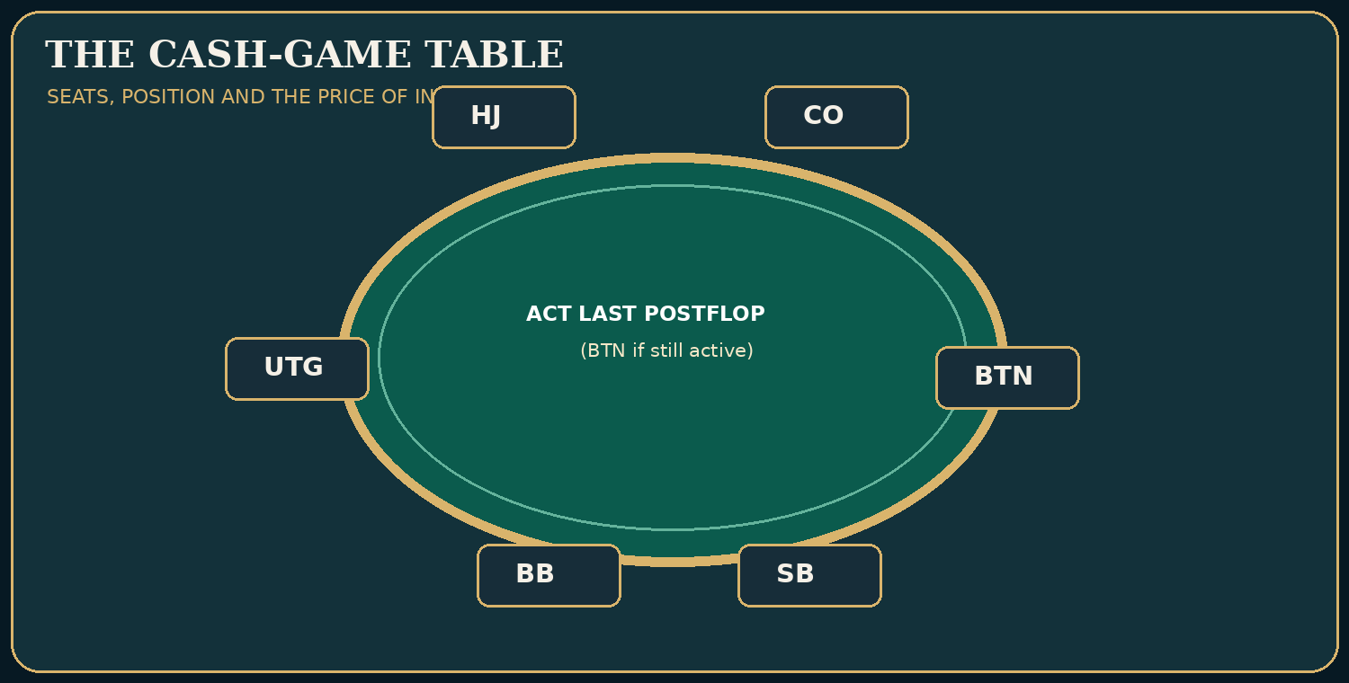
Instructional diagram — table-positions.png

Six checks before buying chips
Check | Why it changes decisions | Question to ask
Blinds and optional/mandatory straddles | Determine the actual cost of playing and alter preflop position | Is the effective first bet $2, $4, or $5?
Buy-in rules and stack distribution | Determine money at risk and potential future winnings | Who covers whom, and by how much?
Rake, cap, promotional drop, time | Remove profit from marginal pots | What is actually taken, and when?
Typical open and 3-bet sizes | Alter the price of speculative holdings | Is the normal open $7, $15, or $25?
Number of callers and aggression | Change equity realization and bluffing incentives | Do three people usually see the flop?
Relative skill and seat position | Determine how hard future decisions will be | Who sits to my left and right?
The checks are not a promise that a table will be profitable. They are the minimum facts needed before judging a strategy. The house takes money according to its published rules; a player needs an edge greater than those costs before expecting a positive long-run result.

Effective stacks are player-specific
At a $1/$2 table, suppose Hero has $550, Mara has $180, and Ruth has $800. In a heads-up pot against Mara, the maximum Hero can win from Mara is $180, plus any existing dead money. Against Ruth, Hero could contest $550 from Ruth if both are willing and legally able to put that amount in. In a multiway pot, there is no single effective-stack number for the entire table. Main pots and side pots determine who can win which chips. If Mara goes all-in for $180 and Hero and Ruth continue betting, the extra wagers between Hero and Ruth belong to a side pot Mara cannot win.
The distinction becomes crucial when a student argues, ‘I can call because someone at the table has a thousand dollars.’ An enormous stack belonging to somebody who has already folded cannot finance your implied odds. An enormous stack belonging to a tight player who folds whenever the flush completes may also be far less useful than it first appears.

The cost of a small pot
Imagine a $1/$2 game with a fictional illustration rule of 10% rake capped at $6, plus a $2 fixed promotional drop whenever a flop is dealt and the pot qualifies. A $20 final pot might surrender $2 in percentage rake and another $2 in the drop, leaving $16 for the winner. A $100 final pot might surrender the capped $6 plus $2, leaving $92. Actual houses can have different thresholds and rounding; these are just examples. Notice what happens: winning many small contested pots may still be expensive, and an already narrow call can flip to a loss after the fee.
If someone says the winner of the $20 pot ‘won $20,’ ask what net proceeds they received and how much they invested. If the winner personally contributed $10 and receives $16 after rake and drop, the return is a net $6, not $16 or $20. An educational hand ledger should always distinguish money in the pot, money committed by Hero, and net winnings.

The etiquette that protects decisions
Act in turn. State large bets clearly. Place chips so the dealer can distinguish a call from a raise. Protect your hole cards; show them only when required or intentionally permitted. Do not talk about the contents of live hands in a way that influences other players. A verbal declaration may be binding under the applicable house rules. Unclear string-raise and one-chip situations are common sources of disputes. Ask the dealer before doing something ambiguous, and accept that house procedures may differ from tournament rules.
A new player can earn more by refusing to play uncertain spots than by pretending to know every local convention. There is no embarrassment in asking, ‘Is the straddle live?’ or ‘How much is the bet?’ Those are questions about the contract, not clues about your cards.

A live-room decision
Hero enters a $1/$2 game with $200. Owen has $65 and sits immediately to Hero’s right; Ruth has $650 and sits on Hero’s left. The game has a live $5 straddle and the normal opening raise is $25. Hero is dealt 6♠5♠ in middle position. There are two callers of the $5 straddle; action is on Hero, with Ruth still to act.
Should Hero treat the hand as an ordinary $2 limp? No. The minimum voluntary entry price is now $5, the normal raise is much larger, Ruth has position on Hero, and the short player offers limited future payment. The actual opportunity is very different from a passive, unstraddled $1/$2 game in which the button can call $2 after several limpers. Folding can be entirely reasonable; the mere fact that 6♠5♠ is suited is not sufficient to decide.
Decision check. Which change makes a speculative call more attractive, other things equal? A: a straddle increases the price; B: the deep loose opponent moves to your right and rarely raises; C: the rake rises; D: effective stacks fall from $300 to $60. Answer B. The other changes generally reduce your price or playability advantage.
Change one variable: put Hero on the button, remove the straddle, and replace the short-stacked opponent with a loose caller who has $500. We have not proven a call is profitable, but the conditions for realizing future value have improved substantially.
Takeaway: read the room before you read your hand. An otherwise sensible poker concept can become a leak when applied to the wrong betting environment.

SKILL LAB 01 — The room: rules, prices and chip movement
Objective: Know who may act, how much a legal raise costs, and whose chips are at risk.
Work the five problems before uncovering the answer key. Problems are invented but modeled on legal, plausible cash-game settings; they are not presented as actual recorded hands. Numerical items have stated conditions, because real game-room rules and rake vary.

Drill SFFT-MCS2-DR-01-01 — Calculate
Situation: A nine-handed $1/$2 game has no antes or straddle; nobody has yet voluntarily put chips in.
Your task: How much is in the pot before the first voluntary action?
A. $1
B. $2
C. $4
D. $3
Write down before revealing: (a) the action or calculation; (b) the most important assumption; (c) one change that could reverse your conclusion.

Drill SFFT-MCS2-DR-01-02 — Calculate
Situation: Three players limp $2, Hero overlimps $2 on the button, the $1 small blind completes by adding $1, and the big blind checks. No rake is taken before the flop.
Your task: What is the six-way pot before the flop?
A. $10
B. $14
C. $12
D. $8
Write down before revealing: (a) the action or calculation; (b) the most important assumption; (c) one change that could reverse your conclusion.

Drill SFFT-MCS2-DR-01-03 — Calculate
Situation: Unstraddled $1/$2, preflop. UTG raises to $10 total (a raise of $8 over the $2 big blind). Action folds to Hero, who has not posted a blind.
Your task: What is the minimum legal re-raise total in ordinary no-limit betting?
A. $8
B. $18
C. $12
D. $20
Write down before revealing: (a) the action or calculation; (b) the most important assumption; (c) one change that could reverse your conclusion.

Drill SFFT-MCS2-DR-01-04 — Interpret
Situation: A player with $60 goes all in against two players holding $400 each. Both larger stacks remain in the hand.
Your task: What happens if the deep players keep betting against each other?
A. The short stack also wins any later wagers
B. Only one pot may exist in cash poker
C. A main pot and one or more side pots can be formed
D. All stacks become $60 for every betting purpose
Write down before revealing: (a) the action or calculation; (b) the most important assumption; (c) one change that could reverse your conclusion.

Drill SFFT-MCS2-DR-01-05 — Interpret
Situation: Hero has invested $85 by the river, and an opponent now makes a large bet.
Your task: Which principle should govern the next decision?
A. Call to protect all previously invested chips
B. Compare the new call price with the hand’s equity against the betting range
C. Call whenever Hero has top pair
D. Fold whenever the pot exceeds $200
Write down before revealing: (a) the action or calculation; (b) the most important assumption; (c) one change that could reverse your conclusion.

Skill Lab Answer Key and Coaching Notes

SFFT-MCS2-DR-01-01: D. $3
- A — Why not: Counts only the small blind. This does not follow from the specified cards, pot, actions or model.
- B — Why not: Counts only the big blind. This does not follow from the specified cards, pot, actions or model.
- C — Why not: Counts a nonexistent extra blind. This does not follow from the specified cards, pot, actions or model.
- D — CORRECT: Correct. The $1 small blind plus $2 big blind equals $3.
Change one variable: Add a $5 live straddle: the forced money becomes $8, but confirm the room’s straddle rules.

SFFT-MCS2-DR-01-02: C. $12
- A — Why not: Misses the big blind or small blind contribution.
- B — Why not: Counts an additional player who did not enter.
- C — CORRECT: Correct. Six active players have each invested exactly $2, yielding $12.
- D — Why not: Misses forced blind contributions or one of the limpers.
Change one variable: If the small blind folds instead of completing, the pot contains $11 and only five players see the flop.

SFFT-MCS2-DR-01-03: B. $18
- A — Why not: This is less than the amount already wagered. This does not follow from the specified cards, pot, actions or model.
- B — CORRECT: Correct. The minimum increment equals the preceding full raise of $8; new total $10+$8=$18. Short all-ins can have special reopening rules.
- C — Why not: A $2 increase does not meet the previous $8 raise increment.
- D — Why not: This would be a legal raise, but it is more than the minimum.
Change one variable: If UTG raises to $15 instead, the increment is $13 and the minimum re-raise is to $28.

SFFT-MCS2-DR-01-04: C. A main pot and one or more side pots can be formed
- A — Why not: Wrong: the short stack cannot win chips they did not contest.
- B — Why not: Wrong: side pots are standard when players are all in for different amounts.
- C — CORRECT: Correct. The $60 player contests an eligible main pot. The deeper players may continue competing for a separate side pot.
- D — Why not: Wrong: the two $400 players may contest additional chips against each other.
Change one variable: Change the second deep stack to $70; the available side-pot wagering between those two becomes much smaller.

SFFT-MCS2-DR-01-05: B. Compare the new call price with the hand’s equity against the betting range
- A — Why not: Wrong: earlier chips are sunk; they do not justify a fresh loss.
- B — CORRECT: Correct. The current price, ranges, rake and possible future action determine the decision.
- C — Why not: Wrong: top pair has no universal call entitlement.
- D — Why not: Wrong: the nominal pot size is not a fold rule.
Change one variable: Make the call price half as large; recompute the required win frequency rather than changing your mind because of the earlier investment.
Mastery checkpoint: A correct letter alone is insufficient. Explain the relevant price, range, effective stack or game condition without looking at the solution. Return to this lab after the final examination.

2. Table Selection and the Six Opponents
Level: Intermediate · Objective: Describe and test opponent tendencies using evidence rather than stereotypes. Prerequisite: Chapter 1.
Poker theory frequently asks what you should do with the cards you receive. Live cash games permit an earlier decision: whether to sit at this table and, sometimes, whether to request another seat or another table. Choosing a manageable game may matter as much as choosing the best action on a particular river. But game selection is not a license to assume anyone is weak from appearance, accent, age, gender, or confidence. The useful evidence is how they actually play.

The first orbit is reconnaissance
Take notes mentally on the decisions that happen to be shown, and distinguish observations from guesses. Someone has limped four times; that is observable. ‘They never raise strong hands’ is a hypothesis requiring much more evidence. A player check-called two rivers and revealed middle pair; that may indicate a relatively wide calling range in those situations, but not necessarily when facing a shove. Someone tabled a bluff once; that does not prove every oversized bet is a bluff.
The six fictional regulars provide a laboratory of differing strategic incentives. Mara Vale enters many pots and is reluctant to fold pairs. Vince Calder’s large river bets have tended to be strong. Lena Cruz applies pressure and understands leverage. Owen Pike buys in shallow. Nico Bell plays more carefully in position. Ruth Mercer brings deep chips and sometimes pays off big hands. The characters are useful only if we tie any adjustment to a specific observed behavior.
Working read | High-quality evidence | Example adjustment | Evidence that reverses it
Calls too many river bets | Multiple similar showdowns where weak bluff-catchers call | Value bet somewhat thinner; bluff less | The player folds to larger river sizes
Raises rarely without strength | Repeated raise/showdown patterns plus low aggressive frequency | Fold more marginal bluff-catchers to large raises | Revealed missed-draw raises in comparable spots
Three-bets excessively from blinds | Observed raises across numerous opportunities | Tighten dominated calls; consider value four-bets | Three-bet range proves strongly value-heavy
Gives up after missed c-bet | Repeated check-fold sequences | Consider more delayed pressure with relevant blockers | Turn check-raises become common
Short-stacked | Visible stack and known bet size | Reduce speculative calls needing large future payments | Player reloads to deep stack
A strong tendency read answers: Against whom, in which position, facing what size, on what board, with what prior action? Remove context and you remove much of the evidence.

The person on your left can matter more than the one on your right
Suppose Ruth is a loose, deep caller and Lena is an aggressive opponent who three-bets frequently. Being to Ruth’s left lets Hero act after Ruth on later streets, which can make value extraction and pot control easier. Having Lena to Hero’s left means more uncertainty and more raises after Hero enters. An apparently juicy table can become hard to play if the players most capable of pressuring you are positioned to act after you.
The choice of seat need not be theatrical. It is about which errors you expect to make less often, and which future decisions become simpler. Strong players often prefer position on weaker players, but no seat guarantees a positive expectation; table changes are opportunities to reduce difficulty, not a substitute for strategy.

Avoid mistaking action for an advantage
A table can look exciting because a great deal of money enters pots. That does not by itself establish that it is profitable to join. If the deep players are strong, the rake is high, the preflop price is large, and the weak players are short, the game can be expensive despite dramatic pots. Conversely, a quiet game with one player making consistent, exploitable mistakes may be attractive even if the largest pot is only $150.
Do not evaluate a game by the biggest pot of the previous hour. Ask how often opponents make mistakes you can recognize and respond to. If that answer is uncertain, your best move may be to observe another orbit instead of paying tuition by overentering pots.

Counting opportunities versus observations
A player who has raised twice in ten opportunities has a different observed frequency from a player who raised twice in one hundred. Even the first observation is not proof of a stable 20% tendency. Small samples are noisy; strong adjustments require either clear qualitative evidence or more data. An unusual showdown is memorable and often misleading. A call followed by a hand that never reaches showdown is evidence about willingness to continue, but tells us less about the exact private cards.
In offline study, keep a little ledger: context | action | showdown? | confidence | alternative explanations. For example, BTN river after checked turn | called 75% pot | showed second pair | moderate | missed draw in Hero's range may have influenced call. The object is disciplined revision, not collecting imaginary secrets.

A table-selection exercise
Two $1/$2 tables are available. Table A has many $500 pots but is heavily straddled, open sizes are $25, and the players with $700 stacks are competent. Table B has smaller pots, three visibly loose callers with $300 stacks, and no straddle. Assume equal rake and you have $300 to play.
The mathematically honest answer is we cannot determine a certain winner from those descriptions alone. Table B may offer simpler opportunities if the loose callers make persistent postflop mistakes and you can obtain a useful seat. Table A may still be good if the competent players are overaggressive and make costly mistakes, but a large observed pot is not proof. A student who says ‘Table A because it has the bigger pots’ has confused possible reward with expected reward.
Decision check. What is the best immediate action? A: buy into A because one pot was $700; B: buy into B because loose players must lose; C: compare rake, seat position, typical entry costs, effective stacks, and actual observed tendencies before choosing; D: both games must have the same EV because the blinds match. Answer C. A and B turn limited evidence into certainty; D ignores the other variables.
Change one variable: suppose Table B’s loose callers all have $40. Deep implied odds evaporate even if those players make obvious mistakes. Adjust the profitable line accordingly, rather than clinging to the old table label.
Takeaway: read the people, but do not write a novel about them. An exploit needs a credible behavioral deviation, and a bigger-than-normal deviation demands better evidence.

SKILL LAB 02 — Choosing a cash game
Objective: Treat rake and game conditions as measurable costs instead of assuming busy tables are profitable.
Work the five problems before uncovering the answer key. Problems are invented but modeled on legal, plausible cash-game settings; they are not presented as actual recorded hands. Numerical items have stated conditions, because real game-room rules and rake vary.

Drill SFFT-MCS2-DR-02-01 — Calculate
Situation: A fictional $1/$2 room takes exactly 10% of each contested pot, capped at $6; there is no other drop. The gross pot is $70.
Your task: What is the rake?
A. $5
B. $10
C. $6
D. $7
Write down before revealing: (a) the action or calculation; (b) the most important assumption; (c) one change that could reverse your conclusion.

Drill SFFT-MCS2-DR-02-02 — Calculate
Situation: A fictional room takes 10% rake capped at $6 plus a separate $2 promotional drop on an eligible $70 gross pot. Ignore tips.
Your task: How much is removed from the pot?
A. $9
B. $8
C. $6
D. $7
Write down before revealing: (a) the action or calculation; (b) the most important assumption; (c) one change that could reverse your conclusion.

Drill SFFT-MCS2-DR-02-03 — Calculate
Situation: A player estimates winning 8 big blinds per hour before rake and tips but pays 11 big blinds per hour in these expenses. This is a deliberately simplified accounting model.
Your task: What is the net hourly result under those assumptions?
A. -3 bb/hour
B. 3 bb/hour
C. 8 bb/hour
D. 19 bb/hour
Write down before revealing: (a) the action or calculation; (b) the most important assumption; (c) one change that could reverse your conclusion.

Drill SFFT-MCS2-DR-02-04 — Interpret
Situation: The room has one table with gigantic pots, high rake, six competent aggressive regulars and little weak calling. Another table has medium pots, weaker opponents, manageable rake and favorable seats.
Your task: Which observation best predicts an attractive game?
A. The table with the largest pot in the last hour
B. The game with opponents who make costly errors relative to its rake and structure
C. Any table where players drink alcohol
D. A table is profitable whenever Hero is the youngest player
Write down before revealing: (a) the action or calculation; (b) the most important assumption; (c) one change that could reverse your conclusion.

Drill SFFT-MCS2-DR-02-05 — Interpret
Situation: A room charges a meaningful rake on small pots and has a frequently straddled $1/$2 game.
Your task: What must Hero check before importing a standard 100bb preflop chart?
A. Nothing: all $1/$2 games use identical ranges
B. Only the color of the chips
C. Effective stacks in straddle units, action order, open sizes and rake
D. Whether the last winner showed a bluff
Write down before revealing: (a) the action or calculation; (b) the most important assumption; (c) one change that could reverse your conclusion.

Skill Lab Answer Key and Coaching Notes

SFFT-MCS2-DR-02-01: C. $6
- A — Why not: Understates 10% of $70 and is below the cap. This does not follow from the specified cards, pot, actions or model.
- B — Why not: Confuses the 10% rate with ten dollars. This does not follow from the specified cards, pot, actions or model.
- C — CORRECT: Correct. The raw percentage is $7, but the capped rake is $6.
- D — Why not: Ignores the stated $6 cap. This does not follow from the specified cards, pot, actions or model.
Change one variable: If the pot were $40, the rake would be $4.

SFFT-MCS2-DR-02-02: B. $8
- A — Why not: Adds the promo to the uncapped $7, ignoring the cap.
- B — CORRECT: Correct. The rake is min($7,$6)=$6, plus $2 drop, totaling $8.
- C — Why not: Forgets the separate $2 promotional drop. This does not follow from the specified cards, pot, actions or model.
- D — Why not: Uses 10% of $70 while ignoring both the cap and the promo drop.
Change one variable: If there is no promotional drop, the same pot loses $6.

SFFT-MCS2-DR-02-03: A. -3 bb/hour
- A — CORRECT: Correct. 8−11=−3 big blinds per hour. The estimate is hypothetical, not a prediction for any real player.
- B — Why not: Loses the minus sign. This does not follow from the specified cards, pot, actions or model.
- C — Why not: Ignores all expenses. This does not follow from the specified cards, pot, actions or model.
- D — Why not: Adds the cost instead of subtracting it. This does not follow from the specified cards, pot, actions or model.
Change one variable: Reduce costs to 5 bb/hour and the same gross estimate becomes +3 bb/hour.

SFFT-MCS2-DR-02-04: B. The game with opponents who make costly errors relative to its rake and structure
- A — Why not: Wrong: past pot magnitude is not expected value.
- B — CORRECT: Correct. Exploitable mistakes, costs, stack geometry, relative skill and position matter more than spectacle.
- C — Why not: Wrong: a demographic cue is not a measured strategic edge.
- D — Why not: Wrong: age is not a substitute for assessing opponents.
Change one variable: Add an enormous time charge to the second game. Reassess whether its player weakness still compensates for the cost.

SFFT-MCS2-DR-02-05: C. Effective stacks in straddle units, action order, open sizes and rake
- A — Why not: Wrong: straddles, stacks and rake materially alter the strategic configuration.
- B — Why not: Wrong: chip color does not set a range. This does not follow from the specified cards, pot, actions or model.
- C — CORRECT: Correct. Nominal blinds do not fully describe the game after a live straddle.
- D — Why not: Wrong: one dramatic showdown does not identify the game model.
Change one variable: Remove the straddle but halve effective stacks; the imported ranges may still require different adjustments.
Mastery checkpoint: A correct letter alone is insufficient. Explain the relevant price, range, effective stack or game condition without looking at the solution. Return to this lab after the final examination.

3. Deep Stacks, SPR, and Pot Geometry
Level: Intermediate · Objective: Calculate stack-to-pot ratio and anticipate how bet sizes change commitment and future decisions.
A player with $1,000 on the felt looks dangerous. But stack depth is not magic. It changes the stakes of error, the number of meaningful bets that can occur, the strength required to play for stacks, and the attractiveness of hands capable of making disguised, very strong holdings. We need to measure the relevant stack against the pot, not simply admire the tower of chips.
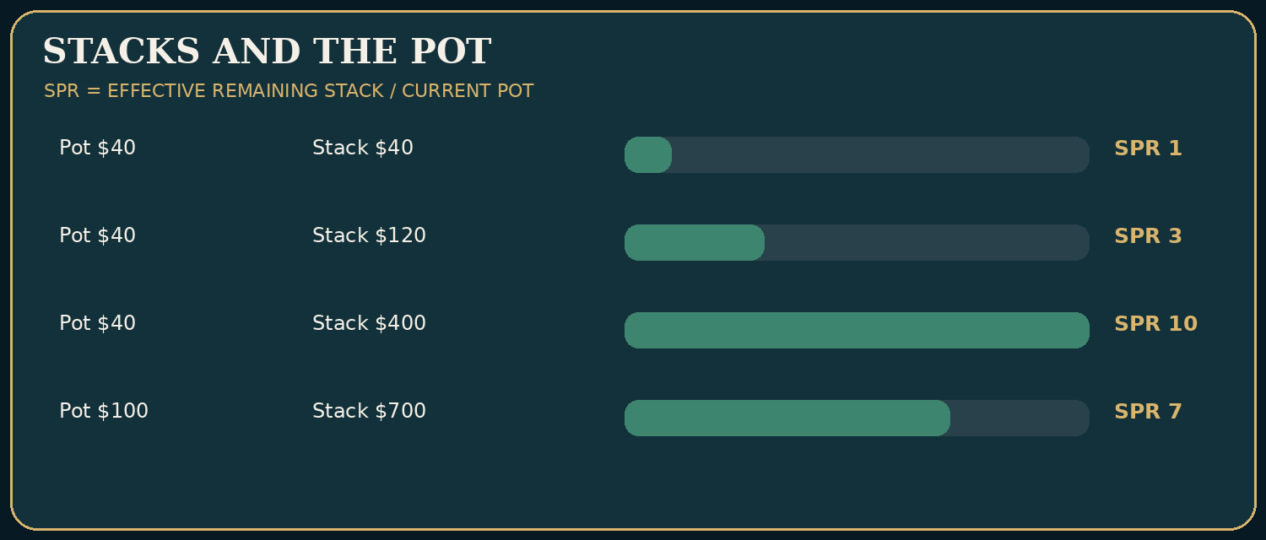
Instructional diagram — spr-chart.png

How to calculate SPR
Stack-to-pot ratio (SPR) at the start of a postflop street is the smaller relevant remaining stack divided by the pot. If the pot is $50 and the effective remaining stack is $250, the flop SPR is 5. If the pot is $50 and only $75 remains, SPR is 1.5. The flop already contains substantial money relative to future bets in the second case.
SPR is not a secret command telling you when to go broke. It is a descriptive ratio. A top pair with a strong kicker may be comfortable playing for stacks at low SPR against an opponent who can overplay worse pairs; against a tight value range in a very deep pot, the same hand may be an expensive bluff-catcher. An SPR of 1 does not make a dominated hand good, and an SPR of 10 does not automatically make a flush draw profitable.
Flop pot | Effective remaining stack | SPR | Typical strategic implication
$40 | $40 | 1 | Few bets remain; small mistakes in sizing can commit stacks
$40 | $120 | 3 | One or two substantial bets can play for stacks
$40 | $400 | 10 | More future betting; nut advantage and reverse implied odds loom larger
$100 | $700 | 7 | Large amounts still behind; plan turn and river sizes
Use the table as a map of possibilities, not a solver prescription. Players’ ranges, board texture, rake, and multiway context can dominate any general SPR statement.

Planning backward from the river
Suppose heads-up on the flop the pot is $50 and each player has $250 behind. Hero wishes to size a three-street value line with a strong hand. A 50%-pot bet on the flop is $25; if called, the turn pot becomes $100 and effective remaining stack becomes $225. A 75%-pot turn bet is $75; if called, the river pot becomes $250 and Hero has $150 left. Hero can now make a river shove of $150—only 60% of the river pot. The important lesson is not that these are perfect sizes. It is that early sizing constructs later choices.
Street | Pot before Hero’s bet | Hero bets | Pot after one call | Each player’s remaining stack
Start of flop | $50 | $25 | $100 | $225
Start of turn | $100 | $75 | $250 | $150
Start of river | $250 | $150 | $550 | $0
That final $550 includes the original $50 plus $500 of combined postflop wagers. It does not mean Hero profits $550; relative to the flop decision, Hero has contributed $250 and the opponent has contributed $250. An accurate teaching diagram should distinguish the pot awarded from the amount won net.

The danger of accidentally committing yourself
Mara calls too much with medium pairs, so Hero has been value betting confidently. But on a river that completes every draw, a shove is no longer automatically good. A beginner may say, ‘I have already put $100 into this pot, so I cannot fold.’ This is the sunk-cost fallacy. Money already in the pot is not recovered by making an unprofitable new call. The decision compares the additional amount to call with the chance of winning the available pot, plus any future consequences.
The converse mistake is refusing to invest further because ‘I only started with a $2 limp.’ Once you make a very strong hand, the old $2 is history. The right river value bet depends on hands that will call now, not on the cheap price of entry.

Multiway SPR is not a single number
Suppose the flop pot is $60 with Hero holding $420 behind, Mara holding $90, and Ruth holding $600. The effective remaining stack against Mara is $90, giving SPR 1.5. Against Ruth, Hero has $420 available, giving SPR 7. Side pots can arise if one player is all-in. A decision to bet $120 must consider that Mara cannot call the whole amount if she has only $90, and may induce different reactions from Ruth. Whenever you see ‘effective stacks $420’ in a multiway teaching hand, ask effective against whom?

Size and strategy interact
Large bets tend to put more pressure on the portion of an opponent’s range that cannot profitably continue; they also expose your own weak hands to more risk. Some boards and range configurations support frequent small betting, while others support checking or a polarizing large size. There is no sound rule to bet half pot with every strong hand or to bet a full pot whenever a draw is possible. In live low-stakes games, the opponent’s actual calling behavior may be the strongest predictor of your best value-bet size.

Mini laboratory
The pot is $75; you have $225 effective remaining. Calculate SPR: 3. Villain bets $50, and you call. The pot becomes $175 and each player’s remaining effective stack is $175, giving turn SPR 1. If someone describes the turn as ‘deep’ because the starting stacks were $300, they are ignoring the money already committed.
Decision check. If a $60 flop pot has $360 effective remaining, Hero bets $30 and is called, what is the start-of-turn SPR? A: 2.75; B: 3.5; C: 5.5; D: 6. Answer A. The turn pot is $120, with $330 effective remaining. 330/120 = 2.75. This is the calculation we would validate automatically before publishing the quiz.
Change one variable: Villain instead raises the flop to $90 total and Hero calls. The pot and remaining stacks both change, so the new SPR cannot be read from the original chart.
Takeaway: count the chips, then ask what future bets can accomplish. Deep stacks make plans more consequential, but do not make weak holdings secretly strong.

SKILL LAB 03 — Effective stacks and SPR
Objective: Track the money that can actually be wagered, then recalculate pot geometry.
Work the five problems before uncovering the answer key. Problems are invented but modeled on legal, plausible cash-game settings; they are not presented as actual recorded hands. Numerical items have stated conditions, because real game-room rules and rake vary.

Drill SFFT-MCS2-DR-03-01 — Calculate
Situation: The pot at the beginning of the flop is $60. The smaller of the two remaining heads-up stacks is $300. There are no side pots.
Your task: What is the flop stack-to-pot ratio (SPR)?
A. 360.00
B. 5.00
C. 3.00
D. 6.00
Write down before revealing: (a) the action or calculation; (b) the most important assumption; (c) one change that could reverse your conclusion.

Drill SFFT-MCS2-DR-03-02 — Calculate
Situation: Two active players start the flop with $420 and $250, respectively. No third player remains.
Your task: How much can the larger stack win from this particular opponent from that point, ignoring money already in the pot?
A. $250
B. $420
C. $670
D. $170
Write down before revealing: (a) the action or calculation; (b) the most important assumption; (c) one change that could reverse your conclusion.

Drill SFFT-MCS2-DR-03-03 — Calculate
Situation: A heads-up pot starts the turn at $80. Villain bets $40, Hero calls $40, and there is no rake or other contribution.
Your task: What pot starts the river?
A. $120
B. $80
C. $200
D. $160
Write down before revealing: (a) the action or calculation; (b) the most important assumption; (c) one change that could reverse your conclusion.

Drill SFFT-MCS2-DR-03-04 — Interpret
Situation: At the flop, a player has top pair with a weak kicker. One hand has SPR 1 and the otherwise identical hand has SPR 12. Opponent ranges are unchanged.
Your task: What is the main strategic distinction?
A. Top pair is always the nuts at SPR 1
B. SPR alters the risk of commitment; top pair is much more vulnerable to large future wagers at SPR 12
C. A high SPR forces an automatic fold on the flop
D. SPR does not affect postflop planning
Write down before revealing: (a) the action or calculation; (b) the most important assumption; (c) one change that could reverse your conclusion.

Drill SFFT-MCS2-DR-03-05 — Interpret
Situation: Three players remain: Hero $500, Villain A $120, Villain B $650. All stacks are measured at the current decision.
Your task: Which statement is correct?
A. Every player has one universal effective stack of $120
B. Hero may contest up to $120 more with A and up to $500 more with B, subject to pot eligibility
C. Hero may win $650 from B despite having only $500
D. The player with $120 must fold before a side pot can be made
Write down before revealing: (a) the action or calculation; (b) the most important assumption; (c) one change that could reverse your conclusion.

Skill Lab Answer Key and Coaching Notes

SFFT-MCS2-DR-03-01: B. 5.00
- A — Why not: Adds stack and pot rather than dividing. This does not follow from the specified cards, pot, actions or model.
- B — CORRECT: Correct. SPR = effective remaining stack ÷ pot = 300/60 = 5.00.
- C — Why not: Would correspond to a $100 pot rather than $60.
- D — Why not: Reverses or misreads the stack-to-pot relationship.
Change one variable: If the pot is $150 with the same $300 remaining, SPR falls to 2.00.

SFFT-MCS2-DR-03-02: A. $250
- A — CORRECT: Correct. The opponent can contribute at most $250 more: that is the effective remaining stack for this confrontation.
- B — Why not: Uses the larger stack rather than the smaller one.
- C — Why not: Adds the stacks together. This does not follow from the specified cards, pot, actions or model.
- D — Why not: Uses their difference rather than the smaller stack.
Change one variable: Add a second $420 player: additional side-pot action may now occur between deep players.

SFFT-MCS2-DR-03-03: D. $160
- A — Why not: Includes the first bet but forgets Hero’s call.
- B — Why not: Does not include new contributions. This does not follow from the specified cards, pot, actions or model.
- C — Why not: Adds one extra $40 contribution. This does not follow from the specified cards, pot, actions or model.
- D — CORRECT: Correct. 80+40+40 = $160. The stated mathematical and betting assumptions control this result.
Change one variable: If Villain bets $60 and Hero calls, the river pot becomes $200.

SFFT-MCS2-DR-03-04: B. SPR alters the risk of commitment; top pair is much more vulnerable to large future wagers at SPR 12
- A — Why not: Wrong: low SPR cannot turn top pair into the nuts.
- B — CORRECT: Correct. A high SPR allows much larger future wagers relative to the existing pot; range strength still matters.
- C — Why not: Wrong: no one number determines all actions. This does not follow from the specified cards, pot, actions or model.
- D — Why not: Wrong: SPR is central to pot geometry. This does not follow from the specified cards, pot, actions or model.
Change one variable: Replace top pair with the nut straight and discuss how commitment considerations change.

SFFT-MCS2-DR-03-05: B. Hero may contest up to $120 more with A and up to $500 more with B, subject to pot eligibility
- A — Why not: Wrong: effective stacks depend on the relevant pair and possible side pots.
- B — CORRECT: Correct. Against A the cap is $120, while against B the cap is Hero’s $500.
- C — Why not: Wrong: Hero cannot win more from B than Hero can put at risk.
- D — Why not: Wrong: short stacks may go all in and remain eligible for the main pot.
Change one variable: Change Villain B’s stack to $80: both opposing stacks now cap Hero’s direct winnings at their respective amounts.
Mastery checkpoint: A correct letter alone is insufficient. Explain the relevant price, range, effective stack or game condition without looking at the solution. Return to this lab after the final examination.

4. The Cheap Flop and the Enormous Pot
Level: Intermediate · Objective: Separate attractive potential payoffs from mathematically credible speculative investments. Prerequisites: Pot odds, equity realization, rake, effective stacks.
The most seductive live-poker argument goes like this: ‘People are putting hundreds of dollars into these pots. It only costs me two dollars to see a flop. Why shouldn’t I come along with almost anything?’ It contains one important truth and several traps. The truth is that a small, controllable present investment can sometimes expose you to disproportionately large future payments. The traps are that you rarely win the advertised maximum, you do not always reach the next card cheaply, your opponent may make a better hand, and the house takes its share.
Book One introduced implied odds. Here we build a more careful contract: how often do you improve to a hand that can win; how often do you get paid; how much do you receive; how much do you lose when something goes wrong? If we cannot name those quantities, we have an interesting story rather than a demonstrated edge.
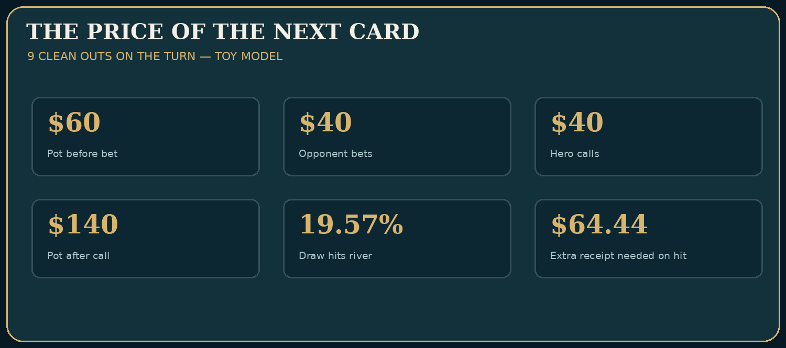
Instructional diagram — implied-odds.png

A six-way $1/$2 example
The game is unstraddled $1/$2, no ante. Three early/middle players limp for $2 each. Hero holds 8♠7♠ on the button and overlimps for $2. The small blind adds $1, and the big blind checks. Six players see the flop: three limpers, Hero, small blind, and big blind. Their $2 each forms a $12 pot before rake. All players have at least $350 at the beginning of the hand, and the table often remains passive preflop. This price is not free: someone could still have raised behind the limpers before the action closed, although on the button only the blinds remain.
The flop is T♣9♦2♥. Hero now holds an open-ended straight draw. The nominal straight-completing ranks are sixes and jacks: eight cards among the 47 unseen cards. The next-card chance of hitting one of those ranks is 8/47 = 17.02%. Be careful: a jack can also help a hand such as Q-J or Q-8 in ways the novice may overlook, and an opponent may already have a set or two pair that can improve later. Thus ‘eight straight-completing cards’ does not guarantee eight clean winning outs against arbitrary ranges. The calculation below is a conditional toy model, deliberately assuming those eight cards win when they arrive on the turn and that Hero loses otherwise.
The small blind checks; the big blind bets $8 into $12. The first limper calls $8, the second calls $8, and the third folds. Action reaches Hero on the button. The pot now contains $12 + $8 + $8 + $8 = $36. Calling costs $8, and would make a $44 pot. The immediate price requires $8/$44 = 18.18% equity if there is no additional betting and the call realizes the relevant showdown outcome. Our simple next-card chance, 17.02%, is slightly short, even before rake. It is also wrong to assume the river card is guaranteed for the same $8; opponents can bet again on the turn.
The implied-odds question is now narrow: if Hero hits a clean winner on the turn, can Hero expect sufficient additional net winnings from opponents to make up the immediate shortfall, after considering failed draws, future costs, and occasional reverse-implied losses? Under the unrealistically simple one-card model, the needed extra net receipt when hitting is about $3: 8 ÷ (8/47) − 44 = 3. That is a small threshold, but the safety margin disappears if one or two of the eight nominal outs are dirty, the turn requires another call, or fees matter. A student who treats an eight-out calculation as the entire EV of a four-way postflop decision has not finished the job.

The turn: the price of a second card
Suppose Hero calls $8, the blinds and two callers’ earlier money are already counted, and the turn is 4♣, missing the straight. The $44 pot remains. The big blind now bets $35; both other remaining opponents fold. Hero must call $35 into a pot that currently contains $79, making $114 after calling. A single remaining card offers a nominal eight-card improvement chance of 8/46 = 17.39% when exactly 46 unseen cards remain. The immediate price requires 35/114 = 30.70%. Without enough credible future payment, this is a fold. The fact that a previous $2 investment and a previous $8 call are already in the middle is not a reason to make an expensive turn call.
If instead the turn were 6♣, Hero would hold a T-high straight using 6-7-8-9-T. That can be very strong, but Hero must still inspect possible opposing straights, sets that can improve to full houses, remaining stacks, and whether a large bet will actually be called by worse hands. Making a straight is an achievement in arithmetic, not permission to ignore the range.

A one-card implied-odds model
At a different turn decision, the pot contains $60 before a $40 opponent bet, and Hero has a nine-out flush draw. Calling $40 makes the pot $140. With 46 unseen cards, and assuming all nine outs win the river with no ties, the hit probability is p = 9/46 = 19.565%. If a hit wins only the current pot, the call loses money: p × $100 − (1−p) × $40 ≈ −$12.61. The $100 is the pot available to win net of Hero’s fresh $40 call; it includes the original $60 plus the opponent’s $40.
Let W be additional net money won from an opponent on the river only when the draw hits and remains good. The toy-model EV is p × ($100 + W) − (1−p) × $40. At break-even, W = ($40 / p) − $140 = about $64.44. This means Hero needs to expect roughly $64.44 of extra net payment on every successful hit on average, given the artificially favorable assumption that every hit wins. If the opponent pays another $100 only half the time after a hit, the average additional receipt is $50, not $100, and is insufficient. If Hero sometimes hits and loses to a better flush, the required payment is larger. Any further fees also increase the threshold.
Turn draw scenario | Extra river receipt when hit | Payment frequency when hit | Average conditional receipt | Compare with $64.44 threshold
Tight opponent often folds | $100 | 20% | $20 | Insufficient
Opponent calls half the time | $100 | 50% | $50 | Insufficient
Very loose caller | $100 | 80% | $80 | Sufficient under toy assumptions
Only $45 effective remains | $45 maximum | 100% | $45 | Insufficient
This table is not a solver result. It is a sensitivity analysis of a deliberately limited model, and it ignores additional bluff opportunities, drawing to second-best hands, and other conditional developments. Its purpose is to force the student to say what must actually happen in the future for the call to work.

When the $2 limp may be reasonable
An overlimp with 8♠7♠ on the button becomes more credible if preflop raises are rare, effective stacks against likely callers are deep, the opponents habitually pay large value bets with inferior hands, and rake doesn’t overwhelm the marginal opportunity. Suited connectors produce occasional straights, flushes, strong combination draws, and disguised hands, but also many weak pairs and misses. Their attractiveness comes from the whole future strategy, not from the romance of cracking somebody’s aces.
Now compare 7♣2♦, an unconnected offsuit holding. It can make two pair or trips, of course, but it is more frequently unplayable and may make vulnerable, dominated outcomes. ‘Only $2’ is not an independent argument. A player who completes forty unnecessary $2 calls has already spent $80 before considering the larger losses from pursuing marginal hits. Rake will also reduce the value of winning small pots. Cheap does not mean good.

The five-gate speculative test
- Price gate: What is the exact price now, and how likely is a raise behind?
- Nut-potential gate: What hands can I make that will still be strong against several ranges?
- Stack gate: Who can pay a large bet later, and is that player still in this pot?
- Behavior gate: Is there actual evidence that these opponents will pay enough when I improve?
- Future-cost gate: Can I realize my equity in position without facing repeated, expensive bets?
Fail several gates and the apparent bargain is usually a trap. Passing them gives permission to analyze the call, not a proof of profit.
Decision check. You have 8♠7♠ on the button, $400 effective, no straddle, three limpers. Which statement is sound? A: call any raise because suited hands have good implied odds; B: the call is certainly +EV because the table had a $900 pot earlier; C: a small overlimp may be defensible if future payment and equity realization are favorable, but the actual rake and aggression must be considered; D: fold because suited connectors never win. Answer C. A and B disregard price and future behavior; D is a false absolute.
Change one variable: the first limper routinely limp-reraises to $45. The original $2 ‘option’ now carries a substantial chance of facing a much higher price. Your entry plan must change before you put the chips in.
Takeaway: the cheap flop is a business proposal, not a lottery ticket. Demand an explanation of the revenue, costs, uncertainty, and worst case.

SKILL LAB 04 — The cheap flop and its true price
Objective: Separate the price of one card from the uncertain cost and payoff of subsequent streets.
Work the five problems before uncovering the answer key. Problems are invented but modeled on legal, plausible cash-game settings; they are not presented as actual recorded hands. Numerical items have stated conditions, because real game-room rules and rake vary.

Drill SFFT-MCS2-DR-04-01 — Calculate
Situation: Hero holds 8♠7♠ on T♣9♦2♥ in a six-way $1/$2 flop. Assume no exposed folded cards. Sixes and jacks complete an open-ended straight.
Your task: What fraction of the 47 unseen cards completes that straight on the TURN (not necessarily a winning hand)?
A. 17.02%
B. 34.04%
C. 8.51%
D. 31.45%
Write down before revealing: (a) the action or calculation; (b) the most important assumption; (c) one change that could reverse your conclusion.

Drill SFFT-MCS2-DR-04-02 — Calculate
Situation: Six players put in $2 each preflop ($12). On T♣9♦2♥, BB bets $8 and two other players call $8 each. Hero is last to act, facing $8.
Your task: What minimum all-in-equivalent equity would be required for a call if no more betting existed and rake/ties were zero?
A. 22.22%
B. 66.67%
C. 17.02%
D. 18.18%
Write down before revealing: (a) the action or calculation; (b) the most important assumption; (c) one change that could reverse your conclusion.

Drill SFFT-MCS2-DR-04-03 — Calculate
Situation: Hero has an eight-rank straight draw on the turn, with exactly 46 unseen cards under the information model. Pot is $44 before a $35 bet, and Hero must call $35.
Your task: What is the immediate equity requirement ignoring later bets and rake?
A. 44.30%
B. 79.55%
C. 30.70%
D. 17.39%
Write down before revealing: (a) the action or calculation; (b) the most important assumption; (c) one change that could reverse your conclusion.

Drill SFFT-MCS2-DR-04-04 — Interpret
Situation: At a passive $1/$2 table, Hero is on the button with 8♠7♠ after three limpers. The action has not yet reached the blinds. Stacks are $400 effective.
Your task: Which conclusion is defensible BEFORE Hero invests $2?
A. Always enter with any two cards because last hand’s pot was $850
B. The inexpensive overlimp may be considered after assessing blinds, nut potential, rake, and likely future payments
C. It is guaranteed that the turn and river cost only $2
D. Suited connectors always have enough implied odds
Write down before revealing: (a) the action or calculation; (b) the most important assumption; (c) one change that could reverse your conclusion.

Drill SFFT-MCS2-DR-04-05 — Interpret
Situation: A $2 entry with 8♠7♠ looks attractive because opponents are deep, but one caller frequently holds higher suited hands and a flush board will be obvious.
Your task: Which risk deserves explicit modeling?
A. Winning too much when a flush comes
B. Reverse implied odds: making a second-best flush or being unable to get paid
C. A suited connector cannot ever make a straight
D. That a cash game automatically has no rake
Write down before revealing: (a) the action or calculation; (b) the most important assumption; (c) one change that could reverse your conclusion.

Skill Lab Answer Key and Coaching Notes

SFFT-MCS2-DR-04-01: A. 17.02%
- A — CORRECT: Correct. Eight ranks-completing cards remain among 47 unseen: 8/47 = 17.02%. They are not guaranteed clean winning outs.
- B — Why not: Uses the approximate two-card shortcut even though only the turn is being considered.
- C — Why not: Counts only four cards instead of eight. This does not follow from the specified cards, pot, actions or model.
- D — Why not: This is approximately the two-card hit probability, not one card.
Change one variable: If an opponent exposes a six as a folded card, conditional on that reliable information only seven straight-completing cards remain.

SFFT-MCS2-DR-04-02: D. 18.18%
- A — Why not: Divides by the $36 pot before Hero’s call rather than the $44 final pot.
- B — Why not: Divides cost by the $12 old pot. This does not follow from the specified cards, pot, actions or model.
- C — Why not: Confuses the hand’s one-card straight-hit percentage with the price of a call.
- D — CORRECT: Correct. The pot is $12+$8+$8+$8=$36 before Hero’s call and $44 after; 8/44=18.18%. This is a price calculation, not proof the actual multiway call is good.
Change one variable: Make one of the two opponents fold instead of calling: final pot after Hero calls is $36 and the required equity rises to 22.22%.

SFFT-MCS2-DR-04-03: C. 30.70%
- A — Why not: Uses $35/$79, excluding Hero’s call from the final pot.
- B — Why not: Uses the earlier pot incorrectly. This does not follow from the specified cards, pot, actions or model.
- C — CORRECT: Correct. 35/(44+35+35) = 35/114 = 30.70%. The nominal draw chance is 8/46 = 17.39%, well below the immediate price.
- D — Why not: This is the eight-card river improvement chance, not the required call equity.
Change one variable: Reduce the opponent’s bet to $10; the required equity falls to 10/64=15.63%, before accounting for dirty outs or rake.

SFFT-MCS2-DR-04-04: B. The inexpensive overlimp may be considered after assessing blinds, nut potential, rake, and likely future payments
- A — Why not: Wrong: prior pot size is not a forecast of this hand’s EV.
- B — CORRECT: Correct. Price, position, likelihood of a squeeze, equity realization and payment on strong hits must all be assessed.
- C — Why not: Wrong: the blinds can raise and future betting is unknown.
- D — Why not: Wrong: implied odds are not automatic. This does not follow from the specified cards, pot, actions or model.
Change one variable: Change the big blind to a player who often raises limped pots to $35; reassess the risk of the original entry.

SFFT-MCS2-DR-04-05: B. Reverse implied odds: making a second-best flush or being unable to get paid
- A — Why not: Wrong: big payoffs are not guaranteed; the losses are the issue.
- B — CORRECT: Correct. Some made hands are dominated, and obvious completed draws may stop future calls.
- C — Why not: Wrong: connected ranks can form straights. This does not follow from the specified cards, pot, actions or model.
- D — Why not: Wrong: most rooms have some form of cost; verify local structure.
Change one variable: Make the opponent a calling station with low flush holdings instead; investigate whether the payable range changes.
Mastery checkpoint: A correct letter alone is insufficient. Explain the relevant price, range, effective stack or game condition without looking at the solution. Return to this lab after the final examination.

5. Limpers, Isolation, and the Price of Entry
Level: Intermediate · Objective: Distinguish open-limping, overlimping, and isolation raising in live low-stakes games.
A full-ring live cash game can begin with the same ritual for hours: call, call, call, someone sighs, and the button announces a raise. A player raised to $12 because a chart says ‘three times the big blind’ and wonders why five opponents call anyway. The mistake is not necessarily the hand. It may be the assumption that live opponents respond to every price like an idealized simulation.
Open-limping means being first voluntarily into an unopened pot by calling the big blind. Overlimping means calling after another player has limped. Isolation raising means raising to obtain value or a more favorable number of opponents against weaker limpers. They are distinct decisions, and the presence of prior limpers changes the price, the ranges, and the purposes of a raise.

Why most ordinary open-limps are unattractive
Entering by calling sacrifices an immediate opportunity to win the blinds uncontested, can reveal a capped or weak-looking range, and permits opponents to see cheap flops. That doesn’t make limping universally irrational; certain structures, player pools, and specialized strategies use it. But a beginner default of ‘limp anything playable’ usually produces excessive out-of-position multiway participation and fees. Compare an early-position open-limp with a button overlimp after multiple callers: neither is mechanically the same as making a small opening raise.

Raise for a reason, not a ritual
Suppose $1/$2, $300 effective, UTG and MP limp for $2, and Hero on the cutoff holds A♠Q♠. The pot before Hero acts contains $1 small blind + $2 big blind + $2 + $2 = $7. If Hero raises to $14 total, the raise is a $14 contribution, not an extra $14 on top of a call. If the button, small blind, and big blind fold and one limper calls by adding $12, the resulting preflop pot is $7 + $14 + $12 = $33. If both limpers call the extra $12, it is $45. The difference between one and two callers changes the postflop strategy.
A suited ace-queen is often a strong value candidate against limp-calling ranges, but whether $14 is the best size depends on who calls $14 versus $20 and whether better hands limp-reraise. Larger opens do not automatically ‘isolate’ if everyone calls anyway. An overly large raise with a marginal hand can make the pot bigger while leaving the same number of opponents.
Adjustment | Benefit sought | Main risk
Raise larger with genuinely strong value hands | Charge broad calling ranges more | Opponents’ continuing ranges may become stronger
Overlimp a playable speculative hand in position | Preserve favorable entry price | Raises behind, rake, reverse implied odds
Fold a dominated offsuit holding | Avoid hard postflop decisions | Forfeit some weakly positive opportunities if read is wrong
Raise to attack frequent limp-folds | Capture dead money | Limp-reraises or loose calls defeat plan

The five-call mistake
You open J♠T♠ to $10 after three limpers because it feels ‘strong enough to raise.’ All four call. You now have a large multiway pot, lower fold equity, and a hand often making one pair with a vulnerable kicker. If the objective was to get heads-up, the raise failed. The lesson is not automatically ‘raise to $30 next time.’ At $30, you may be called only by ranges that dominate J-T, or simply end up creating an expensive pot with four callers. Consider whether overlimping or folding was superior before deciding how much to raise.
You cannot know in advance how many will call, but you can estimate from earlier hands. Build a table-specific response model: 50% of $12 isolation raises attract three callers, 30% attract one, and 20% collect the pot. These are illustrative observations, not universal frequencies. Reevaluate the plan when conditions change.

Straddles rewrite the price
In an unstraddled $1/$2 game, calling $2 after limpers commits two dollars. With a live $5 UTG straddle, a player must generally match the $5 straddle to remain, and the straddler may retain an option to raise when action returns (subject to house rules). A player who imagines that the original small and big blinds set the only meaningful price will misread both pot odds and who is left to act.

A simple comparison
Consider two tables, same Hero holding 9♣9♦ on the button. At Table A, three players limp, a $14 raise is regularly called by weaker pairs and broadway hands, and no one behind frequently three-bets. A substantial value/isolation raise can be sensible. At Table B, the earliest limper has limp-reraised twice in comparable situations and the blinds squeeze aggressively; an automatic raise becomes riskier and may require a different plan. The fact that pocket nines is the same hand does not erase the population difference.
Decision check. A player is in the cutoff facing three $2 limps and raises to $18 total. What does ‘to $18’ mean? A: put $18 more after first calling $2; B: contribute $18 total, assuming no prior contribution; C: make the whole pot $18; D: each limper must put in another $18. Answer B. Raising to a specified amount sets that player’s total street contribution; each limper who previously put in $2 needs $16 more to call.
Change one variable: all three limpers routinely fold to $18. Isolation bluffs may become attractive, but you must account for blinds and how frequently the apparent folds actually occur. Betting to steal dead money is not the same as value raising a hand that wants calls.
Takeaway: the presence of limpers creates choices; it does not create a universal command to raise big or join cheaply.

SKILL LAB 05 — Limpers and isolation
Objective: Reconstruct the pot accurately and distinguish entering a limped pot from facing a raise.
Work the five problems before uncovering the answer key. Problems are invented but modeled on legal, plausible cash-game settings; they are not presented as actual recorded hands. Numerical items have stated conditions, because real game-room rules and rake vary.

Drill SFFT-MCS2-DR-05-01 — Calculate
Situation: At $1/$2, UTG and MP limp $2 each. Hero on the button raises to $14 total. The blinds fold. UTG calls the extra $12; MP folds. No rake yet.
Your task: What is the preflop pot?
A. $31
B. $45
C. $35
D. $33
Write down before revealing: (a) the action or calculation; (b) the most important assumption; (c) one change that could reverse your conclusion.

Drill SFFT-MCS2-DR-05-02 — Calculate
Situation: At $1/$2 Hero opens to $12 total. Villain 3-bets to $42 total. Hero has posted no blind and no one else remains.
Your task: How much MORE must Hero put in to call?
A. $54
B. $12
C. $30
D. $42
Write down before revealing: (a) the action or calculation; (b) the most important assumption; (c) one change that could reverse your conclusion.

Drill SFFT-MCS2-DR-05-03 — Calculate
Situation: Unstraddled $2/$5. Villain raises to $20 total, which increases the current bet from $5 by $15. Hero is next and can make a normal full 3-bet.
Your task: What is the minimum legal re-raise TOTAL?
A. $15
B. $35
C. $25
D. $40
Write down before revealing: (a) the action or calculation; (b) the most important assumption; (c) one change that could reverse your conclusion.

Drill SFFT-MCS2-DR-05-04 — Interpret
Situation: Four players have limped $2 each, and Hero is on the button with A♠Q♠. The table calls too often, and the blinds are weak.
Your task: What is the clearest strategic reason to consider an isolation raise?
A. Because raising guarantees a heads-up pot
B. To extract value and possibly thin the field while retaining position
C. Because AQ suited cannot play multiway
D. To punish the dealer for distributing weak hands
Write down before revealing: (a) the action or calculation; (b) the most important assumption; (c) one change that could reverse your conclusion.

Drill SFFT-MCS2-DR-05-05 — Interpret
Situation: UTG enters by limping first; later, after two limpers, Hero on the button also calls the blind amount with a small suited connector.
Your task: What technical distinction matters?
A. Both actions are identical open-limps
B. UTG open-limped; Hero overlimped behind existing limpers
C. Hero 3-bet by calling
D. The button is automatically first to act postflop
Write down before revealing: (a) the action or calculation; (b) the most important assumption; (c) one change that could reverse your conclusion.

Skill Lab Answer Key and Coaching Notes

SFFT-MCS2-DR-05-01: D. $33
- A — Why not: Forgets the $2 small and big blinds total $3 in forced money (not $1).
- B — Why not: Incorrectly includes an MP call of $12 that never occurred.
- C — Why not: Double counts part of the limping contribution.
- D — CORRECT: Correct. Blinds $3 + limpers $4 + Hero $14 + UTG’s extra $12 = $33.
Change one variable: If MP also calls $12 more, the pot increases to $45.

SFFT-MCS2-DR-05-02: C. $30
- A — Why not: Adds the amounts instead of subtracting. This does not follow from the specified cards, pot, actions or model.
- B — Why not: Counts only Hero’s existing investment. This does not follow from the specified cards, pot, actions or model.
- C — CORRECT: Correct. 42−12 = $30 additional. The price of the call still depends on the entire pot and possible rake.
- D — Why not: Counts Villain’s total wager but ignores Hero’s prior $12.
Change one variable: If Villain raises to $52 total instead, the extra call is $40.

SFFT-MCS2-DR-05-03: B. $35
- A — Why not: Less than the current bet. This does not follow from the specified cards, pot, actions or model.
- B — CORRECT: Correct. The previous full raise increment is $15; 20+15=$35.
- C — Why not: Only adds the blind instead of the prior $15 raise increment.
- D — Why not: A legal amount, but above the minimum. This does not follow from the specified cards, pot, actions or model.
Change one variable: If the opening raise is to $25, the new increment is $20, so the minimum re-raise is $45.

SFFT-MCS2-DR-05-04: B. To extract value and possibly thin the field while retaining position
- A — Why not: Wrong: calling stations may not fold, so isolation is not guaranteed.
- B — CORRECT: Correct. A value-oriented raise can exploit loose calls while denying cheap equity; size and postflop plan depend on the table.
- C — Why not: Wrong: AQs can play multiway though its advantages vary.
- D — Why not: Wrong: the dealer has no strategic stake. This does not follow from the specified cards, pot, actions or model.
Change one variable: Replace the callers with players who 3-bet frequently; reevaluate raise sizing and expected action.

SFFT-MCS2-DR-05-05: B. UTG open-limped; Hero overlimped behind existing limpers
- A — Why not: Wrong: entry order changes pot context and available strategies.
- B — CORRECT: Correct. An overlimp after other limpers is different from opening the pot with a limp.
- C — Why not: Wrong: calling a blind amount is not a re-raise.
- D — Why not: Wrong: button generally acts last postflop among surviving players.
Change one variable: If all players fold to Hero on the button, calling the big blind as first entrant becomes an open-limp rather than an overlimp.
Mastery checkpoint: A correct letter alone is insufficient. Explain the relevant price, range, effective stack or game condition without looking at the solution. Return to this lab after the final examination.

6. Aggression Without Panic
Level: Intermediate · Objective: Develop calibrated responses to aggressive live opponents without automatically calling or overfolding.
Lena Cruz three-bets twice in an orbit. Then she raises a flop. The third player at the table announces, ‘She’s bluffing all the time.’ The fourth announces, ‘She must have it every time.’ Both are describing their emotional reaction, not her strategy. Aggression is valuable partly because it challenges opponents to make decisions with weak information. Our response should be to define the range, price, position, and remaining stacks—not to claim a secret certainty.

What a three-bet actually represents
A three-bet is the first re-raise preflop: blind bets exist, a player raises (the second bet), and another raises again (the third bet). In a $1/$2 cash game, if Hero opens to $8 and Lena raises to $30 total, she is three-betting to $30. If Hero has already committed $8, calling requires another $22. A four-bet re-raises the three-bet. The size matters both for preflop profitability and for the SPR of the resulting pot.
Suppose Hero opens the cutoff to $8 with A♦J♦; Lena three-bets to $32 on the button, blinds fold, and action returns. Before rake, the current pot contains Hero $8 + Lena $32 + small blind $1 + big blind $2 = $43. Calling $24 more would make $67. The immediate share required in an all-in/no-future-betting abstraction is $24/$67 = 35.82%, but that is not a valid standalone reason to call a deep-stacked three-bet pot. Hero will be out of position against a potentially strong range, often making a dominated ace or jack pair. The realized EV depends on future action. Against a demonstrably wide three-bettor, A♦J♦ may sometimes continue; against a very tight one, folding may be wise. The price calculation is necessary, not sufficient.

How aggression becomes predictable
Ask whether Lena aggresses disproportionately from the button, against late-position opens, after checks, or on scare cards. ‘Aggressive’ without a situation is too vague to exploit. A frequent button three-bet can be met with stronger value four-bets, selective defensive calls from hands that realize equity, and tighter marginal opens if the pressure is severe. Calling with every offsuit broadway hand creates exactly the weak, dominated range that an aggressor wants to attack.
A bluff only benefits from folds if the target folds often enough. If a player bets $80 into a $100 pot with zero chance of winning at showdown when called, the wager must induce a fold more than 80/(100+80) = 44.44% of the time to have positive EV before rake. This is the basic one-street risk/reward formula. When a betting player retains showdown equity, or when a raise changes future streets, more variables enter. Don’t blindly apply a pure-bluff threshold to a semi-bluff.

Use four defensive tools
Tool | Good reason | Warning
Value re-raise | Opponent continues too widely with weaker hands | Do not mistake a bluff catcher for a premium value hand
Selective call | Hand can realize equity and retains enough strength against betting range | Future position and reverse implied odds matter
Timely fold | Betting range genuinely exceeds your hand’s profitable defense range | An aggressive reputation alone isn’t proof of value
Counter-bluff | Opponent credibly overfolds to a specific raise or runout | Bluffing someone who hates folding is expensive
A fifth tool is often overlooked: check. You need not bet every time Lena checks. On some boards checking protects your own range, avoids building a pot vulnerable to a check-raise, and preserves bluff-catching opportunities.

Respect changing stack sizes
When $500 remains behind, a flop raise may imply significant turn and river pressure. When $40 remains, there are fewer decisions left and less capacity to bluff someone off a medium-strength holding across three streets. An aggressor’s statistical tendency does not override the amount of money they can still bet.

The overreaction trap
Hero has K♠Q♠ in the big blind and faces a button raise. Lena has opened the last three buttons. Hero responds by three-betting exceptionally large every time, hoping to ‘teach her a lesson.’ That may instead create pots in which Lena folds worse hands and continues with stronger holdings or well-chosen four-bets. Better to form an evidence-based defense plan, with hands selected by strength, blockers, and playability and bet sizes selected for their purpose.
Decision check. An opponent has shown multiple light three-bets from the button. Which adjustment is most defensible? A: call every three-bet with any ace; B: stop opening the cutoff entirely; C: adjust your opening and defense ranges, continue with appropriate hands, and consider value four-bets against a demonstrably wide range; D: always shove regardless of stack depth. Answer C. The alternatives rely on extremes instead of range construction.
Change one variable: Lena’s three-bets occur only after early-position opens rather than against cutoff/button opens. A population read of excessive blind defense is no longer supported. Re-estimate the range.
Takeaway: aggression creates information only when combined with context. Your objective is not to win a dominance contest; it is to select higher-EV responses.

SKILL LAB 06 — Aggression and fold equity
Objective: Connect betting pressure to the price, the required folds and plausible counterstrategies.
Work the five problems before uncovering the answer key. Problems are invented but modeled on legal, plausible cash-game settings; they are not presented as actual recorded hands. Numerical items have stated conditions, because real game-room rules and rake vary.

Drill SFFT-MCS2-DR-06-01 — Calculate
Situation: A river pot is $100. Hero makes a pure bluff for $60 with exactly zero equity when called. Ignore rake.
Your task: How often must Villain fold for the bluff to break even?
A. 28.57%
B. 50.00%
C. 37.50%
D. 60.00%
Write down before revealing: (a) the action or calculation; (b) the most important assumption; (c) one change that could reverse your conclusion.

Drill SFFT-MCS2-DR-06-02 — Calculate
Situation: A pure river bluff risks $60 to win a $100 pot. Villain folds exactly 30% of the time. Hero loses whenever called; no rake.
Your task: What is the expected value of the bluff?
A. $70.00
B. $-12.00
C. $12.00
D. $30.00
Write down before revealing: (a) the action or calculation; (b) the most important assumption; (c) one change that could reverse your conclusion.

Drill SFFT-MCS2-DR-06-03 — Calculate
Situation: Pot is $90 before Villain bets $45 on the river. Hero can call $45, there is no further action and rake/ties are ignored.
Your task: What showdown equity is required to call?
A. 25.00%
B. 33.33%
C. 50.00%
D. 20.00%
Write down before revealing: (a) the action or calculation; (b) the most important assumption; (c) one change that could reverse your conclusion.

Drill SFFT-MCS2-DR-06-04 — Interpret
Situation: Villain three-bets often from the blinds and has shown both value and bluffs; Hero holds a middling offsuit broadway hand and is out of position relative to another player.
Your task: Which response is most disciplined?
A. Always call because Villain is aggressive
B. Always four-bet every offsuit broadway
C. Construct a response range considering sizing, position, domination, and effective stacks
D. Make a huge preflop raise to show courage
Write down before revealing: (a) the action or calculation; (b) the most important assumption; (c) one change that could reverse your conclusion.

Drill SFFT-MCS2-DR-06-05 — Interpret
Situation: A recreational player has made three oversized river bets in one session, and one was shown as a bluff.
Your task: What can you validly infer?
A. The player always bluffs large
B. The player is mathematically guaranteed to bluff next
C. There is some evidence of bluffing, but the sample is small and must be interpreted with ranges
D. All previous decisions were wrong
Write down before revealing: (a) the action or calculation; (b) the most important assumption; (c) one change that could reverse your conclusion.

Skill Lab Answer Key and Coaching Notes

SFFT-MCS2-DR-06-01: C. 37.50%
- A — Why not: This is not the fold threshold for a $60 bluff into $100.
- B — Why not: Would apply to a pot-sized pure bluff. This does not follow from the specified cards, pot, actions or model.
- C — CORRECT: Correct. Required folds = risk/(old pot+bet) = 60/(100+60) = 37.50%.
- D — Why not: Compares bet only with old pot rather than the reward-plus-risk.
Change one variable: If the bet increases to $100 into $100, the pure-bluff threshold becomes 50%.

SFFT-MCS2-DR-06-02: B. $-12.00
- A — Why not: Treats the call rate as net winnings. This does not follow from the specified cards, pot, actions or model.
- B — CORRECT: Correct. EV = 0.30×$100 − 0.70×$60 = −$12. The stated mathematical and betting assumptions control this result.
- C — Why not: Correct magnitude, incorrect sign. This does not follow from the specified cards, pot, actions or model.
- D — Why not: Counts only success without subtracting losing bets.
Change one variable: If folds increase to 45%, EV becomes +$12.

SFFT-MCS2-DR-06-03: A. 25.00%
- A — CORRECT: Correct. 45/(90+45+45)=45/180=25%. The stated mathematical and betting assumptions control this result.
- B — Why not: Divides $45 by $135, leaving out Hero’s call. This does not follow from the specified cards, pot, actions or model.
- C — Why not: Uses call divided by old pot. This does not follow from the specified cards, pot, actions or model.
- D — Why not: Understates the cost compared with the final pot.
Change one variable: If Villain bets a full $90 instead, the required equity becomes 33.33%.

SFFT-MCS2-DR-06-04: C. Construct a response range considering sizing, position, domination, and effective stacks
- A — Why not: Wrong: aggression alone does not justify any two-card continue.
- B — Why not: Wrong: weak broadway cards can be dominated, and 4-betting any of them is not sound.
- C — CORRECT: Correct. Continue only with hands and frequencies justified by the configuration.
- D — Why not: Wrong: emotional sizing is not a technical adjustment.
Change one variable: Change Hero to A♠A♥ at 100bb; reassess value 4-betting and traps against the opponent’s actual tendencies.

SFFT-MCS2-DR-06-05: C. There is some evidence of bluffing, but the sample is small and must be interpreted with ranges
- A — Why not: Wrong: one observed bluff does not imply a 100% frequency.
- B — Why not: Wrong: poker outcomes and strategic frequencies are uncertain.
- C — CORRECT: Correct. Observations matter but must be weighted by sample size and situation.
- D — Why not: Wrong: one bluff shows nothing definitive about all prior decisions.
Change one variable: Add thirty comparable observed bets with very few bluffs; the evidence supports a different update.
Mastery checkpoint: A correct letter alone is insufficient. Explain the relevant price, range, effective stack or game condition without looking at the solution. Return to this lab after the final examination.

7. Multiway Mathematics and Equity Realization
Level: Intermediate–advanced · Objective: Explain why the number of opponents changes value, bluffing, drawing, and future-street play.
A familiar live scene: Hero raises A♠K♠, three players call, and the flop comes K♦9♦8♣. Hero has top pair, top kicker. It would be easy to announce, ‘I raised preflop, I have top pair, so I must bet.’ But there are now four ranges interacting with a coordinated board. The winning hand at showdown must beat everyone, not just one opponent. The chance of a later bet being called or raised is different from a heads-up pot. A hand that can value bet three streets heads-up may prefer a cautious path against three players, especially when turn cards complete connected draws.

Why raw equity is not your paycheck
Equity is the share of the pot a hand expects to receive at showdown against specified opposing hands or ranges, if all remaining cards are dealt under the model. Equity realization is how much of that theoretical share is actually converted into EV given future betting, position, fold equity, and the difficulty of navigating runouts. A suited hand can possess decent raw equity yet lose much of its practical value by facing an expensive flop bet with no clear continuation plan. Conversely, a hand may win more than its raw showdown share by successfully forcing folds.
In multiway pots, raw equity usually spreads among more players. But a casual claim that ‘your equity falls by exactly half when there are twice as many opponents’ is false; ranges and dependencies matter. The same draw may be chasing another player’s better draw, and completing a flush can make an opponent a full house on a paired board. Your betting strategy must account for the stronger collective range that can continue against you.

The five-card rule does not change
Some players react to crowded pots by exaggerating the likelihood of specific monsters. Not every three-way flop contains a hidden set, and not every bet represents the nuts. The solution is to estimate combinations in each opponent’s plausible range, respect the joint possibility of strong holdings, and compare the price to a realistic continuation strategy. In very complex multiway spots, a prudent fold with a marginal hand is often better than pretending to have a precise equity figure.

Why bluffs often need stronger reasons
Consider a pure $60 bluff into a $90 pot, with no showdown value if called. Against one opponent who folds 50%, its immediate EV is 0.50×90 − 0.50×60 = +$15 before rake. Now suppose two opponents each fold 50% conditionally and independently, a very simplified model. Both fold only 25% of the time, and the same bluff has EV 0.25×90 − 0.75×60 = −$22.50. In real games their folds are neither independent nor necessarily 50%, so this example is not a general forecast. It illustrates why ‘one of them will fold’ is not enough: for an uncontested win, all remaining opponents must fold.
The joint chance of everyone folding can be small even if each opponent looks individually vulnerable. Multiway bets therefore often require more robust value or carefully selected bluff candidates with equity and favorable blockers. But avoid the opposite absolute: multiway bluffs can be profitable, especially when ranges are capped after repeated checks and the remaining players overfold in a specific spot. Strategy depends on the evolving tree, not a ban on bluffing.

Calling to make a draw
Hero holds 8♠7♠ on J♠9♠2♦: a flush draw with nine spade-completing cards (assuming no unknown spades are removed), plus potential straight development. Are there ‘twelve outs’? We must not count one rank twice, and we must not declare every nominal improvement a winning card. An opponent may have A♠X♠ for a higher flush draw; a nine may pair the board; and multiple opponents can hold sets or better redraws. Against more than one opponent the vulnerability of non-nut flush draws becomes more consequential.
The next-card probability of hitting a spade from the flop with two spades in hand and two on board is 9/47 = 19.15%. That is the probability of completing a flush on the turn, not automatically the chance of winning. A full evaluation must ask which spades are clean and what happens after a hit. With very deep stacks, the bad consequences of making a second-best flush can outweigh the occasional large payment.

A postflop sizing illustration
Flop pot $60, Hero has A♥K♦ on K♣9♣8♠ in a four-way pot. Two opponents check to Hero and one opponent remains behind. A large $50 bet may collect value from dominated K-Q or some draws, but it can also isolate strong hands and reduce future flexibility. Checking may allow free cards but preserves Hero’s medium-strength holdings against a check-raise and controls the pot. There is no universally superior action without preflop ranges, positions, and opponent tendencies. The book’s method is to enumerate what calls, what raises, and what folds at each contemplated size.
Candidate plan | Questions to answer
Small value/protection bet | Which worse pairs and draws pay? Who can raise?
Large value bet | Do worse hands actually call enough?
Check | How will Hero react to turn aggression or a dangerous card?
Bluff | Must one or several players fold? What equity remains if called?

The side-pot problem
Suppose Hero and Ruth each have $400 available; Owen has $60. A three-way preflop all-in can create a main pot Owen contests and a side pot only Hero and Ruth contest. A call may be profitable in the side pot even if Owen has a very strong main-pot range, or vice versa. No single sentence about ‘needing 30% equity’ can properly evaluate different eligibility and payout possibilities. Explicit side-pot diagrams are part of the Master Series advanced curriculum.
Decision check. Hero makes a $60 pure bluff into $90 against two opponents; either opponent calling defeats the bluff. If both independently fold with probability 50%, what is the immediate EV? A: +$15; B: −$22.50; C: $0; D: +$30. Answer B. Only 25% of the time do both fold. EV = .25×90 − .75×60 = −22.50.
Change one variable: each opponent folds 80% under the same artificial independence assumption. Both fold 64%; EV = .64×90 − .36×60 = +$36. This does not imply that real opponents fold independently, but it demonstrates the importance of the joint event.
Takeaway: in a multiway hand, think about everyone who can win the pot, not just the person who made the last bet.

SKILL LAB 07 — Multiway poker
Objective: Calculate contributions and show why several opponents change risk and fold equity.
Work the five problems before uncovering the answer key. Problems are invented but modeled on legal, plausible cash-game settings; they are not presented as actual recorded hands. Numerical items have stated conditions, because real game-room rules and rake vary.

Drill SFFT-MCS2-DR-07-01 — Calculate
Situation: A $70 multiway pot sees a $25 flop bet that two other active players call. No player raises.
Your task: What is the pot after the two calls?
A. $170
B. $145
C. $95
D. $120
Write down before revealing: (a) the action or calculation; (b) the most important assumption; (c) one change that could reverse your conclusion.

Drill SFFT-MCS2-DR-07-02 — Calculate
Situation: Hero makes a pure flop bluff into TWO opponents. Each independently folds with probability 50% under a simplified model.
Your task: What is the probability both opponents fold?
A. 25.00%
B. 50.00%
C. 75.00%
D. 100.00%
Write down before revealing: (a) the action or calculation; (b) the most important assumption; (c) one change that could reverse your conclusion.

Drill SFFT-MCS2-DR-07-03 — Calculate
Situation: A $90 pot. Hero makes a $60 pure bluff into two opponents who independently fold 50% each. Hero has no showdown equity when called.
Your task: What is Hero’s EV in this simplified model?
A. $22.50
B. $-15.00
C. $30.00
D. $-22.50
Write down before revealing: (a) the action or calculation; (b) the most important assumption; (c) one change that could reverse your conclusion.

Drill SFFT-MCS2-DR-07-04 — Interpret
Situation: Four players see Q♠J♠9♥. Hero has A♦Q♦ and faces substantial betting and a raise.
Your task: Which adjustment is most important?
A. Top pair is always an automatic stack-off
B. Top pair faces more possible strong draws and made hands in multiway action than on many dry heads-up boards
C. The number of players does not matter
D. A raise means nobody can have a straight
Write down before revealing: (a) the action or calculation; (b) the most important assumption; (c) one change that could reverse your conclusion.

Drill SFFT-MCS2-DR-07-05 — Interpret
Situation: A player argues that because he has 35% raw showdown equity against a field, he will always win 35% of the pot’s value by calling.
Your task: What is missing?
A. Nothing; raw equity always equals realized value
B. Equity realization: future bets, position, rake, domination and fold pressure can prevent full realization
C. A lucky coin
D. The number of community cards dealt at a cash table is optional
Write down before revealing: (a) the action or calculation; (b) the most important assumption; (c) one change that could reverse your conclusion.

Skill Lab Answer Key and Coaching Notes

SFFT-MCS2-DR-07-01: B. $145
- A — Why not: Counts three calls instead of two. This does not follow from the specified cards, pot, actions or model.
- B — CORRECT: Correct. 70+$25 bet+$25 call+$25 call = $145. The stated mathematical and betting assumptions control this result.
- C — Why not: Includes only the bet and no calls. This does not follow from the specified cards, pot, actions or model.
- D — Why not: Includes only one of the two calls. This does not follow from the specified cards, pot, actions or model.
Change one variable: If only one player calls, the resulting pot is $120.

SFFT-MCS2-DR-07-02: A. 25.00%
- A — CORRECT: Correct. Under the stated independence model, P(both fold)=0.5×0.5=25%.
- B — Why not: Counts one opponent only. This does not follow from the specified cards, pot, actions or model.
- C — Why not: Calculates at least one fold instead of both. This does not follow from the specified cards, pot, actions or model.
- D — Why not: Assumes both always fold. This does not follow from the specified cards, pot, actions or model.
Change one variable: If each opponent instead folds 70% of the time independently, the joint probability is 49%.

SFFT-MCS2-DR-07-03: D. $-22.50
- A — Why not: Correct magnitude, wrong sign. This does not follow from the specified cards, pot, actions or model.
- B — Why not: Overstates fold success or understates call frequency.
- C — Why not: Assumes the pot is won half the time, although both must fold.
- D — CORRECT: Correct. Both fold 25%: EV=.25×90 − .75×60 = −$22.50. Independence and zero equity are teaching assumptions.
Change one variable: If each opponent folds 80%, both fold 64%; EV becomes .64×90−.36×60=$36.

SFFT-MCS2-DR-07-04: B. Top pair faces more possible strong draws and made hands in multiway action than on many dry heads-up boards
- A — Why not: Wrong: multiway strength and large raises can make top pair fragile.
- B — CORRECT: Correct. Multiple ranges, connected texture and betting action reduce the certainty of a one-pair holding.
- C — Why not: Wrong: number of opponents is central to relative equity.
- D — Why not: Wrong: K-T or T-8 can already form a straight on Q-J-9 depending on hole cards.
Change one variable: Change the flop to Q♣7♦2♥ and make the action check through three players; the hand’s vulnerability and evidence change.

SFFT-MCS2-DR-07-05: B. Equity realization: future bets, position, rake, domination and fold pressure can prevent full realization
- A — Why not: Wrong: a hand can be forced to fold before showdown or pay too much.
- B — CORRECT: Correct. Equity is conditional showdown share; monetary realization depends on the game tree.
- C — Why not: Wrong: luck is not a calculable strategic condition.
- D — Why not: Wrong: ordinary Hold’em has five community cards by the river.
Change one variable: Put Hero in position with no further betting allowed; realization changes because an enforced free showdown removes future-price risk.
Mastery checkpoint: A correct letter alone is insufficient. Explain the relevant price, range, effective stack or game condition without looking at the solution. Return to this lab after the final examination.

8. Broadway Hands in the Real World
Level: Intermediate · Objective: Distinguish high-card strength from dominated top-pair exposure and adjust broadway play to position and action.
An ace and a king look formidable under fluorescent lights. King-queen suited makes beautiful straights and flushes. Queen-jack creates respectable one-pair outcomes and useful draws. But high ranks alone do not guarantee profitable entry, and a broadway hand that appears attractive can become a trap against a narrow opposing range. The trick is not to despise high cards; it is to know which part of their value survives the action so far.
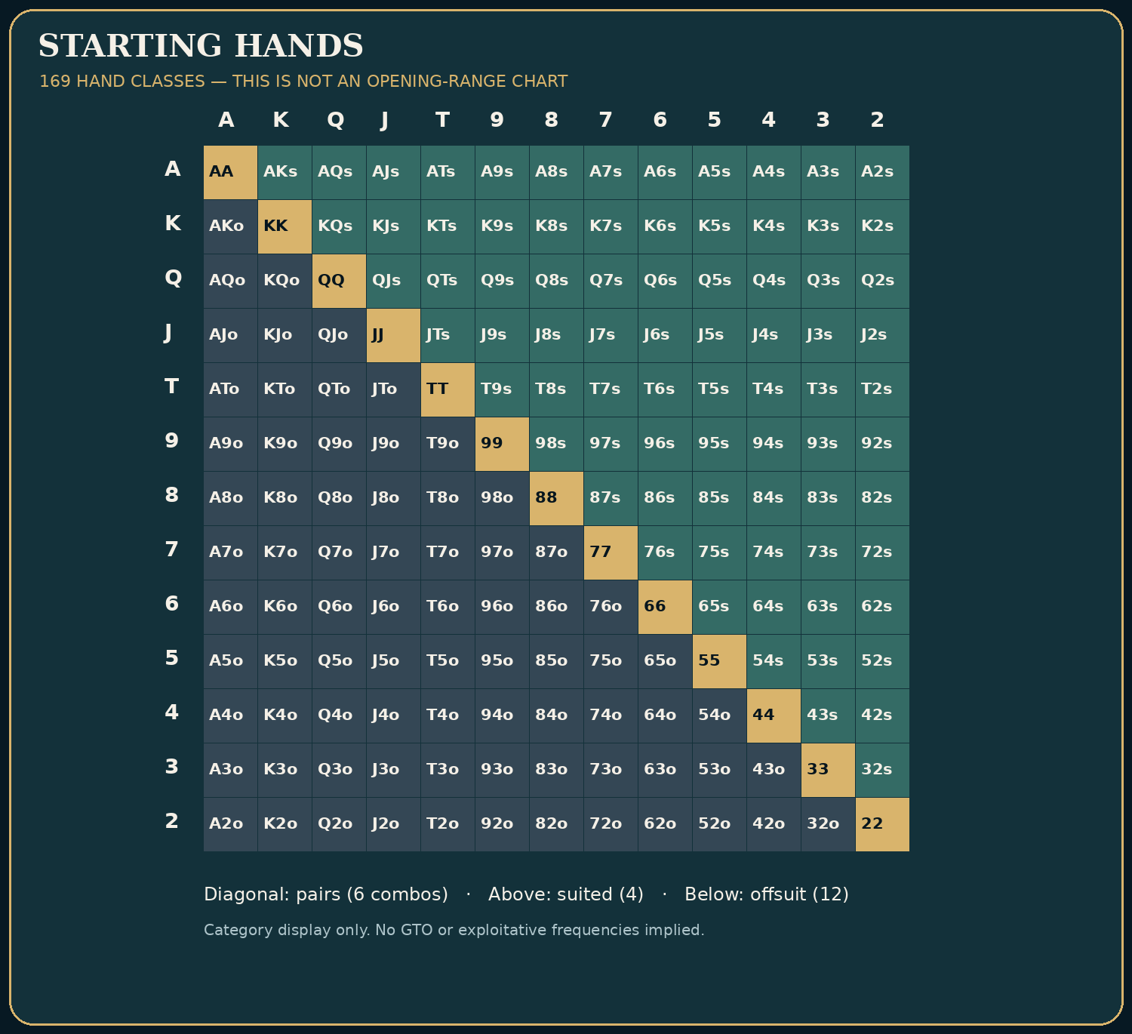
Instructional diagram — hand-matrix.png

Broadway is a family, not a single hand
Broadway ranks are ten, jack, queen, king, and ace. Any five-card straight A-K-Q-J-T is a ‘Broadway straight.’ A starting hand containing two broadway-ranked cards has high-card and high-pair potential, and some combinations are suited or connected. A♠K♠ and J♣T♦ occupy the same broadway family but possess very different preflop strength and domination risk.
Holding | Major strengths | Common danger
A-K suited | Premium high-card strength; nut-flush potential; robust against many ranges | Missed flops and deep multiway aggression
A-Q suited | Strong high-card and flush potential | Can be dominated by A-K against tight three-bet ranges
K-Q suited | Good connected high cards and flush potential | Top pair can be dominated by A-K or A-Q structures
K-J offsuit | Makes top pair and straights sometimes | Often dominated when facing strong early-position action
Q-J suited | Connected, suited, strong drawing potential | One pair rarely supports deep, uncritical stack-offs
J-T suited | Connected suited hand with broadway-straight potential | Vulnerable one-pair value and expensive chasing
There are six combinations of any pocket pair, four combinations of a specific suited unpaired rank pair, twelve offsuit combinations, and sixteen total combinations if suitedness is ignored and neither rank is blocked. Visible cards remove some combinations. The numbers help us understand why an opponent can have more offsuit A-K than suited A-K, and why a particular ace on the board reduces the possible combinations of top set or ace-high holdings.

High cards versus realized value
If Ruth calls three preflop raises with worse aces and queens, A-Q may earn substantial value against her. If Vince three-bets only A-A, K-K, Q-Q, and A-K, the same A-Q that seemed attractive in the cutoff can become a difficult continuing hand, especially out of position. It is not enough to say that A-Q is ‘top ten’ or that suitedness adds a certain fixed percent to EV. A hand’s raw equity, rake cost, positional control, fold equity, and the frequency of domination interact.

A disguised expensive error
Hero has K♠J♦ on the button and calls an early-position $20 open. Both begin with $400. The flop is K♥8♣3♦, and Villain bets $35. Hero has top pair with a jack kicker. That is certainly a made hand, but against an early-position range containing A-K, K-Q, sets, and some bluffs, its value depends on how often the opponent barrels weaker holdings and how the price develops. Suppose Hero calls, the turn is 2♣, and Villain bets $100. A novice may celebrate ‘top pair on a blank turn.’ A more disciplined player asks how often Villain fires this size with Q-Q, missed A-Q, or draws, and whether the prior range estimate ever justified the preflop call.
The strategic mistake may have occurred long before the difficult turn. Calling a strong early-position raise with a dominated offsuit holding can create reverse implied odds: Hero wins little when ahead and pays heavily when behind. The answer is not ‘never play K-J.’ On an unopened button it can be a good raise; the same hand is not necessarily a good call against a narrow raising range.

Playing A-K when you miss
A-K is not an automatic three-street bluff because it raised preflop. A-K can have substantial showdown equity on a safe unpaired board, can benefit from checking behind, and can justify betting on range-favorable textures. In a four-way pot on T♣9♣8♦, A♠K♥ has no made pair and encounters multiple connected ranges. C-betting automatically because ‘I represented aces’ misunderstands both equity and fold equity.
Conversely, a flop of A♦7♣2♥ in a heads-up raised pot may favor an early-position raiser’s range over a big blind caller’s, though the correct strategy still depends on actual ranges and stack sizes. The broadway lesson is relational: ask how the ranks in your hand interact with the ranks your opponent plausibly holds.

What a broadway straight does not protect against
A-K-Q-J-T is the highest possible straight, not the highest possible poker hand. A flush, full house, quads, or straight flush can still beat it. If the board contains a flush possibility, even a Broadway straight deserves a range-aware assessment. ‘I have the nuts’ means no legal opposing hand beats yours given the current board and your hole cards, not that you have the highest straight category.
Decision check. Which statement best explains why K-J offsuit is more attractive as an unopened button raise than as an out-of-position call against a tight early-position opener? A: button cards change their rank; B: the button hand generally enjoys position and fold equity, while the call faces greater domination and future-pressure risk; C: K-J never makes a straight after a raise; D: rake disappears on the button. Answer B. The ranks are unchanged; the situation is different.
Change one variable: the early-position raiser is now an extremely loose player who opens many weak holdings and underbluffs postflop. The raw domination concern may diminish, while the difficulty of out-of-position equity realization remains. Update one inference at a time.
Takeaway: broadway cards are tools for constructing profitable ranges, not licenses to ignore position, bet size, or opponent strength.

SKILL LAB 08 — Broadway cards and removal effects
Objective: Quantify how high-card combinations are counted and removed by known cards.
Work the five problems before uncovering the answer key. Problems are invented but modeled on legal, plausible cash-game settings; they are not presented as actual recorded hands. Numerical items have stated conditions, because real game-room rules and rake vary.

Drill SFFT-MCS2-DR-08-01 — Calculate
Situation: No hole cards or board cards are exposed. Consider one specific offsuit starting-hand class, KJo.
Your task: How many KJo combinations exist in a 52-card deck?
A. 12 combos
B. 4 combos
C. 16 combos
D. 6 combos
Write down before revealing: (a) the action or calculation; (b) the most important assumption; (c) one change that could reverse your conclusion.

Drill SFFT-MCS2-DR-08-02 — Calculate
Situation: Hero holds A♠K♠. Opponent ranges are counted from the remaining deck, with no board exposed.
Your task: How many possible A-K combinations remain for Villain?
A. 16 combos
B. 12 combos
C. 6 combos
D. 9 combos
Write down before revealing: (a) the action or calculation; (b) the most important assumption; (c) one change that could reverse your conclusion.

Drill SFFT-MCS2-DR-08-03 — Calculate
Situation: Hero holds K♣J♦ and the flop is K♥8♠2♦. How many pocket-ace combinations could an opponent hold, assuming no other cards are revealed?
Your task: Count Villain’s A-A combinations.
A. 12 combos
B. 3 combos
C. 6 combos
D. 4 combos
Write down before revealing: (a) the action or calculation; (b) the most important assumption; (c) one change that could reverse your conclusion.

Drill SFFT-MCS2-DR-08-04 — Interpret
Situation: You hold K♠J♦ and face a tight UTG open followed by a tight middle-position 3-bet, 100bb deep.
Your task: What is the principal danger of treating K-J offsuit as a premium call?
A. Too many flush draws when offsuit
B. Domination by stronger kings, stronger jacks and premium pairs, coupled with costly postflop decisions
C. K-J can never flop a pair
D. You must make a straight whenever you call
Write down before revealing: (a) the action or calculation; (b) the most important assumption; (c) one change that could reverse your conclusion.

Drill SFFT-MCS2-DR-08-05 — Interpret
Situation: A player calls Q♠J♠ a “Broadway hand” and argues that Q♠J♠ and Q♣J♦ have exactly the same strategic properties.
Your task: Which response is correct?
A. All broadway holdings are interchangeable
B. Suitedness creates flush possibilities and can improve playability, while both holdings remain vulnerable to domination
C. Offsuit holdings always dominate suited ones
D. A suited holding guarantees a flush by the river
Write down before revealing: (a) the action or calculation; (b) the most important assumption; (c) one change that could reverse your conclusion.

Skill Lab Answer Key and Coaching Notes

SFFT-MCS2-DR-08-01: A. 12 combos
- A — CORRECT: Correct. 4×4=16 K-J holdings, of which four are suited; 12 are offsuit.
- B — Why not: Counts only suited KJs combinations. This does not follow from the specified cards, pot, actions or model.
- C — Why not: Counts both suited and offsuit KJ together. This does not follow from the specified cards, pot, actions or model.
- D — Why not: Uses the pocket-pair combination count. This does not follow from the specified cards, pot, actions or model.
Change one variable: If suited KJ is included, the entire KJ class contains 16 combinations.

SFFT-MCS2-DR-08-02: D. 9 combos
- A — Why not: Ignores both cards held by Hero. This does not follow from the specified cards, pot, actions or model.
- B — Why not: Removes only a single card class or applies a partial blocker correction.
- C — Why not: Uses the pocket-pair combination count. This does not follow from the specified cards, pot, actions or model.
- D — CORRECT: Correct. Three aces and three kings remain, giving 3×3=9 combinations, both suited and offsuit.
Change one variable: If Hero instead holds Q♠J♠, all 16 A-K combinations remain.

SFFT-MCS2-DR-08-03: C. 6 combos
- A — Why not: Uses offsuit non-pair count. This does not follow from the specified cards, pot, actions or model.
- B — Why not: Incorrectly removes aces even though none are visible.
- C — CORRECT: Correct. All four aces are unseen, and C(4,2)=6 possible AA combinations remain.
- D — Why not: Uses suited-hand count; pairs have C(4,2)=6. This does not follow from the specified cards, pot, actions or model.
Change one variable: If the flop contains A♠ instead of K♥, only three aces remain and AA drops to C(3,2)=3 combinations.

SFFT-MCS2-DR-08-04: B. Domination by stronger kings, stronger jacks and premium pairs, coupled with costly postflop decisions
- A — Why not: Wrong: suitedness is not the primary issue in this spot.
- B — CORRECT: Correct. Relative range strength and realization dominate the raw attractive appearance of two high cards.
- C — Why not: Wrong: K-J can clearly flop pairs. This does not follow from the specified cards, pot, actions or model.
- D — Why not: Wrong: no such guarantee exists. This does not follow from the specified cards, pot, actions or model.
Change one variable: Change the opener to a loose button steal and eliminate the 3-bet; the defending decision is entirely different.

SFFT-MCS2-DR-08-05: B. Suitedness creates flush possibilities and can improve playability, while both holdings remain vulnerable to domination
- A — Why not: Wrong: suits change draw structure and realization.
- B — CORRECT: Correct. Suitedness matters, but neither version should be played without position/range considerations.
- C — Why not: Wrong: suit has no such dominance rule. This does not follow from the specified cards, pot, actions or model.
- D — Why not: Wrong: a flush is never guaranteed. This does not follow from the specified cards, pot, actions or model.
Change one variable: Move both hands from button to UTG against strong opponents; opening and defending frequencies often tighten.
Mastery checkpoint: A correct letter alone is insufficient. Explain the relevant price, range, effective stack or game condition without looking at the solution. Return to this lab after the final examination.

9. Pocket Pairs and the Set-Mining Contract
Level: Intermediate · Objective: Measure the frequency of flopping a set and evaluate the extra money required to justify a preflop call.
Pocket fives look modest. Yet a concealed set of fives can collect substantial value from an opponent with an overpair or top pair. This is why small pocket pairs have a special place in live poker folklore. It is also why they can quietly drain a bankroll when players treat ‘set mining’ as a mathematical entitlement rather than a conditional investment.

The probability is not negotiable
With a pocket pair, 50 cards remain unseen preflop. Exactly two match your pair’s rank. The probability that at least one of the three flop cards matches your rank is 1 − (48/50)×(47/49)×(46/48) = 1 − (47×46)/(50×49) = 11.755%. This includes flops where you make a set or quads, but it is technically the probability of flopping at least three of a kind using your pocket pair, not precisely ‘exactly a set’ because both remaining cards can appear. The common ‘one in 8.5 flops’ approximation corresponds to the probability of hitting at least one of the two remaining ranks.
The exact probability of flopping exactly one of the two rank-matching cards is C(2,1)×C(48,2)/C(50,3) = 11.51%. The probability of flopping both is C(2,2)×C(48,1)/C(50,3) = 0.245%. The first event makes three of a kind with your pocket pair; the second makes four of a kind. Those outcomes need not both win the pot.
Calculation | Approximate result
At least one matching rank on the flop | 11.755%
Exactly one matching rank (a set) | 11.510%
Both matching rank cards (quads) | 0.245%
Miss all matching ranks | 88.245%

Why ‘20-to-1’ is not a universal answer
You may hear the guideline ‘call if the effective stack is twenty times the price of your call.’ That can be a useful caution against shallow set mining, but it is not a theorem. A preflop call might win without a set, a set may be outdrawn, some opponents refuse to pay, some multiway pots have more available money, and rake changes the result. A complete EV estimate weighs all of those outcomes.
Consider a deliberately simplified hit-or-fold model. Calling costs $10. Assume Hero folds every flop that misses and, when a set hits, always wins; assume the only future extra benefit is an additional amount W earned on hit. For ease, let the pot after Hero’s call be $25, and ignore rake. Let p = 0.11755. The breakeven additional net winnings conditional on a hit are W = 10/p − 25 ≈ $60.07. This already requires the opponent to pay a meaningful amount on average after the hit, even under assumptions extremely favorable to Hero. If Hero sometimes loses despite hitting or pays turn/river bets before showdown, required payment increases. If Hero sometimes wins by bluffing or with an unimproved pair, that changes the model in the other direction.
A $10 preflop call with only $45 available behind against the sole opponent cannot earn $60 of extra future net payment. Thus the toy model fails the stack-capacity test before we worry about opponent behavior.

Why middle and small pairs differ
Nines can sometimes win unimproved at showdown against overcards, and sometimes serve as value hands on low boards. Deuces seldom enjoy that same position. A pocket pair is not ‘set mining only’ by definition. In certain situations medium pairs are credible opens, raises, or three-bets; in others they are calls, and in tighter conditions they can be folds. Position and future stack dynamics matter at least as much as the rank printed on the cards.

The hidden set is not automatically safe
Hero holds 5♠5♦ on K♣9♠5♥ and makes bottom set. Against a player with A-K, Hero is very strong on the flop, but must still consider turn and river possibilities. On K♣9♠5♥T♥J♥, straights and backdoor hearts are possible (though a flush requires enough hearts among the seven cards; three hearts on the board with both hole cards hearts is sufficient). A set can lose. On paired boards, an opponent’s better full house can dominate your own full house. The correct line depends on the exact runout and ranges; never infer ‘I flopped a set’ is synonymous with ‘I was entitled to the stack.’

The exploit against the slow payer
Ruth sometimes pays very large turn and river bets with one pair. If that tendency is credible, a hidden set in position can have enhanced implied value against her when effective stacks are deep. Vince, by contrast, is careful about expensive river bets. A set against Vince may still deserve value betting, but assuming he will blindly pay a $300 river shove is wishful thinking. Against Owen with $60 effective, the payout ceiling is obvious. The correct preflop entry can differ among all three players despite the same holding and open size.
Decision check. You hold 5♠5♦ against one opponent with only $40 available behind after a $10 preflop call. Under the toy model above you need about $60 of additional average payment on a hit. Which conclusion is correct? A: the call is proven profitable because sets are disguised; B: the specific hit-only model cannot break even because the available additional stack is insufficient; C: the opponent’s $40 counts as $400 implied odds; D: flopping quads happens half the time. Answer B. The conclusion concerns that stated simple model, not every conceivable strategic line with pocket fives.
Change one variable: the opponent now covers $600 but folds top pair to all big turn bets. The payment ceiling improves dramatically, but expected payment frequency may not. Stack depth alone is not the answer.
Takeaway: the set-mining contract pays rarely, sometimes richly, and never automatically. Price the contract with probabilities and believable future receipts.

SKILL LAB 09 — Set mining
Objective: Use exact set probabilities but never confuse making a set with winning a stack.
Work the five problems before uncovering the answer key. Problems are invented but modeled on legal, plausible cash-game settings; they are not presented as actual recorded hands. Numerical items have stated conditions, because real game-room rules and rake vary.

Drill SFFT-MCS2-DR-09-01 — Calculate
Situation: Hero holds 5♣5♦ preflop. With no other cards shown, two fives remain among 50 unseen.
Your task: What is the exact chance to flop at least one of the two remaining fives?
A. 2.00%
B. 17.02%
C. 20.00%
D. 11.76%
Write down before revealing: (a) the action or calculation; (b) the most important assumption; (c) one change that could reverse your conclusion.

Drill SFFT-MCS2-DR-09-02 — Calculate
Situation: With a pocket pair preflop and no exposed cards, how likely is it to flop quads (both remaining rank cards among the three flop cards)?
Your task: Give the exact probability rounded to two decimal places.
A. 1.00%
B. 11.76%
C. 0.24%
D. 0.02%
Write down before revealing: (a) the action or calculation; (b) the most important assumption; (c) one change that could reverse your conclusion.

Drill SFFT-MCS2-DR-09-03 — Calculate
Situation: Hero calls $12 strictly to hit at least one matching card on the flop with a pocket pair (probability 11.7551%). Simplified model: Hero folds on a miss, always wins a fixed NET reward X on a hit, and has no later costs.
Your task: Approximately how large must that net reward be to break even?
A. $75.00
B. $90.08
C. $12.00
D. $102.08
Write down before revealing: (a) the action or calculation; (b) the most important assumption; (c) one change that could reverse your conclusion.

Drill SFFT-MCS2-DR-09-04 — Interpret
Situation: A player calls $18 with 4♣4♦ solely because effective stacks are $500. The raiser routinely abandons overpairs against aggression.
Your task: What is the missing input in a set-mining calculation?
A. Nothing: stacks above 20 times the call guarantee profit
B. Whether enough future net money will actually be paid when Hero makes a strong hand
C. The color of the chips
D. Hero’s birth month
Write down before revealing: (a) the action or calculation; (b) the most important assumption; (c) one change that could reverse your conclusion.

Drill SFFT-MCS2-DR-09-05 — Interpret
Situation: Hero holds 6♣6♦ in a four-way raised pot, flops 6♥9♠T♠, and faces a bet and call.
Your task: Which statement best describes the flopped set?
A. It is always invulnerable and must slow-play
B. It is strong but must consider existing straights, flush draws, multiway action and future board changes
C. It loses automatically to any flush draw
D. The opponent cannot have 7-8
Write down before revealing: (a) the action or calculation; (b) the most important assumption; (c) one change that could reverse your conclusion.

Skill Lab Answer Key and Coaching Notes

SFFT-MCS2-DR-09-01: D. 11.76%
- A — Why not: Confuses the number of ranks/cards with probability.
- B — Why not: Confuses eight-outs next-card odds with this three-card flop event.
- C — Why not: Overestimates the event. This does not follow from the specified cards, pot, actions or model.
- D — CORRECT: Correct. P(at least one five) = 1 − C(48,3)/C(50,3) ≈ 11.7551%, rounded to 11.76%.
Change one variable: This is a hit frequency only, not the probability that a flopped set survives to win.

SFFT-MCS2-DR-09-02: C. 0.24%
- A — Why not: Overstates the event. This does not follow from the specified cards, pot, actions or model.
- B — Why not: Confuses quads with at least one matching flop card.
- C — CORRECT: Correct. Ways to place both remaining matching cards on the flop: C(48,1)/C(50,3) ≈ 0.2449%, or 0.24%.
- D — Why not: Understates the event by an order of magnitude.
Change one variable: If Hero holds a non-paired hand, this specific pocket-pair quads calculation does not apply.

SFFT-MCS2-DR-09-03: B. $90.08
- A — Why not: Understates the reward needed for such a relatively rare event.
- B — CORRECT: Correct. Required net win X=C×(1−p)/p = $12×0.882449/0.117551 ≈ $90.08. This simplified model does not imply the set always wins.
- C — Why not: Mistakes the call price for the required payoff.
- D — Why not: Uses total return instead of net reward on a hit.
Change one variable: If Hero cannot plausibly earn that net amount on hits, the stipulated model rejects the call.

SFFT-MCS2-DR-09-04: B. Whether enough future net money will actually be paid when Hero makes a strong hand
- A — Why not: Wrong: stack depth is a capacity, not a commitment to pay.
- B — CORRECT: Correct. Opponent payment frequencies, position, rake and reverse-implied risk determine realizable return.
- C — Why not: Wrong: irrelevant. This does not follow from the specified cards, pot, actions or model.
- D — Why not: Wrong: irrelevant. This does not follow from the specified cards, pot, actions or model.
Change one variable: Change the raiser into an opponent who regularly pays three streets with overpairs; the implied-payment model improves.

SFFT-MCS2-DR-09-05: B. It is strong but must consider existing straights, flush draws, multiway action and future board changes
- A — Why not: Wrong: sets can lose to straights, flushes and bigger sets.
- B — CORRECT: Correct. A set has strong value potential yet is not an automatic winner on coordinated boards.
- C — Why not: Wrong: a draw does not already beat a made set.
- D — Why not: Wrong: 7-8 completes a 6-7-8-9-T straight using the six on the board.
Change one variable: Change the flop to 6♥9♣2♦ and reassess immediate vulnerability.
Mastery checkpoint: A correct letter alone is insufficient. Explain the relevant price, range, effective stack or game condition without looking at the solution. Return to this lab after the final examination.

10. Suited Connectors and Disguised Hands
Level: Intermediate · Objective: Explain the conditional value of suited connectors and one-gappers without exaggerating frequency or payoff.
A small suited connector can make a poker table feel like a scene from a crime film: Hero buys a flop cheaply, a board falls low and connected, the deepest player insists that an overpair must be good, and a small stack of black chips becomes a much larger one. These hands make vivid stories because the good outcomes are spectacular. Stories are dangerous evidence because the many quiet folds disappear from memory.

What 9♠8♠ can actually make
Suited connectors offer multiple paths to good outcomes: straight draws, flush draws, combo draws, and two pair or trips. Those paths are not all equally likely. Some are visibly obvious when completed, making future payment less reliable; others make strong but non-nut hands. 9♠8♠ does not have the same nut-flush advantage as A♠K♠. When four spades appear on a board, an opponent with a higher spade can dominate it in one-card-flush situations. Even on a three-spade board, another two-spade hand may make a higher flush.
Compare 9♠8♠ with 9♠7♠ (a suited one-gapper) and 9♠3♠ (suited but badly disconnected). The value of suitedness is not an invitation to play all three equally. High-card structure, connectivity, position, and domination risk jointly determine playability.

How position earns back equity
Suppose Hero holds 8♥7♥ in position and flops an open-ended draw against one opponent. Hero may be able to call a small bet, check behind on a dangerous turn, or represent a credible strong hand on a later scare card. Out of position, Hero may face an expensive turn bet after calling the flop, or risk betting into a stronger range. The same raw card equity can generate very different realized values.
Deep stacks amplify this difference. You have more room to maneuver, but also more room to lose when making a second-best straight or flush. A tight, strong opponent with position on you can punish excessive speculative entry. A loose player who calls wide and makes expensive mistakes can sometimes justify more participation.

The difference between a draw and a made monster
Hero holds 9♠8♠ on J♠T♠2♦. There are nine spades still unaccounted for and eight ranks of seven or queen that may make a straight immediately (depending on blockers and whether the resulting hand actually wins). However, the queen of spades and seven of spades appear in both sets, so the total count of distinct nominal straight-or-flush completing cards is 9+8−2 = 15, not 17. The true number of winning outs can be lower: an opposing A♠K♠ already has a higher flush draw, and a queen can also produce higher straights for some opponent holdings. This is a classic example of why the overlapping-outs calculation matters.
For fifteen hypothetical clean outs and no opposing redraws, next-card hit probability is 15/47 ≈ 31.91%. Over both cards the chance of hitting at least one is 1 − (32/47)×(31/46) ≈ 54.12%, but you are not automatically entitled to see two future cards for one flop call, and ‘hit at least one draw-completing rank’ is not identical to showdown equity. No serious instructional book should equate those without qualification.

Sizing your semi-bluff
A semi-bluff has two routes to profit: opponents can fold now, or Hero may improve and win when called. Its EV requires both parts and their dependence on future actions. A simple $40 flop bet into $60 is not equivalent to investing $40 to win $60 in every branch if called, because Hero can still win by improving or lose more after future betting. The opponent’s folding behavior, calling range, and remaining stack matter.
A semi-bluff is less attractive when three players must fold and the bet leaves you unable to realize your draw. Conversely, an appropriate semi-bluff can be powerful when Hero holds nut potential, position, and credible value hands in the betting range. The correct choice may still be to call or check—raising is not a certificate of expertise.

A cheap-flop contrast
In a $1/$2 game, Hero on the button faces three $2 limps holding 7♦6♦ and $450 effective against two loose players. Overlimping can be reasonable if a raise behind is unlikely, the house fee is manageable, and Hero can play well when the flop misses. Change the blinds to a live $10 straddle, place a strong squeeze-happy player in the straddle, and reduce the effective stacks to $80. The same suited connector now has far less credible implied upside relative to the cost. The hand didn’t become uglier. The environment changed.
Decision check. With 9♠8♠ on J♠T♠2♦, which count correctly avoids double-counting the seven and queen of spades? A: 17 nominal straight-or-flush cards; B: 15 distinct nominal cards; C: 9 distinct nominal cards; D: 8 distinct nominal cards. Answer B. Nine spades plus eight straight-completing ranks minus the two overlapping spade cards equals fifteen; the count is not a guaranteed clean-out count.
Change one variable: Hero faces an opponent whose range is heavily concentrated in higher spade draws and strong made hands. The mathematical number of distinct ways to improve is unchanged, but the chance improvement wins can fall dramatically.
Takeaway: disguised hands earn their reputation by occasionally being strong and poorly represented. Their long-run value depends on everything that happens in the far more numerous ordinary hands.

SKILL LAB 10 — Connectors and drawings
Objective: Count card completions precisely and identify when nominal outs are not clean wins.
Work the five problems before uncovering the answer key. Problems are invented but modeled on legal, plausible cash-game settings; they are not presented as actual recorded hands. Numerical items have stated conditions, because real game-room rules and rake vary.

Drill SFFT-MCS2-DR-10-01 — Calculate
Situation: Hero holds 9♠8♠ on Q♠7♠2♣. None of Hero’s flush-completing spades are otherwise known to be exposed.
Your task: How many spades remain unseen to complete a flush on the next card?
A. 12 spades
B. 4 spades
C. 9 spades
D. 8 spades
Write down before revealing: (a) the action or calculation; (b) the most important assumption; (c) one change that could reverse your conclusion.

Drill SFFT-MCS2-DR-10-02 — Calculate
Situation: Hero has 8♠7♠ on a flop of T♣9♦2♥. Only the turn card is being considered; sixes and jacks complete a straight.
Your task: What is the next-card rank-completion probability?
A. 34.04%
B. 17.02%
C. 31.45%
D. 8.51%
Write down before revealing: (a) the action or calculation; (b) the most important assumption; (c) one change that could reverse your conclusion.

Drill SFFT-MCS2-DR-10-03 — Calculate
Situation: Hero has 8♠7♠ on 9♠6♠2♦. Count cards that complete EITHER a flush OR a straight on the NEXT card. Do not claim all such improvements win at showdown.
Your task: How many unique completing cards are there?
A. 15 cards
B. 17 cards
C. 9 cards
D. 8 cards
Write down before revealing: (a) the action or calculation; (b) the most important assumption; (c) one change that could reverse your conclusion.

Drill SFFT-MCS2-DR-10-04 — Interpret
Situation: Hero holds a small suited connector in early position versus a tight three-bet and has only 40bb effective.
Your task: Which feature is most likely to damage the speculative call?
A. The hand is suited, therefore it must win
B. Expensive entry, poor position, and a limited future-payout ceiling
C. There are always nine winning flush outs preflop
D. Connected cards cannot make top pair
Write down before revealing: (a) the action or calculation; (b) the most important assumption; (c) one change that could reverse your conclusion.

Drill SFFT-MCS2-DR-10-05 — Interpret
Situation: Hero makes a queen-high flush against an opponent who can hold A♠X♠ and K♠X♠ on a three-spade board.
Your task: What must be checked before stacking off deep?
A. Flushes always tie
B. Whether the opponent’s range includes higher flushes and whether this line is underbluffed
C. Hero must fold every flush
D. The cost of calling no longer matters
Write down before revealing: (a) the action or calculation; (b) the most important assumption; (c) one change that could reverse your conclusion.

Skill Lab Answer Key and Coaching Notes

SFFT-MCS2-DR-10-01: C. 9 spades
- A — Why not: Forgets some spades are already seen. This does not follow from the specified cards, pot, actions or model.
- B — Why not: Confuses a flush draw with a gutshot straight draw.
- C — CORRECT: Correct. Thirteen spades in the deck minus two in Hero’s hand and two on board = nine. Completing a flush does not guarantee the nuts.
- D — Why not: Confuses flush draws with open-ended straight draws.
Change one variable: On a non-spade turn, those same nine spades remain among 46 unseen, for 9/46=19.57%.

SFFT-MCS2-DR-10-02: B. 17.02%
- A — Why not: Applies the approximate rule of four to a one-card question.
- B — CORRECT: Correct. There are eight completion cards among 47 unseen; 8/47=17.02%. They are not necessarily clean against all opposing ranges.
- C — Why not: Uses the two-card probability despite asking only for turn.
- D — Why not: Counts one of the two four-card straight-completing ranks.
Change one variable: After a blank turn and with 46 unseen cards, the nominal river chance is 8/46=17.39%.

SFFT-MCS2-DR-10-03: A. 15 cards
- A — CORRECT: Correct. There are 9 spades plus 8 cards of ranks 5/T, minus the two overlapping spades 5♠ and T♠: 9+8−2=15.
- B — Why not: Adds nine flush cards and eight straight cards but double-counts 5♠ and T♠.
- C — Why not: Counts only flush completions. This does not follow from the specified cards, pot, actions or model.
- D — Why not: Counts only open-ended straight completions. This does not follow from the specified cards, pot, actions or model.
Change one variable: If one such completion card were reliably exposed elsewhere, the count would decrease by one.

SFFT-MCS2-DR-10-04: B. Expensive entry, poor position, and a limited future-payout ceiling
- A — Why not: Wrong: suitedness never guarantees a winner. This does not follow from the specified cards, pot, actions or model.
- B — CORRECT: Correct. Limited implied payment and difficult realization often erase the speculative argument.
- C — Why not: Wrong: there are no fixed nine clean winning outs preflop.
- D — Why not: Wrong: a connector can pair, though often vulnerably.
Change one variable: Put Hero on the button in an unraised multiway pot 250bb deep; this creates a materially different decision.

SFFT-MCS2-DR-10-05: B. Whether the opponent’s range includes higher flushes and whether this line is underbluffed
- A — Why not: Wrong: flushes have different ranks. This does not follow from the specified cards, pot, actions or model.
- B — CORRECT: Correct. Non-nut flushes can incur enormous reverse implied losses at deep stacks.
- C — Why not: Wrong: a non-nut flush can still be strong relative to an opponent range.
- D — Why not: Wrong: pot odds and ranges determine the current decision.
Change one variable: Change the opponent to one who overplays sets and two pair; a large value call may improve.
Mastery checkpoint: A correct letter alone is insufficient. Explain the relevant price, range, effective stack or game condition without looking at the solution. Return to this lab after the final examination.

11. Building, Protecting, and Controlling Pots
Level: Intermediate–advanced · Objective: Choose betting sizes with explicit target ranges and understand how early bets shape later streets.
‘Build a big pot with a big hand’ is useful beginner advice until somebody confuses it with ‘bet as much as possible whenever you have top pair.’ A big hand is only valuable to the extent that weaker hands pay enough, stronger hands do not dominate the action, and the line makes sense through the river. The purpose of a value bet is to extract money from hands that can call and are worse often enough—not to signal confidence.

Ask what worse hands pay
Hero holds A♠K♦ on A♥9♣4♠. The preflop pot is $40 heads-up against Mara, a loose caller. A $15 bet may be called by many nine-x hands, weak aces, pocket pairs, and some backdoor holdings. A $65 overbet may be called by a much narrower range, perhaps mostly stronger aces and two pair. That does not make the $15 bet universally superior: with convincing evidence Mara calls $65 with worse pairs, the large bet can be excellent. We need an actual calling-range estimate and a future-street plan.
For a simplified one-street value wager of B into pot P, suppose opponents either fold or call, nobody raises, and Hero always wins when called (a deliberately unrealistic starting point). The incremental EV of betting instead of checking depends on the calling probability and the extra B won when called. If the opponent calls 70% of $40 bets but only 20% of $120 bets, expected extra payment from the bets alone is .70×$40 = $28 versus .20×$120 = $24. This toy comparison omits equity denial, bluff inducement, future action, and losses when called by better. It nevertheless shows that ‘bigger’ is not synonymous with ‘more profitable.’

Protection versus value
‘Bet to protect’ means denying opponents a free opportunity to realize equity or collecting money from draws that continue at a poor price. It is not a separate magical source of profit. A bet may simultaneously earn value from worse pairs, charge draws, and cause hands with live equity to fold. A player who bets simply because ‘this board is wet’ without identifying what can call may be bloating a pot against an unfavorable range.
On J♦T♦7♠, A♣A♥ is still an overpair, but the board supports two-pair combinations, sets, strong draws, and straights. Against one passive caller, a value bet may be reasonable; against several aggressive opponents, the price and danger of a raise rise. A hand’s title (‘overpair’) is not a strategy.

Using pot geometry intentionally
The $50 flop-pot example from Chapter 3 is our basic geometry lesson: bet $25 and get called, pot becomes $100; bet $75 and get called, pot becomes $250; put in the last $150, final pot is $550. But this line assumes $250 effective remaining on the flop and that the opponent calls the first two bets. A player cannot demand all three calls simply by writing an attractive river-size formula. Whenever you plan a big value pot, identify the weaker range that plausibly follows the line.
Small bet: often targets a wide continuing range, denies some equity, and preserves flexibility. Medium bet: can balance value and pressure against an appropriately strong opponent range. Large bet or overbet: often represents a more polarized range or exploits an opponent who overcalls or overfolds. These are patterns, not laws; size choices depend on positions, range advantage, nut advantage, SPR, and exploitative reads.

A river value problem
River pot $160, Hero has top two pair, and Mara checks. Two possible bets are $50 and $120. Assume the following illustrative behavior: Mara calls $50 with worse 65% of the time, and calls $120 with worse 30% of the time; she never check-raises and never has a better hand in the toy model. Then expected extra value from the bet is $50×.65 = $32.50 versus $120×.30 = $36. The larger bet is slightly better in this simplified world. But if the $120 call rate falls to 20%, its extra value becomes $24 and the smaller bet is better. The exact break point is a function of calling frequency, not personal bravery.
Now add a 5% chance that Mara holds a better hand and will call every size, while worse hands behave as before. The model needs to subtract expected additional losses when she calls with the superior holding, and potentially consider how checking would perform. An educational hand must include that correction before claiming the bet truly maximizes EV.

When pot control is rational
Checking a hand that can call some later bets is not always a sign of weakness. It can preserve the bluffing range of an aggressive opponent, avoid raising the stakes with a dominated hand, and protect your own checking range. But ‘pot control’ must not become an excuse to miss clear value against callers who pay too much. A thoughtful check states what future cards, sizes, and opponents’ actions will matter.

The discipline of a value target
Write one sentence before every illustrative bet: ‘I expect this size to be called by these worse hands at approximately this rate, and those hands matter enough to outweigh the stronger calls and raises.’ It may be impossible to know the rate exactly. But making the model explicit is better than declaring a bet ‘standard’ without context.
Decision check. In the one-street toy model, an opponent calls $40 70% of the time and $120 20% of the time with worse hands. Which earns more extra payment from successful calls? A: $40 bet, $28 expected; B: $120 bet, $120 expected; C: both yield $40; D: checking earns more by definition. Answer A. Multiply bet by relevant call frequency: 0.7×40 = 28, compared with 0.2×120 = 24. The computation does not settle a real hand without stronger-call and future-action assumptions.
Change one variable: the larger bet’s call rate rises to 30%. Its expected extra payment becomes $36, so the ranking reverses in the toy model.
Takeaway: successful pot building is the art of getting paid by worse hands with a credible plan, not simply announcing a large number.

SKILL LAB 11 — Building pots on purpose
Objective: Track how different bet sizes change the payoff and price of future streets.
Work the five problems before uncovering the answer key. Problems are invented but modeled on legal, plausible cash-game settings; they are not presented as actual recorded hands. Numerical items have stated conditions, because real game-room rules and rake vary.

Drill SFFT-MCS2-DR-11-01 — Calculate
Situation: A heads-up pot is $100 before Hero bets $75 on the flop. Villain calls the $75. No other contributions or rake.
Your task: How much is in the pot on the turn?
A. $325
B. $250
C. $175
D. $150
Write down before revealing: (a) the action or calculation; (b) the most important assumption; (c) one change that could reverse your conclusion.

Drill SFFT-MCS2-DR-11-02 — Calculate
Situation: A $150 turn pot. Hero bets $100, Villain calls $100, and no rake has yet been collected.
Your task: What is the pot entering the river?
A. $350
B. $250
C. $450
D. $150
Write down before revealing: (a) the action or calculation; (b) the most important assumption; (c) one change that could reverse your conclusion.

Drill SFFT-MCS2-DR-11-03 — Calculate
Situation: On the river, Villain bets twice the previous $100 pot: $200. Hero must call $200 to see showdown. No rake or ties.
Your task: What equity is required?
A. 33.33%
B. 66.67%
C. 50.00%
D. 40.00%
Write down before revealing: (a) the action or calculation; (b) the most important assumption; (c) one change that could reverse your conclusion.

Drill SFFT-MCS2-DR-11-04 — Interpret
Situation: Hero has the current nut straight on a board where an opponent is willing to call large bets with two pair. It is a $1/$2 cash game with no special tournament survival consideration.
Your task: What is the most meaningful reason to value-bet?
A. Punish the opponent emotionally
B. Receive calls from enough worse hands to make betting more profitable than checking
C. Force every better hand to fold
D. Because every nut hand requires a pot-sized bet
Write down before revealing: (a) the action or calculation; (b) the most important assumption; (c) one change that could reverse your conclusion.

Drill SFFT-MCS2-DR-11-05 — Interpret
Situation: A player argues “I should always build the biggest possible pot when I have top pair on the flop.”
Your task: Which correction is best?
A. Always check top pair
B. Bet size and frequency depend on relative range strength, opponent calling range, stacks and future streets
C. Always move all in on the flop
D. Ignore whether the board is wet
Write down before revealing: (a) the action or calculation; (b) the most important assumption; (c) one change that could reverse your conclusion.

Skill Lab Answer Key and Coaching Notes

SFFT-MCS2-DR-11-01: B. $250
- A — Why not: Counts an extra $75 payment. This does not follow from the specified cards, pot, actions or model.
- B — CORRECT: Correct. 100+75+75=$250. The larger flop bet also reduces effective remaining stacks.
- C — Why not: Includes Hero’s bet but not Villain’s call. This does not follow from the specified cards, pot, actions or model.
- D — Why not: Adds only $50 of the $150 contributed. This does not follow from the specified cards, pot, actions or model.
Change one variable: Bet $25 instead and get called: the turn pot is $150.

SFFT-MCS2-DR-11-02: A. $350
- A — CORRECT: Correct. 150+100+100=$350. The stated mathematical and betting assumptions control this result.
- B — Why not: Forgets Villain’s call. This does not follow from the specified cards, pot, actions or model.
- C — Why not: Double-counts a $100 contribution. This does not follow from the specified cards, pot, actions or model.
- D — Why not: Does not add either player’s turn wager. This does not follow from the specified cards, pot, actions or model.
Change one variable: If Hero instead checks behind, the river pot stays $150.

SFFT-MCS2-DR-11-03: D. 40.00%
- A — Why not: This is the price against a pot-sized bet, not a double-pot bet.
- B — Why not: Divides call by the pot after Villain bets but excludes Hero’s call.
- C — Why not: Uses an incorrect denominator. This does not follow from the specified cards, pot, actions or model.
- D — CORRECT: Correct. Required equity=200/(100+200+200)=200/500=40%.
Change one variable: Against a half-pot $50 river bet, required equity falls to 25%.

SFFT-MCS2-DR-11-04: B. Receive calls from enough worse hands to make betting more profitable than checking
- A — Why not: Wrong: emotional punishment is not a strategy.
- B — CORRECT: Correct. Value depends on worse-hand calling ranges, sizing and future risks.
- C — Why not: Wrong: better hands generally will not fold to a value bet just because we call it value.
- D — Why not: Wrong: no universal bet size follows from the nuts.
Change one variable: Make the opponent a skilled folder who only continues with near-nut holdings; the best value size may change.

SFFT-MCS2-DR-11-05: B. Bet size and frequency depend on relative range strength, opponent calling range, stacks and future streets
- A — Why not: Wrong: checking is also not universal. This does not follow from the specified cards, pot, actions or model.
- B — CORRECT: Correct. Pot building is an EV question, not simply a function of one-pair strength.
- C — Why not: Wrong: automatic shoves ignore game geometry. This does not follow from the specified cards, pot, actions or model.
- D — Why not: Wrong: board interaction is critical. This does not follow from the specified cards, pot, actions or model.
Change one variable: Change the board from A♣7♦2♥ to J♠T♠9♥; the same top-pair class becomes substantially more vulnerable.
Mastery checkpoint: A correct letter alone is insufficient. Explain the relevant price, range, effective stack or game condition without looking at the solution. Return to this lab after the final examination.

12. Live Reads: Evidence Before Theater
Level: Intermediate · Objective: Combine betting history, range logic, and live observations without treating theatrical tells as certainty.
A player rearranges her chips. Another talks while betting. A third refuses to look at the board. A spectator announces that every motion has a secret meaning. Live poker attracts elaborate theories about behavior because human beings dislike uncertainty. But a signal is only useful when it changes a well-supported range estimate—and even then the adjustment should reflect how often the signal is reliable.

Start with objective action
The most informative live tells are frequently the least cinematic: position, preflop price, check/call/raise sequence, bet sizing, available stack, and what the opponent has actually shown down. Timing and physical behavior can add context, but they are influenced by fatigue, inexperience, conversational style, deliberate deception, and a dozen unrelated causes. A useful read starts with the hand, not an actor’s face.
Suppose Vince, a player observed to be straightforward, calls a preflop raise, check-calls the flop, and makes a large river raise after a runout that completes multiple strong hands. That line may support a stronger value range than a small blocking bet. The correct conclusion is not ‘Vince always has the nuts.’ It is that the weighted range may contain a higher share of value, and a bluff-catch requires more counterevidence than usual.

Make each observation falsifiable
‘Aggressive player’ is weak evidence. ‘Three-bet four of the last seven button opportunities, including one shown J♠9♠ after an open and call’ is more informative, though still subject to enormous sampling error. ‘Never folds’ should become ‘called four river bets between 40% and 80% pot, showed two medium pairs and one missed draw turned into a bluff catcher.’ This makes the read testable and prevents you from recalling only the one dramatic hand.
Observation | Plausible inference | Alternative explanation | Better follow-up
Large bet after flush completes | Value-heavy range | Opponent may bluff scare cards | Record several comparable showdowns
Long pause before calling | Difficult medium-strength decision | Distraction, deliberate timing, confusion | Use betting line first
Quick small river bet | Possible thin value/blocker | Could be bluff or habit | Compare with known previous small bets
Repeated flop checks after preflop raises | Passive c-bet strategy or board caution | Opponent may check strong traps | Note positions and flop textures
Visible agitation | Possible emotional state | Could be unrelated to cards | Do not infer exact hand from emotion

Do not invent a tell from a single moment
A player has shaky hands while making a large bet. One fashionable rule claims shakiness always means strength; another claims it always means a bluff. Neither can be used as a general poker theorem. Without a personal baseline and repeated validated context, the movement may be noise. A student would be better served calculating whether the betting range contains enough bluffs to call than making a large financial decision on an unvalidated gesture.
Ethically, reads also should not become harassment. Do not provoke people, invade privacy, or use prohibited assistance. A poker table is a competitive environment, not a license to intimidate, exploit sensitive personal information, or break house rules.

Updating a prior read
Suppose after ten similar river opportunities, your rough estimate is that Vince bluffs a large river bet 15% of the time. Then you see one major bluff. You should update—not swing instantly from ‘rarely bluffs’ to ‘always bluffs.’ If the current call requires 33.3% equity and your best estimate remains well below that threshold, a fold may still be appropriate. But avoid reporting an exact 15% posterior probability unless you have a defined data model. In live play, the estimate often remains qualitative: strongly value-heavy, roughly balanced, or uncertain.

The most valuable behavioral split
Some players overcall: they see too many showdowns with hands that should fold. Against them, bet more for value in spots where worse hands continue and bluff less when they will not fold. Others underbluff the large river raise: against them, release marginal bluff-catchers more readily when the line supports that read. Some overfold to pressure: selected bluffs can become valuable, especially with credible blockers and few opposing continuing hands. The exploit is conditional on observed deviation, never the label alone.

Mara and the river
Pot $120 before the river action. Hero bets $60 with a strong top pair. Mara calls with second pair. The showdown confirms that in this spot, her river calling range included a weaker hand. It doesn’t prove she will call a $300 overbet on a four-flush board with any second pair. If Hero infers that, future decisions may be worse. The correct note is size- and board-specific.
Decision check. Which read deserves the greatest weight? A: ‘the player wears sunglasses’; B: ‘the player shifted in their seat’; C: ‘in comparable situations, the player called multiple river bets with weak pairs, and two holdings were shown’; D: ‘the player smiled before the river.’ Answer C. It is specific, relevant, and at least partly corroborated by actual cards.
Change one variable: the next time Mara faces a large river shove on a completed flush board, she instantly folds. That adds evidence she responds differently to size and board texture. Revise rather than extrapolate.
Takeaway: a good read is a measured change in a probability distribution, not a cinematic revelation.

SKILL LAB 12 — Opponent evidence
Objective: Translate observed action into cautiously weighted ranges, not imagined certainty.
Work the five problems before uncovering the answer key. Problems are invented but modeled on legal, plausible cash-game settings; they are not presented as actual recorded hands. Numerical items have stated conditions, because real game-room rules and rake vary.

Drill SFFT-MCS2-DR-12-01 — Calculate
Situation: A river bettor has 8 equally weighted value combinations that beat Hero and 4 bluff combinations Hero beats. There are no ties.
Your task: What proportion of this modeled betting range is bluffs?
A. 33.33%
B. 50.00%
C. 25.00%
D. 66.67%
Write down before revealing: (a) the action or calculation; (b) the most important assumption; (c) one change that could reverse your conclusion.

Drill SFFT-MCS2-DR-12-02 — Calculate
Situation: The river pot was $100 before Villain bet $75. Villain’s modeled betting range is 8 value combos and 4 bluffs; Hero beats every bluff, loses to all value, no ties and no rake.
Your task: What is Hero’s call EV?
A. $-8.33
B. $33.33
C. $75.00
D. $8.33
Write down before revealing: (a) the action or calculation; (b) the most important assumption; (c) one change that could reverse your conclusion.

Drill SFFT-MCS2-DR-12-03 — Calculate
Situation: A river pot is $100 before Villain bets $75. Assume Hero always beats bluff combos and loses to 7 value combos of equal weight, with no ties or rake.
Your task: What MINIMUM INTEGER number of bluff combinations yields a profitable (strictly positive EV) call?
A. 2 bluffs
B. 7 bluffs
C. 4 bluffs
D. 3 bluffs
Write down before revealing: (a) the action or calculation; (b) the most important assumption; (c) one change that could reverse your conclusion.

Drill SFFT-MCS2-DR-12-04 — Interpret
Situation: You see a player smile confidently and then bet the river. Their recent comparable river showdowns mostly consisted of strong value hands.
Your task: Which is the better evidence source?
A. The smile always means weakness
B. The smile always means strength
C. Repeated comparable actions and shown holdings, with suitable sample-size caution
D. The color of the player’s jacket
Write down before revealing: (a) the action or calculation; (b) the most important assumption; (c) one change that could reverse your conclusion.

Drill SFFT-MCS2-DR-12-05 — Interpret
Situation: Villain makes an unusually large river bet. Hero holds a decent bluff-catcher but only one previous example of Villain bluffing has been observed.
Your task: Which statement is most accurate?
A. That one example proves a 100% bluff rate
B. Hero must use hand strength alone and ignore the wager
C. Estimate value and bluff ranges and test whether the price is justified; disclose the uncertainty of a one-hand sample
D. Every large bet is the nuts
Write down before revealing: (a) the action or calculation; (b) the most important assumption; (c) one change that could reverse your conclusion.

Skill Lab Answer Key and Coaching Notes

SFFT-MCS2-DR-12-01: A. 33.33%
- A — CORRECT: Correct. 4/(8+4)=33.33%. This conclusion is only as good as the specified range and betting weights.
- B — Why not: Uses four divided by eight value combos, not total combos.
- C — Why not: Uses an incorrect denominator of sixteen. This does not follow from the specified cards, pot, actions or model.
- D — Why not: Reports the value share rather than bluff share.
Change one variable: Reduce the bluff group to two combos: bluff share becomes 2/10=20%.

SFFT-MCS2-DR-12-02: D. $8.33
- A — Why not: Correct magnitude, wrong sign: the model has sufficient bluffs to make a call profitable.
- B — Why not: Confuses bluff percentage with dollars earned.
- C — Why not: Treats the call price as profit. This does not follow from the specified cards, pot, actions or model.
- D — CORRECT: Correct. EV=(4/12)×$175 − (8/12)×$75 = $8.33 relative to folding.
Change one variable: Reduce bluffs to three while keeping eight value combos: equity 3/11=27.27%, less than the 30% needed, so the call loses.

SFFT-MCS2-DR-12-03: C. 4 bluffs
- A — Why not: 2/9≈22.2%, below the 30% requirement. This does not follow from the specified cards, pot, actions or model.
- B — Why not: Certainly sufficient but not the minimum. This does not follow from the specified cards, pot, actions or model.
- C — CORRECT: Correct. Required win rate is 75/(100+150)=30%. Three bluffs among ten combos are exactly breakeven; four is the first strictly profitable integer count.
- D — Why not: 3/(7+3)=30%, exactly break-even, not strictly profitable.
Change one variable: Increase the river bet to $100: calling needs over 1/3 bluff share for strict profit.

SFFT-MCS2-DR-12-04: C. Repeated comparable actions and shown holdings, with suitable sample-size caution
- A — Why not: Wrong: uncalibrated tells are unreliable. This does not follow from the specified cards, pot, actions or model.
- B — Why not: Wrong: the reverse absolute claim is equally weak.
- C — CORRECT: Correct. Shown hands and betting context generally make stronger evidence than an isolated gesture.
- D — Why not: Wrong: clothing color is not an established hand signal.
Change one variable: Assume repeated showdowns later demonstrate substantial large-bet bluffing; your range estimates should update.

SFFT-MCS2-DR-12-05: C. Estimate value and bluff ranges and test whether the price is justified; disclose the uncertainty of a one-hand sample
- A — Why not: Wrong: a single event is not a population frequency.
- B — Why not: Wrong: price and opponent behavior matter. This does not follow from the specified cards, pot, actions or model.
- C — CORRECT: Correct. The decision is an expected-value problem with uncertain inputs.
- D — Why not: Wrong: large bets can include bluffs and thinner value in some strategies.
Change one variable: Assume dozens of comparable river bets are known: more evidence can make the opponent model less uncertain.
Mastery checkpoint: A correct letter alone is insufficient. Explain the relevant price, range, effective stack or game condition without looking at the solution. Return to this lab after the final examination.

13. Turn and River Decisions for Deep Stacks
Level: Intermediate–advanced · Objective: Connect hand reading, bluff-catching thresholds, nut potential, and future bet sizes in deep pots.
Preflop hand charts are useful because many decisions repeat. Deep river spots are different: the ranges have been filtered by three previous streets, the bet can be enormous relative to the original blinds, and the price of a mistaken call can dwarf earlier investments. The river asks the cruelest poker question: What can my opponent have, and how much of it am I beating?
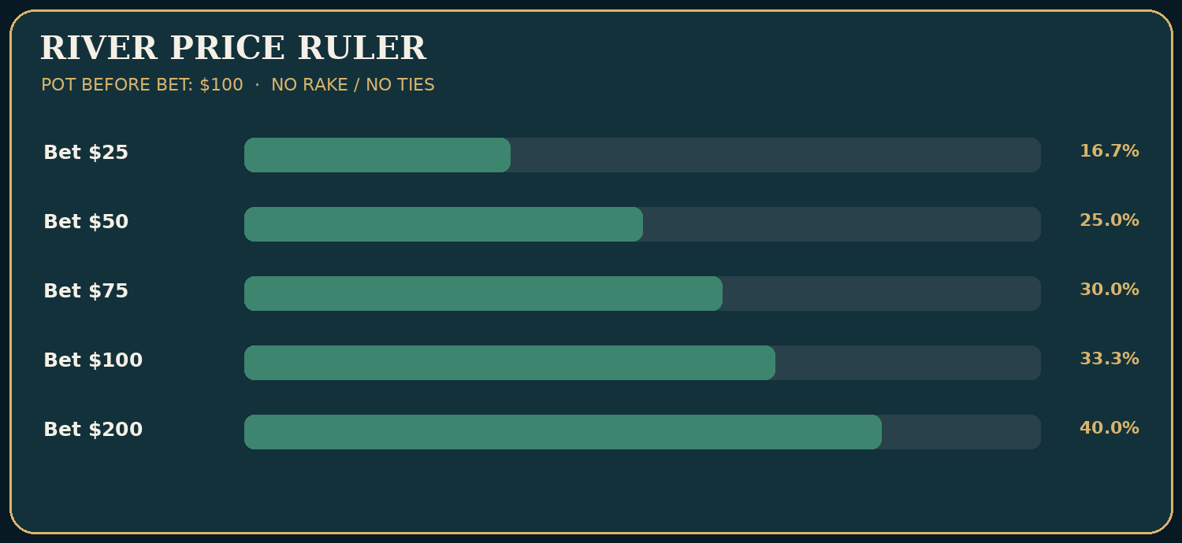
Instructional diagram — pot-odds-ruler.png

The river price ruler
When a player bets a fraction b of the pot before their bet, a closing-action call with no ties or rake requires a win fraction of b/(1+2b) against that betting range. This is basic pot odds, not a command to defend that percentage in every live game.
Villain’s river bet | Example on $100 pre-bet pot | Call needed | Required win rate
1/4 pot | $25 | $25 | 16.67%
1/3 pot | $33.33 | $33.33 | 20.00%
1/2 pot | $50 | $50 | 25.00%
2/3 pot | $66.67 | $66.67 | 28.57%
3/4 pot | $75 | $75 | 30.00%
Pot | $100 | $100 | 33.33%
2× pot | $200 | $200 | 40.00%
Remember that the opponent’s bet is added to the pot before your call and your own call adds again. If the river pot is $300 before the bet and the opponent wagers $240, calling $240 makes an $780 pot. Required win rate is 240/780 = 30.77%. A player who divides $240 by $300 and says 80% has misread the denominator.

Value and bluff combinations
Suppose, under a deliberately simplified weighted opponent model, Villain has 12 value combinations that beat Hero and six bluff combinations that Hero beats. Every combination is bet with equal frequency. Hero’s chance of winning when called is 6/(12+6) = 33.33%. Facing a three-quarter-pot river bet that requires 30%, calling is marginally positive before rake and any tie effects. If the bluff combinations are only three, the winning chance becomes 3/15 = 20%, turning the call unfavorable. That is why a live tendency about river underbluffing can alter the decision even when Hero’s cards and board do not change.
A combinations table is not the same as a betting-range table. Some value hands may bet only half the time, some draws bluff occasionally, and some combinations are blocked by Hero’s hole cards. For an honest estimate, multiply each legal combination by the plausible frequency of arriving and betting in that line. Pretending all possible value hands always bet is no better than pretending every missed draw always bluffs.

Polarization in plain English
A polarized large-bet range tends to contain strong value hands and bluffs, with fewer middling hands that prefer checking or smaller bets. A merged range includes many value hands of varied strengths. Live players do not always follow neat categories. Someone may make a giant river bet with second pair because they misunderstand showdown value; another may slow-play the nuts. Start from observed behavior and the plausible action tree.
A large bet against a player who never bluffs can be easier to fold than a small bet from a player who routinely overvalues weaker hands. Size alone is not a tell. The betting history tells us which holdings could credibly reach the river in the first place.

How a turn bet engineers a river problem
Pot $100 on the turn, effective stacks $400. Hero bets $70; Villain calls. River pot becomes $240, effective stacks $330. A river shove is now $330 into $240, an overbet of 137.5% pot. The opponent’s calling threshold under the no-ties closing-action model is 330 / (240 + 330 + 330) = 36.67%. A player who plans this line with a medium-strength hand should be able to explain what will call the shove. It is no defense to say, ‘I already bet $70 on the turn.’
Deep-stack decisions also include turn checks that preserve river options. A player with a strong draw can sometimes check back, especially if a bet is likely to meet a check-raise that destroys the price of continuing. With a vulnerable value hand, checking can preserve worse holdings and avoid bloating the pot. The right action is range- and opponent-dependent.

Two kinds of ‘big river mistake’
The first is sunk-cost calling. You have invested $250 in earlier streets, face an additional $300, and call mainly to avoid feeling foolish. Earlier contributions are already in the pot. Compare your current chance of winning with the price now.
The second is fearful under-value betting. Against Mara, a player who calls too broadly, you check the river with a strong hand because you are afraid of a rare better combination. That sacrifices repeated value. Good river play is neither brave nor timid; it is calibrated to ranges and prices.
Decision check. River pot $300; Villain bets $240; no rake or ties. What is the minimum win rate for a break-even closing-action call? A: 80%; B: 44.44%; C: 30.77%; D: 20%. Answer C. The final pot after a call is $780. Required win rate = 240/780 = 30.77%.
Change one variable: Hero’s estimated bluff-catching win rate falls from 35% against Lena to 18% against Vince. Same price, different range, opposite answer. The mathematics does not tell you the opponent’s actual bluff frequency; it tells you how high it must be.
Takeaway: river courage is not an emotion. It is a willingness to calculate the price and admit what you cannot know.

SKILL LAB 13 — Turn and river pressure
Objective: Audit the price of big bets and interpret balanced benchmarks correctly.
Work the five problems before uncovering the answer key. Problems are invented but modeled on legal, plausible cash-game settings; they are not presented as actual recorded hands. Numerical items have stated conditions, because real game-room rules and rake vary.

Drill SFFT-MCS2-DR-13-01 — Calculate
Situation: Villain bets the entire $120 river pot: $120. Hero must call $120, and no rake or ties apply.
Your task: What equity is required?
A. 50.00%
B. 25.00%
C. 66.67%
D. 33.33%
Write down before revealing: (a) the action or calculation; (b) the most important assumption; (c) one change that could reverse your conclusion.

Drill SFFT-MCS2-DR-13-02 — Calculate
Situation: Villain bets $75 into $100 in a heads-up river game. Consider only the standard theoretical minimum-defense-frequency benchmark versus pure bluffs, not an instruction to call with any particular holding.
Your task: What is the MDF benchmark?
A. 42.86%
B. 75.00%
C. 57.14%
D. 30.00%
Write down before revealing: (a) the action or calculation; (b) the most important assumption; (c) one change that could reverse your conclusion.

Drill SFFT-MCS2-DR-13-03 — Calculate
Situation: A turn pot is $120. Villain bets $80; Hero calls. No rake is deducted yet.
Your task: What pot will be on the river?
A. $120
B. $280
C. $200
D. $360
Write down before revealing: (a) the action or calculation; (b) the most important assumption; (c) one change that could reverse your conclusion.

Drill SFFT-MCS2-DR-13-04 — Interpret
Situation: Hero considers calling a $200 river bet into a pre-bet pot of $100 while holding a bluff-catcher. Villain is observed to underbluff very large bets.
Your task: What changes most directly?
A. Hero has to win more than half the time
B. Calling requires 40% equity, and the underbluffing read may justify substantial folding
C. Every bluff-catcher must call to satisfy MDF
D. The previous streets are irrelevant when constructing Villain’s range
Write down before revealing: (a) the action or calculation; (b) the most important assumption; (c) one change that could reverse your conclusion.

Drill SFFT-MCS2-DR-13-05 — Interpret
Situation: With a deep remaining stack, Hero has a medium-strength hand on the turn. A large bet would create an enormous river SPR reduction and expose the hand to a shove.
Your task: What is the soundest planning habit?
A. Decide only after the river card, ignoring turn pot growth
B. Calculate pot geometry and the likely river branches before betting
C. Always check to avoid difficult decisions
D. Bet pot automatically because depth is high
Write down before revealing: (a) the action or calculation; (b) the most important assumption; (c) one change that could reverse your conclusion.

Skill Lab Answer Key and Coaching Notes

SFFT-MCS2-DR-13-01: D. 33.33%
- A — Why not: Forgets Hero’s call in the final pot. This does not follow from the specified cards, pot, actions or model.
- B — Why not: This is the requirement for a half-pot bet. This does not follow from the specified cards, pot, actions or model.
- C — Why not: Counts risk relative to an incorrect denominator.
- D — CORRECT: Correct. 120/(120+120+120)=1/3=33.33%. The stated mathematical and betting assumptions control this result.
Change one variable: If Villain bets $60 instead, the requirement becomes 25%.

SFFT-MCS2-DR-13-02: C. 57.14%
- A — Why not: This is the benchmark fold share, not defense share.
- B — Why not: Confuses bet size as a percent of pot with MDF.
- C — CORRECT: Correct. MDF = old pot/(old pot+bet)=100/175=57.14%. Real optimal defense can differ given value ranges and exploitative conditions.
- D — Why not: This is the price of a call, not the defender’s MDF benchmark.
Change one variable: If opponent massively underbluffs, calling with fewer combos than the benchmark may be correct.

SFFT-MCS2-DR-13-03: B. $280
- A — Why not: Ignores both turn contributions. This does not follow from the specified cards, pot, actions or model.
- B — CORRECT: Correct. 120+80+80=$280. The stated mathematical and betting assumptions control this result.
- C — Why not: Forgets Hero’s call. This does not follow from the specified cards, pot, actions or model.
- D — Why not: Adds an extra $80 contribution. This does not follow from the specified cards, pot, actions or model.
Change one variable: If both players instead check the turn, the river pot remains $120.

SFFT-MCS2-DR-13-04: B. Calling requires 40% equity, and the underbluffing read may justify substantial folding
- A — Why not: Wrong: the correct threshold here is 200/(100+400)=40%.
- B — CORRECT: Correct. High pricing combined with a credible value-heavy range often makes folding best.
- C — Why not: Wrong: MDF is not a command against a population read.
- D — Why not: Wrong: earlier actions strongly shape plausible value/bluff combinations.
Change one variable: Reduce the wager from $200 to $25; the call threshold falls to 16.67%, but the range still matters.

SFFT-MCS2-DR-13-05: B. Calculate pot geometry and the likely river branches before betting
- A — Why not: Wrong: turn sizing determines later commitments.
- B — CORRECT: Correct. Plan credible river value, bluff and check lines in advance, accounting for opponent response.
- C — Why not: Wrong: checking can be right, but not automatically.
- D — Why not: Wrong: large bets are not uniformly profitable.
Change one variable: Replace the holding with a strong nut draw that can bluff profitable rivers; reassess turn aggression and blocker effects.
Mastery checkpoint: A correct letter alone is insufficient. Explain the relevant price, range, effective stack or game condition without looking at the solution. Return to this lab after the final examination.

14. When a Monster Is Not the Nuts
Level: Intermediate–advanced · Objective: Recognize how strong absolute hand categories can still be dominated by the opponent’s plausible range.
‘I flopped a set’ is a thrilling sentence. ‘I made a flush’ sounds conclusive. At a deep-stacked cash table, either can be the beginning of a very expensive story. A strong absolute hand is not automatically the strongest relative hand. The objective is not to make heroic folds for their own sake. It is to identify which hands the opponent can reasonably show up with, and whether the river price justifies continuing.

A straight is not always a winner
Hero has 8♠7♦ on J♣T♥9♠2♣3♦. Hero has a jack-high straight: 7-8-9-T-J. But an opponent holding Q-8 has a queen-high straight (8-9-T-J-Q), and K-Q would have a king-high straight (9-T-J-Q-K). A beginner sometimes calls it ‘the straight’ as if the rank were unique. There can be multiple different straights on the same board. Even when Hero has the highest possible straight, a flush or full house may outrank it on other runouts.

Why the second-nut flush can be expensive
Consider this concrete example: Hero holds Q♠J♠ on K♠8♠4♠2♦9♥. Hero has a king-high flush using K-Q-J-8-4. An opponent holding A♠T♠ has a higher ace-high flush using A-K-T-8-4. Hero can still value bet against lower flushes and two-pair holdings, but facing a huge river raise from a tight opponent, the possibility of a nut flush deserves careful combination and behavior analysis. We do not automatically fold the king-high flush; we examine what better hands can actually reach the river and raise.

Sets and board pairing
Hero has 7♣7♦ on A♠K♠7♥9♠9♦. Hero makes a full house—sevens full of nines—using 7♣7♦7♥9♠9♦. This is powerful but not the nuts: an opponent with A♥A♦ holds aces full of nines; one with K♥K♦ holds kings full of nines; one with 9♣9♥ would hold four nines (though the board contains 9♠ and 9♦, so exactly two nines remain). The physical card count helps: there are only two unseen nines available, so 9♣9♥ is exactly one possible pocket-nine combination. There are three unseen aces and kings apiece if one of each is on the board, producing three pocket-ace and three pocket-king combinations before accounting for known hole cards and preflop likelihood. The risk is real but must be weighted, not dramatized.

An overpair is not a guarantee
Hero raises preflop with A♠A♦ and gets three callers. On 9♥8♥7♣, the overpair is a strong category but several ranges interact with pairs, two pairs, sets, straights, and draws. Against a player who only commits a deep stack on that texture with superior made hands, one pair may be well behind. Against a reckless opponent who overplays T-T and flush draws, the same aces can retain significant value. Your task is to identify the particular continuing range, not worship or fear the word ‘aces.’

The cost of reverse implied odds
A speculative hand can make an apparently strong but non-nut holding, then pay substantial later bets to superior hands. In a deep pot, the occasional painful outcome can wipe out many cheap entries. This is why small flushes, bottom-end straights, weak top pairs, and marginal full houses require care when multiple betting lines converge on a polarizing river raise.
The antidote is not ‘fold everything.’ It is the original decision audit: pot, price, actual available better combinations, plausible opponent betting frequencies, worse hands that raise for value, and bluffs that reach this particular river.
Decision check. On A♠K♠7♥9♠9♦, Hero holds 7♣7♦. Which statement is correct? A: Hero has four of a kind; B: Hero has sevens full of nines, which can lose to higher full houses or quads; C: Hero has only three of a kind; D: Hero has the nut flush. Answer B. The hand is strong but not unbeatable.
Change one variable: the aggressive opponent can also river-raise missed draws in this line. That increases potential bluffs and may make a call profitable. The rank of Hero’s hand did not change; the betting-range composition did.
Takeaway: a monster hand deserves value, but only the best relative hand deserves the label ‘nuts.’

SKILL LAB 14 — Folding strong hands
Objective: Separate absolute hand strength from relative strength against a betting range.
Work the five problems before uncovering the answer key. Problems are invented but modeled on legal, plausible cash-game settings; they are not presented as actual recorded hands. Numerical items have stated conditions, because real game-room rules and rake vary.

Drill SFFT-MCS2-DR-14-01 — Calculate
Situation: A $90 river pot faces a $180 overbet. Hero holds a strong-looking but non-nut made hand and considers calling $180. Ignore rake and ties.
Your task: What showdown equity is required?
A. 66.67%
B. 50.00%
C. 40.00%
D. 33.33%
Write down before revealing: (a) the action or calculation; (b) the most important assumption; (c) one change that could reverse your conclusion.

Drill SFFT-MCS2-DR-14-02 — Calculate
Situation: Against a river wager Hero’s model includes 15 value combinations that beat Hero and 1 bluff Hero beats, all equally weighted. No ties.
Your task: What is Hero’s showdown equity against that betting range?
A. 93.75%
B. 6.25%
C. 15.00%
D. 50.00%
Write down before revealing: (a) the action or calculation; (b) the most important assumption; (c) one change that could reverse your conclusion.

Drill SFFT-MCS2-DR-14-03 — Calculate
Situation: A player needs 30% equity to justify a $75 river call into a $100 pre-bet pot with no ties/rake. Their hand beats only 3 of 13 equally weighted betting combos.
Your task: What is the model’s showdown equity?
A. 23.08%
B. 30.00%
C. 33.33%
D. 76.92%
Write down before revealing: (a) the action or calculation; (b) the most important assumption; (c) one change that could reverse your conclusion.

Drill SFFT-MCS2-DR-14-04 — Interpret
Situation: Hero holds a king-high flush on a three-spade board. A very tight Villain makes a huge river raise with 200bb behind and almost never raises less than the nut flush.
Your task: What is the right approach?
A. Always call: a flush is a monster
B. Evaluate the available ace-high flush combinations and whether Villain has enough worse hands/bluffs to justify the price
C. Always fold every flush regardless of the range
D. Make an even larger raise solely because Hero has a flush
Write down before revealing: (a) the action or calculation; (b) the most important assumption; (c) one change that could reverse your conclusion.

Drill SFFT-MCS2-DR-14-05 — Interpret
Situation: Hero has already invested $500 in a deep cash-game hand and faces a fresh $250 river bet. Hero estimates only a 10% chance of winning if called, with no tie or other actions.
Your task: What is the correct decision principle?
A. Call because Hero must protect $500
B. Ignore all earlier range evidence
C. Compare the fresh $250 price with the current pot and estimated 10% equity; do not use sunk cost as justification
D. Call because the player is pot committed by personal pride
Write down before revealing: (a) the action or calculation; (b) the most important assumption; (c) one change that could reverse your conclusion.

Skill Lab Answer Key and Coaching Notes

SFFT-MCS2-DR-14-01: C. 40.00%
- A — Why not: Forgets Hero’s call when calculating the final pot.
- B — Why not: Uses the wrong final-pot denominator. This does not follow from the specified cards, pot, actions or model.
- C — CORRECT: Correct. 180/(90+180+180)=180/450=40%. Strong-looking cards do not change this price.
- D — Why not: Would be correct against a pot-sized bet, not a 2× pot overbet.
Change one variable: Reduce Villain’s bet to $45; the required equity falls to 25%.

SFFT-MCS2-DR-14-02: B. 6.25%
- A — Why not: Reports the value share instead. This does not follow from the specified cards, pot, actions or model.
- B — CORRECT: Correct. 1/(15+1)=6.25%. Such a range makes almost any ordinary sizable river bluff-catch unprofitable.
- C — Why not: Mistakes value-combination count for a percentage.
- D — Why not: Assumes the range has equal value and bluffs. This does not follow from the specified cards, pot, actions or model.
Change one variable: If Villain has six bluffs instead, Hero’s win rate becomes 6/21≈28.57%.

SFFT-MCS2-DR-14-03: A. 23.08%
- A — CORRECT: Correct. 3/13≈23.08%, below 30%, so folding is favored by this model.
- B — Why not: Confuses required equity with actual estimated equity.
- C — Why not: Would be 3 out of 9 combinations, not 13. This does not follow from the specified cards, pot, actions or model.
- D — Why not: Reports the opposing winning share. This does not follow from the specified cards, pot, actions or model.
Change one variable: Increase the number of bluffs beaten to 6 while total combos become 16; equity increases to 37.5%.

SFFT-MCS2-DR-14-04: B. Evaluate the available ace-high flush combinations and whether Villain has enough worse hands/bluffs to justify the price
- A — Why not: Wrong: a high flush is not automatically the nuts.
- B — CORRECT: Correct. Relative strength, card removal, bet size and opponent range can make a disciplined fold correct.
- C — Why not: Wrong: folding all flushes is another false absolute.
- D — Why not: Wrong: a raise without profitable worse-hand action or fold equity is not justified.
Change one variable: Replace Villain with a player known to overplay smaller flushes and sets; a call or value raise may become attractive.

SFFT-MCS2-DR-14-05: C. Compare the fresh $250 price with the current pot and estimated 10% equity; do not use sunk cost as justification
- A — Why not: Wrong: money already invested does not justify an additional mistake.
- B — Why not: Wrong: range evidence directly informs equity.
- C — CORRECT: Correct. Compute the current required equity; no pot size was specified, so a final call/fold cannot be numerically determined yet.
- D — Why not: Wrong: emotion does not determine pot odds. This does not follow from the specified cards, pot, actions or model.
Change one variable: Specify a pre-bet pot of $500: a $250 bet requires 25% equity, so 10% is too low under the model.
Mastery checkpoint: A correct letter alone is insufficient. Explain the relevant price, range, effective stack or game condition without looking at the solution. Return to this lab after the final examination.

15. The Master Cash Game Files
Level: Intermediate to advanced · Objective: Audit fifteen complete decision sequences, including wins, losses, abandoned draws and disciplined folds.
These cases are fictional study hands. They use $1/$2 blinds with explicitly shown incremental chip contributions and no rake or tips deducted from the displayed pot ledgers. When a hand ends on the flop or turn, later board cards are deliberately omitted. Each ledger carries money from earlier streets forward; blinds and limps are counted once. A printed pot total is not Hero’s net profit. Most hands omit opponents who fold without contributing; all extra contributions are shown. For actual casinos, follow the local rake, betting and side-pot rules.

How to audit a file
- Identify the exact additional money required at the decision.
- Check the pot before the new action and the pot after calls or raises.
- List the better hands, worse hands, and bluffs consistent with the line.
- Evaluate future stacks and possible opponent errors.
- Change an assumption and repeat the decision.

Case 01: The Two-Dollar Door
Setup: Nine-handed $1/$2; Hero BTN, Villain UTG; Hero $450, Villain $450; no straddle. Hero: 8♠ 7♠. Shown opponent cards: A♠ T♦ (revealed at showdown).
Board dealt: T♣ 9♦ 2♥ 6♣ 3♥.
Verified chip ledger (rake excluded; every amount below is an additional contribution, not the total lifetime wager)
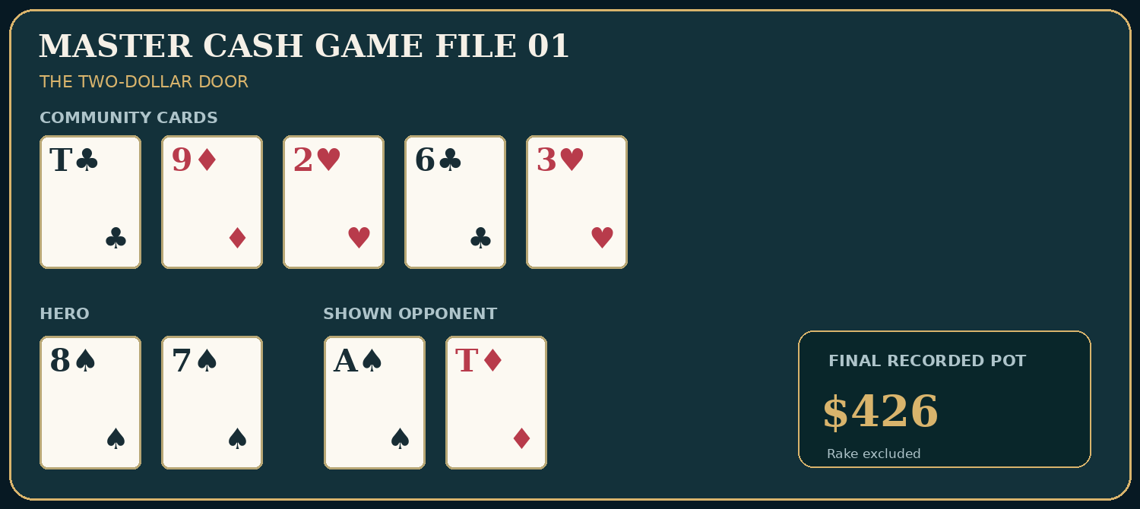
Exact cards and pot: Master Hand File 01

Preflop actions
- SB posts small blind; adds $1. Running pot $1.
- BB posts big blind; adds $2. Running pot $3.
- UTG limps $2; adds $2. Running pot $5.
- MP limps $2; adds $2. Running pot $7.
- HJ limps $2; adds $2. Running pot $9.
- BTN overlimps $2; adds $2. Running pot $11.
- SB completes for $1; adds $1. Running pot $12.
- BB checks option; adds $0. Running pot $12.

Flop actions
- SB checks; adds $0. Running pot $12.
- BB bets $8; adds $8. Running pot $20.
- UTG calls $8; adds $8. Running pot $28.
- MP calls $8; adds $8. Running pot $36.
- HJ folds; adds $0. Running pot $36.
- BTN calls $8; adds $8. Running pot $44.
- SB folds; adds $0. Running pot $44.

Turn actions
- BB bets $22; adds $22. Running pot $66.
- UTG calls $22; adds $22. Running pot $88.
- MP folds; adds $0. Running pot $88.
- BTN raises to $80; adds $80. Running pot $168.
- BB folds; adds $0. Running pot $168.
- UTG calls $58 more; adds $58. Running pot $226.

River actions
- UTG checks; adds $0. Running pot $226.
- BTN bets $100; adds $100. Running pot $326.
- UTG calls $100; adds $100. Running pot $426.
Pot when action ends: $426 before rake.
Teaching question: Value in a large pot must be connected to who is still willing and able to pay, not to the size of the cheapest entry.
Hero buys the button for $2 and sees a six-way $12 flop. T♣9♦2♥ gives 8♠7♠ a genuine open-ended straight draw, not a made straight. On the 6♣ turn Hero improves to a ten-high straight. Raising after BB bets and UTG calls targets hands such as top pair, sets, and two pair that continue too willingly in this fictional loose game. UTG’s A♠T♦ is top pair and pays all streets; Hero wins at showdown. This is one possible payoff scenario, not the average return from overlimping. The original flop call needs a range-aware future plan, and the higher turn raise must respect possible superior straights or redraws.
Change the conditions: Replace UTG with a player who folds one pair to turn raises. The same made straight may earn much less, reducing the preflop speculative value.

Case 02: The Broadway Tax
Setup: Nine-handed $1/$2; Villain UTG $400, Hero BTN $400. Hero: K♠ J♦. Opponent cards: not exposed.
Board dealt: K♥ 8♣ 3♦ 2♣ 4♥.
Verified chip ledger (rake excluded; every amount below is an additional contribution, not the total lifetime wager)
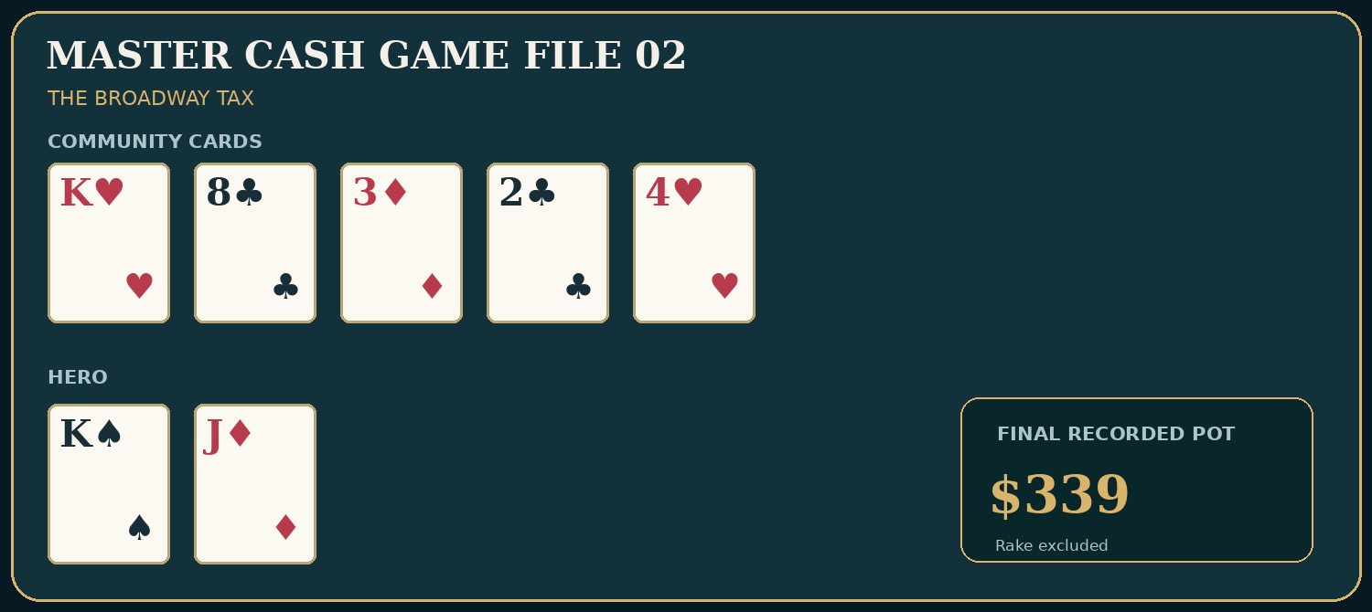
Exact cards and pot: Master Hand File 02

Preflop actions
- SB posts $1; adds $1. Running pot $1.
- BB posts $2; adds $2. Running pot $3.
- UTG raises to $18; adds $18. Running pot $21.
- BTN calls $18; adds $18. Running pot $39.

Flop actions
- UTG bets $25; adds $25. Running pot $64.
- BTN calls $25; adds $25. Running pot $89.

Turn actions
- UTG bets $65; adds $65. Running pot $154.
- BTN calls $65; adds $65. Running pot $219.

River actions
- UTG bets $120; adds $120. Running pot $339.
- BTN folds; adds $0. Running pot $339.
Pot when action ends: $339 before rake.
Teaching question: Top pair is not permission to pay three value-sized bets against a strong early-position range.
Hero calls an $18 early-position raise with K♠J♦. The flop gives top pair, but the range may contain A-K, K-Q, aces, and sets. The turn is superficially blank; that does not create a new bluffing opportunity for Villain by itself. The river call would cost $120 and make a $459 final pot (current pot $339 plus Hero $120), requiring 26.14% win equity. Hero folds against the specified tight, value-heavy line. The earlier preflop and turn calls are the decisions to investigate most closely: are they supported by enough worse value hands or bluffs?
Change the conditions: Give Villain repeated evidence of triple-barrel bluffs and widen their range. The same river price may then justify calling.

Case 03: Aces Meet a Wet Board
Setup: Six-handed $1/$2; Hero CO $450, Villain BTN $450. Hero: A♥ A♦. Opponent cards: not exposed.
Board dealt: 9♥ 8♥ 7♣ 2♦.
Verified chip ledger (rake excluded; every amount below is an additional contribution, not the total lifetime wager)
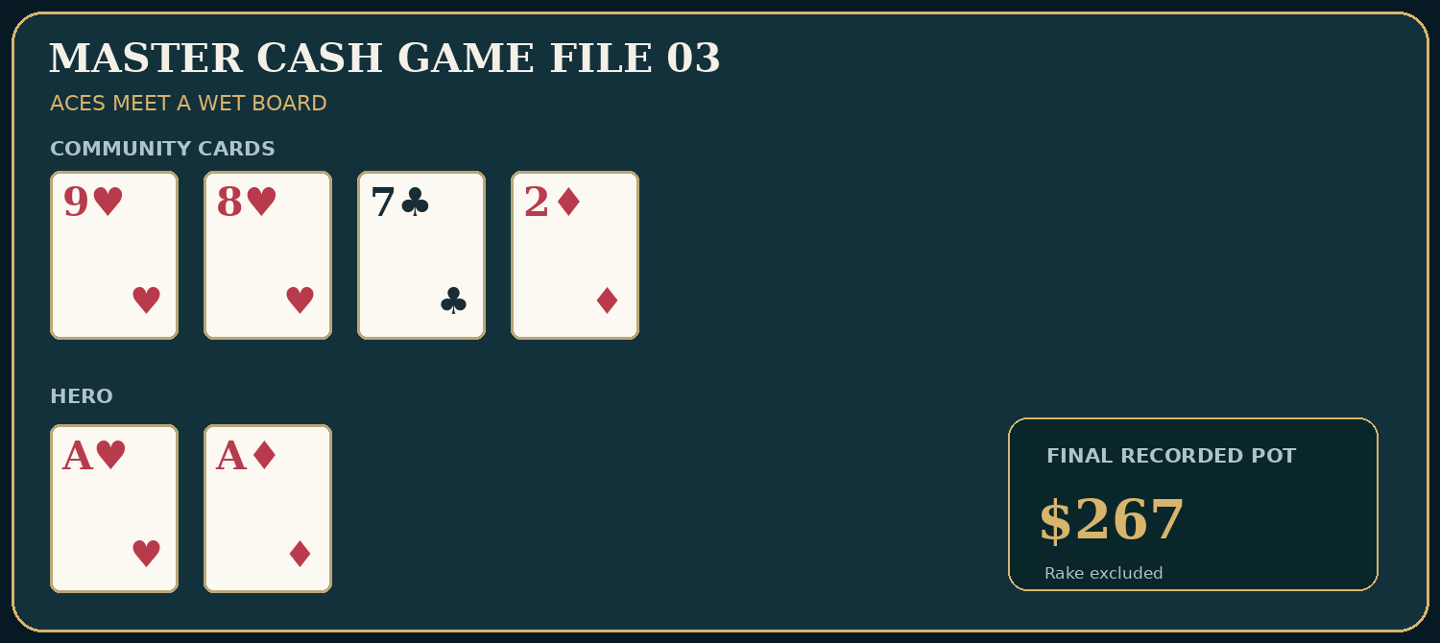
Exact cards and pot: Master Hand File 03

Preflop actions
- SB posts $1; adds $1. Running pot $1.
- BB posts $2; adds $2. Running pot $3.
- CO raises to $12; adds $12. Running pot $15.
- BTN calls $12; adds $12. Running pot $27.

Flop actions
- CO bets $18; adds $18. Running pot $45.
- BTN raises to $65; adds $65. Running pot $110.
- CO calls $47 more; adds $47. Running pot $157.

Turn actions
- CO checks; adds $0. Running pot $157.
- BTN bets $110; adds $110. Running pot $267.
- CO folds; adds $0. Running pot $267.
Pot when action ends: $267 before rake.
Teaching question: An overpair can face a strong range on a connected board even when the turn is a blank.
Hero raises aces and makes a continuation bet on 9♥8♥7♣. The button’s flop raise could contain sets, two pair, straights, combo draws, and bluff candidates. The 2♦ does little to remove that structure. The turn bet is $110 into $157: a call would require $110/$377 = 29.18% against the betting range without future action, but deciding to stack off needs more careful future-street analysis. Hero folds in the teaching line because this Villain has shown a value-heavy continuation after raising wet flops. Against a highly aggressive bluffer, the same fold might be too tight.
Change the conditions: Replace Villain with Lena, who raises enough strong draws to change Hero’s showdown and future equity; compare alternative turn lines.

Case 04: The Evidence-Based Bluff Catch
Setup: Six-handed $1/$2; Hero CO $400, Villain BTN Lena $400. Hero: K♦ J♦. Shown opponent cards: Q♠ T♠ (revealed at showdown).
Board dealt: K♥ 9♣ 6♠ 3♦ 2♠.
Verified chip ledger (rake excluded; every amount below is an additional contribution, not the total lifetime wager)
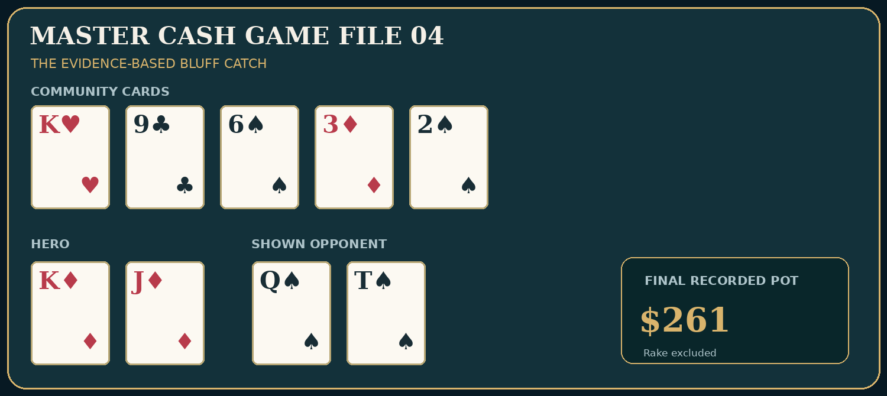
Exact cards and pot: Master Hand File 04

Preflop actions
- SB posts $1; adds $1. Running pot $1.
- BB posts $2; adds $2. Running pot $3.
- CO opens to $10; adds $10. Running pot $13.
- BTN calls $10; adds $10. Running pot $23.

Flop actions
- CO bets $14; adds $14. Running pot $37.
- BTN calls $14; adds $14. Running pot $51.

Turn actions
- CO checks; adds $0. Running pot $51.
- BTN bets $30; adds $30. Running pot $81.
- CO calls $30; adds $30. Running pot $111.

River actions
- CO checks; adds $0. Running pot $111.
- BTN bets $75; adds $75. Running pot $186.
- CO calls $75; adds $75. Running pot $261.
Pot when action ends: $261 before rake.
Teaching question: Use the betting line and showdown price to evaluate a river bluff-catch, not the opponent’s theatrical reputation.
The turn bet can contain strong K-x, draws, and weaker protection hands, while the river bet polarizes a portion of Lena’s range. Calling $75 to make a $261 pot requires 28.74% wins, excluding ties and rake. Lena reveals Q♠T♠, a missed gutshot requiring a jack to make the 9-T-J-Q-K straight. On K♥9♣6♠, Q-T has a gutshot, not an open-ended straight draw, and a weak floating candidate. Its turn stab and river bluff are plausible for a loose aggressive character but not mandatory. Hero wins with kings and jack kicker.
Change the conditions: Replace Lena with Vince, whose river bet range rarely contains hands like Q-T. Hero’s pot odds stay fixed while estimated win frequency falls.

Case 05: Set-Mining Without a Set
Setup: Nine-handed $1/$2; Villain UTG $150, Hero BTN $150. Hero: 5♣ 5♦. Opponent cards: not exposed.
Board dealt: A♦ K♥ 2♣.
Verified chip ledger (rake excluded; every amount below is an additional contribution, not the total lifetime wager)
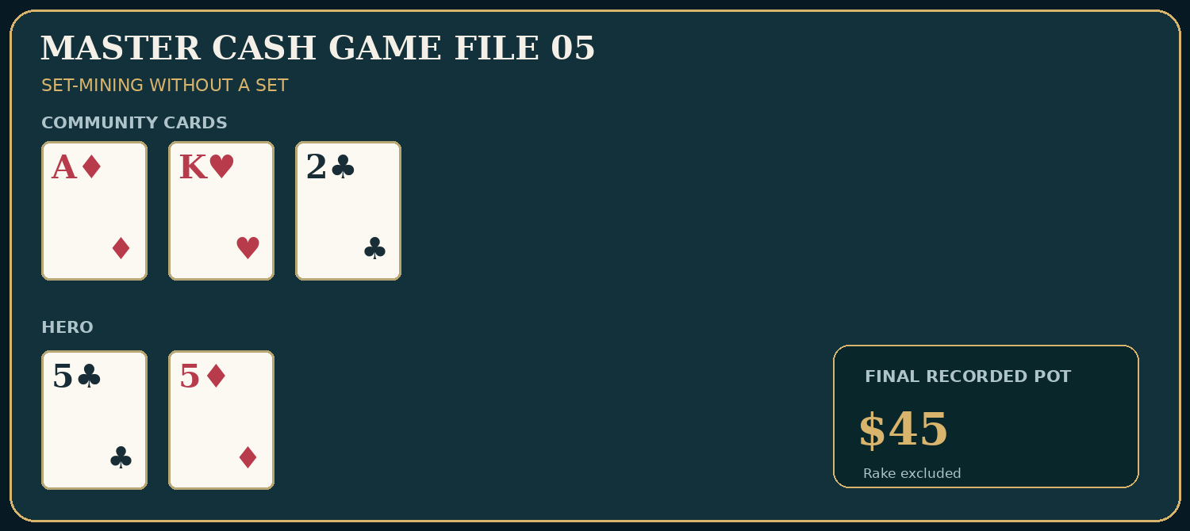
Exact cards and pot: Master Hand File 05

Preflop actions
- SB posts $1; adds $1. Running pot $1.
- BB posts $2; adds $2. Running pot $3.
- UTG opens to $12; adds $12. Running pot $15.
- BTN calls $12; adds $12. Running pot $27.

Flop actions
- UTG bets $18; adds $18. Running pot $45.
- BTN folds; adds $0. Running pot $45.
Pot when action ends: $45 before rake.
Teaching question: A speculative preflop call is judged before the flop; folding misses is part of the planned cost.
Hero calls a $12 early-position raise with pocket fives and sees A♦K♥2♣. The pocket pair has not improved to a set. Against a strong value-heavy flop bet and without a credible profitable continuation plan, Hero folds. Calling preflop may itself have been unattractive at $150 effective with uncertain payment on set flops, especially after rake. Do not count occasional spectacular set wins while forgetting the many $12 misses.
Change the conditions: Change effective stacks to $600 and Villain’s behavior to paying off big bets with one pair. Preflop set-mining incentives change, although the actual flop fold need not.

Case 06: When the Set Gets Paid
Setup: Nine-handed $1/$2; Villain UTG Ruth $450, Hero BTN $450. Hero: 5♣ 5♦. Shown opponent cards: A♣ K♦ (revealed at showdown).
Board dealt: K♣ 9♠ 5♥ 2♦ J♥.
Verified chip ledger (rake excluded; every amount below is an additional contribution, not the total lifetime wager)
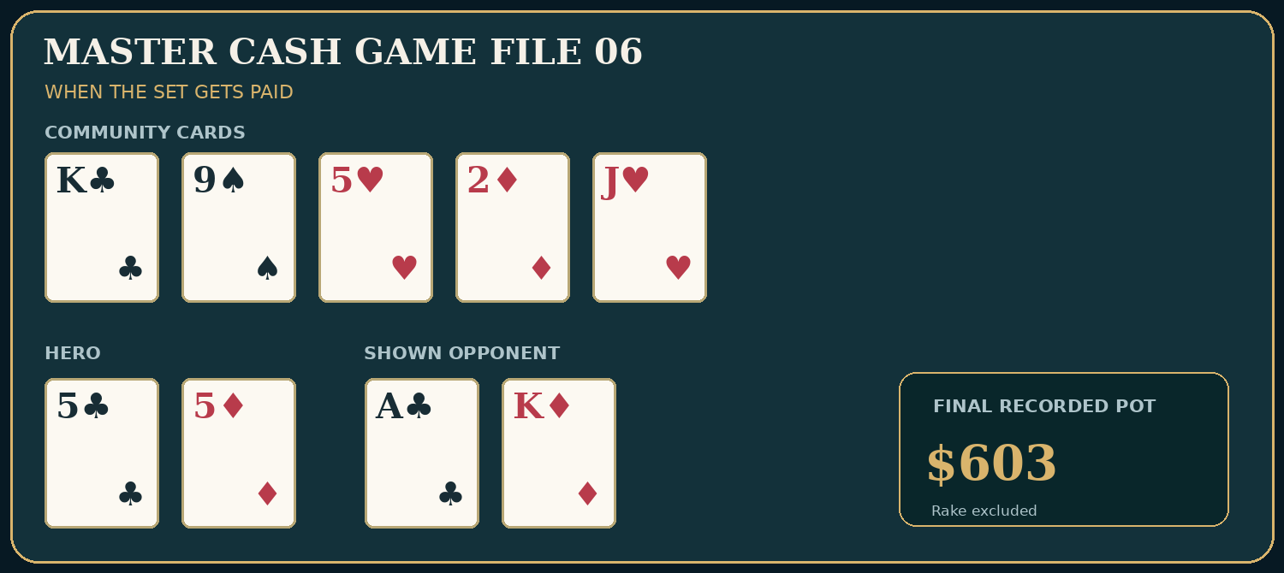
Exact cards and pot: Master Hand File 06

Preflop actions
- SB posts $1; adds $1. Running pot $1.
- BB posts $2; adds $2. Running pot $3.
- UTG raises to $12; adds $12. Running pot $15.
- BTN calls $12; adds $12. Running pot $27.

Flop actions
- UTG bets $18; adds $18. Running pot $45.
- BTN calls $18; adds $18. Running pot $63.

Turn actions
- UTG bets $45; adds $45. Running pot $108.
- BTN raises to $120 total; adds $120. Running pot $228.
- UTG calls $75 more; adds $75. Running pot $303.

River actions
- UTG checks; adds $0. Running pot $303.
- BTN bets $150; adds $150. Running pot $453.
- UTG calls $150; adds $150. Running pot $603.
Pot when action ends: $603 before rake.
Teaching question: Illustrate a positive realization of implied odds without claiming that every small-pair call earns this payout.
On K♣9♠5♥ Hero flops bottom set. Ruth has A♣K♦ and bets into Hero. The 2♦ turn changes little; Hero raises Ruth’s $45 bet to $120 total, and Ruth calls the additional $75. The river J♥ completes no obvious frontdoor flush. Hero value bets $150 and is paid. Hero wins a $603 pot before rake, but this single success must be compared with the large number of times a small pocket pair misses or gets no payoff. All-in stack limits and rake matter to the long-run preflop calculation.
Change the conditions: Keep the same board but let Ruth fold top pair to the turn raise. The large pot vanishes, and the preflop investment’s profitability changes.

Case 07: The Squeeze Behind the Bargain
Setup: Nine-handed $1/$2; Hero BTN $300, Villain SB $300; UTG/MP limp. Hero: 7♥ 6♥. Opponent cards: not exposed.
Board dealt: K♦ 8♠ 3♣.
Verified chip ledger (rake excluded; every amount below is an additional contribution, not the total lifetime wager)
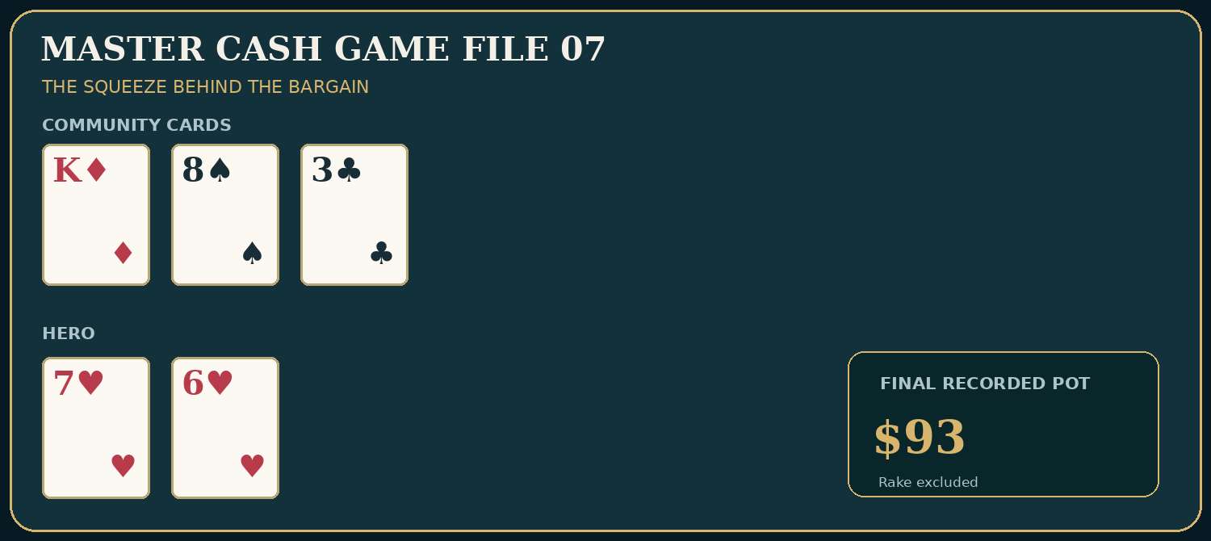
Exact cards and pot: Master Hand File 07

Preflop actions
- SB posts $1; adds $1. Running pot $1.
- BB posts $2; adds $2. Running pot $3.
- UTG limps $2; adds $2. Running pot $5.
- MP limps $2; adds $2. Running pot $7.
- BTN overlimps $2; adds $2. Running pot $9.
- SB raises to $26 total; adds $25. Running pot $34.
- BB folds; adds $0. Running pot $34.
- UTG folds; adds $0. Running pot $34.
- MP calls $24 more; adds $24. Running pot $58.
- BTN folds; adds $0. Running pot $58.

Flop actions
- SB bets $35; adds $35. Running pot $93.
- MP folds; adds $0. Running pot $93.
Pot when action ends: $93 before rake.
Teaching question: A $2 overlimp is not guaranteed to buy a $2 flop; action behind can reopen the price.
Hero overlimps the button after two early limps, but the small blind squeezes to $26. The big blind and UTG fold; MP calls; Hero releases the suited connector rather than paying another $24 in a pot with an aggressive squeeze range. Hero’s sunk $2 does not create a bargain. The $58 preflop pot is simply the blinds, two original limps, Hero’s overlimp, the additional SB raise money, and MP’s additional call. On K♦8♠3♣ the small blind’s $35 bet takes down the pot.
Change the conditions: If the small blind is passive and almost never raises, the $2 overlimp option is more likely to stay cheap.

Case 08: The Incomplete Flush Draw
Setup: Six-handed $1/$2; CO Vince $300, BTN Hero $300, BB $300. Hero: 9♠ 8♠. Opponent cards: not exposed.
Board dealt: Q♠ 7♠ 2♣ 4♦.
Verified chip ledger (rake excluded; every amount below is an additional contribution, not the total lifetime wager)
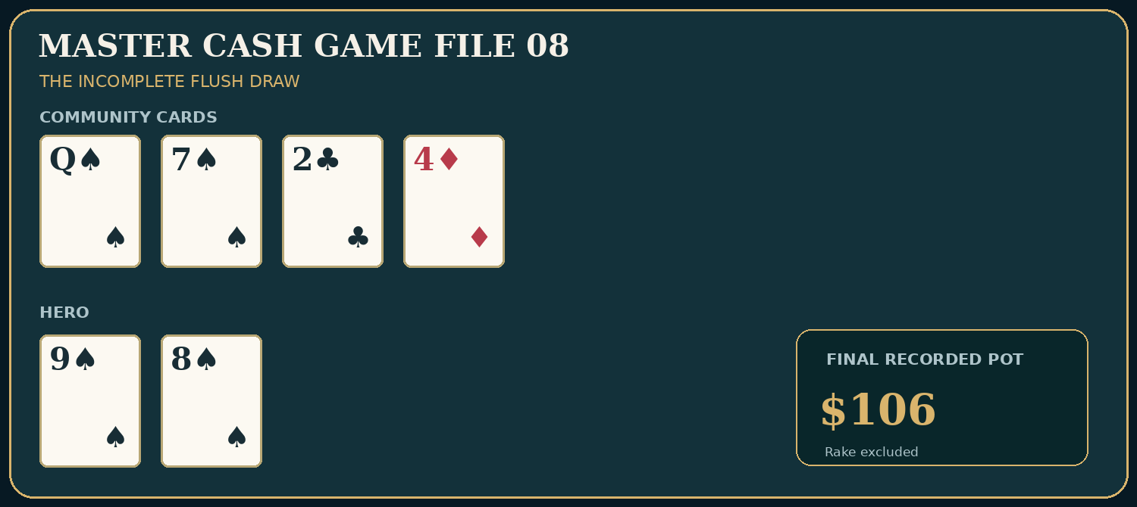
Exact cards and pot: Master Hand File 08

Preflop actions
- SB posts $1; adds $1. Running pot $1.
- BB posts $2; adds $2. Running pot $3.
- CO opens to $10; adds $10. Running pot $13.
- BTN calls $10; adds $10. Running pot $23.
- BB calls $8 more; adds $8. Running pot $31.

Flop actions
- BB checks; adds $0. Running pot $31.
- CO bets $15; adds $15. Running pot $46.
- BTN calls $15; adds $15. Running pot $61.
- BB folds; adds $0. Running pot $61.

Turn actions
- CO bets $45; adds $45. Running pot $106.
- BTN folds; adds $0. Running pot $106.
Pot when action ends: $106 before rake.
Teaching question: A draw that reasonably continues on the flop may correctly fold after the turn price rises.
Hero has a nine-out spade flush draw on Q♠7♠2♣. Calling a $15 flop bet into a $46 pot before Hero’s call makes a $61 pot. The 4♦ turn misses; Vince bets $45 into $61. Calling would make $151 and require 45/151 = 29.80% showdown equity, while nine spades have only 9/46 = 19.57% chance to land on the last card, even before discounting dirty outs. Future implied payment against a tight bettor is weak. Hero folds rather than treating the previous flop call as a commitment.
Change the conditions: If the turn bet were only $10 into $61, the immediate call price would be much more favorable; evaluate other forms of equity as well.

Case 09: Thin Value Against a Caller
Setup: Six-handed $1/$2; Hero BTN $300, Villain BB Mara $300. Hero: A♥ Q♥. Shown opponent cards: K♦ Q♣ (revealed at showdown).
Board dealt: Q♦ 7♣ 2♠ 4♣ 9♠.
Verified chip ledger (rake excluded; every amount below is an additional contribution, not the total lifetime wager)
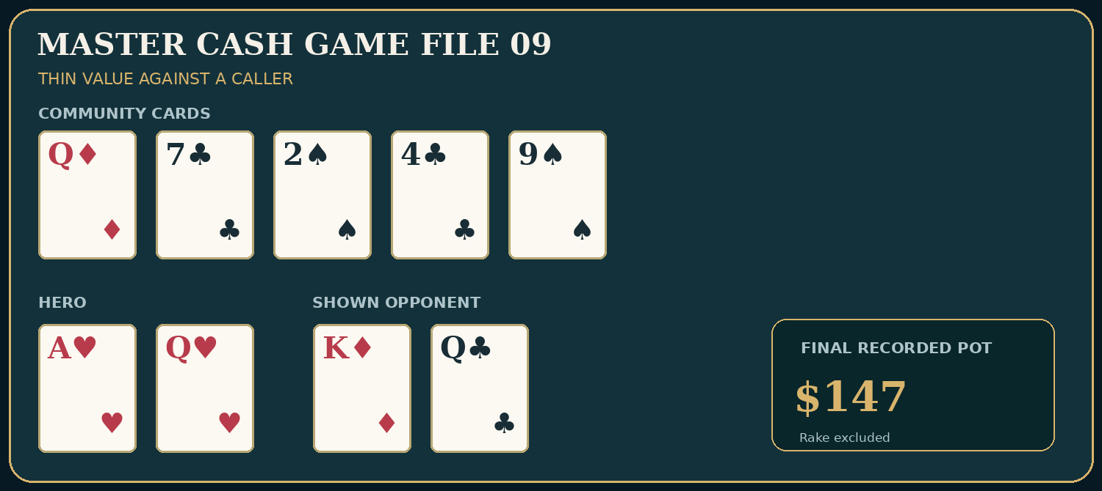
Exact cards and pot: Master Hand File 09

Preflop actions
- SB posts $1; adds $1. Running pot $1.
- BB posts $2; adds $2. Running pot $3.
- BTN opens to $8; adds $8. Running pot $11.
- BB calls $6 more; adds $6. Running pot $17.

Flop actions
- BB checks; adds $0. Running pot $17.
- BTN bets $10; adds $10. Running pot $27.
- BB calls $10; adds $10. Running pot $37.

Turn actions
- BB checks; adds $0. Running pot $37.
- BTN bets $20; adds $20. Running pot $57.
- BB calls $20; adds $20. Running pot $77.

River actions
- BB checks; adds $0. Running pot $77.
- BTN bets $35; adds $35. Running pot $112.
- BB calls $35; adds $35. Running pot $147.
Pot when action ends: $147 before rake.
Teaching question: Value comes from a worse calling range; modest river value bets can outperform automatic shoves.
Hero flops top pair with ace kicker and bets three streets for value. Mara reveals K♦Q♣, top pair with a king kicker, and pays the river. The pot is $147 before rake. The example supports a value bet against this fictional opponent, not the universal claim that every weaker queen calls $35. Against Vince, whose river calls are narrower, Hero might choose a smaller size or a check depending on range.
Change the conditions: Increase the river bet to $150. Will K-Q still call often enough, or will you isolate better hands? Reassess the calling-rate model.

Case 10: The Second-Nut Flush Trap
Setup: Nine-handed $1/$2; Villain Vince UTG $600, Hero BTN $600. Hero: Q♠ J♠. Opponent cards: not exposed.
Board dealt: K♠ 8♠ 4♠ 2♦ 9♥.
Verified chip ledger (rake excluded; every amount below is an additional contribution, not the total lifetime wager)
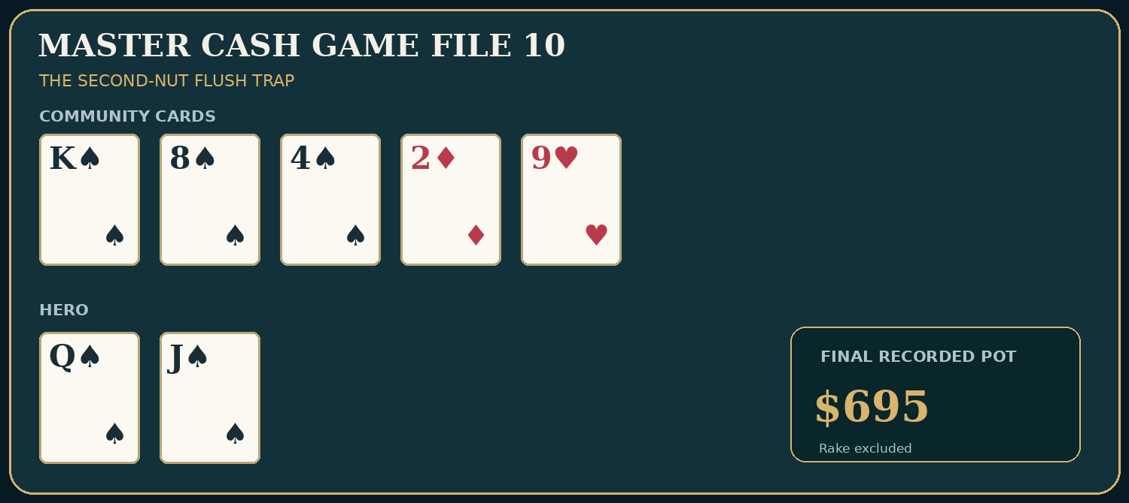
Exact cards and pot: Master Hand File 10

Preflop actions
- SB posts $1; adds $1. Running pot $1.
- BB posts $2; adds $2. Running pot $3.
- UTG raises to $16; adds $16. Running pot $19.
- BTN calls $16; adds $16. Running pot $35.

Flop actions
- UTG bets $25; adds $25. Running pot $60.
- BTN raises to $80 total; adds $80. Running pot $140.
- UTG calls $55 more; adds $55. Running pot $195.

Turn actions
- UTG checks; adds $0. Running pot $195.
- BTN bets $100; adds $100. Running pot $295.
- UTG calls $100; adds $100. Running pot $395.

River actions
- UTG bets $300; adds $300. Running pot $695.
- BTN folds; adds $0. Running pot $695.
Pot when action ends: $695 before rake.
Teaching question: A big flush is not necessarily the nut flush; do not pay huge river aggression without pricing the opponent range.
Hero has a king-high flush on the flop using K♠Q♠J♠8♠4♠. It looks magnificent. But the A♠ remains available to an opponent and can make an ace-high flush if paired with a second spade in that opponent’s hand. Vince check-calls a substantial turn bet, then leads $300 on the river. Calling would cost $300 to make a $995 pot, requiring 30.15% equity. Against Vince’s narrow, underbluffing line the fold can be defensible. This is not proof he holds the nut flush; it is a comparison of likely better value hands against bluffs and worse value.
Change the conditions: Give Vince credible weaker-flush value bets and major river bluffs; the call may become correct even though the ace-high flush remains possible.

Case 11: Paying for the Miss
Setup: Nine-handed $1/$2; Villain Vince UTG $200, Hero HJ $200. Hero: 6♣ 5♣. Opponent cards: not exposed.
Board dealt: A♣ K♦ 8♠.
Verified chip ledger (rake excluded; every amount below is an additional contribution, not the total lifetime wager)
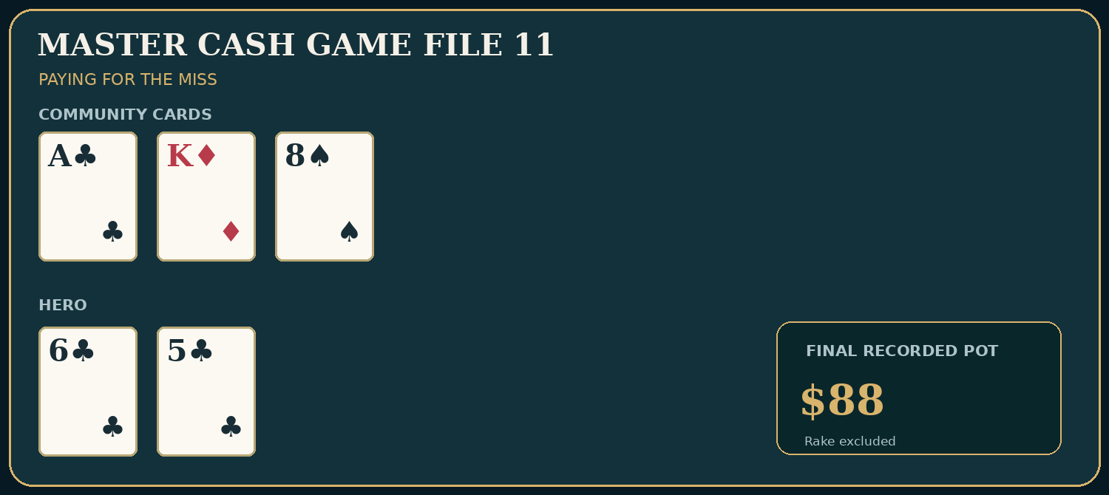
Exact cards and pot: Master Hand File 11

Preflop actions
- SB posts $1; adds $1. Running pot $1.
- BB posts $2; adds $2. Running pot $3.
- UTG opens to $25; adds $25. Running pot $28.
- HJ calls $25; adds $25. Running pot $53.

Flop actions
- UTG bets $35; adds $35. Running pot $88.
- HJ folds; adds $0. Running pot $88.
Pot when action ends: $88 before rake.
Teaching question: Even good-looking suited connectors can become poor investments when the preflop price and stack cap are unfavorable.
The $25 preflop call builds a $53 pot from Hero, UTG, and the blinds. On A♣K♦8♠ Hero has no pair and no immediate flush draw. Vince c-bets $35 and Hero folds. With $200 starting stacks, the preflop investment was a substantial fraction of the money Hero could later win. Saying it was suited or imagining a $500 pot cannot repair the actual payment constraints.
Change the conditions: Change the open to $6, Hero to the button, effective stacks to $600, and Villain to a genuine overcaller. The speculative calculation is a different problem.

Case 12: A-Q Finds the Calling Station
Setup: Nine-handed $1/$2; UTG Mara $500, MP Ruth $500, Hero BTN $500. Hero: A♠ Q♠. Shown opponent cards: Q♦ J♥ (revealed at showdown).
Board dealt: Q♣ 8♦ 4♥ 2♣ 6♠.
Verified chip ledger (rake excluded; every amount below is an additional contribution, not the total lifetime wager)
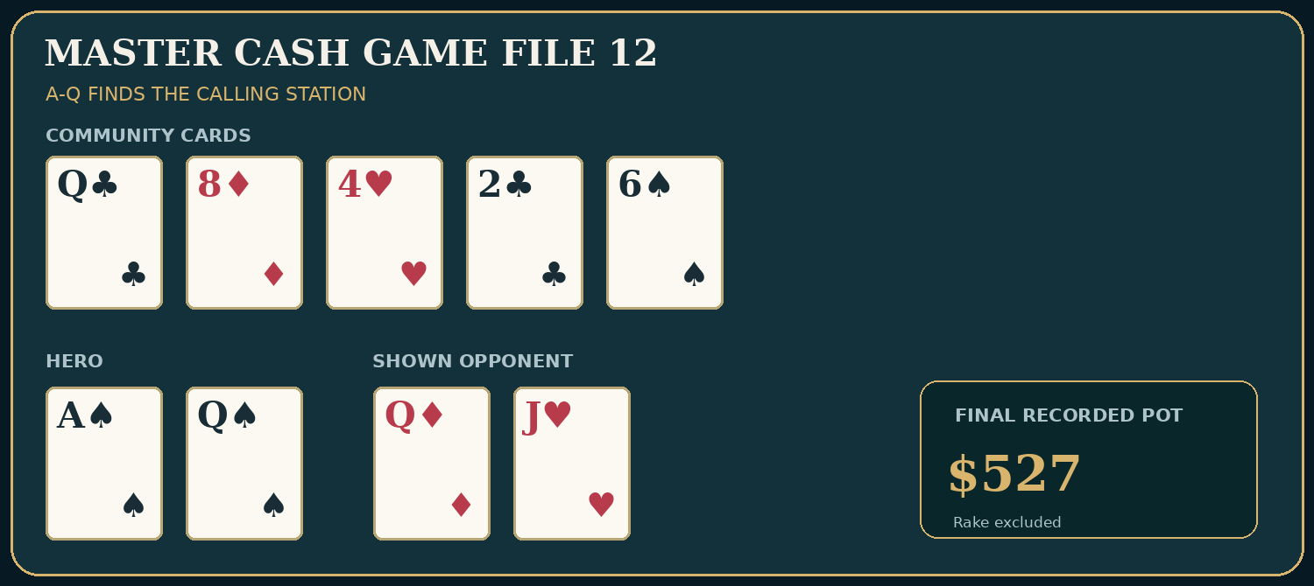
Exact cards and pot: Master Hand File 12

Preflop actions
- SB posts $1; adds $1. Running pot $1.
- BB posts $2; adds $2. Running pot $3.
- UTG limps $2; adds $2. Running pot $5.
- MP limps $2; adds $2. Running pot $7.
- BTN raises to $20 total; adds $20. Running pot $27.
- UTG calls $18 more; adds $18. Running pot $45.
- MP calls $18 more; adds $18. Running pot $63.

Flop actions
- UTG checks; adds $0. Running pot $63.
- MP checks; adds $0. Running pot $63.
- BTN bets $42; adds $42. Running pot $105.
- UTG calls $42; adds $42. Running pot $147.
- MP folds; adds $0. Running pot $147.

Turn actions
- UTG checks; adds $0. Running pot $147.
- BTN bets $90; adds $90. Running pot $237.
- UTG calls $90; adds $90. Running pot $327.

River actions
- UTG checks; adds $0. Running pot $327.
- BTN bets $100; adds $100. Running pot $427.
- UTG calls $100; adds $100. Running pot $527.
Pot when action ends: $527 before rake.
Teaching question: Good value isolation produces calls from weaker holdings; it is not a guarantee, and preflop raise size matters.
Hero raises A♠Q♠ to $20 after two limps and is called twice, making $63 before the flop. On Q♣8♦4♥ Hero has top pair top kicker. Mara pays the flop, turn, and river with Q♦J♥. The final pot is $527 before rake. This illustrates the payoff available when a weaker top pair continues in positionally disadvantaged fashion. It does not prove every $20 isolation raise is best, nor that Mara would pay a larger size.
Change the conditions: Give Mara only Q-Q, 8-8, 4-4, and A-Q after she calls the turn. Hero’s apparent value bet changes sharply when the continuing range narrows.

Case 13: A Multiway Bluff Meets Reality
Setup: Six-handed $1/$2; Hero CO $300, Nico BTN $300, BB Mara $300. Hero: A♦ 5♦. Opponent cards: not exposed.
Board dealt: K♣ 9♥ 7♠ 2♥.
Verified chip ledger (rake excluded; every amount below is an additional contribution, not the total lifetime wager)
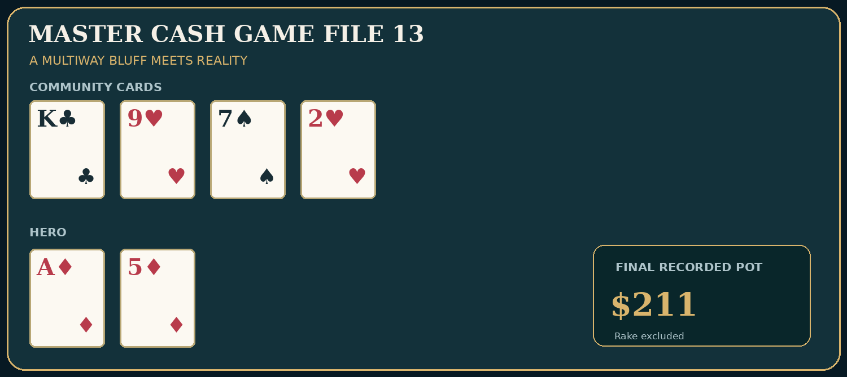
Exact cards and pot: Master Hand File 13

Preflop actions
- SB posts $1; adds $1. Running pot $1.
- BB posts $2; adds $2. Running pot $3.
- CO opens to $10; adds $10. Running pot $13.
- BTN calls $10; adds $10. Running pot $23.
- BB calls $8 more; adds $8. Running pot $31.

Flop actions
- BB checks; adds $0. Running pot $31.
- CO bets $20; adds $20. Running pot $51.
- BTN calls $20; adds $20. Running pot $71.
- BB calls $20; adds $20. Running pot $91.

Turn actions
- BB checks; adds $0. Running pot $91.
- CO checks; adds $0. Running pot $91.
- BTN bets $60; adds $60. Running pot $151.
- BB calls $60; adds $60. Running pot $211.
- CO folds; adds $0. Running pot $211.
Pot when action ends: $211 before rake.
Teaching question: In multiway pots a bluff must navigate the joint continuing range, not only one opponent’s likely fold.
Hero continuation-bets A♦5♦ with ace-high into two opponents on K♣9♥7♠, hoping to represent a strong opening range. Both call. On the 2♥ turn, Hero checks; Nico bets $60; Mara calls; Hero folds. The flop bluff has collected no fold equity against this group. It may not be inherently bad in every configuration, but against known sticky multiway callers, c-betting weak hands broadly is a leak. The action ledger illustrates why one opponent folding is insufficient to win the pot uncontested.
Change the conditions: If both opponents frequently fold to a modest flop bet on this texture, the bluff’s immediate EV may improve; estimate the chance that both fold.

Case 14: The Expensive Full-House Draw
Setup: Nine-handed $1/$2; Vince UTG $600, Hero BTN $600. Hero: 4♥ 4♦. Opponent cards: not exposed.
Board dealt: A♠ 8♠ 4♣ 9♠ 2♠.
Verified chip ledger (rake excluded; every amount below is an additional contribution, not the total lifetime wager)
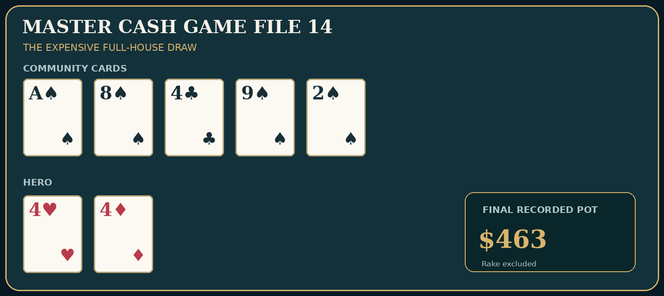
Exact cards and pot: Master Hand File 14

Preflop actions
- SB posts $1; adds $1. Running pot $1.
- BB posts $2; adds $2. Running pot $3.
- UTG opens to $20; adds $20. Running pot $23.
- BTN calls $20; adds $20. Running pot $43.

Flop actions
- UTG bets $30; adds $30. Running pot $73.
- BTN calls $30; adds $30. Running pot $103.

Turn actions
- UTG bets $80; adds $80. Running pot $183.
- BTN calls $80; adds $80. Running pot $263.

River actions
- UTG bets $200; adds $200. Running pot $463.
- BTN folds; adds $0. Running pot $463.
Pot when action ends: $463 before rake.
Teaching question: Folding the river can be correct even when Hero made a set; an earlier draw-chasing call may still have been the leak.
Hero flops bottom set on A♠8♠4♣. The 9♠ turn completes a three-spade board. Against a made flush, Hero could improve to quads or a full house on ten of the 46 unseen rivers: one 4, three aces, three eights, and three nines. That is 10/46 = 21.74%, short of the $80 turn call’s direct threshold of 80/263 = 30.42%. The turn call therefore needs additional implied value or a broader opponent range; we should not defend it automatically. The 2♠ river completes four spades on board, and Vince makes a large $200 bet. With no spade in the Hero hand, the fold against this value-heavy line avoids compounding a possibly bad turn call.
Change the conditions: Give Vince demonstrably frequent non-spade river bluffs. Even then, compare bluff frequency with the $200 river price instead of calling from resentment.

Case 15: The River That Did Not Help
Setup: Six-handed $1/$2; Hero CO $400, Lena BTN $400. Hero: J♠ T♠. Opponent cards: not exposed.
Board dealt: A♣ 8♦ 4♠ 9♥ 2♣.
Verified chip ledger (rake excluded; every amount below is an additional contribution, not the total lifetime wager)
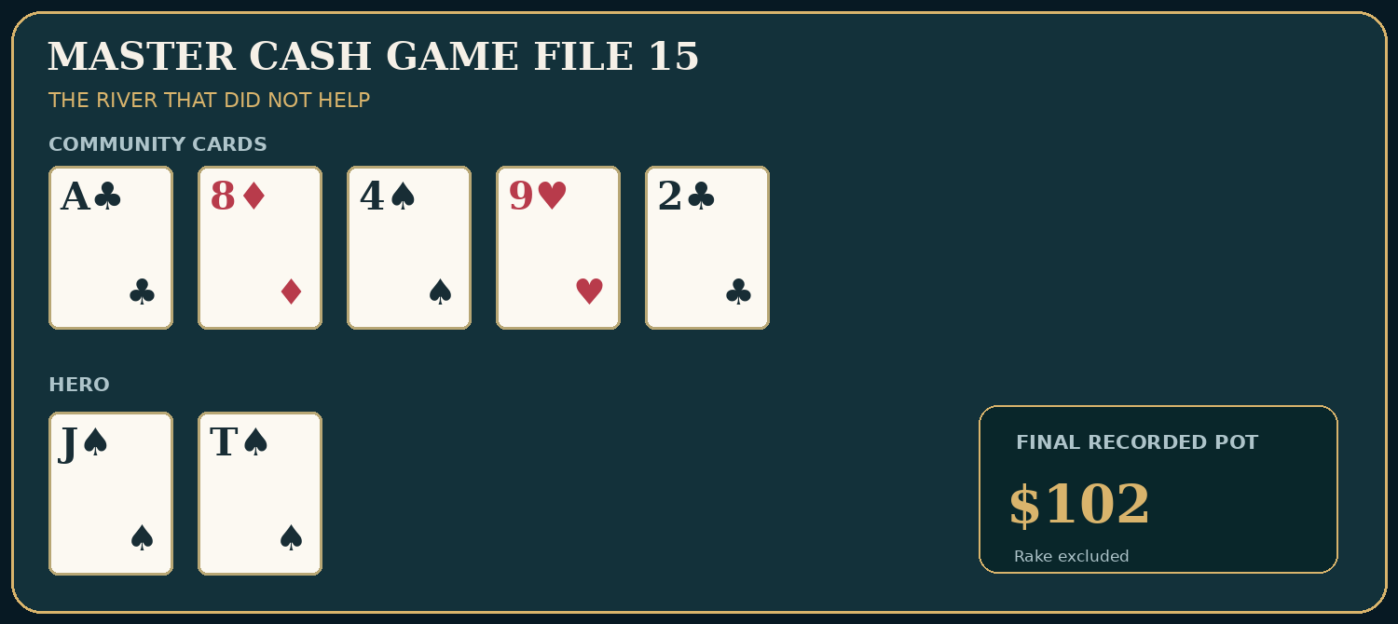
Exact cards and pot: Master Hand File 15

Preflop actions
- SB posts $1; adds $1. Running pot $1.
- BB posts $2; adds $2. Running pot $3.
- CO opens to $12; adds $12. Running pot $15.
- BTN calls $12; adds $12. Running pot $27.

Flop actions
- CO bets $15; adds $15. Running pot $42.
- BTN calls $15; adds $15. Running pot $57.

Turn actions
- CO checks; adds $0. Running pot $57.
- BTN checks; adds $0. Running pot $57.

River actions
- CO bets $45; adds $45. Running pot $102.
- BTN folds; adds $0. Running pot $102.
Pot when action ends: $102 before rake.
Teaching question: A river bluff may succeed, but a single fold does not validate the bet without a credible range and fold-frequency estimate.
Hero holds J♠T♠ on A♣8♦4♠9♥2♣ and finishes with jack-high. After the turn checks through, the river $45 bet into $57 needs folds greater than 45/(57+45) = 44.12% to work as a pure bluff with no showdown value. The observed fold this time proves only that Lena folded. Hero should investigate what value hands can credibly bet this river, what Lena can have after calling the flop and checking the turn, and how her calling frequency changes with size.
Change the conditions: Replace Lena with Mara, who calls nearly every river bet with a pair. The bluff may be unprofitable even though it worked once against Lena.

16. The Night-Shift Examination and Study Plan
Objective: Apply the book’s mathematical and observational tools without confusing outcomes with good decisions.
You now return to the fictional late-night cash room. Before answering, write the game, price, position, remaining stacks, likely opposing range, and what could reverse your conclusion. Do not guess merely to obtain a score. You can repeat this examination in the accompanying WordPress drill, which records results in the browser when permitted.

How the examination works
Fifty questions are grouped into five ten-question sections. Each has exactly four options with one defensible answer under its stated assumptions. The correct answer and explanation appear in the answer key after the questions. Where real strategic situations mix actions, the question asks about the proper reasoning rather than pretending that only one real-world bet size can work.
Scoring: 1 point for each correct response. Scores below 35 suggest rereading fundamentals and the mathematics; 35–44 suggest targeted review; 45–50 reflect strong understanding of these specific exercises, not proof of real-game profitability.

The fifty questions

SFFT-MCS2-001 — Game conditions
In an unstraddled $1/$2 game, how many chips are in the pot before any voluntary action, ignoring antes?
A. $1
B. $2
C. $3
D. $4

SFFT-MCS2-002 — Game conditions
Hero has $500, but the lone opponent has $80. What is the most Hero can win from that opponent in a heads-up hand, ignoring dead money?
A. $80
B. $500
C. $580
D. Unlimited

SFFT-MCS2-003 — Game conditions
Which statement about a live $5 straddle in a nominal $1/$2 game is most accurate?
A. It never affects preflop cost
B. It always makes the small blind $5
C. It changes the betting structure; verify who acts and who has an option under local rules
D. It removes rake

SFFT-MCS2-004 — Game conditions
Which is most useful to learn before choosing an opening range at a live table?
A. Last night’s largest pot
B. Current rake, stack depths, positions, action sizes and caller tendencies
C. The dealer’s favorite hand
D. Whether the room has neon lights

SFFT-MCS2-005 — Game conditions
A pot before rake is $20. A fictional room takes 10% rake plus a $2 promotional drop. What remains under this simplified rule?
A. $20
B. $18
C. $16
D. $14

SFFT-MCS2-006 — Game conditions
Three people are contesting a pot, one with $60 and two with $400. Which is correct?
A. All stacks are effectively $60
B. The $60 player may contest only an eligible main pot; deeper players can make a side pot
C. The $60 player wins all future side-pot wagers
D. Side pots are impossible in cash games

SFFT-MCS2-007 — Game conditions
Which observation is better evidence for a live read?
A. A player looks confident
B. A player wears sunglasses
C. A player calls several comparable river bets and shows weak pairs
D. A player is older than the dealer

SFFT-MCS2-008 — Game conditions
Which is correct about the pot already invested when facing a new river bet?
A. You must protect your prior investment by calling
B. Past contributions are sunk; evaluate the new price and winning chance
C. Fold only if you invested nothing
D. Calling is mandatory with top pair

SFFT-MCS2-009 — Game conditions
In an unopened pot, an ordinary opening raise “to $12” means Hero contributes how much total on that street if Hero has posted no blind?
A. $10
B. $12
C. $14
D. $24

SFFT-MCS2-010 — Game conditions
What is the best description of a table that has recently produced several $800 pots?
A. Certainly profitable for every caller
B. Proof that any suited hand can be entered
C. Potentially high variance, but profitability requires examining entry costs, rake, stacks and players
D. A mandatory table change

SFFT-MCS2-011 — Math
A river pot is $100 before Villain bets $50. Calling costs $50. What minimum win rate is required with no rake or ties?
A. 20%
B. 25%
C. 33.3%
D. 50%

SFFT-MCS2-012 — Math
A river pot is $100 and Villain bets $100. What equity does a closing-action call require, assuming no ties/rake?
A. 25%
B. 30%
C. 33.33%
D. 50%

SFFT-MCS2-013 — Math
A river pot is $100 and Villain bets $200. Required win rate for calling?
A. 20%
B. 33.3%
C. 40%
D. 66.7%

SFFT-MCS2-014 — Math
River pot $300 before a $240 bet. Calling $240 produces what final pot?
A. $540
B. $600
C. $720
D. $780

SFFT-MCS2-015 — Math
On the flop, with two hole cards and three board cards known, how many cards are unseen?
A. 45
B. 46
C. 47
D. 48

SFFT-MCS2-016 — Math
With 8 clean outs on the flop, what is the chance of hitting one on the turn, ignoring other players’ hidden information?
A. 8/46 = 17.39%
B. 8/47 = 17.02%
C. 16/47 = 34.04%
D. 8/52 = 15.38%

SFFT-MCS2-017 — Math
With 9 clean outs on the turn, what is the probability of hitting on the river?
A. 9/47 = 19.15%
B. 9/46 = 19.57%
C. 18/46 = 39.13%
D. 9/52 = 17.31%

SFFT-MCS2-018 — Math
A $60 pure bluff into $90 must make the lone opponent fold what fraction to break even (no showdown value)?
A. 25%
B. 40%
C. 50%
D. 66.7%

SFFT-MCS2-019 — Math
A $45 pure bluff into $57 needs approximately what fold frequency?
A. 30%
B. 40%
C. 44.12%
D. 55.88%

SFFT-MCS2-020 — Math
You hold a pocket pair. Probability of flopping at least one matching-rank card is approximately?
A. 2%
B. 6%
C. 11.76%
D. 25%

SFFT-MCS2-021 — Pot construction
Preflop $1/$2: SB $1, BB $2, cutoff raises to $8, button calls $8, both blinds fold. Pot before flop?
A. $16
B. $17
C. $18
D. $19

SFFT-MCS2-022 — Pot construction
Flop pot $40; Hero bets $20; one opponent calls. Pot on turn?
A. $60
B. $70
C. $80
D. $100

SFFT-MCS2-023 — Pot construction
Flop pot $50, $250 effective remains. Hero bets $25 and is called. Pot and effective stacks at turn?
A. $75 and $225
B. $100 and $225
C. $100 and $250
D. $50 and $200

SFFT-MCS2-024 — Pot construction
Turn pot $100, effective stack $400. Hero bets $70 and is called. River pot?
A. $170
B. $200
C. $240
D. $300

SFFT-MCS2-025 — Pot construction
Turn pot $100, effective $400. After a $70 bet/call, what effective stack remains?
A. $260
B. $300
C. $330
D. $470

SFFT-MCS2-026 — Pot construction
Flop pot $60, effective remaining $360. Hero bets $30 and is called. Turn SPR?
A. 2.75
B. 3.0
C. 4.5
D. 6.0

SFFT-MCS2-027 — Pot construction
A live $1/$2 player raises to $18 after calling nothing. An earlier limper has $2 in. How much more must that limper call?
A. $14
B. $16
C. $18
D. $20

SFFT-MCS2-028 — Pot construction
What does SPR measure at the start of a street?
A. Past pots won per hour
B. Effective remaining stack divided by current pot
C. Total chips on table divided by blind
D. Equity multiplied by raise size

SFFT-MCS2-029 — Pot construction
A river pot is $160. Villain bets $120. A call costs $120. Final pot after call?
A. $160
B. $280
C. $360
D. $400

SFFT-MCS2-030 — Pot construction
In a multiway pot, why is there not necessarily one effective stack?
A. Everyone has identical stacks
B. Each opponent pair and each side-pot eligibility can differ
C. Rake sets effective stack
D. The biggest stack always determines it

SFFT-MCS2-031 — Implied odds
Which best defines implied odds?
A. The current pot divided by rake
B. Potential future net payment you may win if your hand improves, weighted by how often it happens
C. A guarantee that all draws are profitable
D. The number of chips already lost

SFFT-MCS2-032 — Implied odds
Which condition generally weakens set-mining incentive?
A. Deep opponents who overpay sets
B. A small raise in position
C. A short effective stack with a large preflop call price
D. An opponent who rarely folds top pair

SFFT-MCS2-033 — Implied odds
Nine clean outs on turn, $40 call making $140. With all hits always winning and no fees, how much extra net river payment is needed per hit on average to break even?
A. About $0
B. About $20
C. About $64.44
D. About $140

SFFT-MCS2-034 — Implied odds
You need $64.44 of extra net river payment on average on successful draws; the opponent pays $100 only 50% of hits. Is that enough?
A. Yes, average is $100
B. Yes, average is $75
C. No, average is $50
D. No, average is $0

SFFT-MCS2-035 — Implied odds
What are reverse implied odds?
A. The chance of making any pair
B. Future losses from continuing with a dominated or second-best hand
C. A way to ignore the pot price
D. A guarantee that suited cards lose

SFFT-MCS2-036 — Implied odds
Which hand is most naturally vulnerable to domination against a very tight early-position opening range?
A. A♠A♦
B. K♣J♦ offsuit
C. K♠K♥
D. A♠K♠

SFFT-MCS2-037 — Implied odds
Why can a $2 overlimp become an expensive decision?
A. Blinds disappear
B. A player still to act may raise, and future betting may be costly
C. The hand has no chance to make a straight
D. The dealer always increases rake before the flop

SFFT-MCS2-038 — Implied odds
With 9♠8♠ on J♠T♠2♦, how many distinct nominal turn cards complete a straight or flush, before checking dirty outs?
A. 9
B. 12
C. 15
D. 17

SFFT-MCS2-039 — Implied odds
What is the strongest reason to reject a speculative hand even if the table had many big pots earlier?
A. It has a dark-colored suit
B. Your current price, nut potential, future payment and reverse-implied risk cannot support a credible +EV line
C. All large pots are fake
D. The opponent smiled

SFFT-MCS2-040 — Implied odds
Which statement about set mining is correct?
A. A pocket pair always hits the flop one time in four
B. Hitting a set guarantees a win
C. At least one matching flop rank appears about 11.76% of the time, but profitability depends on payments and losses
D. Calling any open is profitable with a pair

SFFT-MCS2-041 — Multiway and reads
Why can a pure multiway bluff be harder than a heads-up bluff?
A. Two opponents mean no draws
B. To win uncontested, all opponents with a live decision must fold
C. The pot cannot grow
D. Cards change rank

SFFT-MCS2-042 — Multiway and reads
If two opponents each independently fold 50% against a pure bluff, what is probability that both fold?
A. 25%
B. 50%
C. 75%
D. 100%

SFFT-MCS2-043 — Multiway and reads
Which player type is generally a better target for thinner value bets?
A. One who calls with too many weaker hands
B. One who folds every weak hand
C. One who never calls river bets
D. One who has already left the table

SFFT-MCS2-044 — Multiway and reads
If a player rarely bluffs when making a large river raise, what should you generally do with marginal bluff-catchers?
A. Call wider automatically
B. Fold more often when the line and price support that read
C. Bluff-raise every time
D. Ignore the read

SFFT-MCS2-045 — Multiway and reads
Which fact about a large opponent stack is relevant to implied odds?
A. It pays you automatically
B. It can only matter if that opponent is eligible, stays involved and is likely to pay
C. It always means they are weak
D. It overrides rake

SFFT-MCS2-046 — Multiway and reads
Which is a reliable response to one surprising showdown?
A. Treat it as permanent proof
B. Forget everything observed before
C. Update your hypothesis modestly and seek comparable observations
D. Play every pot against that opponent

SFFT-MCS2-047 — Multiway and reads
With a river pot of $120, Villain bets $80. Required closing-action win rate with no ties/rake?
A. 20%
B. 25%
C. 28.57%
D. 40%

SFFT-MCS2-048 — Multiway and reads
Villain’s betting range has 12 equally weighted hands that beat you and 6 bluffs you beat. What is your win fraction?
A. 20%
B. 25%
C. 33.33%
D. 50%

SFFT-MCS2-049 — Multiway and reads
What makes a large river bet by a known underbluffer different from the same bet by a frequent bluffer?
A. The pot odds formula changes
B. The likely composition of the betting range changes, while the numerical price stays the same
C. One bet becomes legally smaller
D. Only the dealer knows the hand

SFFT-MCS2-050 — Multiway and reads
Against a 75%-pot river bet requiring 30% win equity, do you call with exactly 20% equity and no future betting?
A. Always, because you have a pair
B. No, fold is higher EV under stated assumptions
C. Yes, because the pot is large
D. Only if the last card was red

Answer key and explanations
SFFT-MCS2-001 — C. Small blind $1 plus big blind $2 = $3. Other answers omit or invent a forced contribution.
SFFT-MCS2-002 — A. One player cannot win more from the opponent than that opponent can put in. Hero’s excess stack is not contestable.
SFFT-MCS2-003 — C. A live straddle often changes the current price and action; it is room-dependent. It does not automatically change the posted small blind or remove rake.
SFFT-MCS2-004 — B. Costs, price, position and who continues determine EV. The others are not strategy inputs.
SFFT-MCS2-005 — C. Ten percent of $20 is $2; another $2 leaves $16. This assumes the stated rule applies and ignores rounding.
SFFT-MCS2-006 — B. Effective stacks vary by pairing. Extra chips between deeper players may form a side pot the $60 player cannot win.
SFFT-MCS2-007 — C. Repeated contextual behavior and observed showdowns are more relevant than appearance or assumptions.
SFFT-MCS2-008 — B. Money already in the pot cannot justify a losing new call. Calculate the incremental decision.
SFFT-MCS2-009 — B. A raise to $12 is a total contribution of $12; it is not $12 added after first calling.
SFFT-MCS2-010 — C. Large prior pots do not reveal future expected value or guarantee payment.
SFFT-MCS2-011 — B. The final pot after the call is $200; 50/200 = 25%.
SFFT-MCS2-012 — C. Calling $100 makes a $300 pot; 100/300 = one-third.
SFFT-MCS2-013 — C. Call $200 to make a $500 final pot; 200/500 = 40%.
SFFT-MCS2-014 — D. The final pot is $300+$240+$240=$780.
SFFT-MCS2-015 — C. 52 minus five visible cards equals 47 unknown cards.
SFFT-MCS2-016 — B. One card is drawn from 47 unseen cards on the flop: 8/47 ≈ 17.02%.
SFFT-MCS2-017 — B. On the turn six cards are known, leaving 46 unseen: 9/46.
SFFT-MCS2-018 — B. Break-even fold frequency is 60/(60+90)=40%. A bluff with showdown equity needs a richer model.
SFFT-MCS2-019 — C. Risk divided by risk plus reward: 45/(45+57)=44.12%.
SFFT-MCS2-020 — C. 1 − C(48,3)/C(50,3) = approximately 11.755%, including rare quads.
SFFT-MCS2-021 — D. $1+$2+$8+$8 = $19. Do not add blinds twice.
SFFT-MCS2-022 — C. Both contribute $20, so $40+$20+$20=$80.
SFFT-MCS2-023 — B. Pot adds $50 to become $100, and each stack loses $25 to $225.
SFFT-MCS2-024 — C. The two $70 contributions increase the pot to $240.
SFFT-MCS2-025 — C. Each player has put in $70 of the $400, leaving $330.
SFFT-MCS2-026 — A. Turn pot $120, effective remaining $330; 330/120=2.75.
SFFT-MCS2-027 — B. The limper already committed $2; $18−$2=$16 additional.
SFFT-MCS2-028 — B. SPR describes the relation between money available to bet and pot size; it does not dictate action alone.
SFFT-MCS2-029 — D. $160+$120+$120=$400.
SFFT-MCS2-030 — B. The amount contestable against each opponent depends on their contribution capacity and eligibility.
SFFT-MCS2-031 — B. Implied odds concern credible future winnings, not assured money or past costs.
SFFT-MCS2-032 — C. A short stack limits future payment compared with the price of calling to hit a rare set.
SFFT-MCS2-033 — C. p=9/46, W=40/p−140≈$64.44. Real risks and fees may increase this threshold.
SFFT-MCS2-034 — C. Conditional average extra payment is .50×100=$50, below $64.44.
SFFT-MCS2-035 — B. Improving to a hand that is still second-best can induce costly future calls or raises.
SFFT-MCS2-036 — B. K-J offsuit can make top pair dominated by A-K or K-Q and often realizes poorly against stronger early-position action.
SFFT-MCS2-037 — B. The call is only a cheap initial investment; raises behind and future streets can change the price.
SFFT-MCS2-038 — C. Nine spades plus eight seven/queen rank cards minus overlapping 7♠ and Q♠ gives 15 distinct nominal completions.
SFFT-MCS2-039 — B. Past spectacular pots do not establish a positive expected value for this hand.
SFFT-MCS2-040 — C. The exact probability is near 11.755%; it is not a guarantee of winning or payment.
SFFT-MCS2-041 — B. A fold by one player does not win the pot if someone else calls.
SFFT-MCS2-042 — A. Under this artificial independence assumption, .5×.5=.25. Real opponents are not generally independent.
SFFT-MCS2-043 — A. A documented overcaller supplies value when worse holdings continue. Bet size still matters.
SFFT-MCS2-044 — B. An underbluffing river range reduces the chance your bluff-catcher wins; check price and evidence.
SFFT-MCS2-045 — B. Stack capacity is only one necessary condition; payment behavior and pot eligibility matter.
SFFT-MCS2-046 — C. One hand can be evidence without supporting extreme certainty.
SFFT-MCS2-047 — C. 80/(120+80+80)=80/280≈28.57%.
SFFT-MCS2-048 — C. Six wins among 18 equally weighted combos = one-third. Real betting frequencies may be unequal.
SFFT-MCS2-049 — B. Pot odds depend on bet and pot sizes. An opponent read changes estimated winning probability, not the price itself.
SFFT-MCS2-050 — B. 20% is below the 30% threshold. A losing river call is not rescued by earlier investment.

The forty-minute study routine
First ten minutes: choose one incorrect decision from your last examination. Reconstruct the pot, price, and remaining stacks from first principles.
Next ten minutes: rewrite the likely opposing range and label assumptions. Ask what bluff or value combinations would be required to change your preferred action.
Next ten minutes: change a single variable—position, bet size, effective stack, or observed population tendency—and predict the new result.
Final ten minutes: practise two previously missed concepts without looking at the answer key. Record whether your confidence matched your performance.

Completion is not certification
Poker education cannot guarantee winnings. Passing a quiz means that a student can solve the modeled decisions; it does not prove that the same assumptions hold in an unfamiliar real game, that opponents will cooperate with an implied-odds plan, or that a particular financial risk is appropriate. The most valuable result is a habit of clearly reasoned decisions under uncertainty.
End of Book Two — The Live Cash Game Masterclass.

The Reference Desk

A. Pot-odds and pure-bluff prices
Let P be the pot before the opponent acts and B the size of the opponent’s bet. If Hero faces that bet and is closing the action, calls B and has no future betting, the final pot is P + 2B. With no ties or rake, the minimum showdown win probability to call is B/(P+2B). With a pure bluff for B into P, and zero equity when called, the minimum fold probability is B/(P+B). These are different formulas answering different questions.
Bet size / pre-bet pot | Required win rate for call | Required fold frequency for pure bluff
1/4 | 16.67% | 20.00%
1/3 | 20.00% | 25.00%
1/2 | 25.00% | 33.33%
2/3 | 28.57% | 40.00%
3/4 | 30.00% | 42.86%
1 | 33.33% | 50.00%
2 | 40.00% | 66.67%
Never add implied odds as a percentage to pot odds. To incorporate extra future money, construct an EV tree with plausible conditional payments and losses. When ties are possible, treat equity as win probability plus an appropriate share of tied outcomes; the simplest tables above assume no ties.

B. Exact drawing approximations
For the first flop-to-turn card, there are 47 unseen cards after Hero’s two hole cards and three board cards are specified. After the turn, 46 unseen remain. The following table assumes all counted cards are clean improvements and does not automatically indicate showdown wins.
Clean out count | Hit on the next card from flop | Hit on the river from turn | Hit at least once over two cards from flop
4 | 8.51% | 8.70% | 16.47%
6 | 12.77% | 13.04% | 24.14%
8 | 17.02% | 17.39% | 31.45%
9 | 19.15% | 19.57% | 34.97%
12 | 25.53% | 26.09% | 44.96%
15 | 31.91% | 32.61% | 54.12%
Two-card probability is 1 − ((47−outs)/47)×((46−outs)/46). You must be entitled to see both cards—for example because all remaining players are all-in—or model the extra turn betting separately. An out that makes a draw but does not win the pot is not a clean out. Card removal from known opposing hole cards changes the denominator and remaining outs.

C. Set probability and hand combinations
For an unpaired starting-hand rank combination, the unsuited rank pair spans 16 starting combinations: four suited and twelve offsuit. A pocket pair has 6 combinations. A 13×13 matrix displays 169 rank classes—not 169 equally likely physical combinations. Hero’s cards and exposed board cards reduce what remains possible.
With a pocket pair, exactly one of the two remaining matching-rank cards appears on the flop with probability 2×C(48,2)/C(50,3) ≈ 11.51%, and both appear with probability C(48,1)/C(50,3) ≈ 0.245%. The total probability of making at least three of a kind from the pocket pair on the flop is approximately 11.755%. That does not mean a set will win or be paid when it hits.

D. The decision audit card
Question | Write down before deciding
Who remains? | Number of players and positions
How much is the pot? | Before the bet, not including an imagined future call
What exactly does calling cost? | Incremental investment, not prior committed chips
What are the effective stacks? | Per opponent, including side-pot eligibility
What beats this holding? | Better legal combinations on the exact board
What draws and bluffs remain? | With relevant frequencies and blockers
Will a strong hit get paid? | How often, by whom, and for how much?
How might I lose more? | Reverse implied odds, raises, redraws
What about rake? | Room-specific rule and amount
What changes the answer? | One assumption or piece of evidence

E. Glossary
Absolute position: who acts later in the street order. Action frequency: estimated fraction of a hand class taking an action. Blocker: a known card reducing the number of an opponent’s possible combinations. Broadway: ace, king, queen, jack, and ten; also the highest straight. C-bet: a continuation bet by a previous street’s aggressor. Dirty out: an apparent improvement that may not win. Equity: mathematical share of showdown outcomes given specified opposing holdings/ranges. Equity realization: conversion of showdown equity into EV under future betting. Effective stack: maximum stack amount that can be contested between particular players in a pot. EV: expected value of a decision, averaging possible results under a model. Implied odds: potential extra future money won after improvement, conditional on opponent responses. Isolation raise: raise intended to win value or reduce the field against limpers. MDF: a game-theoretic minimum defense-frequency concept for limited toy models; not a universal requirement for live calling. Nut advantage: proportion of strongest possible holdings within one range relative to another. Overlimp: call the blind after other players have limped. Polarized range: one concentrated toward strong value and bluffs. Pot geometry: how present bets determine the sizes of later pots and effective stacks. Rake: house fee, subject to local method and cap. Range: hands an opponent could plausibly possess, with appropriate action weights. Reverse implied odds: expected future cost of making a second-best hand or paying while behind. SPR: stack-to-pot ratio at a specific street. Straddle: optional or mandatory blind-like live wager permitted under local rules. Three-bet: first re-raise preflop following an open raise. Value bet: bet intended to receive enough calls from worse hands to be profitable.

F. Further reading and factual framework
These materials are useful independent explanations of terms and theory; no solver frequencies or proprietary charts have been reproduced. Readers should verify their casino’s current cash rules independently because tournament rules and room practices are not interchangeable.
- PokerStars Learn, Pot Odds Explained, https://www.pokerstars.com/poker/learn/lesson/pot-odds/ (pot odds, implied and reverse implied odds).
- PokerStars Learn, Calculating implied odds and when it matters (May 29, 2025), https://www.pokerstars.com/poker/learn/strategies/calculating-implied-odds-and-when-it-matters/.
- GTO Wizard, Andrew Brokos, Equity Realization (November 16, 2022), https://blog.gtowizard.com/equity-realization/.
- GTO Wizard, 10 Tips for Multiway Pots in Poker, https://blog.gtowizard.com/10-tips-multiway-pots-in-poker/.
- Poker Tournament Directors Association, TDA Poker Rules, https://www.pokertda.com/poker-tda-rules/. This is a tournament-rule reference and not a blanket statement of every cash room’s rules.

G. Editorial methodology and limitations
All fifteen fictional hand files have a structured source containing known cards and incremental player contributions. The publishing script checks that no card is duplicated within a hand, that suit/rank notation is valid, and that the printed pot equals the sum of known contributions. Numerical checkpoints also test the key drawing, implied-odds and bluff-threshold formulas. This reduces arithmetic and typographical errors but does not replace independent strategic review. In particular, opponent ranges and action frequencies are modeled teaching assumptions, not experimentally verified truths about a named player pool; they have not been tested against a licensed commercial solver.
Card and pot diagrams are generated from structured records. The promotional cover is imaginative AI art and should not be consulted for poker rules. The WordPress importer is draft-only; all hyperlinks and uploaded image URLs need staging and functional checks before publication. A separate quiz component stores progress locally in the reader’s browser. Its educational score does not imply expected profits in live play.

Closing note
The difference between a good cash-game player and a person who merely remembers lucky nights is often a notebook full of questions. What was the actual price? Who could pay? Was the draw to the nuts? Did the opponent really bluff that line? Which assumption would make folding correct? If those questions have become habitual, this book has done its work.

